Supplemental Material

Imaging Data Preprocessing
Structural imaging data preprocessing included: 1) removal of image noise using a spatially adaptive non-local means filter, which has been demonstrated to potentially improve the brain extraction, registration, segmentation and subsequent default network mapping , 2) removal of non-brain tissue using a hybrid watershed/surface deformation procedure , 3) automated segmentation of the white matter and deep gray matter volumetric structures , 4) a two-step registration of the high-resolution anatomical image to the common MNI152 stereotaxic space .
Functional preprocessing employed here was conducted based on a modified version of the ‘1000 Functional Connectomes Project’ scripts with updates on the nuisance signals extraction from the individual specific global brain, white matter and CSF masks (http://www.nitrc.org/projects/fcon_1000): 1) discarding the first 5 EPI volumes from each scan to allow for signal equilibration, 2) slice timing correction, 3) 3D motion correction, 4) co-registration between individual functional and anatomical images using boundary-based registration in FreeSurfer, 5) spatial smoothing (6 mm FWHM Gaussian kernel), 6) 4D mean-based intensity normalization, 7) band-pass temporal filtering (0.01-0.1Hz), 8) removal of linear and quadratic trends, 9) removal of various nuisance covariates (signals from white matter, cerebrospinal fluid, the full brain, and 24 motion parameters). The resultant 4D residual time series was used for subsequent participant-level analyses.

Test-Retest Reliability Analysis
It is crucial for clinical applications to evaluate the test-retest reliability of brain imaging measures . Particularly, in the current study, the resting state functional imaging scans were conducted for each subject with a relatively short duration (i.e., 4.7 mins), such reliability analyses can provide additional confidences on the data quality and stability of findings. To examine the test-retest reliability of the default network connectivity, we conducted statistical reliability analysis based upon all individual default network functional connectivity maps derived from the seed region (PCC). Specifically, the intra-class correlation coefficient (ICC) was computed to assess the test-retest reliability of default network connectivity based upon REST1 and REST2 for CON subjects. To calculate the ICC for each voxel, we consider a random sample of subjects with repeated measurements of a continuous variable characterizing the default network connectivity. To avoid negative and get more accurate estimation of sample ICC, the variance components in a linear mixed-effects model were estimated with the restricted maximum likelihood (ReML) approach built in MATLAB with Linear Mixed Effect (LME) toolbox.
Table S1 Treatment details of OCD patients
Treatment | Number of case | Average dosage (mg)
citalopram | 2 |  | 40
clomipramine | 1 |  | 100
fluoxetine | 1 |  | 46.7
fluvoxamine | 2 |  | 250
mirtazapine | 1 |  | 30
paroxetine | 3 |  | 60
sertraline | 2 |  | 162.5
paroxetine + sodium valproate | 1 |  | 40 + 666.7
paroxetine + quetiapine | 2 |  | 40 + 200

Figure S1. The Test-Retest Reliability of Default Network Connectivity. The PCC was used to generate all individual default network resting state functional connectivity (RSFC) maps. The final intraclass correlation (ICC) maps derived from PCC are visualized as 4 hemispheric surfaces (cortical regions: 2 for left hemisphere [LH] and 2 for right hemisphere [RH]).

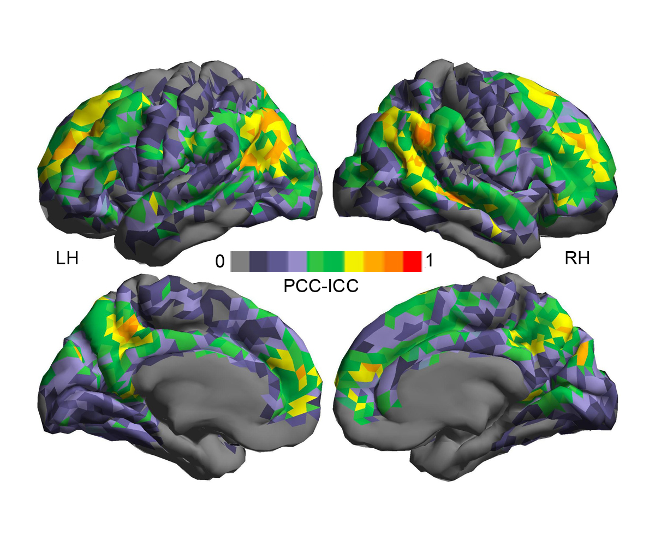

References
Andersson J, Jenkinson M, Smith S (2007). R07JA2: Non-linear registration, aka Spatial normalisation. FMRIB Analysis Group Technical Reports.
Biswal BB, Mennes M, Zuo XN, Gohel S, Kelly C, Smith SM, Beckmann CF, Adelstein JS, Buckner RL, Colcombe S, Dogonowski AM, Ernst M, Fair D, Hampson M, Hoptman MJ, Hyde JS, Kiviniemi VJ, Kotter R, Li SJ, Lin CP, Lowe MJ, Mackay C, Madden DJ, Madsen KH, Margulies DS, Mayberg HS, McMahon K, Monk CS, Mostofsky SH, Nagel BJ, Pekar JJ, Peltier SJ, Petersen SE, Riedl V, Rombouts SA, Rypma B, Schlaggar BL, Schmidt S, Seidler RD, Siegle GJ, Sorg C, Teng GJ, Veijola J, Villringer A, Walter M, Wang L, Weng XC, Whitfield-Gabrieli S, Williamson P, Windischberger C, Zang YF, Zhang HY, Castellanos FX, Milham MP (2010). Toward discovery science of human brain function. Proceedings of the National Academy of Sciences of the United States of America 107, 4734-4739.
Fischl B, Salat DH, Busa E, Albert M, Dieterich M, Haselgrove C, van der Kouwe A, Killiany R, Kennedy D, Klaveness S, Montillo A, Makris N, Rosen B, Dale AM (2002). Whole brain segmentation: automated labeling of neuroanatomical structures in the human brain. Neuron 33, 341-355.
Fischl B, Salat DH, van der Kouwe AJ, Makris N, Segonne F, Quinn BT, Dale AM (2004). Sequence-independent segmentation of magnetic resonance images. Neuroimage 23 Suppl 1, S69-84.
Jenkinson M, Bannister P, Brady M, Smith S (2002). Improved optimization for the robust and accurate linear registration and motion correction of brain images. Neuroimage 17, 825-841.
Jenkinson M, Smith S (2001). A global optimisation method for robust affine registration of brain images. Medical Image Analysis 5, 143-156.
Segonne F, Dale AM, Busa E, Glessner M, Salat D, Hahn HK, Fischl B (2004). A hybrid approach to the skull stripping problem in MRI. Neuroimage 22, 1060-1075.
Shehzad Z, Kelly AM, Reiss PT, Gee DG, Gotimer K, Uddin LQ, Lee SH, Margulies DS, Roy AK, Biswal BB, Petkova E, Castellanos FX, Milham MP (2009). The resting brain: unconstrained yet reliable. Cerebral Cortex 19, 2209-2229.
Wang JH, Zuo XN, Gohel S, Milham MP, Biswal BB, He Y (2011). Graph theoretical analysis of functional brain networks: test-retest evaluation on short- and long-term resting-state functional MRI data. PLoS One 6, e21976.
Xing XX, Zhou YL, Adelstein JS, Zuo XN (2011). PDE-based spatial smoothing: a practical demonstration of impacts on MRI brain extraction, tissue segmentation and registration. Magnetic Resonance Imaging 29, 731-738.
Zuo XN, Di Martino A, Kelly C, Shehzad ZE, Gee DG, Klein DF, Castellanos FX, Biswal BB, Milham MP (2010a). The oscillating brain: complex and reliable. Neuroimage 49, 1432-1445.
Zuo XN, Kelly C, Adelstein JS, Klein DF, Castellanos FX, Milham MP (2010b). Reliable intrinsic connectivity networks: test-retest evaluation using ICA and dual regression approach. Neuroimage 49, 2163-2177.
Zuo XN, Kelly C, Di Martino A, Mennes M, Margulies DS, Bangaru S, Grzadzinski R, Evans AC, Zang YF, Castellanos FX, Milham MP (2010c). Growing together and growing apart: regional and sex differences in the lifespan developmental trajectories of functional homotopy. The Journal of Neuroscience 30, 15034-15043.
Zuo XN, Xing XX (2011). Effects of non-local diffusion on structural MRI preprocessing and default network mapping: statistical comparisons with isotropic/anisotropic diffusion. PLoS One 6, e26703.

