SUPPLEMENTARY MATERIAL

Supplementary Method
Seed based functional connectivity analysis
Four areas were selected as seed regions for the functional connectivities analysis (Fox ＆ Greicius, 2010; Fox et al. 2005), that is, the left mPFC, the left PCC, and bilateral amygdala. For each subject, a correlation map was produced by computing the cross-correlation coefficient (r score) between the reference time series of the each seed region and the time series of each voxel within the whole brain. Correlation coefficients were then converted to z values using Fisher’s r-to-z transform to standardize the statistical analysis because the correlation coefficient r is not normally distributed (Fox et al. 2005; Qi et al. 2013). Within each group, a random effect one-sample t tests were performed on individual z value map in a voxel-wise manner to determine brain regions showing significant functional connectivity to each seed region. Significant thresholds were set at a corrected p < 0.01 [multiple correction using family-wise error (FWE) correction across the whole brain] (Supplementary figure 1). Then a random effect two-sample t test in a voxel-wise manner was performed to determine the differences of each seed’s functional connectivity network between PTSD patients and controls, with age, gender, and education importing as covariates. Statistical threshold was set at p < 0.05, false discovery rate (FDR) corrected (Supplementary figure 2).

Supplementary Results
Seed based functional connectivity results
Within each seed region, the mPFC showed significantly positive connectivities with bilateral frontal, parietal, temporal, occipital and cerebellum cortices. The PCC display significantly positive connectivities with posterior cingulated/precuneus, medial frontal gyrus, bilateral parahippocampa gyri, and negatively connected with bilateral dorlateral prefrontal cortices, supplementary motor area, parietal cortices, inslula, and basal ganglia. The left/right amygdala both positively connected with many cerebral and cerebellum cortices, and basal ganglia (Supplementary figure1).
Compared with the controls, the PTSD patients showed decreased positive functional connectivities with mPFC in left postcentral gyrus, bilateral PCC/precuneus, bilateral parahippocampal gyri, orbital frontal gyrus. In addition, the patients showed increased negative functional connectivities between left PCC and bilateral insula, as well as decreased positive functional connectivities between bilateral amygdala with bilateral middle frontal gyri and medial frontal gyrus (Supplementary figure 2).

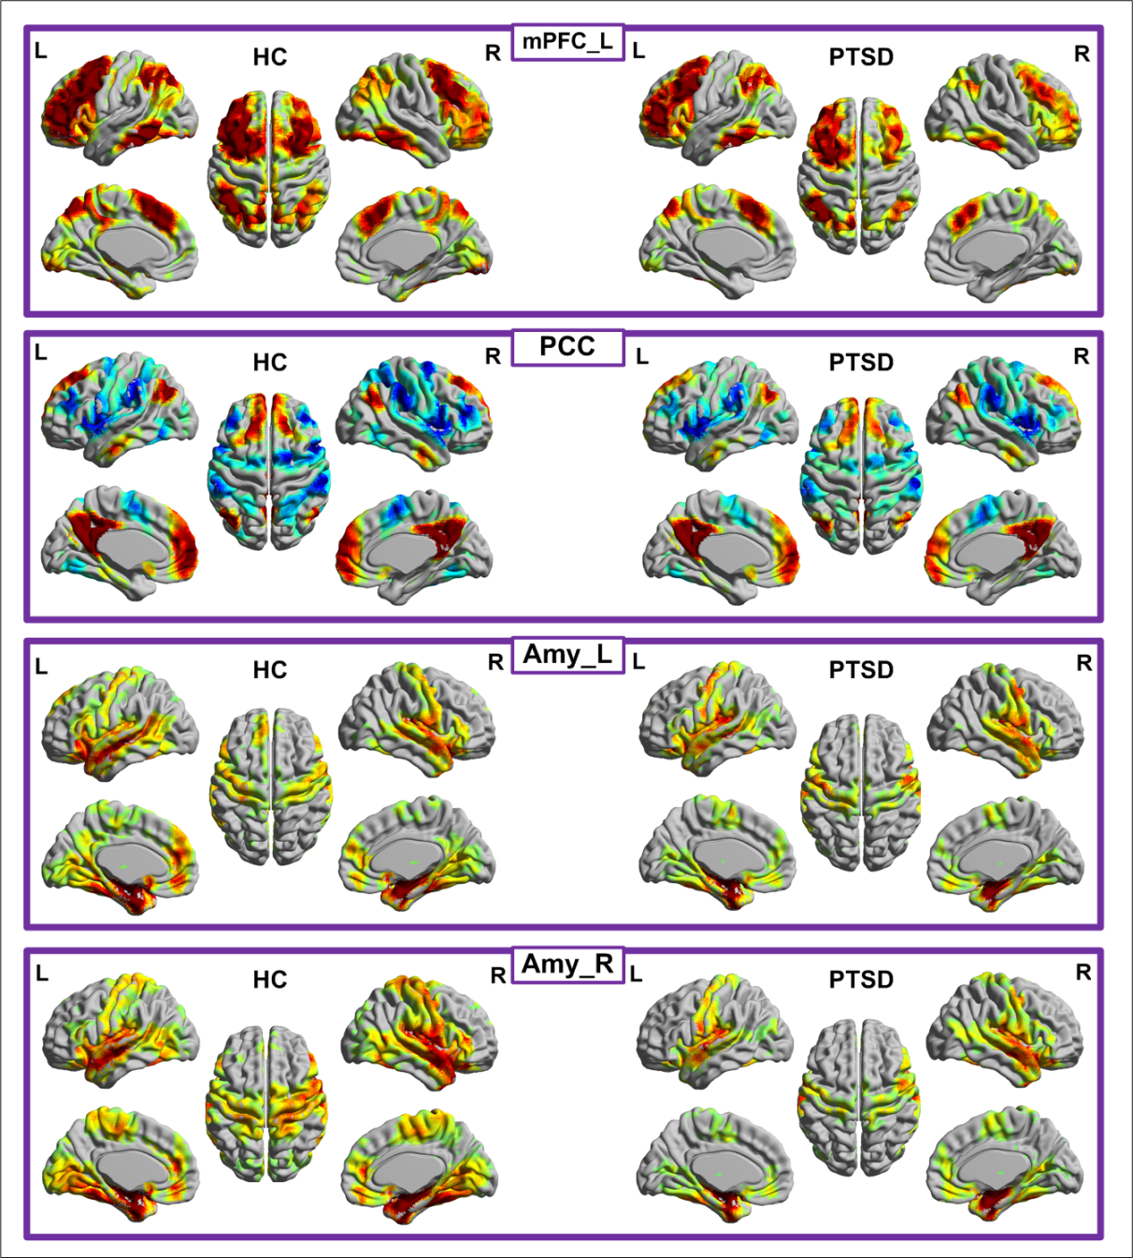
Supplementary figure 1 Within group maps of functional connectivity network of each seed region in PTSD and control groups.

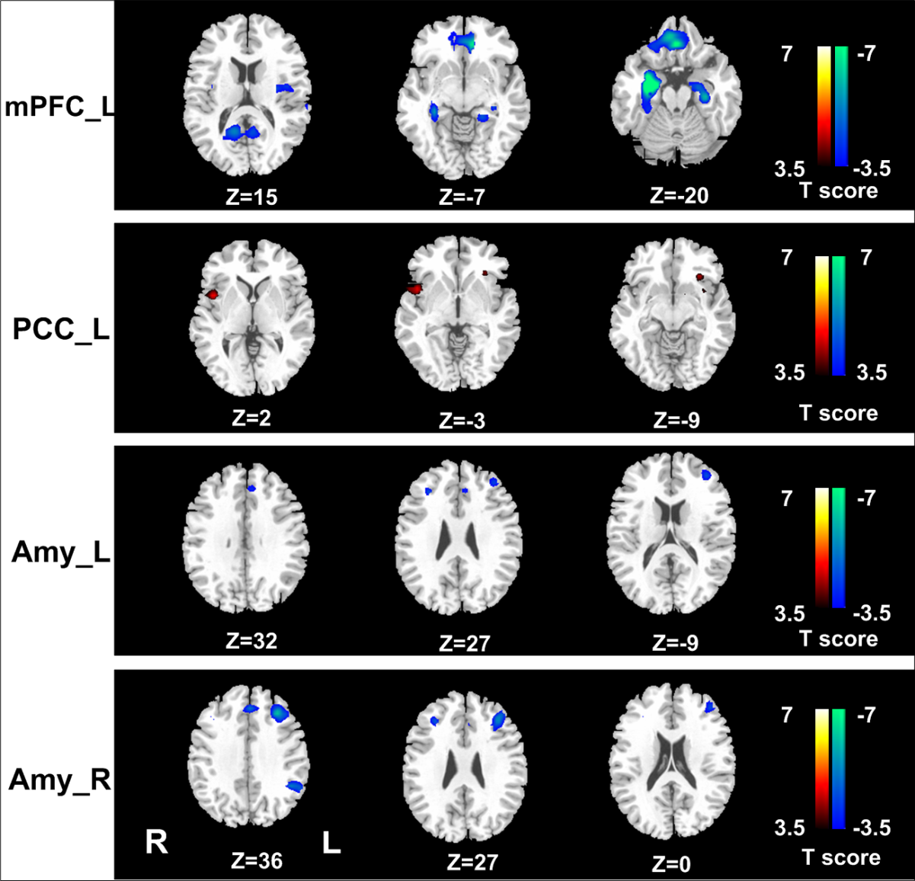
Supplementary figure 2 Differences of the functional connectivity networks of each seed region between PTSD and control groups.

References
Fox MD, Greicius M (2010). Clinical applications of resting state functional connectivity. Frontiers in Systems Neuroscience 4, 19.
Fox MD, Snyder AZ, Vincent JL, Corbetta M, Van Essen DC, Raichle ME (2005). The human brain is intrinsically organized into dynamic, anticorrelated functional networks. Proceedings of the National Academy of Sciences of the United States of America 102, 9673-8.
Qi R, Zhang LJ, Zhong J, Zhang Z, Ni L, Zheng G, Lu GM (2013). Disrupted thalamic resting-state functional connectivity in patients with minimal hepatic encephalopathy. European Journal of Radiology.

