Supplementary Table S1. CIRCUITS tasks and neuropsychological skills required
Abstract tasks (simple, abstract content) | Neuropsychological Skills Required
Codes | Divided attention, verbal working memory
Comparisons | Divided attention, cognitive flexibility
Cut the line | Visual attention, cognitive flexibility
Hands and feet | Perspective taking, visual working memory
Image copy | Visual attention, cognitive flexibility
Image recall | Visuo-spatial long-term memory
Learning a list (icons and words) and recall | Long-term memory, strategy use
Moving arrows | Sustained attention, working memory, response inhibition
Overlapping figures | Visual/verbal attention, working memory
Rotations | Visuo-spatial working memory
Vigilance | Sustained attention, working memory, response inhibition

Exercises (complex, ecologically valid)
Comprehension | Comprehension, verbal long-term memory
CV | Comprehension, long-term memory, problem-solving
Dual task | Divided attention, working memory, cognitive flexibility
Extract the gist | Abstraction, working and long-term memory, comprehension
Gist recall | Long-term memory, comprehension
Multiple memory (faces and places) | Long-term memory, strategy use
Perspective taking | Working memory, cognitive flexibility
Plan a day | Comprehension, planning, strategy use, long-term memory, sequencing
Recipe | Comprehension, long-term memory, sequencing
Seating plan | Problem-solving, comprehension, working and long-term memory
Shopping | Planning, strategy use, working memory, flexibility
Timing the journey | Comprehension, problem-solving, cognitive flexibility, planning
Train journey | Sustained attention, working and long-term memory

Supplementary Table S2. CIRCUITS instructional techniques additional to Table 1.

Engage by:
- using a normalising stance for deficits and participation (“mental gym”)
- link deficits to daily living performance
- link tasks to results of any assessments
- encourage personal goal setting
- review and reinforce progress

Varying:
- session length (10-60 minutes) according to attention (usually 4-8 tasks)
- number and frequency of sessions by negotiation
- types of task for interest

To encourage cue use:
- therapist verbalises cues
- therapist prompts participants to verbalise cues
- therapist allows spontaneous verbalisation
- therapist encourages covert verbalisation

Cover part of screen to limit information load

Break down task

Simplify or shorten task

Encourage chunking of information

Encourage rehearsal

Use mnemonics

Provide written prompts

Supplementary Table S3. Neuropsychological assessments and their rationales
Task | Neuropsychological rationale | Significance in previous CR trials
Computerized, metacognitive version of the Wisconsin Card Sort Task (WCST) | categories complete measures schema formation¹ | Predicted a range of psychosocial outcomes³⁻⁵
 | free choice improvement measures metacognitive skill² | Predicted a range of psychosocial outcomes³⁻⁵
Trailmaking A | vigilance and motor speed | Predicted psychosocial outcome^{3,4}
Trailmaking B | set alternation and working memory | Predicted psychosocial outcome^{3,4}
0-back version of the N-back task | basic continuous performance test (CPT)⁶ | CPT predicted psychosocial outcomes^{3,4,7}
Immediate and 30 minute paragraph recall | memory skills related to structured narrative⁸⁻¹¹ expected to be important in CBTp | Predicted social skills improvement; predicted social function outcomes of linked rehabilitation programs^{3,8,9,12}
Rey-Osterrieth Complex Figure task | accuracy of copying: visual-spatial function | Comparison with structured verbal immediate and delayed recall
Rey-Osterrieth Complex Figure task | 30 minute recall: visual memory

Supplementary Table S4. Neuropsychological outcomes over follow-up by allocation group.
Measure | Group | Baseline | 12 weeks | 42 weeks
Global Cognition score  median (IQR) | CRª  SC^{b} | 100 (91, 114)  100 (92, 104) | 104 (92, 111)  104 (96, 116) | 104 (94, 112)  106 (96, 116)
WCST categories complete  median (minimum, maximum) | CR  SC | 5 (3, 5)  5 (2, 5) | 5 (4, 5)  5 (2, 5) | 5 (1, 5)  5 (0, 5)
Complex Figure copy score  median (IQR) | CR  SC | 34 (32, 36)  34 (31, 35) | 35 (33, 36)  33 (29, 35) | 32.5 (30.5, 34)  32.3 (30, 33.5)

a. Cognitive Remediation

b. Social Contact

Supplementary Table S5. Clinical outcomes over follow-up by allocation group.
Measure | Group | Baseline | 12 weeks | 42 weeks | 54 weeks
PSYRATS  median (IQR) | CRª  SC^{b} | 13 (8, 22)  16.5 (11, 35) | 7 (0, 21)  12 (0, 32) | 12 (0, 29)  15 (4, 27) | 8.5 (0, 28)  15 (0, 32)
PANSS  mean (SD) | CR  SC | 71.3 (13.9)  69.5 (11.7) | 64.4 (13.2)  58.5 (11.6) | 60.7 (15.8)  61.6 (12.8)
CDSS  median (IQR) | CR  SC | 7 (3, 12)  9 (5, 12) | 5 (1.5, 8.5)  5 (1, 10) | 6 (2, 8)  3.5 (1, 14)
BIS  median (IQR) | CR  SC | 12 (11, 13)  12 (10, 14) | 12 (11, 13)  12 (10, 13) | 12 (9.5, 13)  12 (6, 13)
SOFAS  mean (SD) | CR  SC | 59.2 (11.3)  57.7 (11.5) | 60.5 (8.6)  62.8 (11.5) | 60.6 (14.6)  61.5 (10.2)

a. Cognitive Remediation

b. Social Contact

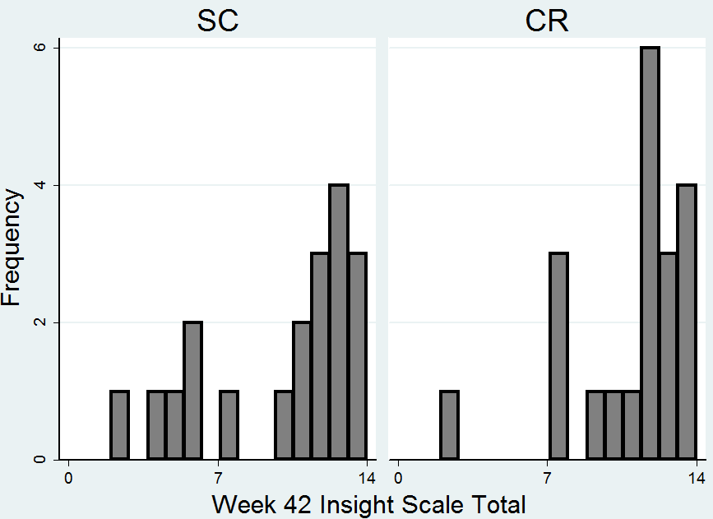
Fig. S1
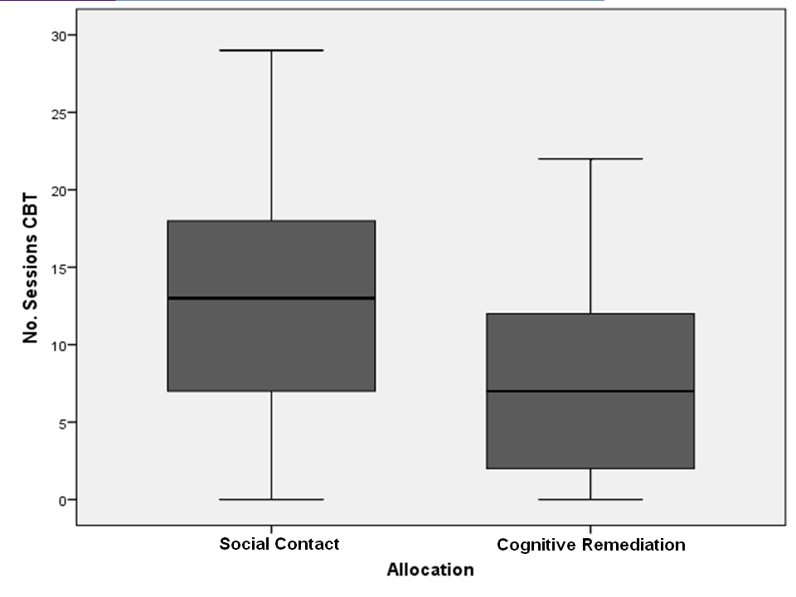
Fig. S2

SUPPLEMENTARY REFERENCES
- Wykes T, Newton E, Landau S, Rice C, Thompson N, Frangou S (2007). Cognitive remediation therapy (CRT) for young early onset patients with schizophrenia: an exploratory randomized controlled trial. Schizophrenia Research. 94 (1-3), 221-30.
- Koren D, Seidman LJ, Poyurovsky M, Goldsmith M, Viksman P, Zichel S, Klein E (2004). The neuropsychological basis of insight in first-episode schizophrenia: a pilot metacognitive study. Schizophrenia Research. 70 (2-3), 195-202.
- Kurtz MM (2011). Neurocognition as a predictor of response to evidence-based psychosocial interventions in schizophrenia: What is the state of the evidence? Clinical Psychology Review. 31, 663–672
- Wykes T, Huddy V (2009). Cognitive remediation for schizophrenia: it is even more complicated. Current Opinion in Psychiatry. 22, 161–167.
- Penadés R, Catalán R, Puig O, Masan G, Pujol N, Navarro V, Guarch J, Gasto C (2010). Executive function needs to be targeted to improve social functioning with Cognitive Remediation Therapy (CRT) in schizophrenia. Psychiatry Research. 177 (1–2), 41–45
- Cornblatt BA, Kelip JG (1994). Impaired attention, genetics and the pathophysiology of schizophrenia. Schizophrenia Bulletin. 20(1), 31-46.
- Gold JM, Goldberg RW, McNary SW, Dixon LB, Lehman AF (2002). Cognitive Correlates of Job Tenure Among Patients With Severe Mental Illness. American Journal of Psychiatry. 159, 1395-1402.
- Bell MD, Bryson GJ, Greig T, Corcoran C, Wexler BE (2001). Neurocognitive enhancement therapy with work therapy: Effects on neuropsychological test performance. Archives of General Psychiatry. 58 (8), 763-68.
- Penadés R, Boget T, Catalán R, Bernardo M, Gastó C, Salamero M (2003). Cognitive mechanisms, psychosocial functioning, and neurocognitive rehabilitation in schizophrenia. Schizophrenia Research. 63, 219–227
- Penadés R, Catalán R, Salamero M, Boget T, Puig O, Guarch J, Gastó C (2006). Cognitive remediation therapy for outpatients with chronic schizophrenia: a controlled and randomized study. Schizophrenia Research. 87, 323—331
- Sartory G, Zorn C, Groetzinger G, Windgassen K (2005). Computerized cognitive remediation improves verbal learning and processing speed in schizophrenia. Schizophrenia Research 75, 219–23
- Fiszdon JM, Choi J, Goulet J, Bell MD (2008). Temporal relationship between change in cognition and change in functioning in schizophrenia. Schizophrenia Research. 105 (1–3), 105-113
- Wykes T, Reeder C (2005). Cognitive remediation therapy for schizophrenia: Theory and Practice. Routledge: London.

