Supplementary Figure S1. PRISMA Flow Diagram
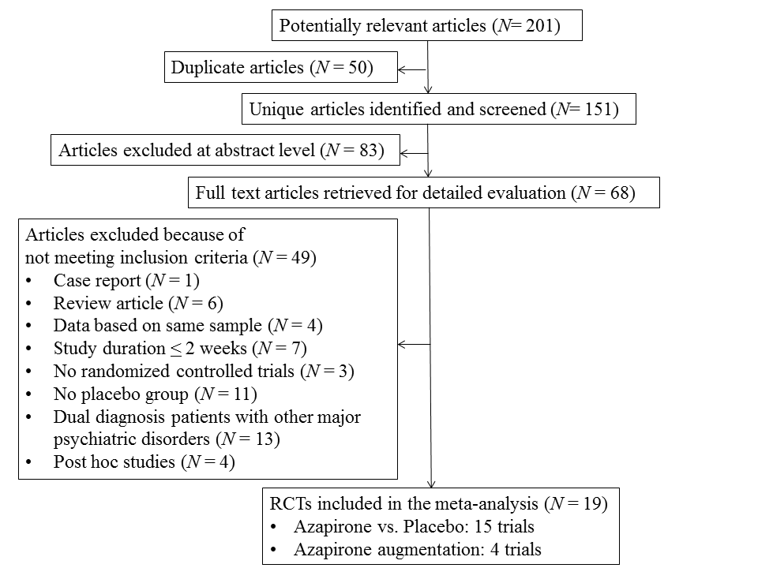
Supplementary Figure S2. Risk of Bias Graph of All Studies Included in the Meta-analysis
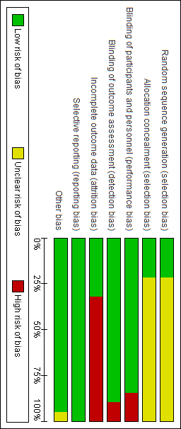
Supplementary Figure S3. The Funnel Plot for Primary Outcome
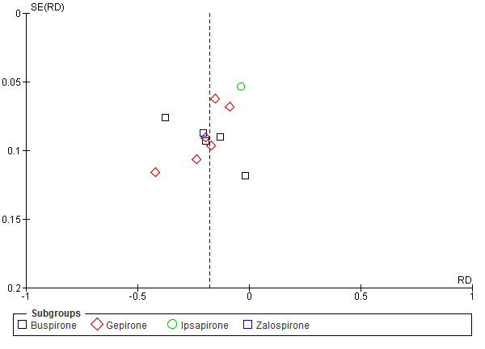

Supplementary Figure S4. Forest Plot of Discontinuation Due to All-cause
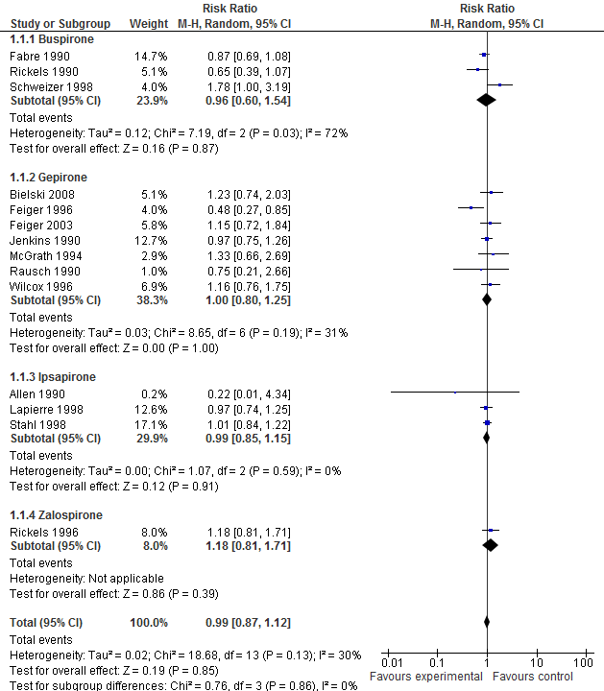

Supplementary Figure S5. Forest Plot of Clinically Signiﬁcant Response as Deﬁned by The Original Studies
