SUPPLEMENTARY ONLINE MATERIAL

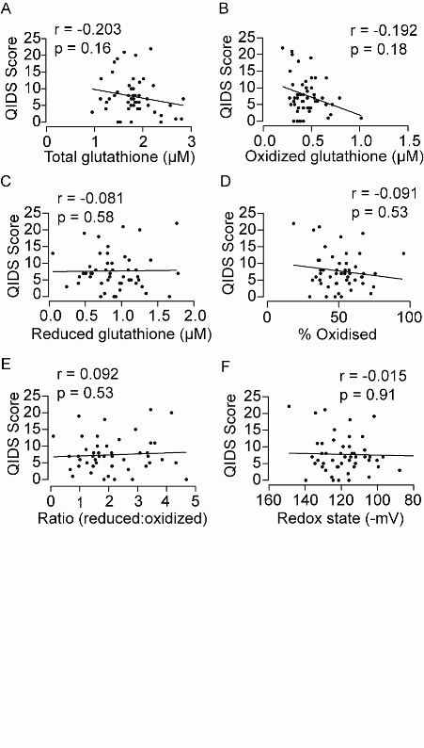
Supplementary Fig. S1
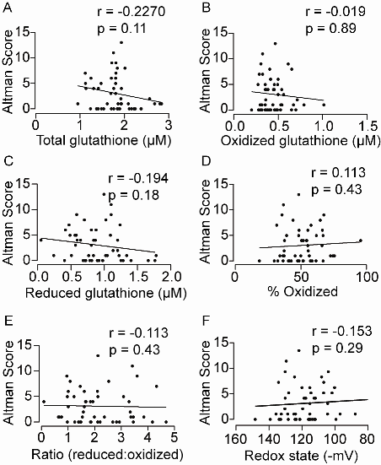

Supplementary Fig. S2

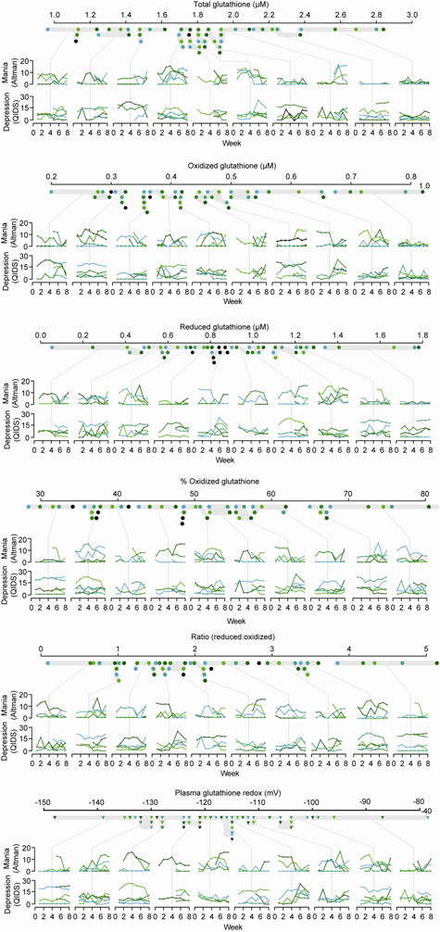
Supplementary Fig. S3

