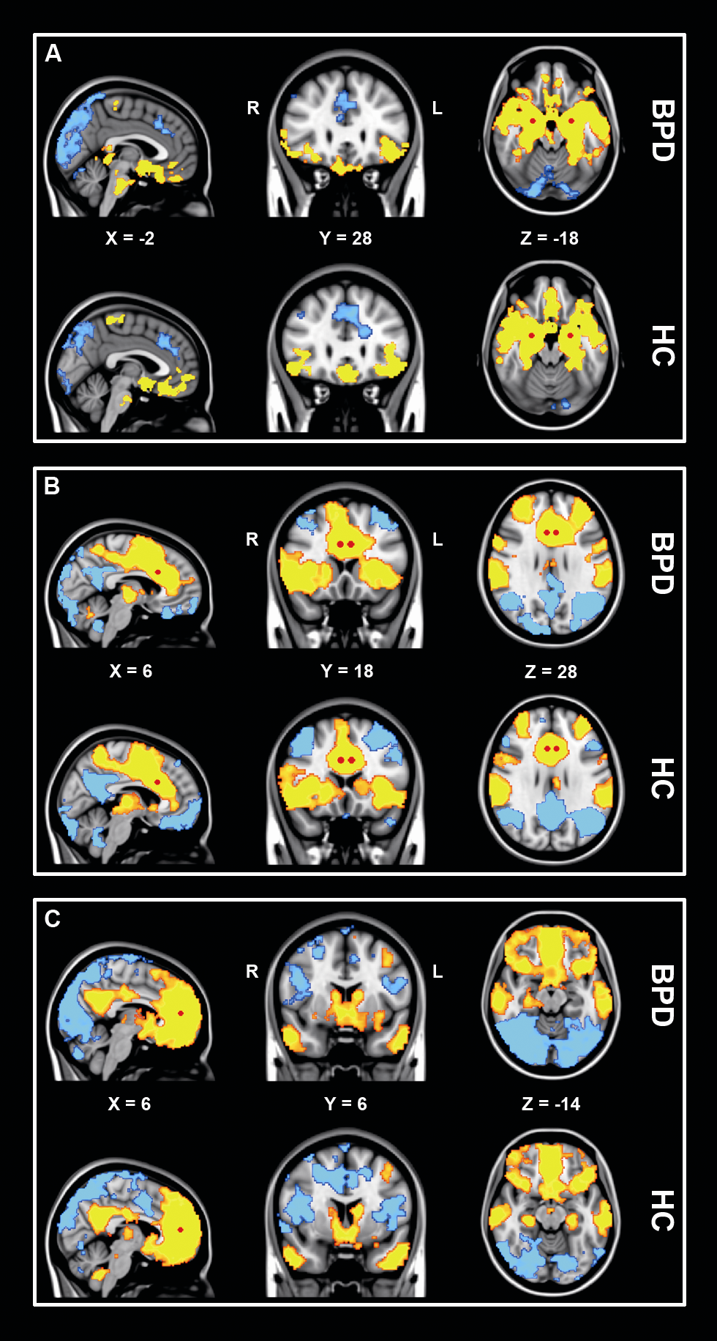
Supplementary Fig. S1. Group main effects (Z>2.3, p<.05; whole brain cluster corrected) demonstrating average functional connectivity in both groups with each of the three seeds: A) Amygdala (medial temporal lobe network); B) Dorsal ACC (salience network); C) Ventral ACC (default mode network). Connectivity differences are overlaid on the MNI 2mm standard space template, according to the radiological convention. Positive connectivity is shown in red to yellow, while blue to light blue illustrates negative connectivity. Red spheres mark the locations of the seeds used in the analysis.

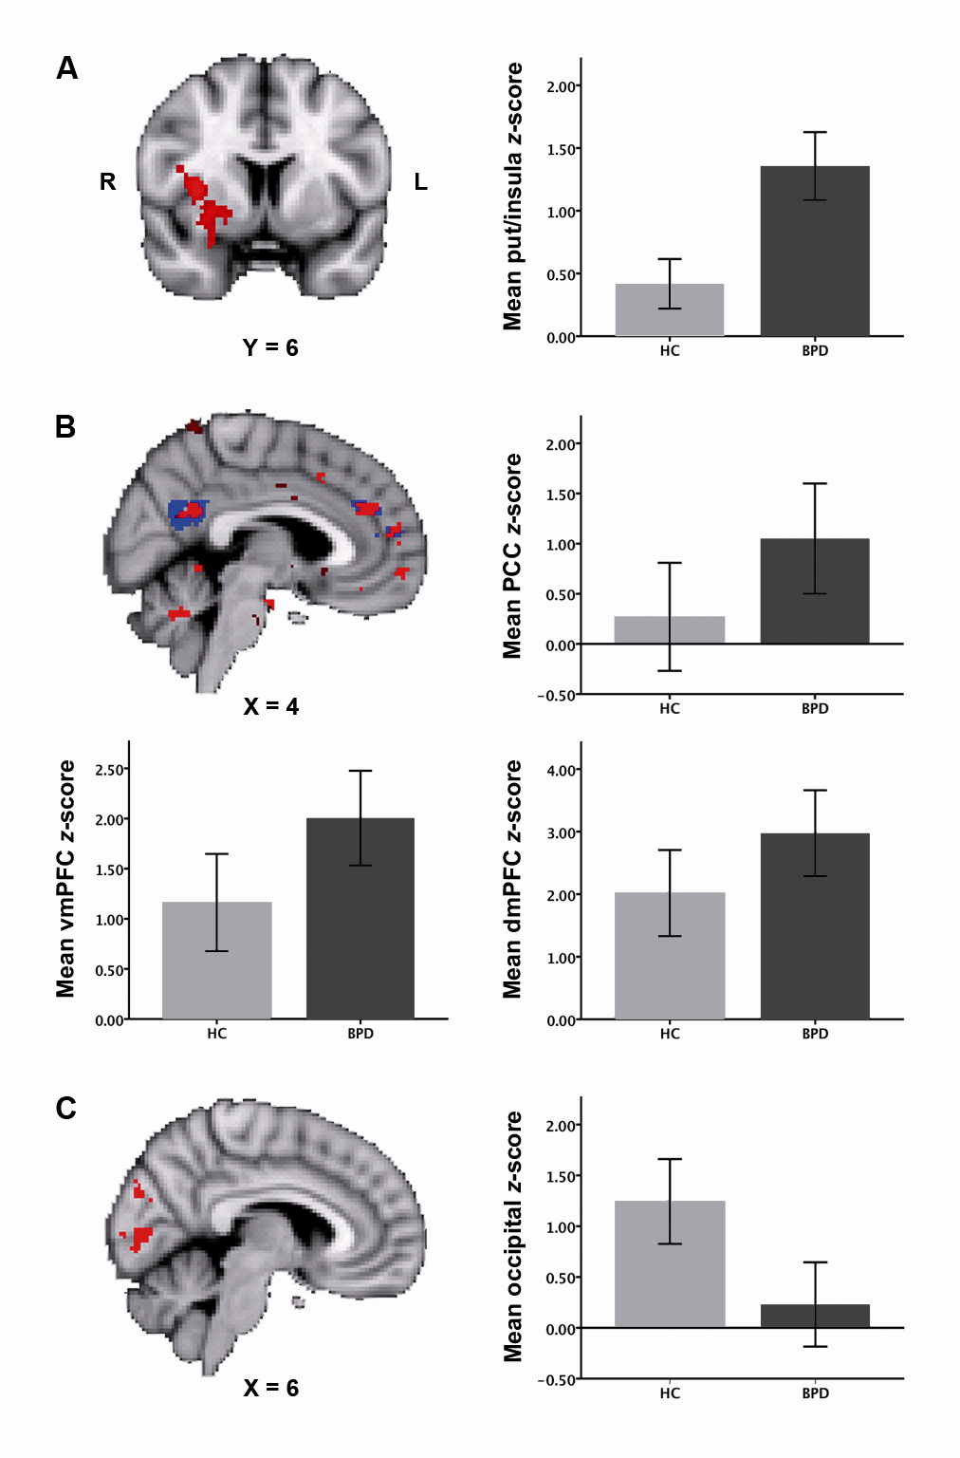
Supplementary Fig. S2. Between-group differences in functional connectivity of each of the three seeds without global signal regression: A) Amygdala (medial temporal lobe network; p<.05, cluster corrected); B) Dorsal ACC (salience network; p<.001, uncorrected, overlaid on the original result with global signal regression in blue); C) Ventral ACC (default mode network; p<.05, cluster corrected). Connectivity differences are overlaid on the MNI 2mm standard space template. Bar graphs plot the mean Z-scores (± 2 standard errors of the mean) in each group for each of the regions where connectivity differences are found.

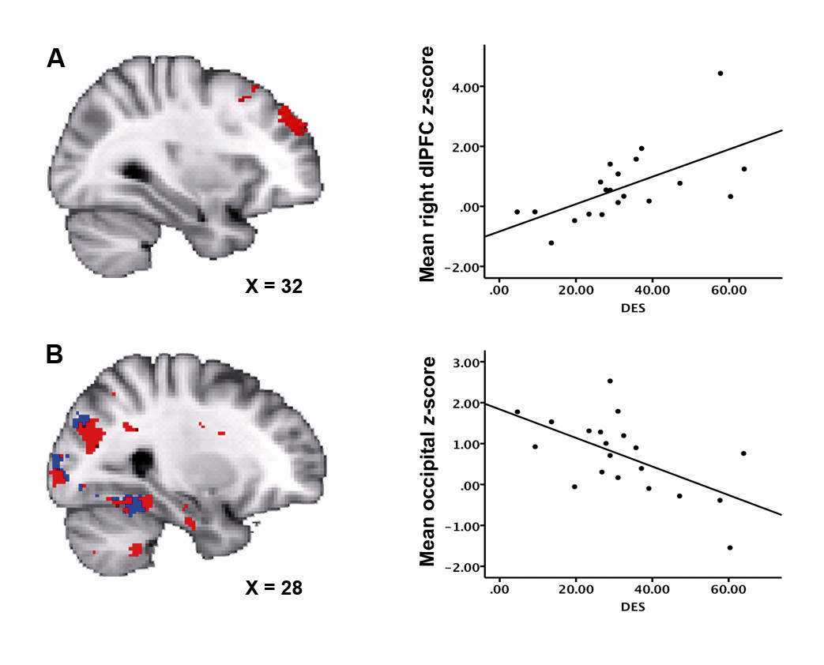
Supplementary Fig. S3. Voxelwise correlations between trait dissociation scores (DES) and amygdala functional connectivity without global signal regression in the borderline group: A) Left amygdala-dlPFC connectivity is positively associated with trait dissociation (p<.05, cluster corrected); B) Left amygdala-occipital cortex connectivity (including the lingual gyrus, intracalcarine cortex, and fusiform gyrus) is negatively associated with trait dissociation (p<.001, uncorrected, overlaid on the original result with global signal regression in blue). Results are overlaid on the MNI 2mm standard space template, according to the radiological convention. Scatter plots illustrate the direction of the correlation, with mean Z-scores plotted against the dissociation scores.

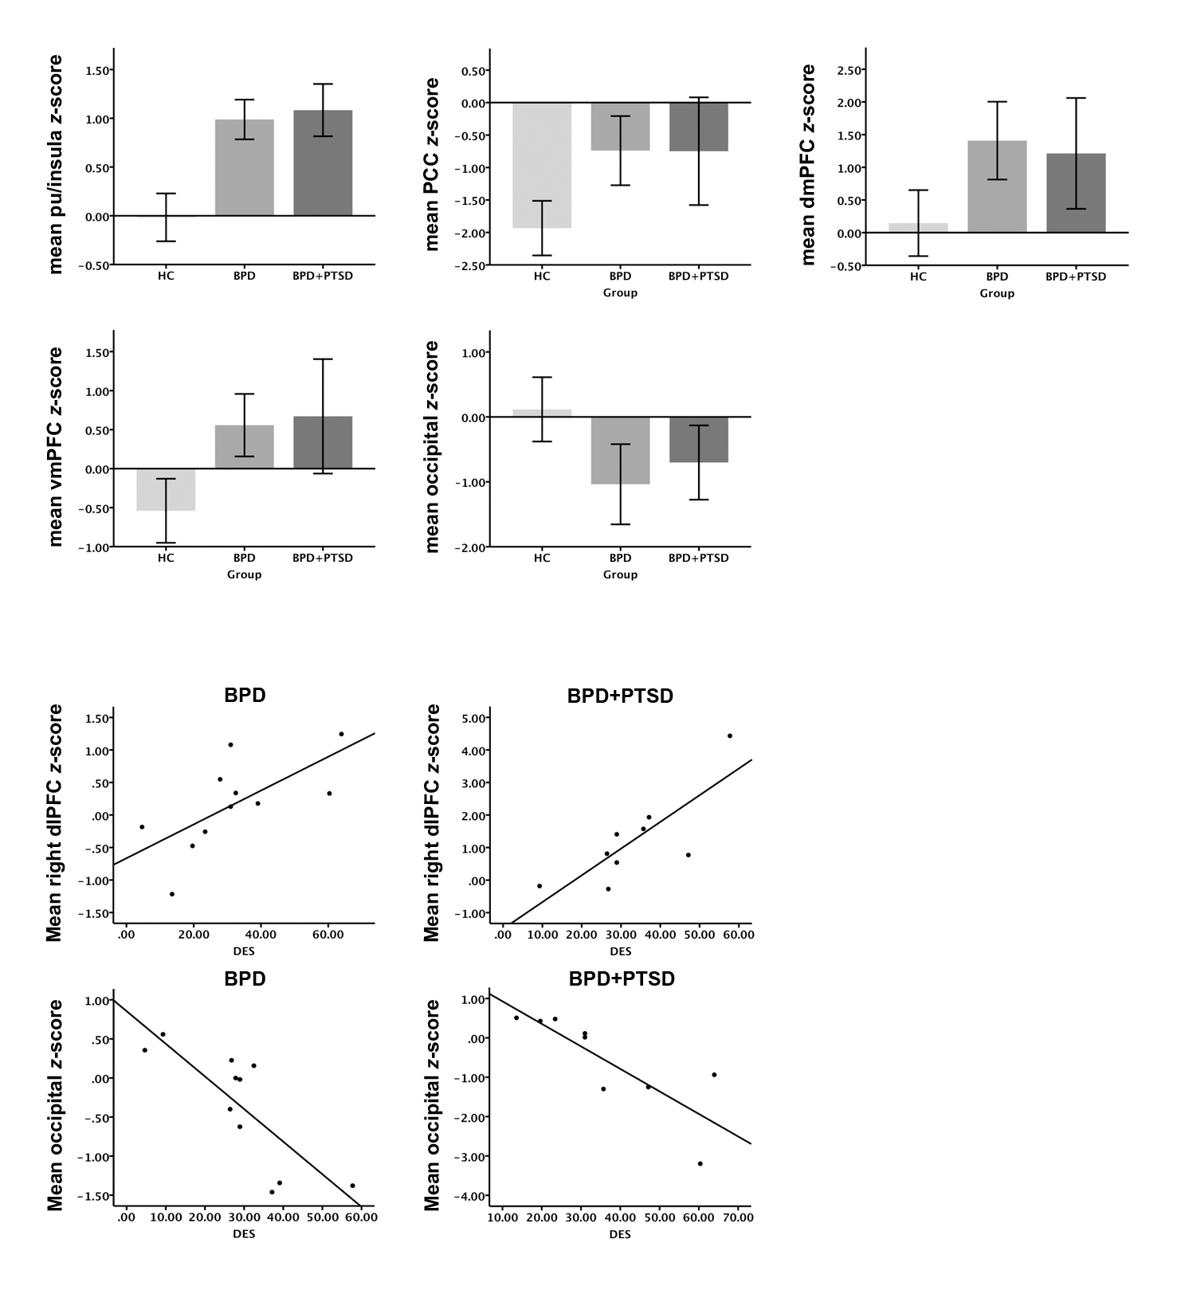
Supplementary Fig. S4. Bar graphs plotting mean Z-scores (± 2 standard errors of the mean) for each of the clusters found in the main analysis, for HC, BPD patients with comorbid PTSD (BPD+PTSD), and BPD patients without comorbidity (BPD) separately.

