SUPPLEMENTARY MATERIAL

Modinos G, Allen P, Frascarelli M, et al. Are We Really Mapping Psychosis Risk? Neuroanatomical Signature Of Affective Disorders In Subjects At Ultra High Risk

This supplementary material includes Supplementary Methods, Supplementary Results, Table S1, Table S2, Table S3, Table S4, Fig. S1 and Fig. S2.

SUPPLEMENTARY METHOD
SAMPLE
Ultra High Risk Group (UHR)
Inclusion criteria required the presence of one or more of: (1) Attenuated Psychotic Syndrome (APS), (2) A brief psychotic episode of less than 1 week’s duration that spontaneously remits without antipsychotic medication or hospitalization (Brief Limited Intermittent Psychotic episode), (3) Trait vulnerability (schizotypal personality disorder or a first-degree relative with psychosis) plus a marked decline in psychosocial functioning (Global Assessment of Functioning, GAF) (American Psychiatric Association, 1994). The at-risk signs and symptoms were assessed with the Comprehensive Assessment of At-Risk Mental States (CAARMS) (Yung et al., 2005), a semi-structured interview designed to assess prodromal psychopathology in people at high clinical risk for psychosis. The CAARMS has a total of 27 items, clustered in seven subscales: Positive Symptoms; Cognitive Change, Attention, and Concentration; Emotional Disturbance; Negative Symptoms; Behavioral Change; Motor/Physical Changes; and General Psychopathology. Global functioning was assessed using the GAF scale.

DATA ANALYSIS
Image Preprocessing
First, T1-weighted volumetric images were preprocessed using the Diffeomorphic Anatomical Registration using Exponentiated Lie algebra (DARTEL) SPM8 toolbox (Ashburner, 2007). This approach involves the creation of a study-specific template and the segmentation of each individual image using said template, with the aim of maximizing accuracy and sensitivity (Yassa and Stark, 2009). The VBM preprocessing involved the following steps: (1) checking for scanner artifacts and gross anatomical abnormalities for each subject, (2) setting the image origin to the anterior commissure, (3) using the DARTEL toolbox, (4) checking for homogeneity across the sample, and (5) using standard smoothing (i.e., 8 mm). A “modulation step” was also included in the normalization to preserve the information about the absolute gray matter values (Ashburner and Friston, 2000, Mechelli et al., 2005). The resulting smoothed, modulated, and normalized data were subsequently used for the statistical analysis.

Pattern Classification Analysis
Very recently, in an attempt to promote the clinical utility of imaging studies, machine learning algorithms have been used that allow inferences at the level of the individual rather than the group. Thus far, there is some evidence that machine learning can be employed in the neuroanatomical classification of the UHR subjects against healthy volunteers, first-episode psychosis patients, or when classifying UHR subjects according to subsequent clinical outcome (e.g., transition to psychosis vs non-transition) (Koutsouleris et al., 2009, Pettersson-Yeo et al., 2013). Therefore, in a third, exploratory hypothesis, we investigated the ability of magnetic resonance imaging (MRI)-based pattern classification to stratify UHR cases according to the presence or absence of comorbidity. On the basis of accumulating pathological changes associated with comorbid diagnoses in neurological populations (Pfefferbaum et al., 2007, Pfefferbaum et al., 2006), we expected the UHR-comorbidity individuals to be classified with a higher degree of accuracy than the UHR-alone relative to healthy controls.

The Pattern Recognition of Brain Image Data (PROBID; http://www.brainmap.co.uk/probid.htm) software package, running under Matlab 8.1, was used. The VBM gray matter segments were used to train a high-dimensional multivariate classifier, and to generate spatial maps of the discriminative morphological patterns between groups. A linear decision boundary in this high dimensional space was defined by a “hyperplane” found by the SVM algorithm, separating the individual images according to a class label (e.g. UHR-comorbidity vs healthy controls -HC-). The optimal hyperplane was computed based on the multivariate pattern of voxel values across each image, rather than examining each brain region individually (Lao et al., 2004). The SVM thus selects from many possible solutions the optimal one, which is determined by the most difficult to classify, hence most informative, training examples (the support vectors). As the classifier is multivariate by nature, the combination of all voxels as a whole is identified as a global spatial pattern by which the groups differ (i.e., the discriminating pattern). The PROBID software allows a linear kernel matrix (measuring similarity between all pairs of brain images) to be pre-computed and supplied to the classifier. A linear rather than a non-linear kernel SVM was used in order to reduce the risk of overfitting the data and to allow direct extraction of the weight vector as an image (i.e. the SVM discrimination map). This approach affords a substantial increase in computational efficiency and permits whole-brain classification without requiring explicit dimensionality reduction.

For each comparison, subject pairs matched for age (±4 years) and gender were used to construct samples for the classifier, with each individual MRI scan treated as a data point located in high-dimensional space and assigned by the operator to a given class. SVM comparator groups comprised 46 subject pairs for UHR versus HC, 32 subject pairs for UHR-comorbidity versus HC, and 20 subject pairs for UHR-alone versus HC and UHR-alone versus UHR-comorbidity. A “leave-one-out” cross-validation method was used which involved excluding a single subject from each group and training the classifier using the remaining subjects; the subject pair excluded was then used to test the ability of the classifier to reliably distinguish between categories. The accuracy of the classifier was calculated by taking the mean of its sensitivity and specificity across all “leave-one-out” cross-validation folds (Hastie et al., 2001). Statistical significance of the accuracy was determined by a permutation test, whereby subjects were randomly assigned to a class and the “leave-one-out” cross-validation cycle repeated 1000 times. This provided a distribution of accuracies reflecting the null hypothesis that the classifier did not exceed chance. The number of times where it was greater than or equal to the true accuracy was then divided by 1000 to estimate a P value for the accuracy.

SUPPLEMENTARY RESULTS
Impact of Depressive and Anxiety Comorbid Disorder on UHR Neuroanatomy
The comparison between the UHR (combined) and HC groups confirmed volumetric abnormalities in regions previously reported in the literature (Table S3, Fig. S1a). UHR individuals had lower GMV than controls in a number of regions in the right frontal cortex: rolandic operculum, inferior frontal gyrus, medial frontal gyrus, and orbital gyrus.

The results changed as a function of comorbidity: compared with controls, UHR-alone individuals had lower GMV in right frontal regions (rolandic operculum and inferior frontal gyrus), while the UHR-comorbidity group showed reduced GMV in temporal in addition to frontal regions (Table S3, Figure S1B and S1C). There were no areas in which UHR individuals had more GMV than controls.

Effect of the inclusion of UHR individuals with Anxiety alone in the UHR-comorbidity group
As described in the main text, 26 out of our 32 UHR-comorbidity subjects (81%) had a comorbid diagnosis of depression alone or in association with anxiety disorders, while 6 participants out of the 32 (19%) had an anxiety disorder alone. For completeness, we removed these 6 subjects with UHR and anxiety alone to test whether their inclusion in the UHR-comorbidity group influenced the observed clinical and neuroanatomical differences with respect to the UHR-alone group.

At the behavioral level, the differences remained similar to what was previously reported in all CAARMS subscales and GAF assessments (Table 1 and Table S2). The UHR-comorbidity group still showed higher levels of Avolition (P = .029), and Depression (P = .043), and Disorganized Speech (P = 0.084, trend level).

There was no change in the neuroanatomical differences between the UHR-comorbidity and UHR-alone groups. The significant ACC gray matter reduction in the UHR-comorbidity group persisted, in the cluster comprising the subgenual prefrontal cortex and the pregenual ACC (MNI coordinates x = -8, y = 27, z = -9; k = 27 voxels; P < 0.05 FWE). Further analysis confirmed the persistence of the trend across the 4 groups in this cluster, with MDD patients showing the most pronounced decreases relative to healthy controls, followed by the UHR-comorbidity and UHR-alone groups (main effect of group F_{(3,114)} =7.983, P < .001; Bonferroni post-hoc comparisons: MDD < HC, P < .001; MDD < UHR-comorbidity, P = .090; MDD < UHR-alone, P < .001; UHR-comorbidity < HC, P = .015; UHR-comorbidity < UHR-alone, P = .022; and HC < UHR-alone, P = .762).

UHR Stratification with Pattern Classification Analysis
SVM analysis classified UHR-comorbidity participants vs HC based on GMV patterns, with 63% sensitivity, 59% specificity, and an overall accuracy of 61% (P = .043). SVM distinguished between UHR-comorbidity and UHR-alone participants with an overall accuracy of 60% (P = .090) (Fig. S2). For the UHR-comorbidity vs HC classifier, the regional pattern most representative of UHR-comorbidity individuals was more caudally and subcortically concentrated in comparison with the HC group. Similarly for the UHR-comorbidity vs UHR-alone classifier, the regional pattern that most typified the UHR-comorbidity group was concentrated in more extreme cortical and caudal regions.

The classifier did not distinguish between UHR-alone vs HC, or UHR (combined) vs HC (see Table S5 for the full SVM results).

These findings only partly confirmed our exploratory hypothesis, as although pattern classification analyses showed that MRI-based discrimination was best achieved when taking into account depressive and anxiety comorbidities, sensitivity and specificity were modest. Patterns of GMV alteration were able to successfully discriminate UHR-comorbidity vs controls, and at a trend level between UHR-comorbidity and UHR-alone. In line with our hypothesis that group discrimination would be best achieved when taking into account depressive or anxiety comorbidities, SVM was unable to discriminate the UHR as a whole (i.e., when comorbidities were not considered) from HC subjects (Koutsouleris et al., 2012, Koutsouleris et al., 2009, Pettersson-Yeo et al., 2013). However, the classification accuracies, around the 60%, are relatively low and future studies are needed to determine the value of using multivariate analysis methods as SVM to classify these individuals.

Bibliography to supplementary material:

American Psychiatric Association (1994). Diagnostic and Statistical Manual of Mental Disorders. American Psychiatric Association: Washington, D.C.
Ashburner, J. (2007). A fast diffeomorphic image registration algorithm. Neuroimage 38, 95-113.
Ashburner, J. & Friston, K. J. (2000). Voxel-based morphometry--the methods. Neuroimage 11, 805-21.
Hastie, T., Tibshirani, R. & Friedman, J. (2001). The elements of statistical learning: Data mining, inference and prediciton. Springer-Verlag: New York, NY.
Koutsouleris, N., Davatzikos, C., Bottlender, R., Patschurek-Kliche, K., Scheuerecker, J., Decker, P., Gaser, C., Moller, H. J. & Meisenzahl, E. M. (2012). Early recognition and disease prediction in the at-risk mental states for psychosis using neurocognitive pattern classification. Schizophrenia Bulletin 38, 1200-15.
Koutsouleris, N., Meisenzahl, E. M., Davatzikos, C., Bottlender, R., Frodl, T., Scheuerecker, J., Schmitt, G., Zetzsche, T., Decker, P., Reiser, M., Moller, H. J. & Gaser, C. (2009). Use of neuroanatomical pattern classification to identify subjects in at-risk mental states of psychosis and predict disease transition. Archives of General Psychiatry 66, 700-12.
Lao, Z., Shen, D., Xue, Z., Karacali, B., Resnick, S. M. & Davatzikos, C. (2004). Morphological classification of brains via high-dimensional shape transformations and machine learning methods. Neuroimage 21, 46-57.
Mechelli, A., Price, C. J., Friston, K. J. & Ashburner, J. (2005). Voxel-based morphometry of the human brain: Methods and applications. Current Medical Imaging Reviews 1, 105-113.
Pettersson-Yeo, W., Benetti, S., Marquand, A. F., Dell'acqua, F., Williams, S. C., Allen, P., Prata, D., McGuire, P. & Mechelli, A. (2013). Using genetic, cognitive and multi-modal neuroimaging data to identify ultra-high-risk and first-episode psychosis at the individual level. Psychological Medicine 43, 2547-62.
Pfefferbaum, A., Rosenbloom, M. J., Adalsteinsson, E. & Sullivan, E. V. (2007). Diffusion tensor imaging with quantitative fibre tracking in HIV infection and alcoholism comorbidity: synergistic white matter damage. Brain 130, 48-64.
Pfefferbaum, A., Rosenbloom, M. J., Rohlfing, T., Adalsteinsson, E., Kemper, C. A., Deresinski, S. & Sullivan, E. V. (2006). Contribution of alcoholism to brain dysmorphology in HIV infection: effects on the ventricles and corpus callosum. Neuroimage 33, 239-51.
Yassa, M. A. & Stark, C. E. (2009). A quantitative evaluation of cross-participant registration techniques for MRI studies of the medial temporal lobe. Neuroimage 44, 319-27.
Yung, A. R., Yuen, H. P., McGorry, P. D., Phillips, L. J., Kelly, D., Dell'Olio, M., Francey, S. M., Cosgrave, E. M., Killackey, E., Stanford, C., Godfrey, K. & Buckby, J. (2005). Mapping the onset of psychosis: the Comprehensive Assessment of At-Risk Mental States. Australian & New Zealand Journal of Psychiatry 39, 964-71.

Table S1. Full Baseline and Longitudinal Clinical (CAARMS) Profiles of the UHR Sample

Characteristic | UHR Total (n=52) | UHR-Alone Group (n=20) | UHR-Depressive or Anxiety Comorbidity Group (n=32) | F | P
BASELINE
Subjective experience, mean (SD) | 2.5 (.9) | 2.4 (1.1) | 2.6 (.8) | .804 | 0.375
Observed Cognitive Change, mean (SD) | 1 (1.1) | .4 (.7) | 1.3 (1.2) | 7.055 | 0.011
Subjective Emotional Disturbance, mean (SD) | 1.6 (1.3) | 1.5 (1.4) | 1.7 (1.3) | .281 | 0.598
Observed Blunted Affect, mean (SD) | .9 (1.1) | .8 (1.2) | .9 (1.1) | .100 | 0.753
Observed Inappropriate Affect, mean (SD) | .5 (.9) | .6 (1) | .4 (1) | .367 | 0.548
Alogia, mean (SD) | 1 (.9) | .5 (.8) | 1.2 (.9) | 6.434 | 0.015
Anhedonia, mean (SD) | 2.2 (1.6) | 1.9 (1.4) | 2.3 (1.8) | .445 | 0.508
Social Isolation, mean (SD) | 2.7 (1.8) | 2.2 (1.5) | 3 (1.9) | 1.876 | 0.178
Impaired Role Function, mean (SD) | 2.6 (2) | 2.5 (1.5) | 2.7 (2.3) | .042 | 0.839
Aggression/Dangerous Behavior, mean (SD) | 2.3 (1.2) | 2.1 (1.4) | 2.5 (1.1) | 1.116 | 0.297
Subjective Impaired Motor Function, mean (SD) | 1 (1.2) | 1 (1.2) | 1 (1.3) | .094 | 0.761
Informant Reported/Observed Change in Motor Function, mean (SD) | .3 (.7) | .1 (.5) | .3 (.9) | 1.001 | 0.323
Subjective Complaints of Impaired Bodily Sensation, mean (SD) | 1.3 (1.6) | 1.7 (1.4) | 1.1 (1.7) | 1.118 | 0.296
Subjective Complaints of Impaired Autonomic Function, mean (SD) | 1.9 (1.6) | 1.5 (1.4) | 2.1 (1.6) | 1.766 | 0.191
Mania, mean (SD) | .8 (1.1) | .7 (1) | 1 (1.2) | .835 | 0.366
Mood Swings/Lability, mean (SD) | 1.4 (1.4) | 1.3 (1.3) | 1.6 (1.5) | .535 | 0.468
Dissociative Symptoms, mean (SD) | 1.1 (1.4) | 1.4 (1.6) | .9 (1.3) | .979 | 0.328
Impaired Tolerance to Normal Stress, mean (SD) | 2.5 (1.8) | 2.3 (1.7) | 2.7 (2) | .404 | 0.528
LONGITUDINAL FOLLOW-UP
Subjective experience, mean (SD) | 1.6 (1.5) | .9 (1.4) | 2 (1.4) | 3.788 | 0.063
Observed Cognitive Change, mean (SD) | .1 (.4) | .2 (.6) | .1 (.3) | .229 | 0.635
Subjective Emotional Disturbance, mean (SD) | .3 (.8) | .2 (.6) | .4 (.9) | 1.044 | 0.314
Observed Blunted Affect, mean (SD) | .3 (.7) | .2 (.6) | .4 (.8) | .831 | 0.369
Observed Inappropriate Affect, mean (SD) | .1 (.4) | .2 (.6) | .04 (.2) | .740 | 0.396
Alogia, mean (SD) | .3 (.7) | .4 (.8) | .3 (.7) | .364 | 0.550
Anhedonia, mean (SD) | .8 (1.4) | .6 (1.2) | .9 (1.5) | .170 | 0.683
Social Isolation, mean (SD) | 1 (1.5) | .1 (.5) | 1.6 (1.7) | 9.677 | 0.004
Impaired Role Function, mean (SD) | .6 (1.3) | 0 | .9 (1.6) | 4.718 | 0.037
Aggression/Dangerous Behavior, mean (SD) | 1.5 (1.5) | 1.9 (1.6) | 1.3 (1.5) | 1.757 | 0.193
Subjective Impaired Motor Function, mean (SD) | .1 (.4) | 0 | .1 (.5) | 1.092 | 0.304
Informant Reported/Observed Change in Motor Function, mean (SD) | 0 | 0 | 0 | 0 | 0
Subjective Complaints of Impaired Bodily Sensation, mean (SD) | .2 (.6) | .2 (.6) | .2 (.7) | .016 | 0.899
Subjective Complaints of Impaired Autonomic Function, mean (SD) | .5 (1.3) | .4 (1.3) | .6 (1.4) | .254 | 0.617
Mania, mean (SD) | .3 (.7) | .5 (.9) | .2 (.5) | 2.101 | 0.156
Mood Swings/Lability, mean (SD) | .9 (1.2) | .7 (1.1) | 1 (1.3) | .663 | 0.421
Dissociative Symptoms, mean (SD) | .2 (1.1) | .4 (1.6) | .1 (.6) | .644 | 0.428
Impaired Tolerance to Normal Stress, mean (SD) | .4 (1.1) | .4 (.9) | .4 (1.2) | .041 | 0.841
Abbreviations: CAARMS, comprehensive assessment of the at-risk mental state; UHR = Ultra High Risk of psychosis.

Table S2. MNI Coordinates and z Scores for Regions Showing Differences in gray matter Volume Between the UHR-alone, UHR-depressive or anxiety comorbidity (UHR-comorbidity), major depressive disorder (MDD), and Healthy Control Groups (HC)
Anatomical Region | Side | MNI coordinates |  |  |  |  | Number of voxels | Z-Value
Anatomical Region | Side | x |  | y |  | z | Number of voxels | Z-Value
HC > UHR (total)
Rolandic Operculum | R | 49 | -14 |  | 20 |  | 129 | 4.37
Inferior Frontal Gyrus | R | 46 | 44 |  | -8 |  | 616 | 4.26
Medial Frontal Gyrus | R | 12 | 58 |  | 3 |  | 145 | 4.00
Orbital Gyrus | R | 7 | 15 |  | -24 |  | 153 | 3.73
HC > UHR-comorbidity
Inferior Frontal Gyrus | R | 46 | 45 |  | -6 |  | 683 | 4.16
Middle Temporal Gyrus | R | 54 | 3 |  | -26 |  | 138 | 3.49
HC > UHR-alone
Rolandic Operculum | R | 49 | -14 |  | 20 |  | 267 | 4.25
Inferior Frontal Gyrus | R | 43 | 4 |  | 28 |  | 278 | 4.05
UHR-alone > UHR-comorbidity (ROI)
Anterior Cingulate Cortex | L | -8 | 27 |  | -9 |  | 90 | 2.90
UHR-alone > UHR-comorbidity (WB)
Medial Frontal Gyrus | L | -8 | -4 |  | 63 |  | 137 | 4.30
Fusiform Gyrus | R | 34 | -34 |  | -24 |  | 151 | 4.10
HC > MDD
Orbital Gyrus |  | 0 | 27 |  | -14 |  | 1533 | 5.35
Medial Frontal Gyrus | R | 9 | 30 |  | -15 |  |  | 4.95
Anterior Cingulate Cortex | L | -8 | 24 |  | -12 |  |  | 4.81
Inferior Parietal Lobule | L | -48 | -48 |  | 48 |  | 2255 | 5.32
Middle Temporal Gyrus | R | 54 | -14 |  | -21 |  | 123 | 4.64
Inferior Parietal Lobule | R | 45 | -51 |  | 54 |  | 810 | 4.51
Medial Frontal Gyrus | L | -8 | 44 |  | 45 |  | 211 | 4.44
UHR-Alone > MDD
Inferior Parietal Lobule | L | -46 | -46 |  | 51 |  | 1035 | 5.00
Inferior Parietal Lobule | R | 43 | -48 |  | 56 |  | 267 | 4.38
Orbital Gyrus |  | 0 | 30 |  | -12 |  | 835 | 4.74
Anterior Cingulate Cortex | L | -8 | 26 |  | 11 |  |  | 4.09
Medial Frontal Gyrus | R | 9 | 30 |  | -15 |  |  | 4.01
UHR-Comorbidity > MDD
Inferior Parietal Lobule | L | -46 | -46 |  | 50 |  | 717 | 4.69
Inferior Parietal Lobule | R | 45 | -60 |  | 40 |  | 190 | 4.05
Postcentral Gyrus | L | -16 | -48 |  | 66 |  | 302 | 4.61
Medial Frontal Gyrus | R | 9 | 30 |  | -15 |  | 135 | 3.72
Orbital Gyrus |  | 0 | 28 |  | -12 |  |  | 3.57
Inferior Frontal Gyrus |  | 13 | 40 |  | -20 |  |  | 3.53
MNI = Montreal Neurological Institute. ROI = region of interest. UHR = Ultra high risk. WB = Whole brain.

Table S3. Univariate Cox-Regression Analysis of UHR Outcomes Depending on Anterior Cingulate Cortex Volume (n = 52)

 |  | Valid | Transition  psychosis | to
Variable | Level | n | n | % | HR | 95% CI | P
UHR Group | Comorbidity | 12 | 6 | 18.8 | 1.092 | .970 - 1.231 | 0.145
 | Alone | 8 | 3 | 15 | 0.972 | .867 - 1.089 | 0.624
 | Total | 22 | 9 | 17.3 | 1.008 | .951 - 1.068 | 0.794
 |  | Valid | Poor  outcome | functional
Variable | Level | n | n | % | HR | 95% CI | P
UHR Group | Comorbidity | 13 | 24 | 40.6 | 1.069 | .992 - .1.151 | 0.081
 | Alone | 5 | 10 | 25 | 0.960 | .860 - .1.073 | 0.476
 | Total | 37 | 19 | 36.5 | 1.014 | .973 - 1.057 | 0.502
 |  | Valid | Good  outcome | functional
Variable | Level | n | n | % | HR | 95% CI | P
UHR Group | Comorbidity | 24 | 11 | 34.4 | 0.955 | .881 - 1.035 | 0.261
 | Alone | 13 | 8 | 40 | 1.000 | .938 - 1.065 | 0.992
 | Total | 37 | 19 | 36.5 | 0.979 | .931 - 1.030 | 0.411
HR, hazards ratio; UHR = Ultra high risk.
Table S4. Classification accuracy, sensitivity, specificity and P value for each binary group comparison, using structural MRI data.

SVM Comparison | SVM Gray Matter Volume
UHR vs Controls (n = 46 pairs)
Classification accuracy, % | 53.26
Sensitivity, % | 47.83
Specificity, % | 58.70
P | 0.287
UHR-alone vs Controls (n = 20 pairs)
Classification accuracy, % | 50
Sensitivity, % | 50
Specificity, % | 50
P | 0.539
UHR-comorbidity vs Controls (n = 32 pairs)
Classification accuracy, % | 60.94
Sensitivity, % | 62.50
Specificity, % | 59.38
P | 0.043
UHR-alone vs UHR-comorbidity (n = 32 pairs)
Classification accuracy, % | 60
Sensitivity, % | 65
Specificity, % | 55
P | 0.090
MRI = Magnetic Resonance Imaging. SVM = Support Vector Machine. UHR = Ultra high risk.

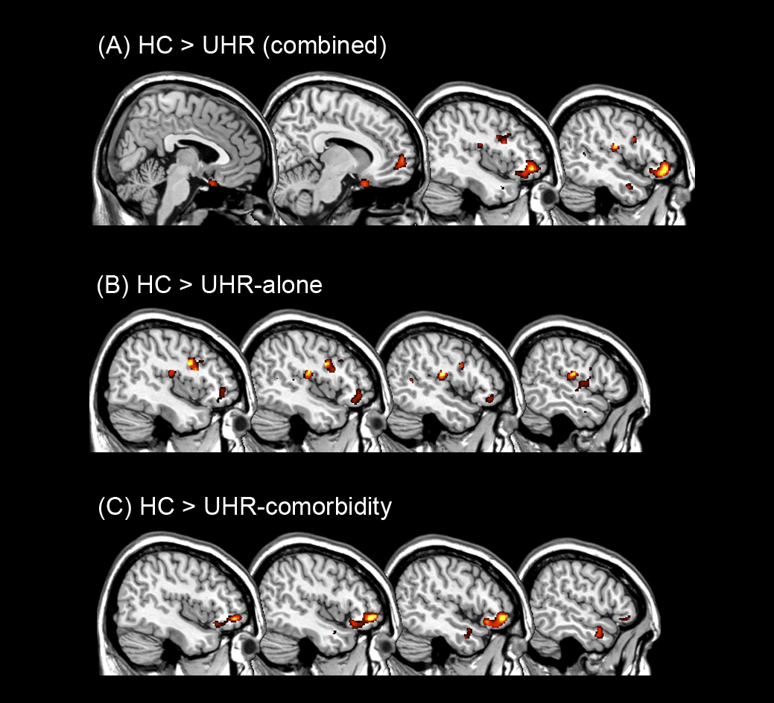
Fig. S1. Group Differences in Gray Matter Volume

Differences between the combined ultra-high-risk sample (UHR combined) and control (HC) groups (A), between HC and the subgroups UHR without depressive or anxiety comorbidity (UHR-Alone) (B), between HC and UHR with comorbidity (C) (P < .05 after family-wise error correction).

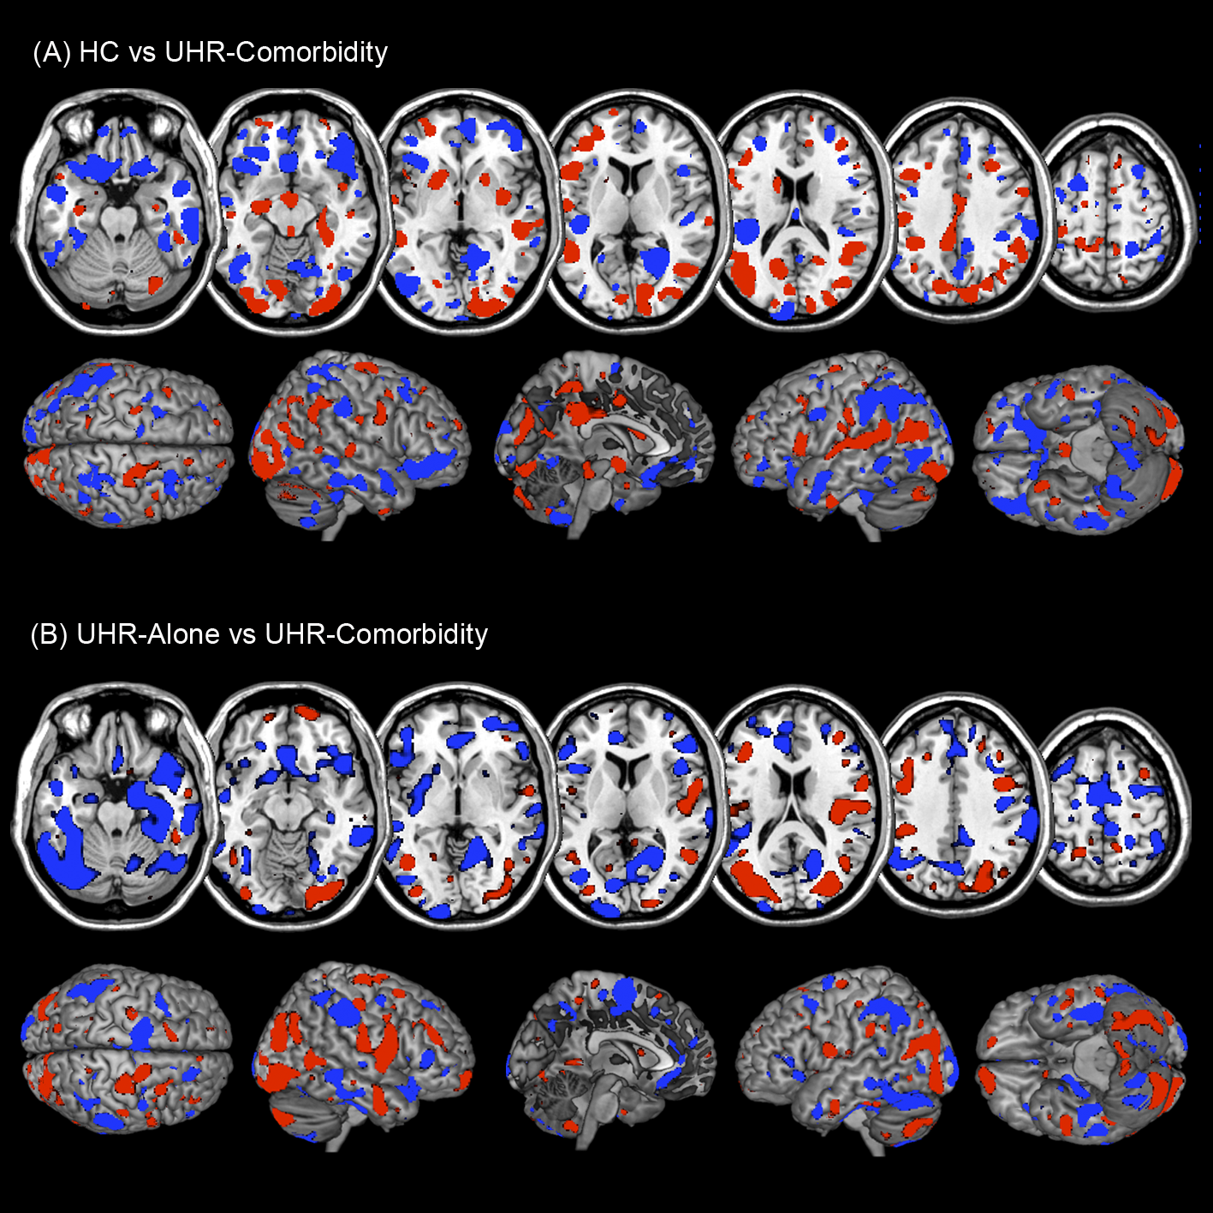
Fig. S2. Neuroanatomical Pattern Classification Results
(A) Discriminative patterns of the healthy control (HC) group vs UHR with depressive or anxiety comorbidity (UHR-comorbidity), with red and blue colors representing gray matter patterns more discriminative of the UHR-comorbidity and the HC group, respectively. (B) Discriminative patterns of the UHR without depressive or anxiety comorbidity (UHR-alone) vs UHR-comorbidity groups, with red and blue colors representing gray matter patterns more discriminative of the UHR-comorbidity and the UHR-alone group, respectively. The gray matter volume reduction scales differed between HC vs UHR-comorbidity (A), and UHR-alone vs UHR-comorbidity (B), with the largest effects being observed in the HC vs UHR-comorbidity classifier, and the subtlest differences, significant at trend level, being present in the discriminative pattern of UHR-alone vs UHR-comorbidity.

