Supplementary Figures

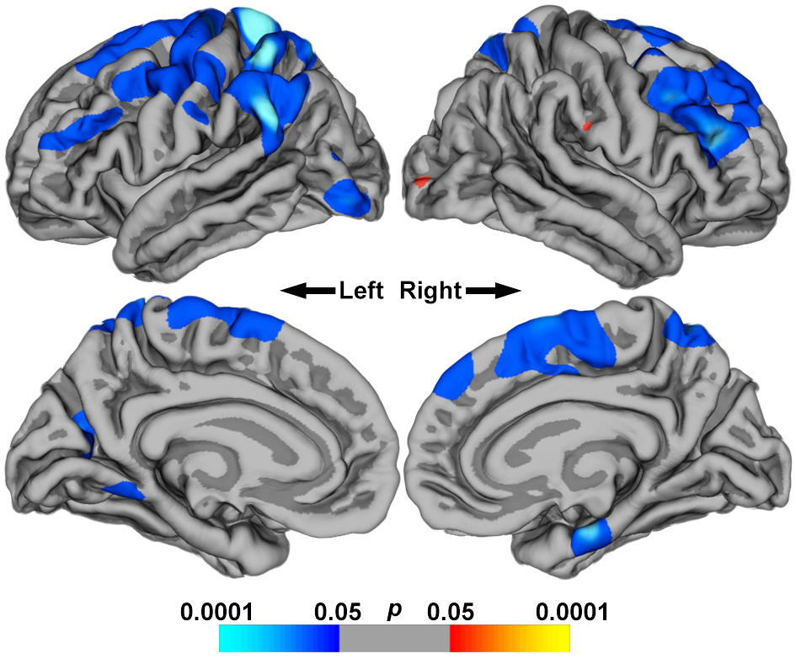
Fig. S1. Uncorrected vertex-wise comparison of cortical thickness in first-episode schizophrenia and affective psychosis subgroups. The schizophrenia subgroup demonstrated reduced thickness (blue) of the right inferior frontal gyrus in addition to the superior frontal gyrus bilaterally and in left superior parietal regions.

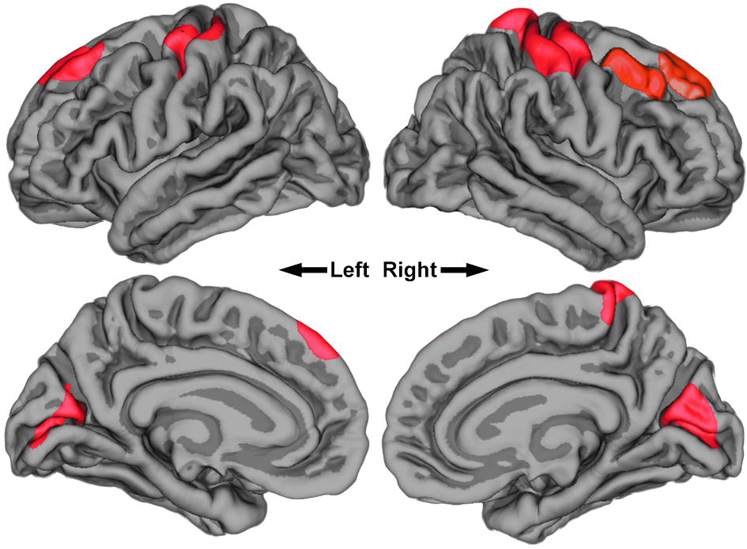
Fig. S2. Regions of reduced cortical thickness (cluster-wise probability, p<0.05) in the subgroup treated with first-generation antipsychotics (FGA) compared to those treated with second-generation antipsychotics (SGA) following the removal of two subjects treated with lithium. A similar pattern is seen when compared to the same comparison in Fig. 2, thus indicating that the lithium subjects did not influence the results.

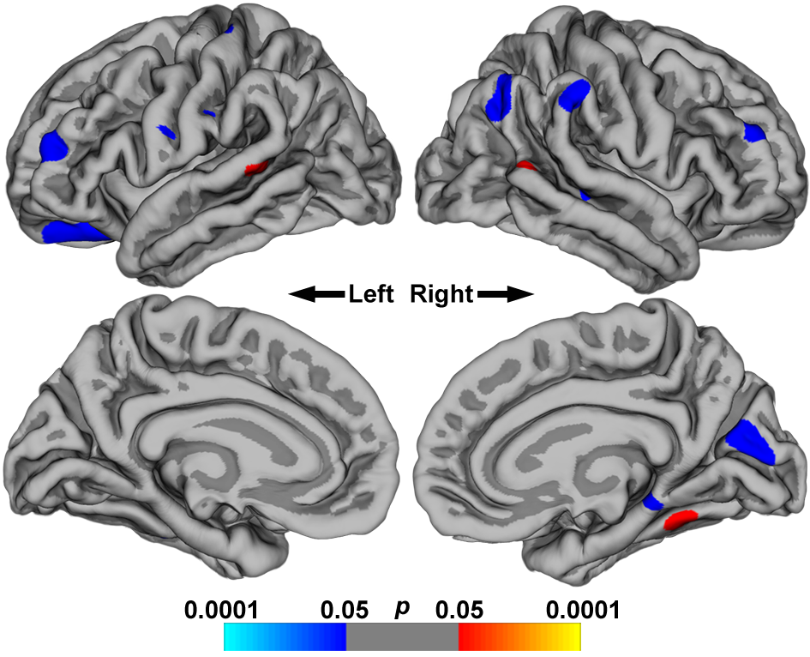
Fig. S3. Uncorrected vertex-wise analysis of interactions between medication and diagnosis. Small and minimally significant clusters representing interactions of diagnosis with reduced cortical thickness in the first-generation antipsychotic (FGA) subgroup were distributed in frontal and parietal regions (blue regions). Smaller clusters representing interactions between diagnosis and increased cortical thickness in the FGA-treated group were also found (red regions). Given the strength of the results compared to the large regions of difference between medication subtypes presented in Fig. 2, these results are likely false-positive.

