Supplementary Material
Table S1
Overlap of Subjects in our Four Samples
Group | Origin High Peer Deviance | Destination High Peer Deviance | Origin Low Peer Deviance | Destination Low Peer Deviance | N
1 | x |  |  |  | 200,708
2 | x | x |  |  | 252,474
3 | x |  |  | x | 79,803
4 |  | x |  |  | 122,301
5 |  | x | x |  | 36,394
6 |  |  | x |  | 94,464
7 |  |  |  | x | 156,590
8 |  |  | x | x | 121,897
 | 532,985 | 411,169 | 252,755 | 358,290

Group 1: Born into High PD community and resided in an intermediate PD community at age 15
Group 2: Born into High PD community and resided in High PD community for 15 years
Group 3: Born into High PD community and resided in Low PD community at age 15
Group 4: Resided at age 15 in High PD community but not born into a High PD community
Group 5: Resided at age 15 in High PD community and born into Low PD community
Group 6: Born into Low PD community and resided in an intermediate PD community at age 15
Group 7: Resided in Low PD community at age 15 but not born into a Low PD community
Group 8: Born into Low PD community and resided in Low PD community for 15 years

Figure Legends

Figure S1a - Origin High Peer Deviance – Hazard ratio (HR) for Drug Abuse in Stayers and Movers per number of years in areas with low or intermediate PD in relative pairs discordant for exposure. HSibP – paternal half-siblings, HSibM – maternal half-siblings, sib – full siblings.

Figure S1b - Destination High Peer Deviance – Hazard ratio (HR) for Drug Abuse in Stayers and Movers per number of years in areas with low or intermediate PD in relative pairs discordant for exposure. HSibP – paternal half-siblings, HSibM – maternal half-siblings, sib – full siblings.

Figure S1c - Origin Low Peer Deviance – Hazard ratio (HR) for Drug Abuse in Stayers and Movers per number of years in areas with intermediate or high PD in relative pairs discordant for exposure. HSibP – paternal half-siblings, HSibM – maternal half-siblings, sib – full siblings. There were too few paternal-half siblings to be informative for these analyses.

Figure S1d - Destination Low Peer Deviance – Hazard ratio (HR) for Drug Abuse in Stayers and Movers per number of years in areas with intermediate or high PD in relative pairs discordant for exposure. HSibP – paternal half-siblings, HSibM – maternal half-siblings, sib – full siblings. There were too few paternal-half siblings to be informative for these analyses.

Figure S1a

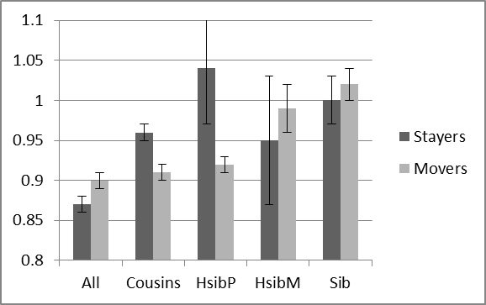
Figure S1b

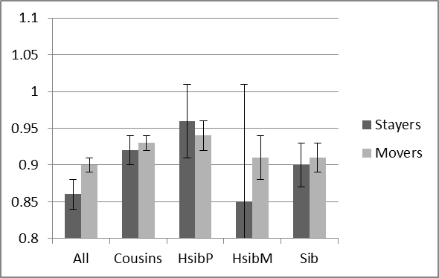
Figure S1c

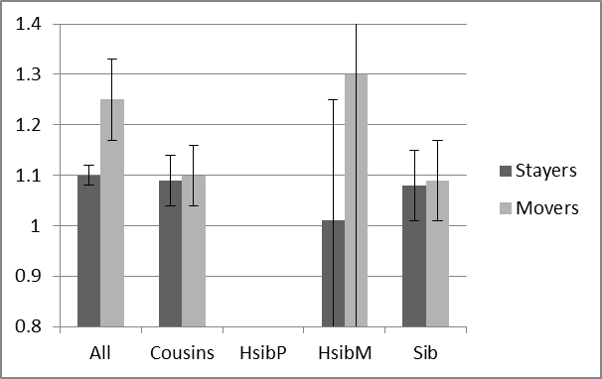
Figure S1d

