SUPPLEMENTARY MATERIAL

Supplementary Figure S1. Trial structure for the gaze-cueing task, showing the presentation of a fixation cross, followed by a face, a shift in fixation to the left or the right and, finally, a target object for categorisation. Valid faces were followed by objects presented on the same side as the shifted fixation; invalid faces were followed by objects on the opposite side.

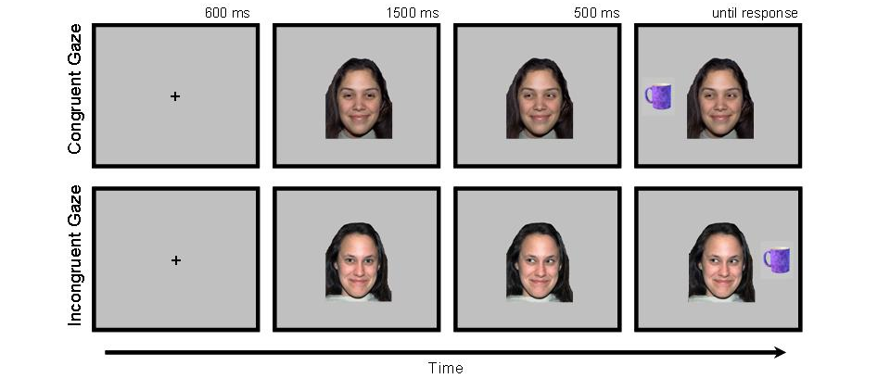

Supplementary Table S1. Treatments in 20 individuals with DSM-IV borderline personality disorder (BPD), 20 (euthymic) individuals with DSM-IV bipolar disorder (BD) and 20 health controls (significance shown for clinical group comparisons only).

 | Bipolar (N=20) | Borderline (N=20) | Healthy controls (N=20)
Any psychiatric med. | 17 (85%) | 13 (65%) | 0 (0%) | χ²(1)=2.133, p=0.144
Antidepressant | 7 | 13 | 0 | χ²(1)=3.600, p=.058
Antipsychotic | 12 | 8 | 0 | χ² (1)=1.600, p=0.206
Mood stabiliser | 8 | 4 | 0 | χ²(1)1.905, p=0.168
Lithium | 5 | 1 | 0 | χ²(1)=3.137, p=0.77
Benzodiazepines | 2 | 4 | 0 | χ²(1)=0.784, p=0.376
Hypnotics | 0 | 2 | 0 | χ²(1)=2.147, p=0.147
Current psy. treat't | 3 | 9 | 0 | χ²(1)=6.144,p=0.038

