Supplementary Material S1:Demographic Data and Clinical Characteristics.

 | ADHD Group Mean (SD) | Control Group  Mean (SD) | Statistics*
No | 24 | 24 | na
Gender (male/female) | 19/5 | 17/7 | χ²=0.44, p=0.51
Age (years) | 11.46 (1.38) | 10.88 (1.45) | t(46)= 1.42, p=0.16
IQ Estimate (WISC-IV) | 112.1 (12.26) | 116.63 (12.59) | t(46)= -1.29, p=0.20
ADHD RS-IV
Total | 39.17 (6.99) | 8.79 (6.54) | t(46)=15.54, p<0.001
Inattention | 20.71 (3.53) | 4.88 (4.29) | t(46)=13.96, p<0.001
Hyperactivity/impulsivity | 18.46 (4.94) | 3.92 (2.98) | t(46)=12.35, p<0.001

* Group differences were tested by means of two-sample t tests (alpha=0.05).

Abbreviations: SD, standard deviations; No, number of subjects; ADHD, attention-deficit/hyperactivity disorder; IQ, intelligence quotient; ADHD RS-IV, ADHD Rating Scale-IV (DuPaul et al., 1998); df, degree of freedom, ns, non significant; na, not applicable.

Supplementary Material S2: Analyses of emotional ratings given by the participants

After the recording session, subjects were asked to rate the valence and arousal of all pictures used as background contexts during the go/nogo task. Valence and arousal are considered to be the primary dimensions of human emotion (Lang et al., 1993; Russell, 1980). Valence refers to the degree to which an emotion is positive (pleasant) or negative (unpleasant), whereas arousal refers to its intensity (ranging from calming to arousing). Group means and standard deviations of valence and arousal for each group and each emotional context can be seen in Table A.

Table A. Emotional ratings given by the participants.
 | ADHD Group³ |  |  | Control Group³ |  |  | ANOVA⁴
 | Negative Context | Neutral  Context | Positive  Context | Negative Context | Neutral  Context | Positive  Context | Group | Emotional Context | Interaction
Valence¹ | 1.45  (0.49) | 3.19  (0.35) | 4.74  (0.27) | 1.63  (0.46) | 3.17  (0.41) | 4.55  (0.49) | F(1,46)= 0.008, p=0.93 | F(2,92)= 623.15, p=0.000, ƞ²_{p}=0.93 | F(2,92)=2.18, p=0.13
Arousal² | 4.39  (0.49) | 3.04  (0.33) | 4.69  (0.31) | 4.09  (0.55) | 2.9  (0.38) | 4.47  (0.6) | F(1,46)= 7.04, p=0.01,ƞ²_{p}=0.1 | F(2,92)= 184.99, p=0.000, ƞ²_{p}=0.8 | F(2,92)=0.46, p=0.63

¹Valence: subjects´ valence ratings of pictures used as background contexts (from 1, negative, to 5, positive); ²Arousal: subjects´ arousal ratings of pictures used as background contexts (from 1, calming, to 5, arousing); ³Means and standard deviations (in parentheses); ⁴Mixed ANOVAs with Group (ADHD and control) as between-subjects factor and Emotional context (negative, neutral and positive) as within-subjects factor.

ANOVAs were then computed for each emotional dimension, using Group (ADHD and control) as between-subjects factor and Emotional context (negative, neutral and positive) as within-subjects factor. The main effect of Group was not significant for valence, but was significant for arousal (Table A). Patients rated the pictures (irrespective of their valence) as more arousing than did control subjects. As expected, the main effect of Emotional context was significant both for valence and arousal (Table A). Bonferroni post hoc comparisons confirmed that negative, neutral and positive contexts differed in their valence (i.e., negative<neutral<positive; all corrected ps<0.05) and that both negative and positive contexts differed from the neutral one in arousal (corrected ps<0.05). Unexpectedly, the positive context was rated as somewhat more arousing than the negative context across groups (corrected p<0.05). Importantly, the interaction between Group and Emotional context was not significant, neither for valence nor for arousal (Table A). These findings indicate that there were no differences between ADHD and control groups in the subjective feeling of valence and arousal caused by each emotional context.

References

Lang PJ, Greenwald MK, Bradley MM, Hamm AO (1993).Looking at pictures: Affective, facial, visceral, and behavioral reactions.Psychophysiology30, 261-273.
Russell JA (1980). A circumplex model of affect. Journal of Personality and Social Psychology 39, 1161-1178.
Supplementary Material S3: Additional analyses on early ERP components.

Given that evidence has been reported to support that in some cases deficits in response inhibition are preceded and caused by perception/attention processing deficits (Banaschewski et al., 2004; Brandeis et al., 1998; McLoughlin et al., 2010), N1, P1 and P2 were also defined and analyzed. These early components were clearly visible in the grand averages (Figure A). N1 showed its maximum amplitude over anterior electrodes at about 140 ms after stimulus presentation, whereas P1 displayed its maximum amplitude in similar latencies but over occipital scalp electrodes. P2 was frontocentrally distributed with a peak latency of 238 ms.

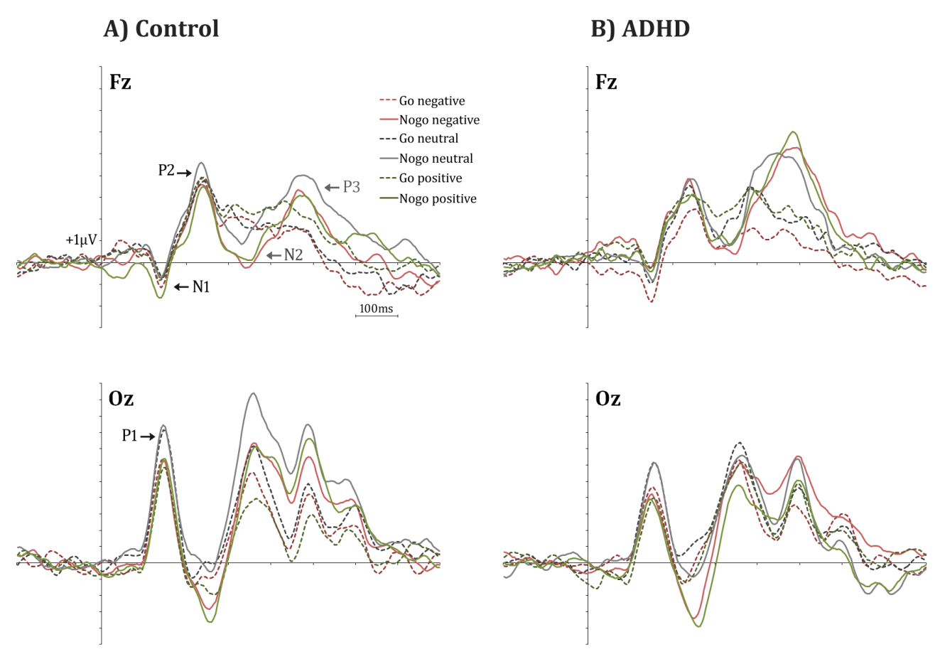
Figure A. Grand average ERPs for the ADHD and Control groups at selected electrodes (Fz and Oz), where N1, P1 and P2 were clearly visible.

As explained in detail in the manuscript, 11 components were extracted from the ERPs after the application of the temporal Principal Component Analysis (Figure B). In addition to N2 and P3, we identified N1/P1 (Factor 8) and P2 (Factor 6). Indeed, factor peak latency (around 140 ms) and topography characteristics (negative at frontal and positive at occipital scalp regions) associate Factor 8 with both N1 and P1. The inversion of polarity of early components is a well-known finding of ERP studies. Factor 6, maximum at frontocentral scalp regions around 240 ms, corresponds with P2. Similar to what we did for the main ERP components (i.e., N2 and P3), scalp regions of interest (scalp-ROI) were defined for N1, P1 and P2 prior to statistical analysis (Figure C).

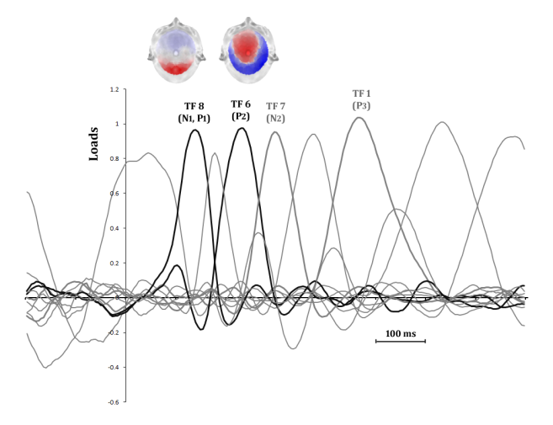
Figure B.Temporal Principal Component Analysis (tPCA): factor loadings after Promax rotation. Temporal factors 8 (N1/P1) and 6 (P2) are drawn in black. Topographic maps of these two factors are also presented.

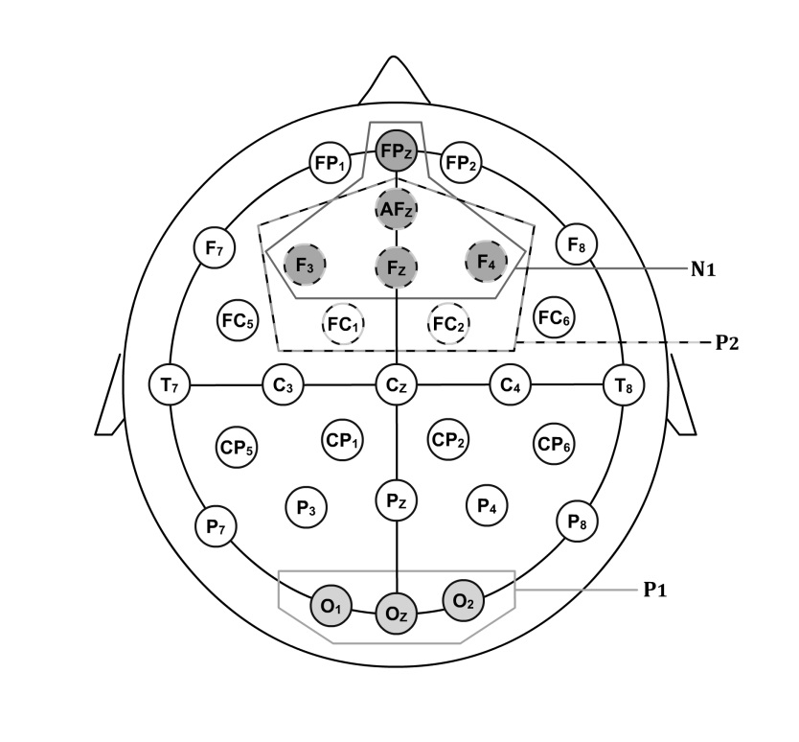
Figure C.Schematic depiction of electrode regions used for ANOVAs: N1 (frontal), P1 (occipital) and P2 (frontocentral).

No group differences were observed in N1 and P2 but, however, we observed significant differences in occipital P1. Specifically, smaller amplitude of P1 was found in the ADHD group than in the control group (main effect of group: F(1,46)=4.48, p=0.04), a finding that has been observed in previous studies (Kemner et al., 1996; Perchetet al., 2001). This reduction was independent of stimulus type (go and nogo) and emotional context (negative, neutral and positive), reflecting an overall deficit not linked to experimental manipulation. The P1 component has been interpreted as an index of visual selective attention originated in the visual cortex (Luck et al., 1990; Mangunet al., 1998). The P1 reduction in ADHD patients fits well with theories about the disorder that indicate the presence of possible changes at all levels of processing (i.e., not only at executive stages: Sergeant et al, 2003; Sergeant, 2005; Sonuga-Barke, 2002). In any case, it should be noted that the alteration in the inhibitory process observed in ADHD patients was not related to earlier perceptual/attentional processing dysfunctions, since the correlation between Nogo-P3 and P1 was not significant, neither in the ADHD nor in the control group (r=-0.03, p=0.9 and r=-0.05, p=0.8, respectively). Therefore, these data suggest that the Nogo-P3 were not associated with abnormalities in earlier processing stages, represented by N1, P1 and P2.
References

Banaschewski T, Brandeis D, Heinrich H, Albrecht B, Bruner E, Rothenberger A (2004). Questioning inhibitory control as the specific deficit of ADHD: Evidence from brain electrical activity.Journal of Neural Transmission 111, 841–864.

Brandeis D, Van Leeuwen TH, Rubia K, Vitacco D, Steger J, Pascual-Marqui RD,Steinhausen, H(1998). Neuroelectric mapping reveals precursor of stop failures in children with attention deficits. Behavioural Brain Research 94, 111–125.

Kemner C, Verbaten MN, Koelega HS, Buitelaar JK, van der Gaag RJ, Camfferman G, van Engeland H (1996). Event-related brain potentials in children with attention-deficit and hyperactivity disorder: effects of stimulus deviancy and task relevance in the visual and auditory modality. Biologicalpsychiatry 40, 522-534.

Luck SJ, Heinze HJ, Mangun GR, Hillyard SA (1990). Visual event-related potentials index focused attention within bilateral stimulus arrays. II. Functional dissociation of P1 and N1 components. Electroencephalography and clinical Neurophysiology 75, 528-542.

Mangun GR, Buonocore MH, Girelli M, Jha AP (1998). ERP and fMRI measures of visual spatial selective attention.Human brain mapping 6, 383-389.

McLoughlin G, Albrech B, Banaschewski T, Rothenberger A, Brandeis D, Asherson P, Kuntsi J(2010). Electrophysiological evidence for abnormal preparatory states and inhibitory processing in adult ADHD.Behavioral and Brain Functions 6, 66.

Perchet C, Revol O, Fourneret P, Mauguière F, Garcia-Larrea L (2001). Attention shifts and anticipatory mechanisms in hyperactive children: an ERP study using the Posner paradigm. BiologicalPsychiatry 50, 44-57.

Sergeant JA (2005).Modeling attention-deficit/hyperactivity disorder: a critical appraisal of the cognitive-energetic model.Biological Psychiatry 57, 1248-1255.

Sergeant JA, Geurts H, Huijbregts S, Scheres A, Oosterlaan J (2003). The top and the bottom of ADHD: a neuropsychological perspective. Neuroscience&BiobehavioralReviews 27, 583-592.

Sonuga-Barke, EJS (2002). Psychological heterogeneity in AD/HD-a dual pathway model of behaviour and cognition.BehaviouralBrainResearch 130, 29-36.

