Altered mesocorticolimbic functional connectivity in psychotic disorder: an analysis of proxy genetic and environmental effects
Supplementary material

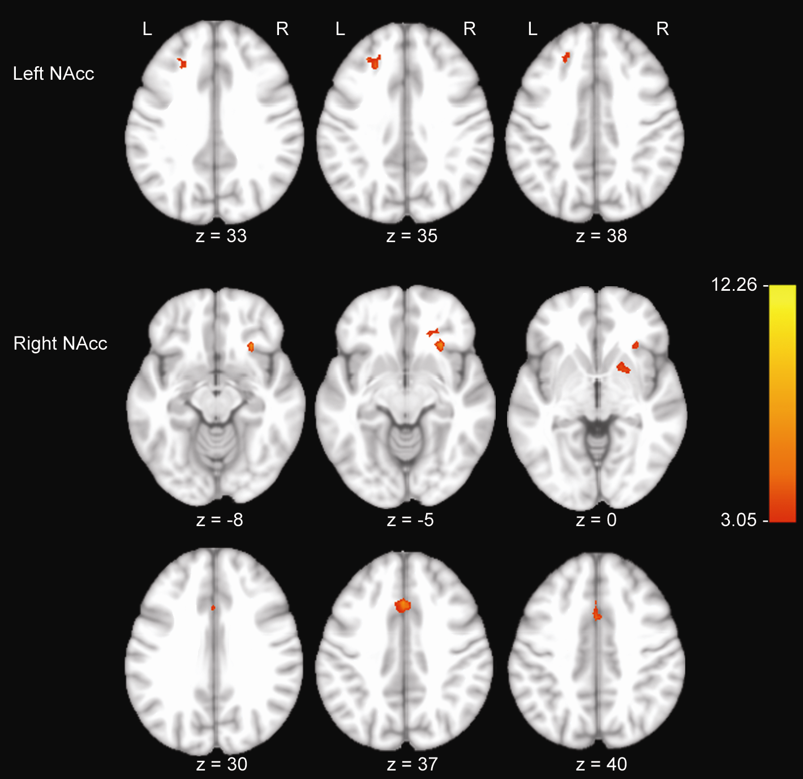

Fig. S1. Thresholded one-sample t-test maps of left and right NAcc connectivity across all participants using a false-discovery rate of q=0.05. Images are depicted along the z-axis. The red-yellow colormap refers to T-values.

