SUPPLEMENTARY MATERIAL

METHODS

Participants
Main characteristics of participants are described in Supplementary Table 1.

Lifetime stress exposure
Participants were asked to remember a particular event, indicating if and when it had occurred (age) and giving a score of severity (1: no significant stress associated with the event; 5: extreme stress). The interview covered 14 categories of events: death of a close relative; death of a friend; personal health problems; health problems of a close person; separations; interpersonal conflicts; occupational, scholastic-academic, legal or other economic problems; personal violence or maltreatment; miscarriages and/or abortions; any other traumatic or stressful events (some examples were given, such as road accidents, exposure to natural disaster, relocation). In the present study, a composite measure of stressful life events was used, corresponding to the total number of negative life events with a severity score reaching at least 3. The average number of stressful negative events was 1.2 (SD=1.0; range 0-5).

Obstetric complications
Data regarding obstetric complications were available for 34 women. Most participants had been born in Padova Hospital (n=17) and data on obstetric complications were available from the hospital archives. We reviewed obstetric records to collect relevant information. In all other cases, we interviewed the parents of participants, using an adapted version of the Pregnancy History Instrument (Buka et al, 2000), an interview covering a wide range of pregnancy, delivery and neonatal complications. In addition, in all these cases, we were able to obtain copies of birth certificates giving details of major complications, gestational age, birth weight/length, head circumference and Apgar scores. All interviews were performed face-to-face with mothers or both parents of participants. The McNeil-Sjöström Scale (McNeil et al, 1994) was used to define obstetric complications. Only complications scored at level 3 (potentially harmful) or higher (clearly harmful) were considered here.

Family psychiatric morbidity
Information was collected about all first-degree relatives by interviewing both participants and their mothers. No maternal psychiatric disorder occurred during pregnancy or the first five years of participants’ lives. Two mothers reported anxiety symptoms in their lifetime, but only one was severe enough to receive psychiatric treatment. Among fathers, one was found to have suffered from a mood disorder and one alcohol dependence. All patients had recovered from these disorders after treatment and were in remission at the time of the interview.

fMRI data acquisition
High-resolution 3D T1-weighted anatomical images were acquired in a gradient-echo sequence (repetition-time=20 sec, echo time=3.78 msec, flip angle= 20°, 160 slices, acquisition voxel size=1×0.66×0.66 mm, field of view=21-22 cm). Resting-state fMRI scan entailed 250 continuous functional volumes (repetition time=2035 msec, echo time=50 msec, flip angle=90°, 21 slices, matrix=128×128, acquisition voxel size=1.8×1.8×6 mm, acquisition-time=8 minutes; field of view=23 cm). Participants were instructed to rest with their eyes closed during the scan and were observed by at least one of the authors during scanning. At the end of the procedure, all subjects were asked about their emotions or tendency to fall asleep during scanning. None of the subjects in the study moved, fell asleep, or reported anxiety or other particular emotion during scanning.

RESULTS
Prenatal stressful events were: accidents (n=2) or accidents to a close relative (n=3); death of a friend or close relative (n=4); severe health problems of a close person (n=3) or need to give assistance to a sick close relative (n=2); severe interpersonal conflicts with partner (n=2) or close relative (n=4); stressful relocations (n=3); recent miscarriages, abortions or offspring death (n=4); severe stress or failure at work (n=3).
Postnatal stressful events were reported by 24 participants (12 reported one stressful event, 7 reported two events, 3 reported 3 events, 1 participant reported 4 and 1 reported 5 events). They were: death of a close relative or a friend (n=14); personal health problems or accidents (n=2); health problems of a close person (n=3); separations (n=5); relocations (n=4); parental conflicts or separations (n=3); interpersonal conflicts (n=5); occupational or scholastic-academic problems (n=4); personal violence or maltreatment (n=2); sudden death of partner (n=1); suicide of a close person (n=1).

SUPPLEMENTARY TABLES AND FIGURES

Supplementary Table 1 - Characteristics of participants (n=35)
 | Mean (SD) or N (%) | Range
Age (years) | 25.6 (6.5) | 14 - 40
Education (years) | 15.5 (2.3) | 8 - 18
Body mass index (kg/m²) | 21.8 (3.0) | 18 - 29
Edinburgh score | 54.4 (43.6) | -94 - 100
High or medium-high social status | 16 (46%) | Low - high
Depression | 0.73 (0.63) | 0 - 2.3
Trait anxiety | 39.2 (9.0) | 26 - 57
State anxiety | 34.7 (7.0) | 20 - 56

Supplementary Table 2 - Regression analyses of prenatal stress and gray matter volumes
 | Adjusted for age and handedness | Adjusted for age, handedness, postnatal stress, obstetric complications, smoking
Temporal lobe  (whole-brain VBM analysis) | -0.07 ± 0.02  (β =-0.53; p=0.002) | -0.06 ± 0.02  (β =-0.47; p=0.012)
Left amygdala | -0.05 ± 0.01  (β =-0.55; p=0.001) | -0.05 ± 0.01  (β =-0.55; p=0.002)
Right amygdala | -0.04 ± 0.01  (β =-0.56; p=0.001) | -0.04 ± 0.01  (β =-0.52; p=0.001)

Value presented as B ± SEM (β; p)
Supplementary Table 3 - Regression analyses of gray matter volumes and measures of anxiety and depression

 | Temporal lobe  (whole-brain VBM analysis) | Left amygdala | Right amygdala
STAI Trait anxiety | -0.002 ± 0.002 §  (β =-0.20; p=0.269)  -0.002 ± 0.002 #  (β =-0.20; p=0.398) | -0.003 ± 0.001 §  (β =-0.39; p=0.026)  -0.002 ± 0.001 #  (β =-0.33; p=0.137) | -0.003 ± 0.001 §  (β =-0.49; p=0.004)  -0.002 ± 0.001 #  (β =-0.38; p=0.064)
STAI State anxiety | -0.002 ± 0.002 §  (β =-0.14; p=0.448)  -0.001 ± 0.002 #  (β =-0.04; p=0.832) | -0.002 ± 0.002 §  (β =-0.28; p=0.118)  -0.001 ± 0.002 #  (β =-0.17; p=0.366) | -0.002 ± 0.001 §  (β =-0.31; p=0.084)  -0.001 ± 0.001 #  (β =-0.16; p=0.372)
Depression (H-SCL) | -0.06 ± 0.02 §  (β =-0.44; p=0.015)  -0.07 ± 0.03 #  (β =-0.52; p=0.021) | -0.50 ± 0.16 §  (β =-0.52; p=0.005)  -0.05 ± 0.02 #  (β =-0.52; p=0.016) | -0.06 ± 0.01 §  (β =-0.65; p<0.001)  -0.05 ± 0.02 #  (β =-0.61; p=0.002)

Value presented as B ± SEM (β; p)
§ accounting for age and handedness
# accounting for age, handedness, postnatal stress, obstetric complications, maternal smoking

Supplementary Figure 1: Areas of significant correlation (TFCE corrected p<0.05) between: (A) depressive symptoms and gray matter volume in left MTL: peak, -36, 16, -34 (cluster size, 140 voxels); (B) stait anxiety and gray matter volume in left MTL: peak, -34, 16, -34 (cluster size, 19 voxels). Graphs show individual average gray matter volumes in areas in which significant correlations were found in relation to prenatal stress, trait anxiety and depressive symptoms. Voxel-based correlation analyses conducted with age and handedness as covariates.
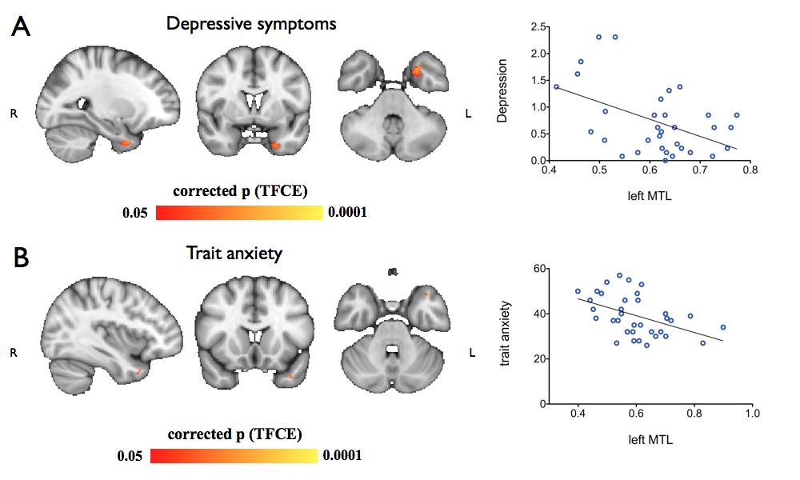
Supplementary Figure 2: Areas of significant correlation (TFCE corrected p<0.05) between: (A) depressive symptoms and gray matter volume in left amygdala: peak, -22, -6, -20 (cluster size, 222 voxels); (B) depressive symptoms and gray matter volume in right amygdala: peak, 24, -4, -24 (cluster size, 272 voxels); (C) trait anxiety and gray matter volume in left amygdala: peak, -20, -8, -18 (cluster size, 161 voxels); (D) trait anxiety and gray matter volume in right amygdala: peak, 24, -4, -24 (cluster size, 249 voxels). Graphs show individual average gray matter volumes in areas in which significant correlations were found in relation to prenatal stress, trait anxiety and depressive symptoms. Voxel-based correlation analyses conducted with age and handedness as covariates.
