Supplementary Material:
Appendix S1: Cost-effectiveness planes (mean (dots) costs and effects of combination therapy and CBT relative to pharmacotherapy and their 95% credible ellipses for the base case scenario and the sensitivity analyses (SA))
Appendix S2: Forest plots for meta-analyses
NMA: Network-meta analysis
COMB: Combination therapy
CBT: Cognitive Behavioural Therapy
PHA: Pharmacotherapy

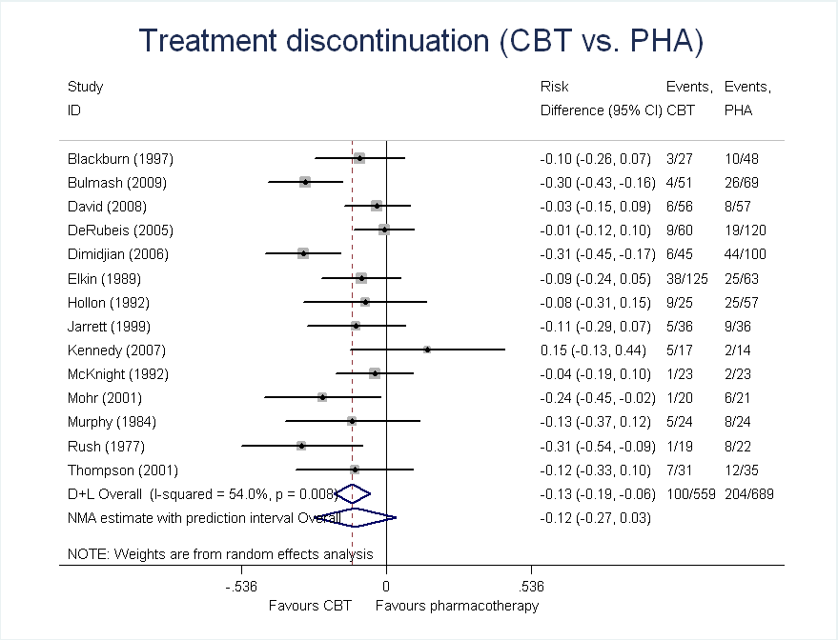
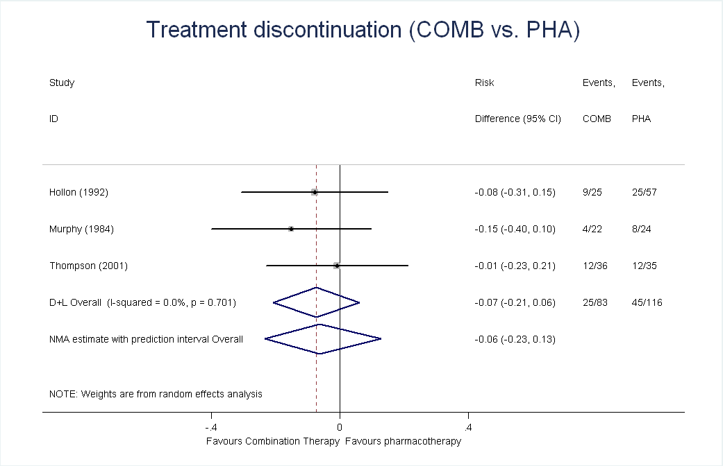
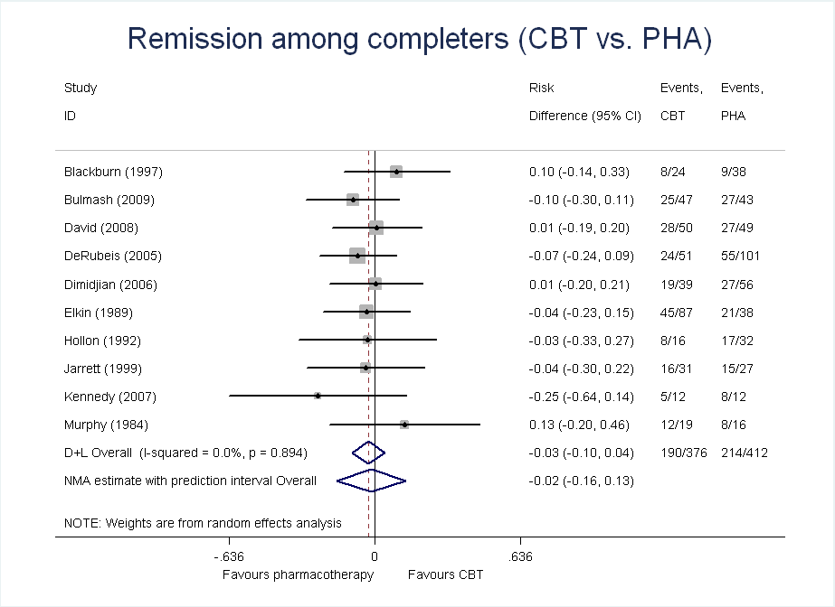

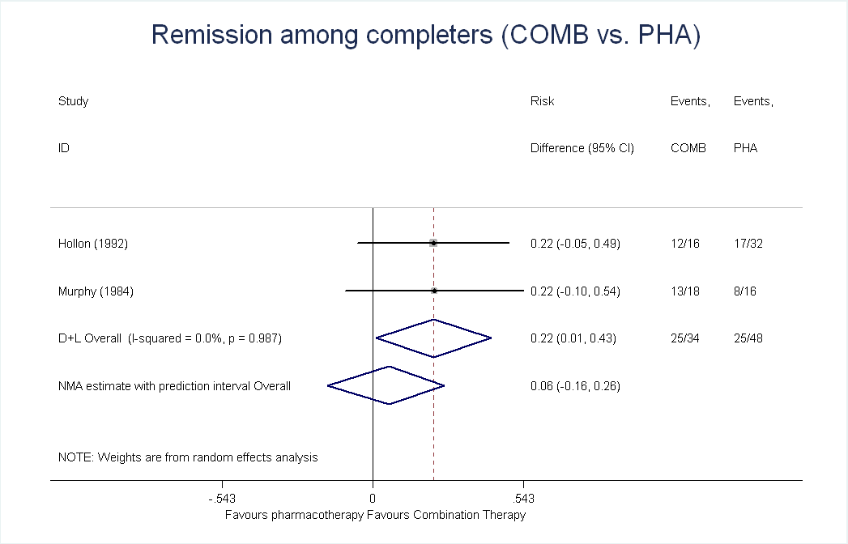
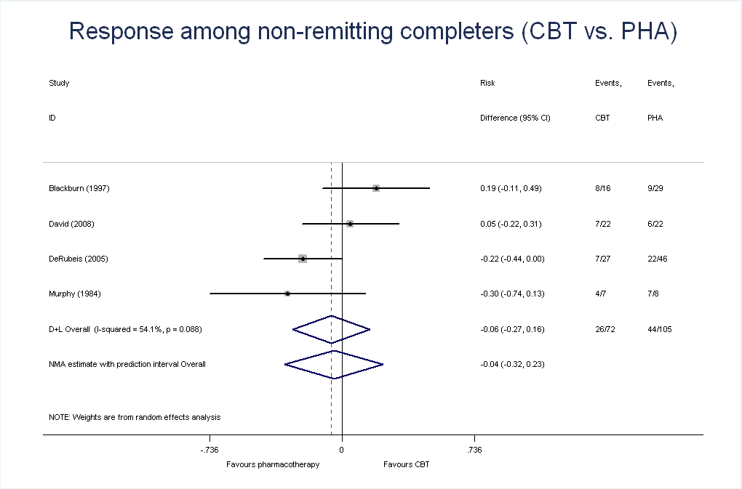

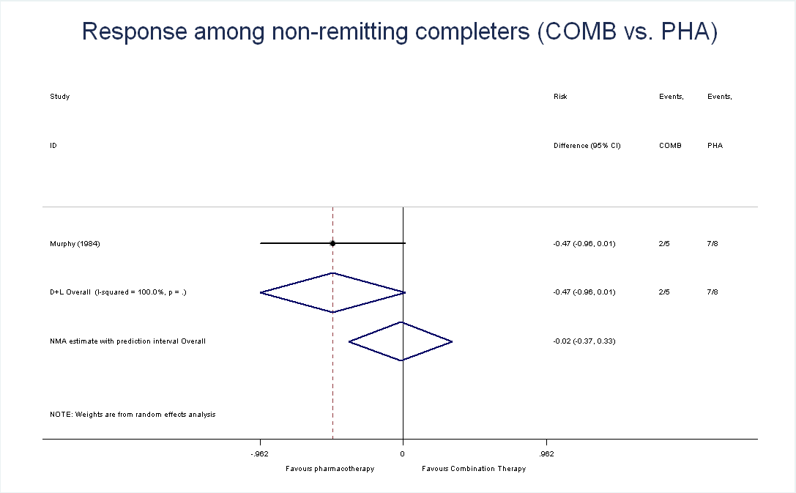

Appendix S3: Data used in meta-analysis
RCTs reporting data on treatment outcomes at the end of the acute treatment phase
Study | Treatment discontinuation among ITT sample |  |  | Remitters among treatment completers |  |  | Responders among treatment completers who do not remit
Study | PHA | CBT | COMB | PHA | CBT | COMB | PHA | CBT | COMB
Base case analysis
 |  | 4/18 | 4/15 |  | 10/14 | 4/11 |  | 1/4 | 5/7
 | 10/48 | 3/27 |  | 9/38 | 8/24 |  | 9/29 | 8/16
 | 26/69 | 4/51 |  | 27/43 | 25/47
 | 8/57 | 6/56 |  | 27/49 | 28/50 |  | 6/22 | 7/22
 | 19/120 | 9/60 |  | 55/101 | 24/51 |  | 22/46 | 7/27
 | 44/100 | 6/45 |  | 27/56 | 19/39
 | 25/63 | 38/120 |  | 21/38 | 45/87
 | 25/57 | 9/22 | 9/25 | 17/32 | 8/16 | 12/16
 | 9/36 | 5/33 |  | 15/27 | 16/31
 | 2/14 | 5/17 |  | 8/12 | 5/12
 | 2/23 | 1/23
 | 6/21 | 1/20
 | 8/24 | 5/24 | 4/22 | 8/16 | 12/19 | 13/18 | 7/8 | 4/7 | 2/5
 | 8/22 | 1/19
 | 12/33 | 7/31 | 12/36
Additional study included in sensitivity analysis
 | 59/226 | 55/228 | 48/227 | 36/167 | 41/173 | 75/179
ITT: Intention-to-treat; PHA: pharmacotherapy; CBT: cognitive behavioural therapy/cognitive therapy; COMB: combination therapy
RCTs reporting data on relapse among remitters after end of acute treatment phase
Study | Relapse among remitters at 12 month follow-up |  |  | Relapse among remaining remitters at 24 month follow-up |  |  | Comments
Study | PHA | CBT | COMB | PHA | CBT | COMB | Comments
Base case analysis
 | 6/12 | 5/17 | 7/19 | 1/6 | 0/12 | 0/12 | The sample sizes in Table 1 are misleading because they do not account for dropouts or loss to follow-ups occur which are discussed in the methods section. Table 3 suggests that patients who relapse at one time point may be counted as being ‘well’ in the next. We were unable to adjust for this.
 | 20/34 | 15/35 |  | 7/14 | 5/20 |  | Figure 3 can be used to infer the number of patients who dropped out of the study over the first 12 months which are not accounted for in Figure 2. Figure 3 does not seem to coincide with the information provided in the section ‘naturalistic-follow’ of the manuscript. It states that “In the pCT group, 5 of 20 patients had a recurrence during the naturalistic follow-up” but Figure 3 suggests that survival was >80% in the CT group. The 24 months figures in this table are based on the information provided in the manuscript.
 | 4/7 | 3/7 |  | 2/3 | 3/4 |  | See Figure 1
Additional studies included in sensitivity analysis
 | 4/11 | 2/10 | 2/13 | 1/7 | 1/8 | 1/11 | Number of patients returning to treatment not available at 12 months. As before we adopted the ‘worst-case scenario’ approach. We used the figure to infer the approximate number of patients relapsed at 12 months.
 | 11/28 | 13/30 |  | 13/17 | 3/17 |  | The relapse rates reported in Figure 1 do not seem to correspond to Figure 2 or the calculations made by the authors themselves in section ‘prevention of relapse’. Also the number of patients who survive the first year follow-up is different in Figure 1 (46) than what is said in the text (48). The 12 months estimates are based on Figure 1. Looking closely, it appears as if Figure 3 does not quite correspond to Figure 2.The 24 month Figures in this table are based on an approximation of figure 2. We ignored the Behavioral Activation arm in this study.

PHA: pharmacotherapy; CBT: cognitive behavioural therapy/cognitive therapy; COMB: combination therapy
References

Beck, A., Hollon, S. D., E., Y. J., C., B. R. & D., B. (1985). TReatment of depression with cognitive therapy and amitriptyline. Archives of General Psychiatry 42, 142-148.
Blackburn, I. M., Eunson, K. M. & Bishop, S. (1986). A two-year naturalistic follow-up of depressed patients treated with cognitive therapy, pharmacotherapy and a combination of both. Journal of Affective Disorders 10, 67-75.
Blackburn, I. M. & Moore, R. G. (1997). Controlled acute and follow-up trial of cognitive therapy and pharmacotherapy in out-patients with recurrent depression. Br J Psychiatry 171, 328-34.
Bulmash, E., Harkness, K. L., Stewart, J. G. & Bagby, R. M. (2009). Personality, stressful life events, and treatment response in major depression. J Consult Clin Psychol 77, 1067-77.
David, D., Szentagotai, A., Lupu, V. & Cosman, D. (2008). Rational emotive behavior therapy, cognitive therapy, and medication in the treatment of major depressive disorder: a randomized clinical trial, posttreatment outcomes, and six-month follow-up. Journal of Clinical Psychology 64, 728-746.
DeRubeis, R. J., D., H. S., D., A. J. & et al. (2005). Cognitive therapy vs medications in the treatment of moderate to severe depression. Archives of General Psychiatry 62, 409-416.
Dimidjian, S., Hollon, S. D., Dobson, K. S., Schmaling, K. B., Kohlenberg, R. J., Addis, M. E., Gallop, R., McGlinchey, J. B., Markley, D. K., Gollan, J. K., Atkins, D. C., Dunner, D. L. & Jacobson, N. S. (2006). Randomized trial of behavioral activation, cognitive therapy, and antidepressant medication in the acute treatment of adults with major depression. J Consult Clin Psychol 74, 658-70.
Dobson, K. S., Hollon, S. D., Dimidjian, S., Schmaling, K. B., Kohlenberg, R. J., Gallop, R. J., Rizvi, S. L., Gollan, J. K., Dunner, D. L. & Jacobson, N. S. (2008). Randomized trial of behavioral activation, cognitive therapy, and antidepressant medication in the prevention of relapse and recurrence in major depression. J Consult Clin Psychol 76, 468-77.
Elkin, I., Shea, M., Watkins, J. T. & et al. (1989). National institute of mental health treatment of depression collaborative research program: General effectiveness of treatments. Archives of General Psychiatry 46, 971-982.
Evans, M. D., Hollon, S. D., DeRubeis, R. J., Piasecki, J. M., Grove, W. M., Garvey, M. J. & Tuason, V. B. (1992). Differential relapse following cognitive therapy and pharmacotherapy for depression. Arch Gen Psychiatry 49, 802-8.
Hollon, S. D., DeRubeis, R. J., Evans, M. D., Wiemer, M. J., Garvey, M. J., Grove, W. M. & Tuason, V. B. (1992). Cognitive therapy and pharmacotherapy for depression. Singly and in combination. Arch Gen Psychiatry 49, 774-81.
Hollon, S. D., DeRubeis, R. J., Shelton, R. C., Amsterdam, J. D., Salomon, R. M., O'Reardon, J. P., Lovett, M. L., Young, P. R., Haman, K. L., Freeman, B. B. & Gallop, R. (2005). Prevention of relapse following cognitive therapy vs medications in moderate to severe depression. Arch Gen Psychiatry 62, 417-22.
Jarrett, R. B., Kraft, D., Schaffer, M., Witt-Browder, A., Risser, R., Atkins, D. H. & Doyle, J. (2000). Reducing relapse in depressed outpatients with atypical features: a pilot study. Psychother Psychosom 69, 232-9.
Jarrett, R. B., Schaffer, M., McIntire, D., Witt-Browder, A., Kraft, D. & Risser, R. C. (1999). Treatment of atypical depression with cognitive therapy or phenelzine: A double-blind, placebo-controlled trial. Archives of General Psychiatry 56, 431-437.
Kennedy, S. H., Konarski, J. Z., Segal, Z. V., Lau, M. A., Bieling, P. J., McIntyre, R. S. & Mayberg, H. S. (2007). Differences in brain glucose metabolism between responders to CBT and venlafaxine in a 16-week randomized controlled trial. Am J Psychiatry 164, 778-88.
McKnight, D. L., Nelson-Gray, R. O. & Barnhill, J. (1992). Dexamethasone suppression test and response to cognitive therapy and antidepressant medication. Behavior Therapy 23, 99-111.
Mohr, D. C., Boudewyn, A. C., Goodkin, D. E., Bostrom, A. & Epstein, L. (2001). Comparative outcomes for individual cognitive-behavior therapy, supportive-expressive group psychotherapy, and sertraline for the treatment of depression in multiple sclerosis. J Consult Clin Psychol 69, 942-9.
Murphy, G. E., Simons, A. D., Wetzel, R. D. & Lustman, P. J. (1984). Cognitive therapy and pharmacotherapy. Singly and together in the treatment of depression. Arch Gen Psychiatry 41, 33-41.
Rush, A., Beck, A., Kovacs, M. & Hollon, S. (1977). Comparative efficacy of cognitive therapy and pharmacotherapy in the treatment of depressed outpatients. Cognitive Therapy and Research 1, 17-37.
Thompson, L. W., Coon, D. W., Gallagher-Thompson, D., Sommer, B. R. & Koin, D. (2001). Comparison of desipramine and cognitive/behavioral therapy in the treatment of elderly outpatients with mild-to-moderate depression. Am J Geriatr Psychiatry 9, 225-40.

Appendix S4: WinBUGS code for evidence synthesis and the decision model

# Model specification

model {

################
# Meta Analyses #
##############
# Treatment arms
# 1: Pharmacotherapy (Reference Treatment)
# 2: CBT
# 3: Combination therapy

## Acute Phase
# Endpoints
# 1: Dropout
# 2: Remission
# 3: Response
# 4: Non response

# Treatment effect model
for(i in 1:ns){ # LOOP THROUGH STUDIES
for (m in 1:3) { # LOOP OVER 3 ENDPOINTS
w[i,1,m] <- 0 # adjustment for multi-arm trials is zero for reference treatment
delta[i,1,m] <- 0 # treatment effect is zero for reference treatment
mu[i,m] ~ dunif(-10,10) # vague prior for baseline rates
}
for (k in 1:na[i]) { # LOOP THROUGH ARMS
for (m in 1:nc[i]) { # LOOP OVER ENDPOINTS
r[i,k,m] ~ dbin(prob[i,k,m],n[i,k,m]) # binomial likelihood
theta[i,k,m]<-mu[i,m] + delta[i,k,m] # link function
logit(prob[i,k,m])<-min(999, max(-999,theta[i,k,m]))
rhat[i,k,m] <- prob[i,k,m] * n[i,k,m] # predicted number events
#Deviance contribution of each category
dv[i,k,m] <- 2 * (r[i,k,m]*(log(r[i,k,m])-log(rhat[i,k,m]))
+(n[i,k,m]-r[i,k,m])*(log(n[i,k,m]-r[i,k,m]) - log(n[i,k,m]-rhat[i,k,m])))
}
dev[i,k] <- sum(dv[i,k,1:nc[i]]) # deviance contribution of each arm
}

for (m in 1:nc[i]) { # LOOP OVER 3 ENDPOINTS
for (k in 2:na[i]) { # LOOP THROUGH ARMS
delta[i,k,m] ~ dnorm(md[i,k,m],taud[i,k,m])
# mean of LHR distributions (with multi-arm trial correction)
md[i,k,m] <- d[t[i,k],m] - d[t[i,1],m] + sw[i,k,m]
# precision of LOR distributions (with multi-arm trial correction)
taud[i,k,m] <- tau[m] *2*(k-1)/k
# adjustment for multi-arm RCTs
w[i,k,m] <- (delta[i,k,m] - d[t[i,k],m] + d[t[i,1],m])
# cumulative adjustment for multi-arm trials
sw[i,k,m] <- sum(w[i,1:k-1,m])/(k-1)
# trial-specific effect sizes (relative to pharmacotherapy)
probrd[i,k,m]<-prob[i,k,m] - prob[i,1,m]
}
}
# summed residual deviance contribution for this trial
resdev[i] <- sum(dev[i,1:na[i]])
}
totresdev <- sum(resdev[]) #Total Residual Deviance
for (m in 1:3) {
d[1,m]<-0 # treatment effect is zero for reference treatment
for (k in 2:nt){ d[k,m] ~ dt(0, 0.63245553203, 2) } # weakly informative t-distribution prior with scale 2.5 for effects on logit scale
prec[m]<-pow(1.64,-2)
var[m]~dlnorm(-2.01,prec[m]) # informative prior for between-trial variance from Turner 2012
tau[m] <- 1/var[m] # between-trial precision = (1/between-trial variance)
}

# Baseline model

for (m in 1:3) { # Looping over outcomes
for (i in 1:ns){ # LOOP THROUGH STUDIES
rbase[i,m] ~ dbin(p.base[i,m],nbase[i,m]) # Likelihood
logit(p.base[i,m]) <- min(999, max(-999,mu.base[i,m])) # Log-odds of response
mu.base[i,m] ~ dnorm(m.base[m],tau.m.base[m]) # Random effects model
}

m.base[m] ~ dunif(-10,10) # vague prior for mean
var.m.base[m] <- 1/tau.m.base[m] # between-trial variance
tau.m.base[m] <- pow(sd.m.base[m],-2) # between-trial precision
sd.m.base[m] ~ dunif(0,5) # vague prior for between-trial SD
}

# Estimate predictive distribution of treatment effects on the natural scale
# given base rates for reference treatment and mutlivariate normality

for (m in 1:3) { # Looping over outcomes
delta.new[1,m]<- 0 # treatment effect is zero for reference treatment
w.new[1,m] <- 0 # adjustment for conditional mean is zero for ref. treat.
for (k in 2:nt) { # LOOP THROUGH TREATMENTS
delta.new[k,m] ~ dnorm(m.new[k,m],tau.new[k,m]) # conditional distribution of each delta.new
m.new[k,m] <- d[k,m] + sw.new[k,m] # conditional mean of delta.new
tau.new[k,m] <- tau[m] *2*(k-1)/k # conditional precision of delta.new
w.new[k,m] <- delta.new[k,m] - d[k,m] # adjustment for conditional mean
sw.new[k,m] <- sum(w.new[1:k-1,m])/(k-1) # cumulative adjustment for cond. mean
}

mu.new[m] ~ dnorm(m.base[m],tau.m.base[m]) # predictive distribution baseline effect
for (k in 1:nt) { # loop through arms of hypothetical roll-out
# predictive prob of event for each treatment arm of the hypothetical rollout of the intervention
logit(p[k,m])<-mu.new[m] + delta.new[k,m]
}
for (k in 2:nt) {
rd[k,m]<-p[k,m]-p[1,m] # predicted effect sizes (relative to pharmacotherapy)
}
}

# Unconditional probability of Endpoints in Acute phase and risk difference

for (k in 1:nt) {
uncprob[k,1]<-p[k,1]
uncprob[k,2]<-(1-p[k,1])*p[k,2]
uncprob[k,3]<-(1-p[k,1])*(1-p[k,2])*p[k,3]
uncprob[k,4]<-(1-p[k,1])*(1-p[k,2])*(1-p[k,3])
}

for (j in 1:4) {
for (k in 2:nt) {
uncprobRD[k,j]<-uncprob[k,j]-uncprob[1,j]
}
}

## 12 Months relapse rates (among remitters)

for(i in 1:nsR12){ # LOOP THROUGH STUDIES
wR12[i,1] <- 0 # adjustment for multi-arm trials is zero for reference treatment
deltaR12[i,1] <- 0 # treatment effect is zero for reference treatment
muR12[i] ~ dunif(-10,10)
for (k in 1:naR12[i]) { # LOOP THROUGH ARMS
rR12[i,k] ~ dbin(probR12[i,k],nR12[i,k]) # binomial likelihood
logit(probR12[i,k]) <- muR12[i] + deltaR12[i,k] # model for linear predictor
rhatR12[i,k] <- probR12[i,k] * nR12[i,k] # expected value of the numerators
devR12[i,k] <- 2 * (rR12[i,k] * (log(rR12[i,k])-log(rhatR12[i,k])) #Deviance contribution
+ (nR12[i,k]-rR12[i,k]) * (log(nR12[i,k]-rR12[i,k]) - log(nR12[i,k]-rhatR12[i,k])))
}
resdevR12[i] <- sum(devR12[i,1:naR12[i]]) # summed residual deviance contribution for this trial
for (k in 2:naR12[i]) { # LOOP THROUGH ARMS
deltaR12[i,tR12[i,k]] ~ dnorm(mdR12[i,k],taudR12[i,k]) # trial-specific LOR distributions
mdR12[i,tR12[i,k]] <- dR12[tR12[i,k]] - dR12[tR12[i,1]] + swR12[i,k] # mean of LOR distributions (with multi-arm trial correction)
taudR12[i,tR12[i,k]] <- tauR12 *2*(k-1)/k # precision of LOR12 distributions (with multi-arm trial correction)
wR12[i,k] <- (deltaR12[i,k] - dR12[tR12[i,k]] + dR12[tR12[i,1]]) # adjustment for multi-arm RCTs
swR12[i,k] <- sum(wR12[i,1:k-1])/(k-1) # cumulative adjustment for multi-arm trials
probR12rd[i,k]<-probR12[i,k] - probR12[i,1] # trial-specific effect sizes (relative to pharmacotherapy)
}
}
totresdevR12 <- sum(resdevR12[]) #Total Residual Deviance
dR12[1] <- 0 # treatment effect is zero for reference treatment
for (k in 2:nt){ dR12[k] ~ dt(0,0.63245553203,2) } # weakly informative t-prior

precR12<-pow(1.64,-2)
varR12 ~ dlnorm(-2.01,precR12)

tauR12 <- 1/varR12 # between-trial precision = (1/between-trial variance)

# Baseline model

for (i in 1:nsR12){ # LOOP THROUGH STUDIES
rbaseR12[i] ~ dbin(p.baseR12[i],nbaseR12[i]) # Likelihood
logit(p.baseR12[i]) <- mu.baseR12[i] # Log-odds of response
mu.baseR12[i] ~ dnorm(m.baseR12,tau.m.baseR12) # Random effects model
}

m.baseR12 ~ dunif(-10,10) # vague prior for mean
var.m.baseR12 <- 1/tau.m.baseR12 # between-trial variance
tau.m.baseR12 <- pow(sd.m.baseR12,-2) # between-trial precision
sd.m.baseR12 ~ dunif(0,5) # vague prior for between-trial SD

# Estimate predictive distribution of treatment effects on the natural scale
# given base rates for reference treatment and mutlivariate normality

delta.newR12[1]<- 0 # treatment effect is zero for reference treatment
w.newR12[1] <- 0 # adjustment for conditional mean is zero for ref. treat.
for (k in 2:nt) { # LOOP THROUGH TREATMENTS
delta.newR12[k] ~ dnorm(m.newR12[k],tau.newR12[k]) # conditional distribution of each delta.new
m.newR12[k] <- dR12[k] + sw.newR12[k] # conditional mean of delta.new
tau.newR12[k] <- tauR12 *2*(k-1)/k # conditional precision of delta.new
w.newR12[k] <- delta.newR12[k] - dR12[k] # adjustment for conditional mean
sw.newR12[k] <- sum(w.newR12[1:k-1])/(k-1) # cumulative adjustment for cond. mean
}

mu.newR12 ~ dnorm(m.baseR12,tau.m.baseR12) # predictive distribution baseline effect
for (k in 1:nt) { # loop through arms of hypothetical roll-out
# predictive prob of event for each treatment arm of the hypothetical rollout of the intervention
logit(pR12[k,1]) <-mu.newR12 + (delta.newR12[tR12[nsR12+1,k]]- delta.newR12[tR12[nsR12+1,1]])
}
for (k in 2:nt) {
rdR12[k,1]<-pR12[k,1]-pR12[1,1]
}

## 24 Month relapse rates (among remitters)

for(i in 1:nsR24){ # LOOP THROUGH STUDIES
wR24[i,1] <- 0 # adjustment for multi-arm trials is zero for reference treatment
deltaR24[i,1] <- 0 # treatment effect is zero for reference treatment
muR24[i] ~ dunif(-10,10) # weakly informative priors for all trial baselines
for (k in 1:naR24[i]) { # LOOP THROUGH ARMS
rR24[i,k] ~ dbin(probR24[i,k],nR24[i,k]) # binomial likelihood
logit(probR24[i,k]) <- muR24[i] + deltaR24[i,k] # model for linear predictor
rhatR24[i,k] <- probR24[i,k] * nR24[i,k] # expected value of the numerators
devR24[i,k] <- 2 * (rR24[i,k] * (log(rR24[i,k])-log(rhatR24[i,k])) #Deviance contribution
+ (nR24[i,k]-rR24[i,k]) * (log(nR24[i,k]-rR24[i,k]) - log(nR24[i,k]-rhatR24[i,k])))
}
resdevR24[i] <- sum(devR24[i,1:naR24[i]]) # summed residual deviance contribution for this trial
for (k in 2:naR24[i]) { # LOOP THROUGH ARMS
deltaR24[i,tR24[i,k]] ~ dnorm(mdR24[i,k],taudR24[i,k]) # trial-specific LOR distributions
mdR24[i,tR24[i,k]] <- dR24[tR24[i,k]] - dR24[tR24[i,1]] + swR24[i,k] # mean of LOR distributions (with multi-arm trial correction)
taudR24[i,tR24[i,k]] <- tauR24 *2*(k-1)/k # precision of LOR24 distributions (with multi-arm trial correction)
wR24[i,k] <- (deltaR24[i,k] - dR24[tR24[i,k]] + dR24[tR24[i,1]]) # adjustment for multi-arm RCTs
swR24[i,k] <- sum(wR24[i,1:k-1])/(k-1) # cumulative adjustment for multi-arm trials
probR24rd[i,k]<-probR24[i,k] - probR24[i,1] # trial-specific effect sizes (relative to pharmacotherapy)
}
}
totresdevR24 <- sum(resdevR24[]) #Total Residual Deviance
dR24[1] <- 0 # treatment effect is zero for reference treatment
for (k in 2:nt){ dR24[k] ~ dt(0,0.63245553203,2) } # weakly informative t prior

precR24<-pow(1.64,-2)
varR24 ~ dlnorm(-2.01,precR24)

tauR24 <- 1/varR24 # between-trial precision = (1/between-trial variance)

# Baseline model

for (i in 1:nsR24){ # LOOP THROUGH STUDIES
rbaseR24[i] ~ dbin(p.baseR24[i],nbaseR24[i]) # Likelihood
logit(p.baseR24[i]) <- mu.baseR24[i] # Log-odds of response
mu.baseR24[i] ~ dnorm(m.baseR24,tau.m.baseR24) # Random effects model
}

m.baseR24 ~ dunif(-10,10) # vague prior for mean
var.m.baseR24 <- 1/tau.m.baseR24 # between-trial variance
tau.m.baseR24 <- pow(sd.m.baseR24,-2) # between-trial precision
sd.m.baseR24 ~ dunif(0,5) # vague prior for between-trial SD

# Estimate predictive distribution of treatment effects on the natural scale
# given base rates for reference treatment and mutlivariate normality

delta.newR24[1]<- 0 # treatment effect is zero for reference treatment
w.newR24[1] <- 0 # adjustment for conditional mean is zero for ref. treat.
for (k in 2:nt) { # LOOP THROUGH TREATMENTS
delta.newR24[k] ~ dnorm(m.newR24[k],tau.newR24[k]) # conditional distribution of each delta.new
m.newR24[k] <- dR24[k] + sw.newR24[k] # conditional mean of delta.new
tau.newR24[k] <- tauR24 *2*(k-1)/k # conditional precision of delta.new
w.newR24[k] <- delta.newR24[k] - dR24[k] # adjustment for conditional mean
sw.newR24[k] <- sum(w.newR24[1:k-1])/(k-1) # cumulative adjustment for cond. mean
}

mu.newR24 ~ dnorm(m.baseR24,tau.m.baseR24) # predictive distribution baseline effect
for (k in 1:nt) { # loop through arms of hypothetical roll-out
# predictive prob of event for each treatment arm of the hypothetical rollout of the intervention
logit(pR24[k,1]) <-mu.newR24 + (delta.newR24[tR24[nsR24+1,k]]- delta.newR24[tR24[nsR24+1,1]])
}
for (k in 2:nt) {
rdR24[k,1]<-pR24[k,1]-pR24[1,1]
}

for (k in 1:nt) {
for (j in 1:2) {
uncprobR24[k,j]<-pR12[k,j] + (1-pR12[k,j])*pR24[k,j]
}
}

######################
# Other parameter inputs #
#####################
# Depression states
# 1: Remission
# 2: Response
# 3: No response

# Cost of service use by depression state

mean.cost[1]<-134*1.16*4
se.cost[1]<-16
mean.cost[2]<-191*1.16*4
se.cost[2]<-31
mean.cost[3]<-352*1.16*4
se.cost[3]<-89
for (i in 1:3) {
prec.cost[i]<-pow(se.cost[i],-2)
cost[i]~dnorm(mean.cost[i],prec.cost[i])
}

# Time horizons (in years)

l[1]<-3/12 # acute phase
l[2]<-9/12 # Time to first follow-up (within first year)
l[3]<-3/12 # Time to first follow-up (within second year)
l[4]<-9/12 # Time to second follow-up (within second year)
l[5]<-3/12 # Time to second follow-up (within third year)
ldrop<-1/12 # Time until dropout

# Treatment costs

tcost.pha.maint<-192
tcost.pha.acute<-676
tcost.pha.incom<-282
tcost.cbt.maint<-208
tcost.cbt.acute<-1664
tcost.cbt.incom<-416
tcost.comb.maint<-tcost.pha.maint+tcost.cbt.maint
tcost.comb.acute<-tcost.pha.acute+tcost.cbt.acute
tcost.comb.incom<-tcost.pha.incom+tcost.cbt.incom

# Utility distribution by depression state

mean.utility[1]<-0.7995228
sesq.utility[1]<-pow(0.0197578,2)
mean.utility[2]<-0.6219333
sesq.utility[2]<-pow(0.0387033,2)
mean.utility[3]<-0.48289
sesq.utility[3]<-pow(0.0525091,2)

for (i in 1:3) {
alpha.utility[i]<-((1-mean.utility[i])/sesq.utility[i]-1/mean.utility[i])*pow(mean.utility[i],2)
beta.utility[i]<-alpha.utility[i]*(1-mean.utility[i])/mean.utility[i]
u[i]~dbeta(alpha.utility[i],beta.utility[i])
}

# Relapse rates among responders
dfactorR.invvar[1]<-pow(0.3,-2)
dfactorR.invvar[2]<-pow(0.3,-2)

pR12[1,2]~dbeta(9.428575,2.571429)
dfactorR12[1]~dnorm(0.5,dfactorR.invvar[1])
dfactorR12[2]~dnorm(0.5,dfactorR.invvar[2])
pR12[2,2]<-pR12[1,2]+dfactorR12[1]*rdR12[2,1]
pR12[3,2]<-pR12[1,2]+dfactorR12[2]*rdR12[3,1]

dfactorR24[1]~dnorm(0.5,dfactorR.invvar[1])
dfactorR24[2]~dnorm(0.5,dfactorR.invvar[2])
pR24[1,2]<-pR24[1,1]
pR24[2,2]<-pR24[1,1]+dfactorR24[1]*rdR24[2,1]
pR24[3,2]<-pR24[1,1]+dfactorR24[2]*rdR24[3,1]

# Patients discontinuing treatment

pDCure.invvar<-pow(0.03,-2)
pDCure~dnorm(0.2,pDCure.invvar) # probability of dropping out because of feeling cured
pDrelap~dbeta(2.4,0.6) # probability of relapsing if dropping out because of feeling cured (based on Jarret 2000)

# discount factor

disc <- 1.035

###############
# Decision Model #
###############

# Pathways definitions:
# 1: Remission + No Relapse
# 2: Remission and relapse at 24 months
# 3: Remission and relapse at 12 months
# 4: Response and no relapse
# 5: Response and relapse at 24 months
# 6: Response and relapse at 12 months
# 7: No response
# 8: Dropout + Remission + No relapse
# 9: Dropout + Remission + Relapse (at 12 months)
# 10: Dropout + No response

# Pathway probabilities

for (k in 1:nt) {
path[k,1]<-(1-p[k,1])*p[k,2]*(1-pR12[k,1])*(1-pR24[k,1])
path[k,2]<-(1-p[k,1])*p[k,2]*(1-pR12[k,1])*pR24[k,1]
path[k,3]<-(1-p[k,1])*p[k,2]*pR12[k,1]
path[k,4]<-(1-p[k,1])*(1-p[k,2])*p[k,3]*(1-pR12[k,2])*(1-pR24[k,2])
path[k,5]<-(1-p[k,1])*(1-p[k,2])*p[k,3]*(1-pR12[k,2])*pR24[k,2]
path[k,6]<-(1-p[k,1])*(1-p[k,2])*p[k,3]*pR12[k,2]
path[k,7]<-(1-p[k,1])*(1-p[k,2])*(1-p[k,3])
path[k,8]<-p[k,1]*pDCure*(1-pDrelap)
path[k,9]<-p[k,1]*pDCure*pDrelap
path[k,10]<-p[k,1]*(1-pDCure)
}

#QALYs by pathway

qaly[1]<-l[1]*(u[1]+u[3])/2+l[2]*u[1]+(l[3]+l[4])*u[1]/disc+l[5]*u[1]/(disc*disc)
qaly[2]<-l[1]*(u[1]+u[3])/2+l[2]*u[1]+l[3]*u[1]/disc+l[4]*(u[1]*5/8+u[3]*3/8)/disc+l[5]*(u[1]*1/8+u[3]*7/8)/(disc*disc)
qaly[3]<-l[1]*(u[1]+u[3])/2+l[2]*(u[1]*5/8+u[3]*3/8)+l[3]*(u[1]*1/8+u[3]*7/8)/disc+l[4]*u[3]/disc+l[5]*u[3]/(disc*disc)
qaly[4]<-l[1]*(u[1]+u[2])/2+l[2]*u[2]+(l[3]+l[4])*u[2]/disc+l[5]*u[2]/(disc*disc)
qaly[5]<-l[1]*(u[1]+u[2])/2+l[2]*u[2]+l[3]*u[2]/disc+l[4]*(u[2]*5/8+u[3]*3/8)/disc+l[5]*(u[2]*1/8+u[3]*7/8)/(disc*disc)
qaly[6]<-l[1]*(u[2]+u[3])/2+l[2]*(u[2]*5/8+u[3]*3/8)+l[3]*(u[2]*1/8+u[3]*7/8)/disc+l[4]*u[3]/disc+l[5]*u[3]/(disc*disc)
qaly[7]<-(l[1]+l[2])*u[3]+(l[3]+l[4])*u[3]/disc+l[5]*u[3]/(disc*disc)
qaly[8]<-qaly[1]
qaly[9]<-qaly[3]
qaly[10]<-qaly[7]

# Cost of service use by pathway (analogous to QALYs except cost[] rather than u[])

su[1]<-l[1]*(cost[1]+cost[3])/2+l[2]*cost[1]+(l[3]+l[4])*cost[1]/disc+l[5]*cost[1]/(disc*disc)
su[2]<-l[1]*(cost[1]+cost[3])/2+l[2]*cost[1]+l[3]*cost[1]/disc+l[4]*(cost[1]*5/8+cost[3]*3/8)/disc+l[5]*(cost[1]*1/8+cost[3]*7/8)/(disc*disc)
su[3]<-l[1]*(cost[1]+cost[3])/2+l[2]*(cost[1]*5/8+cost[3]*3/8)+l[3]*(cost[1]*1/8+cost[3]*7/8)/disc+l[4]*cost[3]/disc+l[5]*cost[3]/(disc*disc)
su[4]<-l[1]*(cost[1]+cost[2])/2+l[2]*cost[2]+(l[3]+l[4])*cost[2]/disc+l[5]*cost[2]/(disc*disc)
su[5]<-l[1]*(cost[1]+cost[2])/2+l[2]*cost[2]+l[3]*cost[2]/disc+l[4]*(cost[1]*5/8+cost[2]*3/8)/disc+l[5]*(cost[2]*1/8+cost[3]*7/8)/(disc*disc)
su[6]<-l[1]*(cost[2]+cost[3])/2+l[2]*(cost[2]*5/8+cost[3]*3/8)+l[3]*(cost[2]*1/8+cost[3]*7/8)/disc+l[4]*cost[3]/disc+l[5]*cost[3]/(disc*disc)
su[7]<-(l[1]+l[2])*cost[3]+(l[3]+l[4])*cost[3]/disc+l[5]*cost[3]/(disc*disc)
su[8]<-su[1]
su[9]<-su[3]
su[10]<-su[7]

# Summing costs and benefits weighted by probability of pathways

for (i in 1:nt) {
for (j in 1:10) {
wqaly[i,j]<-qaly[j]*path[i,j]
wsu[i,j]<-su[j]*path[i,j]
}
e[i]<-sum(wqaly[i,1:10])
totsu[i]<-sum(wsu[i,1:10])
}

# Adding cost of treatment

c[1]<-totsu[1]+p[1,1]*tcost.pha.incom+(1-p[1,1])*(tcost.pha.acute+tcost.pha.maint)-(1-p[1,1])*(1-p[1,2])*(1-p[1,3])*tcost.pha.maint
c[2]<-totsu[2]+p[2,1]*tcost.cbt.incom+(1-p[2,1])*(tcost.cbt.acute+tcost.cbt.maint)-(1-p[2,1])*(1-p[2,2])*(1-p[2,3])*tcost.cbt.maint
c[3]<-totsu[3]+p[3,1]*tcost.comb.incom+(1-p[3,1])*(tcost.comb.acute+tcost.comb.maint)-(1-p[3,1])*(1-p[3,2])*(1-p[3,3])*tcost.comb.maint

# Cost and effect differences

cdiff[2]<-c[2]-c[1] # CBT vs. PHA costs
cdiff[3]<-c[3]-c[1] # COMB vs. PHA costs

ediff[2]<-e[2]-e[1] # CBT vs. PHA QALYs
ediff[3]<-e[3]-e[1] # COMB vs. PHA QALYs

}

## Data
# Acute Phase

t[,1] t[,2] t[,3] na[] nc[] r[,1,1] r[,1,2] r[,1,3] n[,1,1] n[,1,2] n[,1,3] r[,2,1] r[,2,2] r[,2,3] n[,2,1] n[,2,2] n[,2,3] r[,3,1] r[,3,2] r[,3,3] n[,3,1] n[,3,2] n[,3,3] nbase[,1] rbase[,1] nbase[,2] rbase[,2] nbase[,3] rbase[,3]

2 3 NA 2 3 4 10 1 18 14 4 4 4 5 15 11 7 NA NA NA NA NA NA 1 NA 1 NA 1 NA
1 2 NA 2 3 10 9 9 48 38 29 3 8 8 27 24 16 NA NA NA NA NA NA 48 10 38 9 29 9
1 2 NA 2 2 26 27 NA 69 43 NA 4 25 NA 51 47 NA NA NA NA NA NA NA 69 26 43 27 1 NA
1 2 NA 2 3 8 27 6 57 49 22 6 28 7 56 50 22 NA NA NA NA NA NA 57 8 49 27 22 6
1 2 NA 2 3 19 55 22 120 101 46 9 24 7 60 51 27 NA NA NA NA NA NA 120 19 101 55 46 22
1 2 NA 2 2 44 27 NA 100 56 NA 6 19 NA 45 39 NA NA NA NA NA NA NA 100 44 56 27 1 NA
1 2 NA 2 2 25 21 NA 63 38 NA 38 45 NA 125 87 NA NA NA NA NA NA NA 63 25 38 21 1 NA
1 2 3 3 2 25 17 NA 57 32 NA 9 8 NA 25 16 NA 9 12 NA 25 16 NA 57 25 32 17 1 NA
1 2 NA 2 2 9 15 NA 36 27 NA 5 16 NA 36 31 NA NA NA NA NA NA NA 36 9 27 15 1 NA
1 2 NA 2 2 2 8 NA 14 12 NA 5 5 NA 17 12 NA NA NA NA NA NA NA 14 2 12 8 1 NA
1 2 NA 2 1 2 NA NA 23 NA NA 1 NA NA 23 NA NA NA NA NA NA NA NA 23 2 1 NA 1 NA
1 2 NA 2 1 6 NA NA 21 NA NA 1 NA NA 20 NA NA NA NA NA NA NA NA 21 6 1 NA 1 NA
1 2 3 3 3 8 8 7 24 16 8 5 12 4 24 19 7 4 13 2 22 18 5 24 8 16 8 8 7
1 2 NA 2 1 8 NA NA 22 NA NA 1 NA NA 19 NA NA NA NA NA NA NA NA 22 8 1 NA 1 NA
1 2 3 3 1 12 NA NA 35 NA NA 7 NA NA 31 NA NA 12 NA NA 36 NA NA 35 12 1 NA 1 NA

END

# 12 month follow-up
tR12[,1] tR12[,2] tR12[,3] rR12[,1] rR12[,2] rR12[,3] nR12[,1] nR12[,2] nR12[,3] naR12[] nbaseR12[] rbaseR12[]
1 2 3 6 5 7 12 17 19 3 12 6
1 2 NA 20 15 NA 34 35 NA 2 34 20
1 2 NA 4 3 NA 7 7 NA 2 7 4
1 2 3 NA NA NA 1 1 1 3 1 NA

END

# 24 month follow-up

tR24[,1] tR24[,2] tR24[,3] rR24[,1] rR24[,2] rR24[,3] nR24[,1] nR24[,2] nR24[,3] naR24[] nbaseR24[] rbaseR24[]
1 2 3 1 0 0 6 12 12 3 6 1
1 2 NA 7 5 NA 14 20 NA 2 14 7
1 2 NA 2 3 NA 3 4 NA 2 3 2
1 2 3 NA NA NA 1 1 1 3 1 NA
END

# Model parameters

# ns = number of studies (acute phase)
# nsR12=number of studies (relapse at 12 months follow-up);
# nsR24 = number of studies (relapse at 24 months follow-up)
# nt= number of treatments
list(ns = 15, nsR24 = 3, nsR12= 3, nt= 3)

# Initials
#chain 1
list(d = structure(.Data=c(NA,NA,NA, 0,0,0,0,0,0),.Dim=c(3,3)),
mu = structure(.Data=c(0,0,0, 1,0,0, 1,0,0, 1,0,0, 1,0,0, 1,0,0, 0,0,0, 1,0,0, 0,0,0, 0,0,0, 0,0,0, 0,0,0, 0,0,0, 0,0,0, 0,0,0 ),.Dim=c(15,3)), var = c(0.1,0.2,0.3),dR12 = c(NA,0,0), muR12 = c(0,0,0), varR12 = 0.2, dR24 = c(NA,0,0), muR24 = c(0,0,0), varR24 = 0.2, mu.base = structure(.Data=c(0,0,0,0,0, 0,0,0,0,0, 0,0,0,0,0, 0,0,0,0,0, 0,0,0,0,0, 0,0,0,0,0, 0,0,0,0,0, 0,0,0,0,0, 0,0,0,0,0),.Dim=c(15,3)), sd.m.base = c(1,1,1), m.base=c(0,0,0))

#chain 2
list(d = structure(.Data=c(NA,NA,NA, 0.1,0.1,0.1,0.1,0.1,0.1),.Dim=c(3,3)),
mu = structure(.Data=c(0.5,0.5,0.5, 0.5,0.5,0.5, 0.5,0.5,0.5, 0.5,0.5,0.5, 0.5,0.5,0.5, 0.5,0.5,0.5, 0.5,0.5,0.5, 0.5,0.5,0.5, 0.5,0.5,0.5, 0.5,0.5,0.5, 0.5,0.5,0.5, 0.5,0.5,0.5, 0.5,0.5,0.5, 0.5,0.5,0.5, 0.5,0.5,0.5 ),.Dim=c(15,3)), var = c(0.3,0.3,0.3),dR12 = c(NA,0.3,0.3), muR12 = c(0.5,0.5,0.5), varR12 = 0.3, dR24 = c(NA,0.3,0.3), muR24 = c(0.5,0.5,0.5), varR24 = 0.3)

#chain 3
list(d = structure(.Data=c(NA,NA,NA, -0.2,-0.2,-0.2,-0.2,-0.2,-0.2),.Dim=c(3,3)),
mu = structure(.Data=c(1,1,1, 0,1,1, 0,1,1, 0,1,1, 0,1,1, 0,1,1, 1,1,1, 0,1,1, 1,1,1, 1,1,1, 1,1,1, 1,1,1, 1,1,1, 1,1,1, 1,1,1 ),.Dim=c(15,3)), var = c(0.01,0.01,0.01),dR12 = c(NA,-0.1,-0.1), muR12 = c(1,1,1), varR12 = 0.02, dR24 = c(NA,-0.1,-0.1), muR24 = c(1,1,1), varR24 = 0.01)

