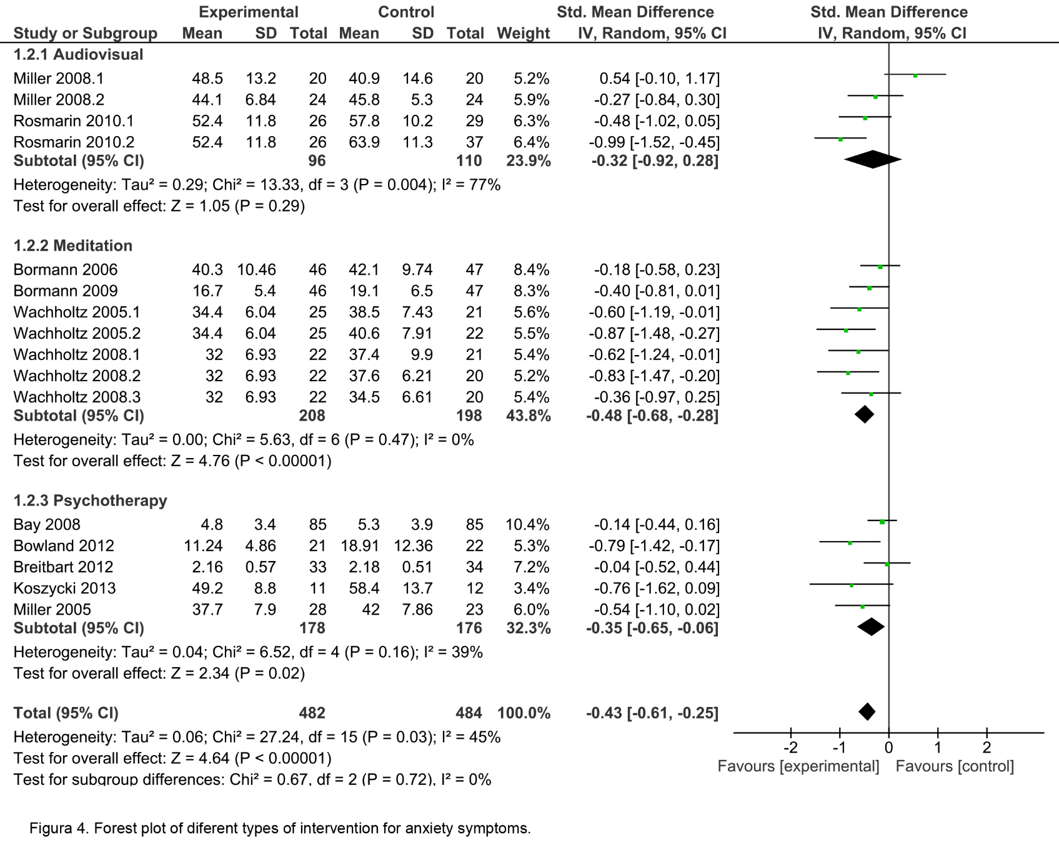
Fig. S1. Forest plot of different types of intervention for anxiety symptoms. See reference Koszycki et al. (2014) for the study Koszycki 2013.

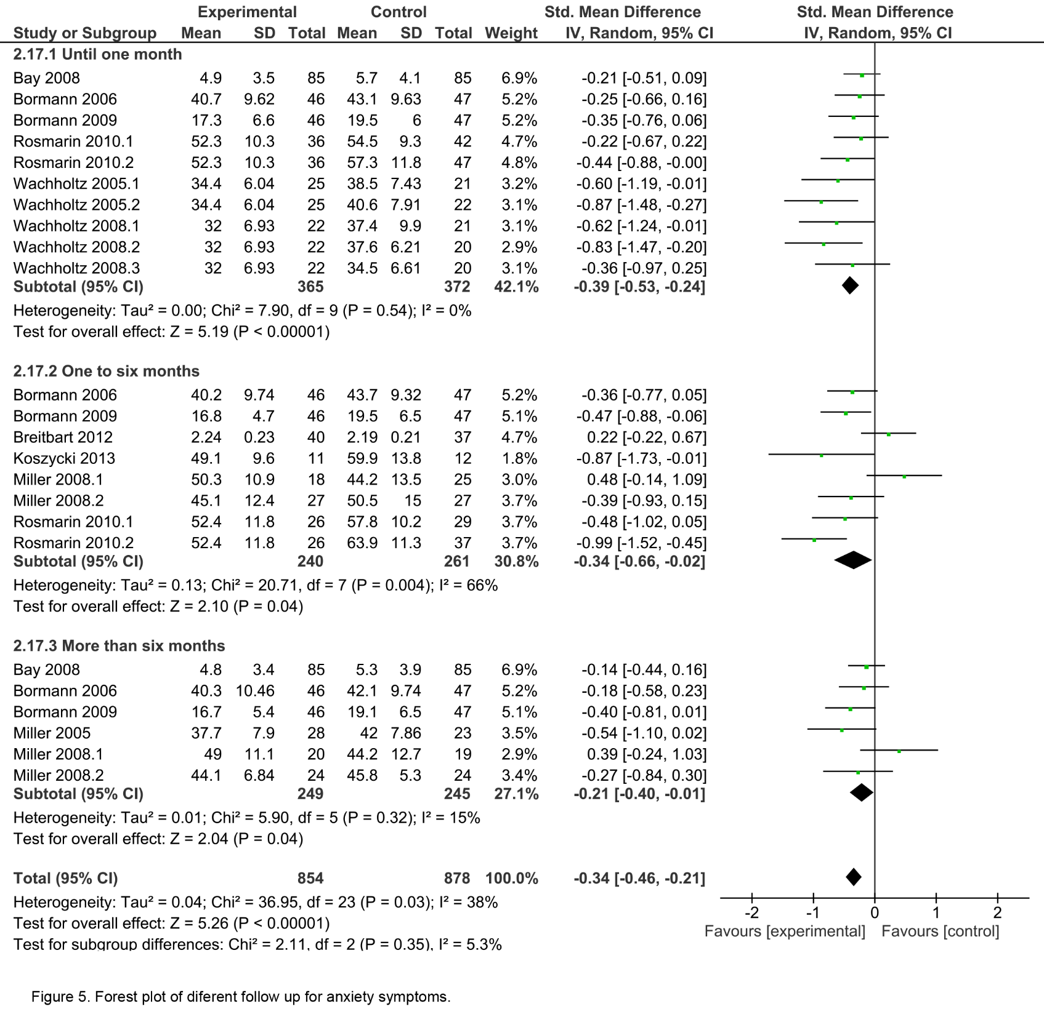
Fig. S2. Forest plot of different follow-up for anxiety symptoms. See reference Koszycki et al. (2014) for the study Koszycki 2013.

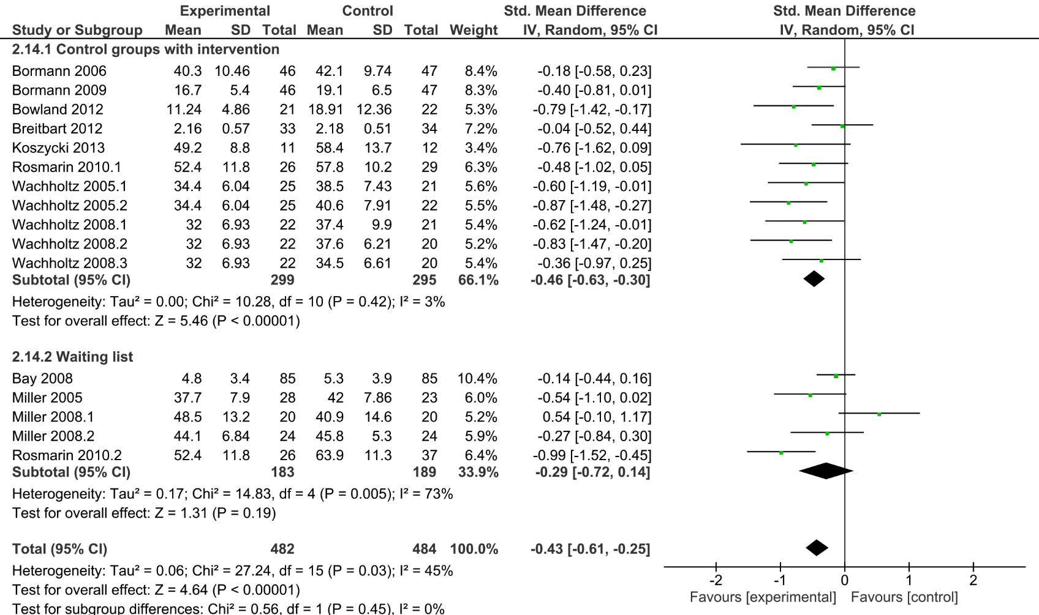
Fig. S3. Forest plot of different control groups for anxiety symptoms. See reference Koszycki et al. (2014) for the study Koszycki 2013.

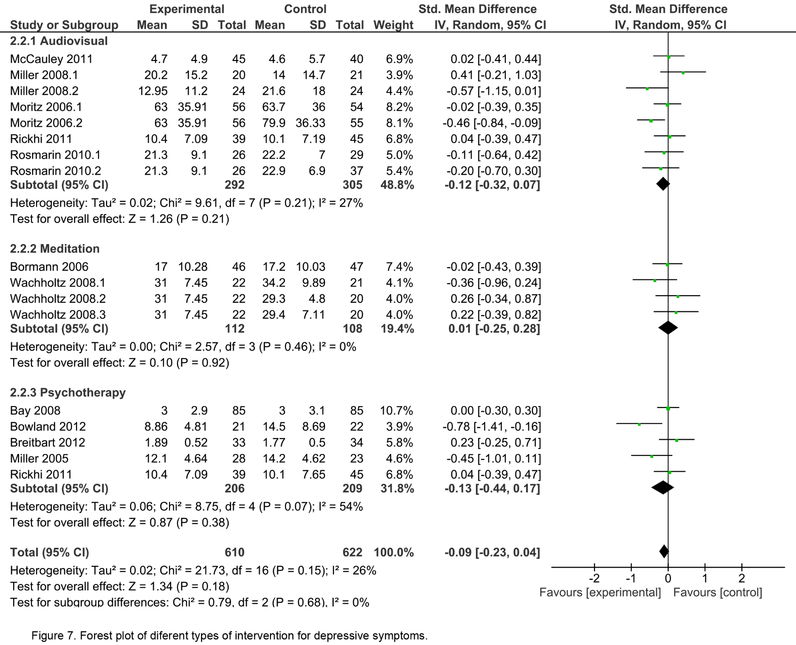
Fig. S4. Forest plot of different types of intervention for depressive symptoms.

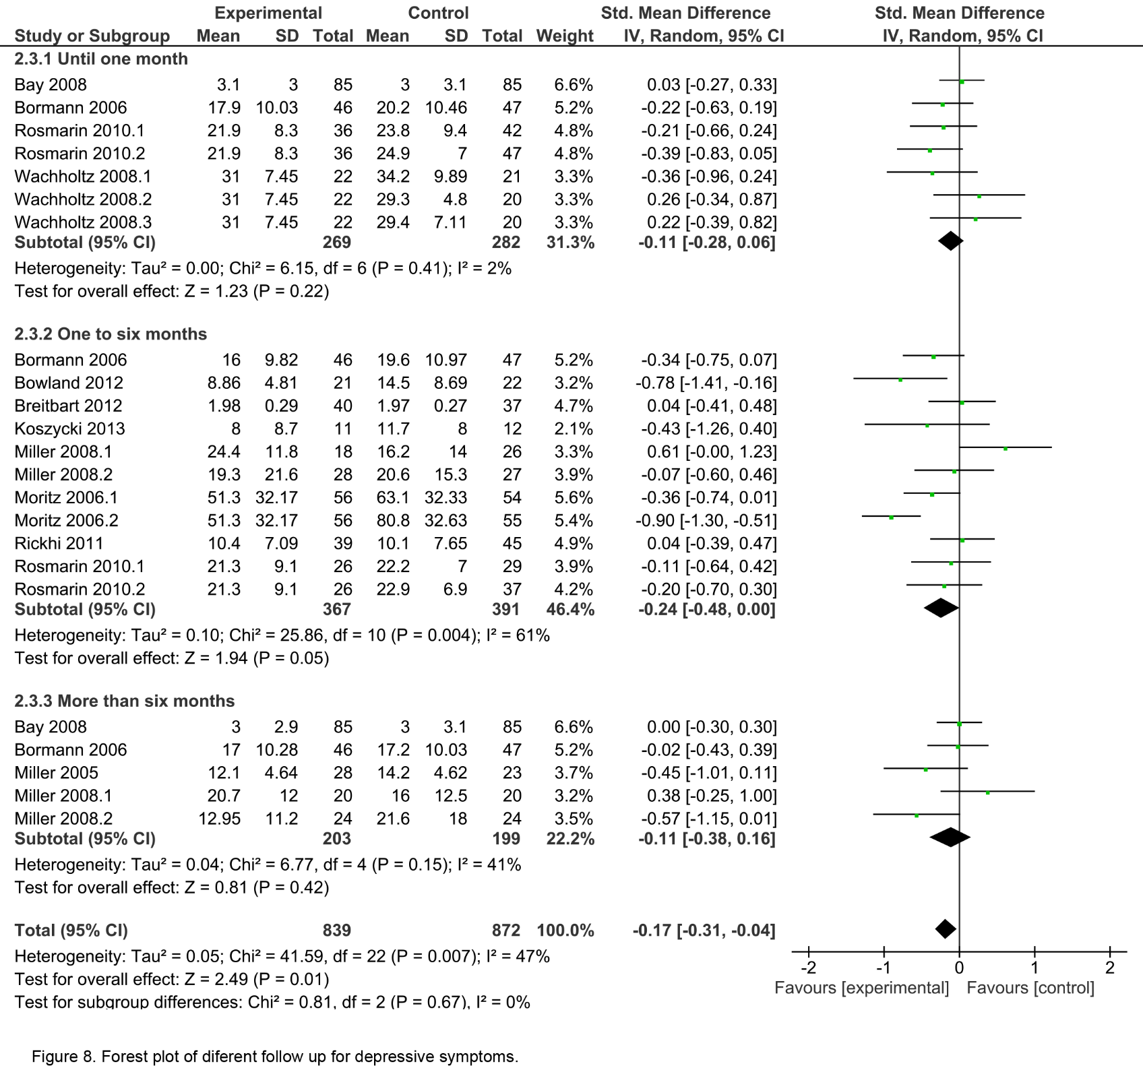
Fig. S5. Forest plot of different follow-up for depressive symptoms. See reference Koszycki et al. (2014) for the study Koszycki 2013.

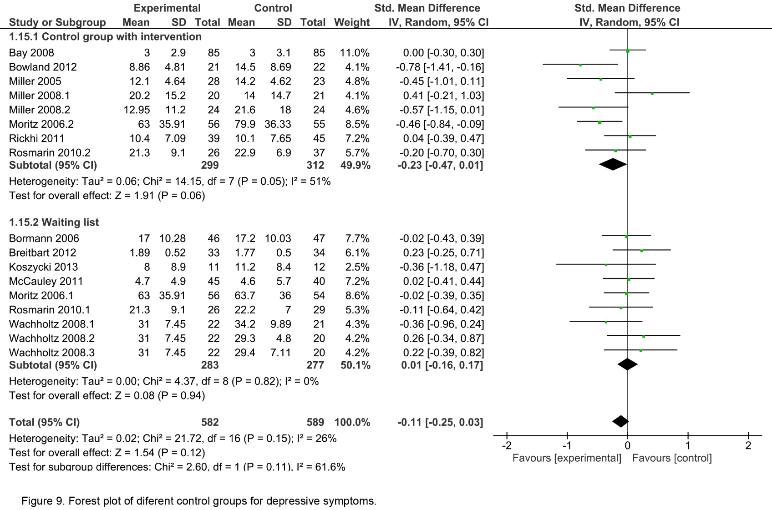
Fig. S6. Forest plot of different control groups for depressive symptoms. See reference Koszycki et al. (2014) for the study Koszycki 2013.

