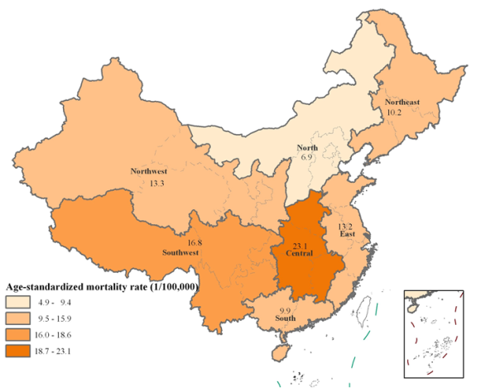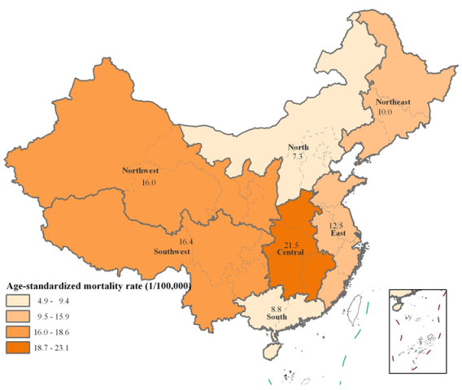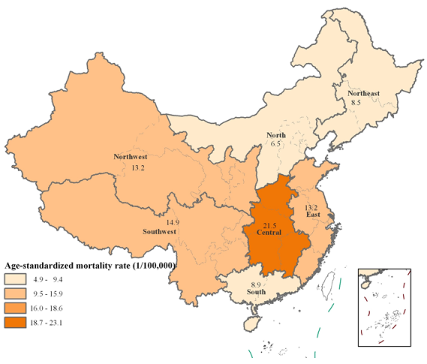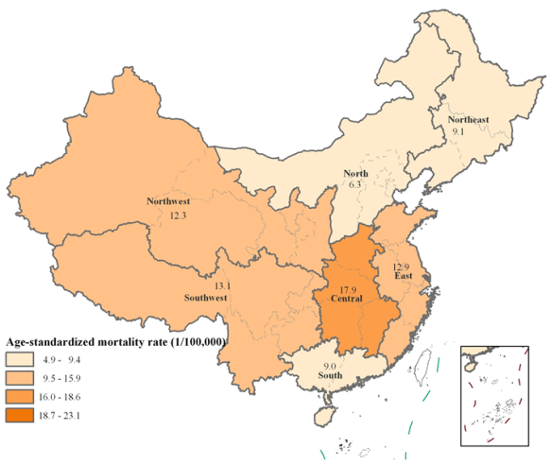
2006
2007
2008
2009

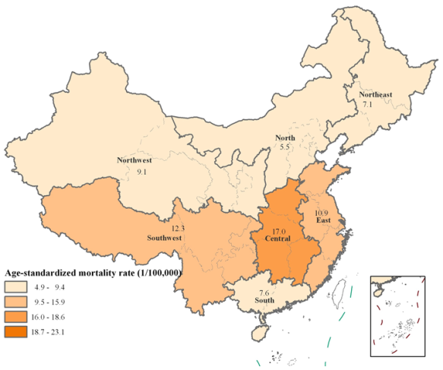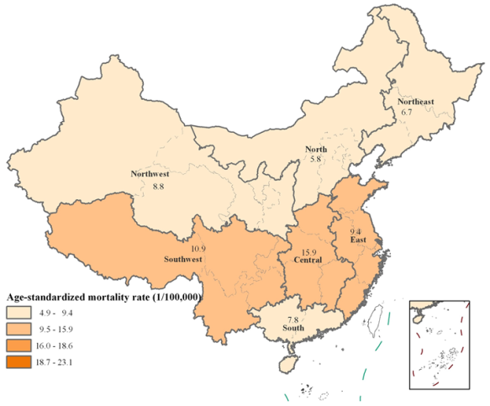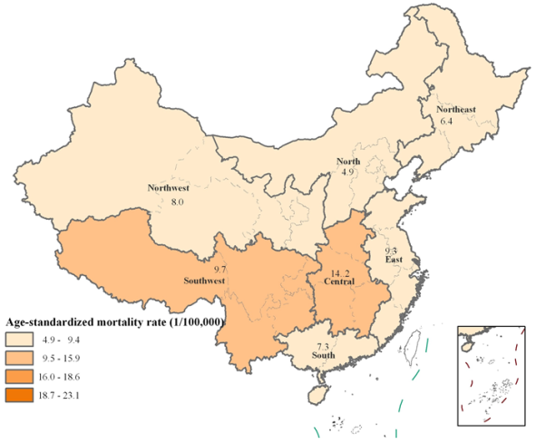
2010
2011
2012

Supplementary Fig S1. Geographical transition of age-standardized suicide rate among seven regions in China, 2006–2012.

Supplementary Table S1. Age-standardized mortality rate (per 100▫000) of suicide among people aged 15 years and above in China, by gender and urban/rural, 2006–2012
Year | Urban | Rural | National | Males |  |  | Females
 |  |  |  | Urban | Rural | Total | Urban | Rural | Total
2006 | 8.41 | 18.55 | 14.65 | 9.11 | 21.33 | 16.63 | 7.76 | 16.09 | 12.87
2007 | 7.44 | 18.32 | 13.82 | 8.66 | 20.74 | 15.73 | 6.30 | 16.19 | 12.10
2008 | 7.23 | 17.21 | 13.11 | 8.17 | 19.07 | 14.57 | 6.33 | 15.66 | 11.81
2009 | 7.21 | 15.44 | 12.17 | 8.10 | 17.31 | 13.64 | 6.33 | 13.69 | 10.76
2010 | 6.24 | 13.90 | 10.66 | 7.35 | 15.73 | 12.18 | 5.17 | 12.26 | 9.27
2011 | 5.52 | 12.73 | 9.86 | 6.24 | 14.41 | 11.15 | 4.79 | 11.17 | 8.63
2012 | 5.35 | 11.94 | 9.10 | 6.23 | 13.37 | 10.29 | 4.49 | 10.60 | 7.96
Total | 6.66 | 15.24 | 11.73 | 7.60 | 17.16 | 13.23 | 5.76 | 13.51 | 10.34

