Supplementary materials

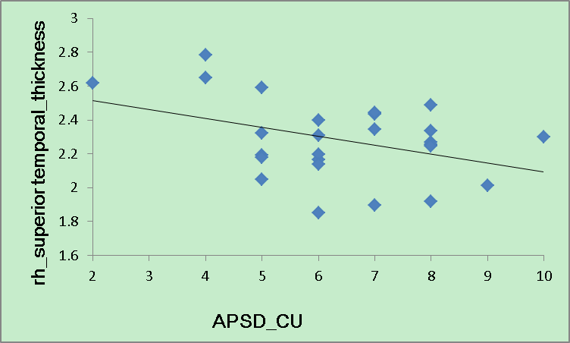

Supplementary Fig. S1. Voxel-wise correlation between Calllus Unemotional scores (measured by Antisocial Process Screening Device) and the right superior temporal cortex thickness (mm) in CD (r = -0.4, p = 0.04), this cluster also includes supramarginal and insula.

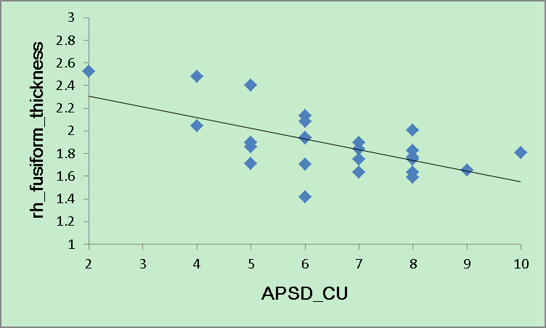

Supplementary Fig. S2. Voxel-wise correlation between Calllus Unemotional scores (measured by Antisocial Process Screening Device) and the right fusiform thickness (mm) in CD (r = -0.63, p = 0.001), this cluster also includes parahippocampal and lingual.

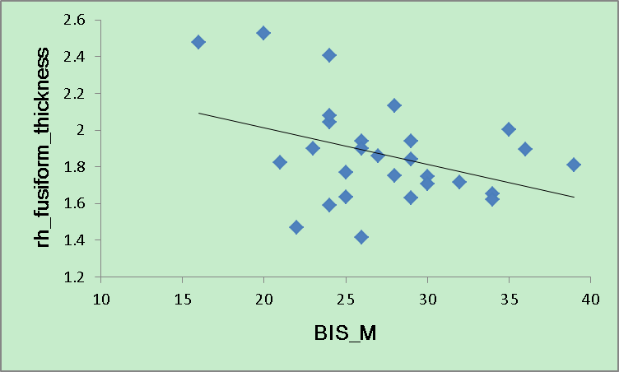

Supplementary Fig. S3. Voxel-wise correlation between motor impulsivity (measured by Barratt Impulsivity Scale) and the right fusiform thickness (mm) in CD (r = -0.38, p < 0.05), this cluster also includes parahippocampal and lingual.

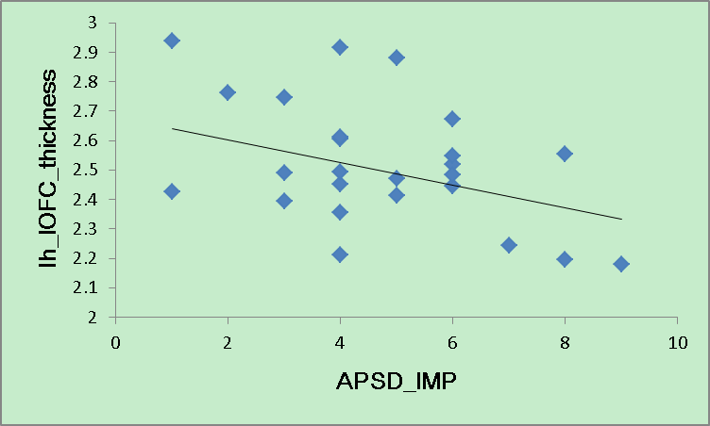

Supplementary Fig. S4. Voxel-wise correlation between impulsivity (measured by Antisocial Process Screening Device) and the left lateral orbitofrontal cortex thickness (mm) in CD (r = -0.33, p = 0.07).

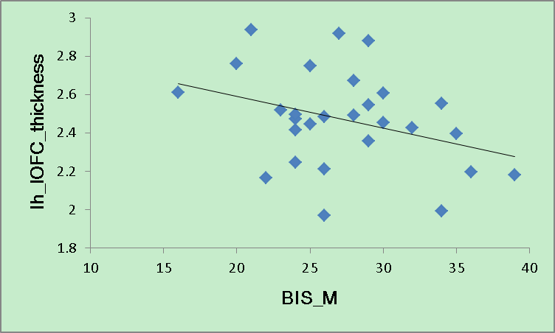

Supplementary Fig. S5. Voxel-wise correlation between motor impulsivity (measured by Barratt Impulsivity Scale) and the left lateral orbitofrontal cortex thickness (mm) in CD (r = -0.35, p = 0.09).

Supplementary Table S1
Clusters of surface area deficits in adolescents in right hemisphere (HC>CD)
Cluster no. | Max | Size  (mm²) | TalX | TalY | TalZ | no.  vertices | Annotation
1 | -2.3 | 747.7 | 46.9 | -21.1 | -26.6 | 1402 | Inferior temporal,  parahippocampal,  fusiform
2 | -2.1 | 702.1 | 47.8 | 4.2 | 17.8 | 1348 | Precentral,  caudal-middle-frontal
CD, conduct disorder; HC, healthy controls; Max, log₁₀ (p value); Tal (X, Y, Z), Talairach (X, Y, Z).
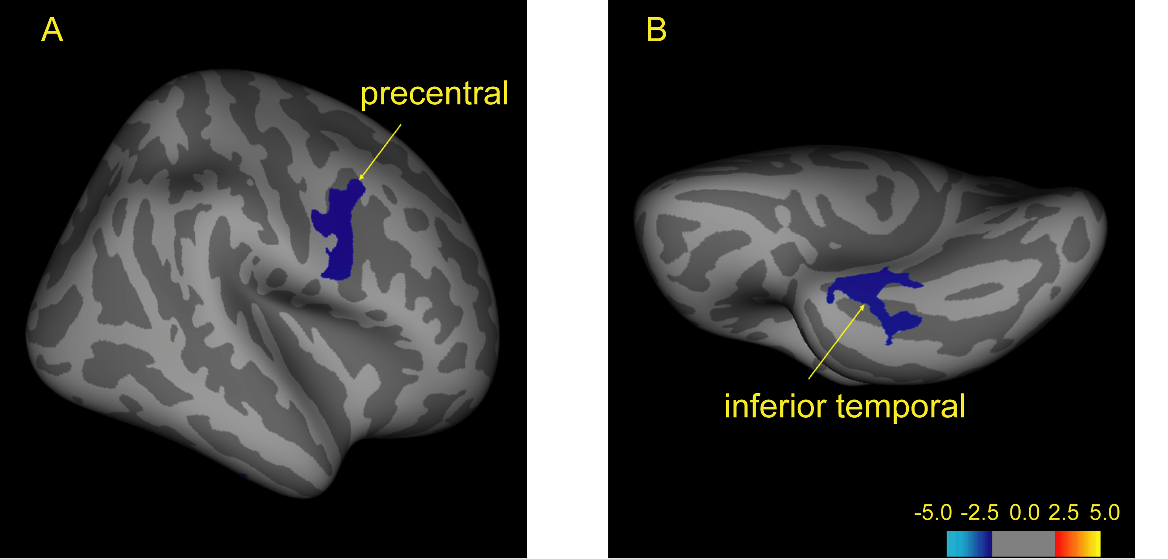
Supplementary Fig. S6 Lateral (A) and inferior (B) views of the right cerebral surfaces show differences in the surface area between AO-CD patients (n = 28) and matched HCs (n = 30). Colored regions are used to indicate significant differences in the surface area for the two groups, with blue representing greater values for the HC group compared with the AO-CD group. Conversely, red/yellow coloring represents greater values for the AO-CD group compared with the HC group. The value of the color bar is a log₁₀ (p value). Cluster labels correspond with those are provided in Table S1.

