Supplementary Table S1. Group differences and correlation between schizophrenia patients and their corresponding siblings and parents in CNI (The age, education year and IQ were controlled)
 | Sibling group |  |  | Parent group |  |  | Correlation
 | SCZ-SIB | SIB | ANCOVA F (p-value) | SCZ-PAR | PAR | ANCOVA F (p-value) | SCZ & SIB | SCZ & PAR
 | (n=49) | (n=49) | ANCOVA F (p-value) | (n=26) | (n=26) | ANCOVA F (p-value) | (n=49) | (n=26)
 | Mean | Mean | ANCOVA F (p-value) | Mean | Mean | ANCOVA F (p-value) | r (p-value) | r (p-value)
 | (SD) | (SD) | ANCOVA F (p-value) | (SD) | (SD) | ANCOVA F (p-value) | r (p-value) | r (p-value)
Motor Coordination | 2.76(2.04) | 1.88(1.76) | 2.76(p=0.300) | 1.96(1.71) | 1.19(1.2) | 1.40(p=0.727) | 0.316* | 0.446*
Sensory Integration | 1.47(1.14) | 1.02(0.92) | 2.44(p=0.367) | 1.62(1.6) | 1.31(0.97) | 7.87(p=0.022)* | 0.391** | 0.397*
Disinhibition | 1.22(1.18) | 0.78(1.1) | 5.46(p=0.064) | 1.58(1.84) | 1.5(1.86) | 2.40(p=0.128) | 0.259 | 0.024
CNI-total | 5.45(3.19) | 3.67(2.39) | 6.73(p=0.034)* | 5.15(2.94) | 4(3.02) | 7.95(p=0.022)* | 0.346* | 0.423*
Note: CNI = Cambridge Neurological Inventory, SCZ = Schizophrenia patients, REL = First-degree relatives of schizophrenia patients, SCZ-SIB = Schizophrenia patients in sibling group, SIB = Siblings of schizophrenia patients, SCZ-PAR = Schizophrenia patients in parent group, PAR = Parents of schizophrenia patients; *, p < 0.05, **, p <0.01

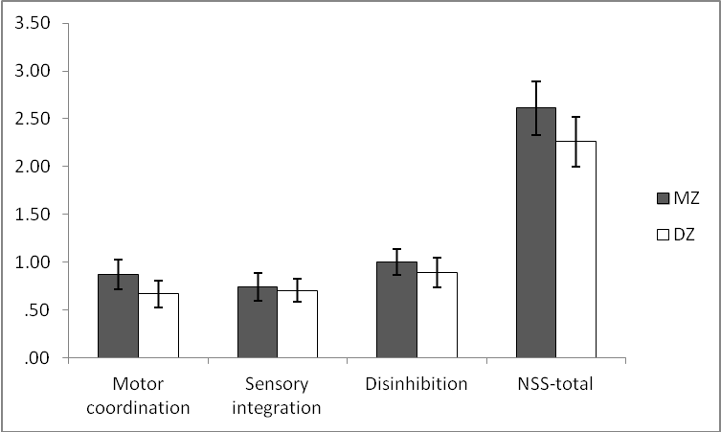
Supplementary Fig. S1. NSS scores of the twin pairs

MZ = monozygotic twins, DZ = dizygotic twins.

