SUPPLEMENTARY MATERIAL
Supplementary material S1: IAPS identification numbers and norm data of the selected pictures
The IAPS identification numbers were the following for neutral pictures: 2190, 2393, 2397, 2411, 2840, 2880, 2890, 5510, 5530, 6150, 7000, 7002, 7003, 7004, 7006, 7009, 7010, 7017, 7020, 7031, 7032, 7035, 7038, 7040, 7041, 7050, 7080, 7090, 7100, 7140, 7150, 7161, 7170, 7175, 7179, 7233, 7491, 7705, 7950, 9210; for aversive pictures: 1120, 1201, 1300, 1304, 1930, 1932, 2811, 3181, 3500, 3530, 5971, 5972, 6230, 6231, 6260, 6313, 6315, 6350, 6510, 6520, 6540, 6550, 6563, 8475, 8485, 9050, 9075, 9163, 9187, 9250, 9410, 9412, 9413, 9414, 9600, 9622, 9635.1, 9908, 9921, 9940.
The norm data of the IAPS pictures indicated that the two selected sets differed in their mean arousal (neutral: M = 2.69, SD = 0.39; aversive: M = 6.64, SD = 0.39) and valence values (neutral: M = 4.98, SD = 0.2; aversive: M = 2.53, SD = 0.79).

Supplementary material S2: Additional Methods and Results of the Picture Rating Session
Method. Patients with obsessive-compulsive disorder (OCD) and healthy controls (HC) evaluated their emotional reaction in response to OCD-related, aversive, and neutral pictures on a 9-point rating scale regarding arousal, unpleasantness, and the potential to induce OC symptoms (where 1 represented a low rating and 9 represented a high rating on each dimension). OCD-related pictures were individually preselected by choosing up to three most relevant OCD themes based on the Y-BOCS Symptom Checklist. Because the Berlin OCD-Picture Set (BOCD-PS; Simon et al., 2012) comprises 25 pictures per OCD theme (expect for the symptom dimension "contamination fear / washing (CW)", which contains 50 pictures), the number of presented OCD-related pictures was either 50 (CW only, or two symptom dimensions other than CW), 75 (CW and one other symptom dimension or three symptom dimensions other than CW), or 100 (CW and two other symptom dimensions) per participant. Healthy controls were presented with the same pictures as the corresponding patient they were matched with, but the OC symptom rating was omitted.
Statistical Analysis. To evaluate subjective emotional responses to pictures, a 3 (picture category: OCD-related, aversive, neutral) × 2 (group: OCD, HC) repeated-measures analyses of variance (ANOVA) was performed for unpleasantness and arousal ratings in the picture rating session. OC symptom ratings were subjected to a one-way ANOVA with picture category as the independent variable.
Results. Mean ratings and between-group test results are displayed in Supplementary Table S1. Analyses on unpleasantness and arousal ratings revealed a main effect of picture category, F(2,92) = 604.32, p < .001, η²_{P} = .93 and F(2,92) = 685.41, p < .001, ɛ = .81, η²_{P} = .94, respectively, a main effect of group, F(1,46) = 92.44, p < .001, η²_{P} = .67 and F(1,46) = 138.0, p < .001, η²_{P} = .75, respectively, and a significant Picture Category × Group interaction, F(2,92) = 93.15, p < .001, η²_{P} = .67 and F(2,92) = 112.73, p < .001, ɛ = .81, η²_{P} = .71, respectively. Independent-samples t-tests comparing valence and arousal ratings for each picture category between groups revealed that OCD patients evaluated OCD-related pictures as more arousing, t(46) = 15.75, p < .001, and more unpleasant, t(46) = 17.30, p < .001, than healthy controls. No significant group differences were observed for neutral and aversive pictures (all ps > .1). Follow-up ANOVAs for each group separately revealed for both arousal and valence ratings a significant main effect of picture category for both groups (all ps < .001). Within the healthy control group, aversive pictures were evaluated as more arousing and unpleasant compared to OCD-related pictures (arousal: t(23) = 23.17, p < .001; unpleasantness; t(23) = 18.48, p < .001), which were in turn evaluated higher in arousal and unpleasantness than neutral pictures (arousal: t(23) = 7.75, p < .001; unpleasantness; t(23) = 8.59, p < .001). Within the OCD group, the same pattern was observed for arousal ratings (AV > OC > NE, all ps ≤ .02), but for unpleasantness ratings, OCD-related pictures did not differ from aversive pictures (p = .26). Regarding OC symptoms, a main effect of picture category was found, F(2,46) = 489.61, p < .001, ɛ = .69, η²_{P} = .96, indicating that OCD patients evaluated OCD-related pictures as inducing stronger symptoms compared to both neutral, t(23) = 23.06, p < .001, and aversive pictures, t(23) = 23.92, p < .001, which did not differ significantly from each other (p > .99).

Supplementary Table S1
Means and standard deviations of unpleasantness, arousal, and symptom ratings for patients with obsessive-compulsive disorder (OCD) and healthy controls (HC) obtained during the rating session one week prior to the emotion regulation task. Between-group test results are shown for unpleasantness and arousal ratings. Symptom ratings were obtained from OCD patients only.
Picture Type | Unpleasantness |  |  |  |  | Arousal |  |  |  |  | Symptoms
Picture Type | OCD | HC | t (df = 46) | p |  | OCD | HC | t (df = 46) | p |  | OCD
OCD-related | 7.3 (1.0) | 2.6 (0.8) | 17.30 | <.001 |  | 6.8 (1.3) | 2.0 (0.6) | 15.75 | <.001 |  | 7.7 (1.3)
Aversive | 7.8 (1.2) | 7.3 (1.3) | 1.40 | .17 |  | 7.8 (1.0) | 7.5 (1.0) | 1.05 | .30 |  | 1.3 (0.5)
Neutral | 1.4 (0.9) | 1.1 (0.2) | 1.33 | .20 |  | 1.2 (0.5) | 1.1 (0.2) | 0.70 | .49 |  | 1.3 (0.8)

Note. Ratings were made on a 9-point rating scale (unpleasantness: 1 = low unpleasantness, 9 = high unpleasantness; arousal: 1 = low arousal, 9 = high arousal; symptoms: 1 = no symptoms, 9 = maximal symptoms)

Supplementary Table S2
Individualized OCD-related pictures selected for the emotion regulation task
Participant # |  | Number of selected OCD-related pictures per symptom dimension (N = 24)
01 |  | CW (15), CH (6), AG (3)
02 |  | CW (23), CH (1)
03 |  | CH (15), AG (5), CW (4)
04 |  | CW (23), AG (1)
05 |  | AG (15), CH (9)
06 |  | CW (24)
07 |  | CW (15), AG (6), CH (3)
08 |  | CW (13), CH (11)
09 |  | CW (22), CH (2)
10 |  | CH (11), CW (8), AG (5)
11 |  | CW (16), CH (8)
12 |  | CW (13), CH (6), AG (5)
13 |  | CW (24)
14 |  | CW (23), CH (1)
15 |  | CW (21), AG (3)
16 |  | CW (20), CH (4)
17 |  | CW (13), OR (9), CH (2)
18 |  | CH (16), CW (8)
19 |  | CW (18), CH (6)
20 |  | CW (8), CH (8), AG (8)
21 |  | CH (13), CW (11)
22 |  | CH (14), OR (9), AG (1)
23 |  | CW (15), OR (6), CH (3)
24 |  | CW (24)

Note. CW, contamination/washing; CH, checking; AG, aggressive obsessions; OR, symmetry/ordering
Supplementary Table S3
Self-reported dispositional emotion regulation in patients with obsessive-compulsive disorder (OCD) and healthy controls (HC)
 | OCD |  |  |  | HC |  |  |  | Statistic
 | M |  | SD |  | M |  | SD |  | t (df = 46) |  | p | Cohen's d
CERQ
Refocus on planning | 10.5 |  | 2.8 |  | 11.7 |  | 3.0 |  | -1.33 |  | .19 | -0.41
Acceptance | 8.7 |  | 2.3 |  | 10.7 |  | 2.6 |  | -2.78 |  | .01 | -0.82
Positive refocusing | 5.2 |  | 1.9 |  | 8.0 |  | 2.7 |  | -4.18 |  | <.001* | -1.20
Positive reappraisal | 8.3 |  | 3.0 |  | 10.6 |  | 3.1 |  | -2.55 |  | .01 | -0.75
Putting into perspective | 8.9 |  | 3.1 |  | 10.7 |  | 2.1 |  | -2.27 |  | .03 | -0.68
Self-blame | 8.9 |  | 2.9 |  | 7.0 |  | 2.2 |  | 2.57 |  | .01 | 0.74
Catastrophizing | 7.0 |  | 2.1 |  | 5.0 |  | 1.8 |  | 3.52 |  | .001* | 1.02
Blaming others | 5.1 |  | 1.9 |  | 4.8 |  | 1.5 |  | 0.69 |  | .49 | 0.18
Rumination | 9.7 |  | 2.9 |  | 8.4 |  | 3.0 |  | 1.52 |  | .14 | 0.44
ERQ
Reappraisal | 3.7 |  | 1.2 |  | 4.9 |  | 1.0 |  | -3.97 |  | <.001* | -1.09
Suppression | 3.5 |  | 1.3 |  | 3.4 |  | 1.1 |  | 0.31 |  | .76 | 0.08

Note. CERQ, Cognitive Emotion Regulation Questionnaire; ERQ, Emotion Regulation Questionnaire. Asterisks indicate comparisons that remain significant after correction for multiple comparisons using a Bonferroni-corrected alpha level of .05/11 = .005

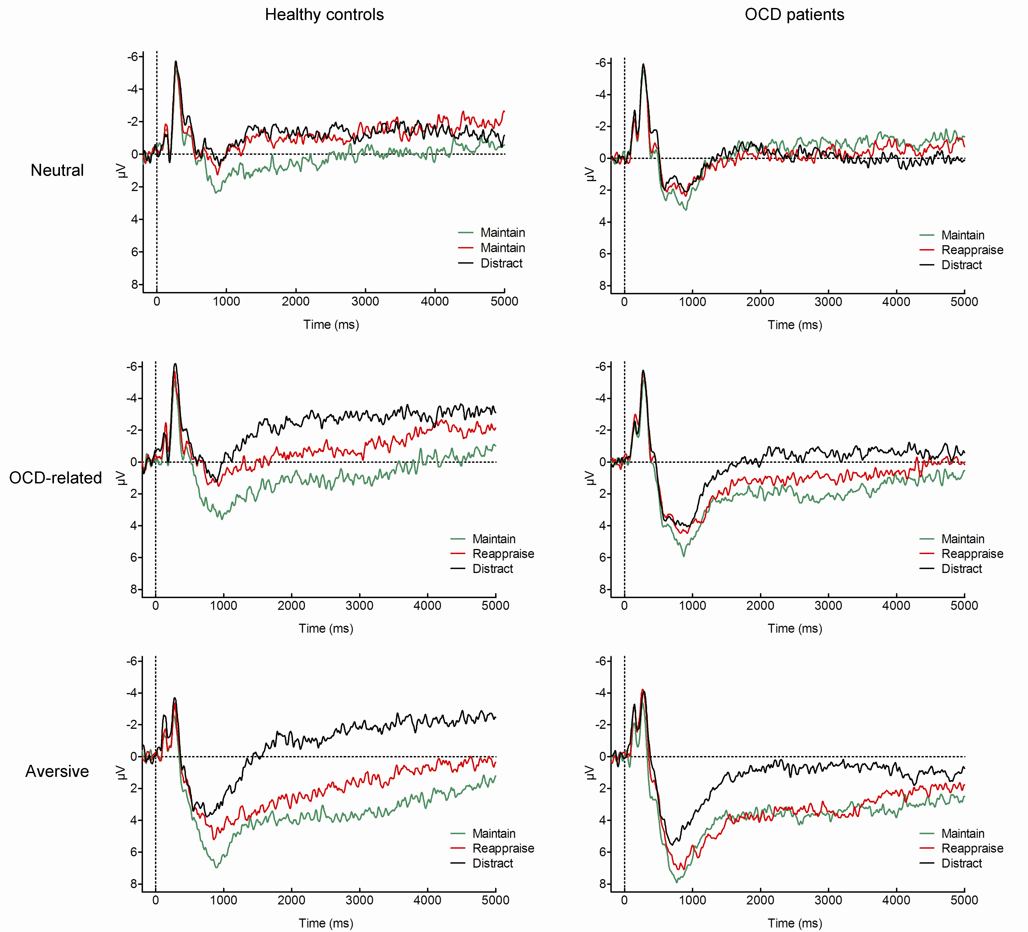
Supplementary Fig. S1. Mean LPP amplitudes for healthy controls (left) and patients with obsessive-compulsive disorder (OCD, right) in response to neutral (top), OCD-related (middle), and aversive pictures (bottom) during the maintain and the two regulation conditions. ERPs were averaged at three centro-parietal recording sites (CP1, CPz, CP2).

