Attentional Bias Modification (ABM) Training Induces Spontaneous Brain Activity Changes in Young Women with Subthreshold Depression: A Randomized Controlled Trial

Haijiang Li¹, Michael Browning⁴, Dongtao Wei^{2, 3}, Qinglin Zhang^{2, 3}, Jiang Qiu^{2, 3}

¹Department of Psychology, Shanghai Normal University, Shanghai 200234, China, ²Key Laboratory of Cognition and Personality (SWU), Ministry of Education, Chongqing 400715, China, ³Faculty of Psychology, Southwest University, Chongqing 400715, China, ⁴Department of Psychiatry, University of Oxford, UK.

Supplementary Materials
Methods
Participants
A total of 67 female undergraduate students were recruited from Southwest University, Chongqing, China. Recruitment proceeded in two stages: First, a large group of participants completed the Beck Depression Inventory-II (BDI; Beck, Steer, & Brown, 1996). From this initial group, participants who scored 14 and above or 6 and below were invited to participate in a second session approximately one week later. In this session, potential participants completed an in-person screening session, which included BDI and administration of the Structured Clinical Interview for DSM-IV-TR Axis I Disorders (SCID; First et al., 2001). The inclusion criteria for the study were: (1) did not fulfil the SCID diagnostic criteria for MDD; (2) had no current bipolar disorder, panic disorder or schizophrenia; (3) had no concurrent psychotherapy and psychotropic medication; and (4) not pregnant and currently not in their menstrual period. A total of 46 subjects who met these criteria and had a BDI score of ≥ 14 at the second assessment session were assigned to the SubD group, the 30 subjects who scored ≤ 6 on the BDI were assigned to the non-depressed control (NC) group. SubDs were randomly assigned to receive either ABM or AC training (n=25 in the ABM group and n=21 in the AC group). Excessive head motion of one participant in the ABM group and 4 participant in the AC group and 4 participants in the NC group resulted in their exclusion from the analyses. Therefore, the present paper reports the results from 24 subjects in the ABM group, 17 subjects in the AC group, and 26 subjects in NC group in all analyses (Figure S2). All participants were right-handed and had no life history of neurological injury or disease. In accordance with the Declaration of Helsinki (2008), written informed consent was obtained prior to engagement in the research tasks. The study was approved by the SWU Brain Imaging Center Institutional Review Board.
Procedure
Participants with SubD underwent a battery of neuropsychological assessments, dot-probe task and resting state imaging scans before and after training on day 1 and day 30. Participants in the NC group only completed the neuropsychological assessments and underwent rs-fMRI scans on day 1. Between day 1 and day 30, each participant in the ABM and AC group completed the training or control task every day for 4 weeks (day2-29) at the laboratory. Following previous (Wells & Beevers, 2010) suggestions, all participants in the ABM and AC group were only told that the aim of the study was to explore the association between emotion and attention. Terms like “training” or “depressive improvements” were not mentioned. All participants in the ABM and AC group were unaware of the study’s real purposes and were not informed of their experimental condition until they were debriefed at the end of the experiment.
Training task
The ABM task was developed to train participants’ attention toward relatively positive information using a computerized, modified dot-probe procedure (MacLeod et al., 2002). Previous studies have demonstrated the effects of this task on reducing individuals’ anxiety or depressive symptoms (Browning, Holmes, & Harmer, 2010; Hakamata et al., 2010). In this task, positive, neutral and negative faces (positive: happy faces; neutral: neutral faces; negative: sad and angry faces) were selected from the NimStim Face Stimulus Set (Tottenham et al., 2009) to create positive-neutral and negative-neutral pairs.
The task involved a total of 128 trials divided across two blocks. Each trial started with a 500ms fixation cross (gray background), followed by the face pair stimuli (visual angle of each stimuli ≈ 5.8°× 6.5°, vertical separation between the center of each stimuli ≈ 11°) for 500ms which was replaced with a pair of dots (i.e., : or . .) in the spatial location previously occupied by one of the stimuli. Participants were instructed to press one of two buttons to indicate the type of dot probe (i.e. horizontal or vertical) as quickly and as accurately as possible. The probes were presented until a response was made or until 2 s had elapsed. In the ABM group, the probe appeared in the location of the relatively positive face on 87.5 % of the trials. In the AC group, the probe appeared in the location of the positive face and the negative face with equal probability (50%). In both groups, the positive and negative faces appeared randomly and equally on either the upper or lower location of the screen.
Dot probe task
A standard dot-probe task was used to measure attentional bias (MacLeod et al, 2002) both before and after training. The task was similar to the AC training task with the following exceptions: 1) Novel facial stimuli, which had not been used in the training tasks, were presented; 2) trials including 2 neutral faces were included to provide variability in the emotional content of the task and were not included in subsequent analyses and 3) A total of 160 trials were presented (32 negative congruent, 32 negative incongruent, 32 positive congruent, 32 positive incongruent, and 32 neutral-neutral trials). A measure of attentional bias toward emotional stimuli was calculated separately for positive and negative stimuli by subtracting the mean reaction time on emotional congruent (e.g., negative congruent) trials from emotional incongruent (e.g., negative incongruent) trials. Positive scores reflect a biased attention towards emotional stimuli and negative scores reflect a biased attention away from emotional stimuli. In the calculation of attention bias scores, we excluded inaccurate trials, trials with reaction times less than 200ms, or trials with reaction times exceeding 2.5 standard deviations beyond the mean for each participants.
MRI data acquisition
MR images were acquired on a 3.0-T Siemens Trio MRI scanner (Siemens Medical, Erlangen, Germany) with an eight-channel phased array coil. Whole-brain resting-state functional images were collected using gradient-echo echo planar imaging (EPI) sequence with parameters: Slices = 32, TR/TE = 2000/30ms, Flip angle = 90°, FOV = 220×220mm², Thickness/Slice gap = 3/1mm, resulting in a voxel with 3.4 × 3.4 × 4mm³. Participants were instructed to remain still and keep their eyes closed during the data acquisition (8 min in duration).
Functional imaging data preprocessing.
The processing of the resting-state fMRI data were performed using statistical parametric mapping (SPM8; http://www.fil.ion.ucl.ac.uk/spm) and the Data Processing Assistant for Resting-State fMRI toolbox (Yan & Zang, 2010). The first 10 volumes of the functional images were discarded to ensure stabilization of magnetic resonance signal and adaptation of participants to the scanning noise. The remaining 232 scans were corrected for slice timing, and then realigned to the middle volume to correct for head motion. Participant with head motion exceeding 3.0 mm in any dimension throughout the course of scans was discarded from further analysis. Subsequently, registered images were spatially normalized to Montreal Neurological Institute (MNI) template (resampling voxel size = 3×3 × 3 mm³). After the spatial smoothing (full width at half maximum = 6 mm Gaussian kernel), linear trend of the time series was removed. Next, nuisance signals representing motion parameters, white matter, and cerebrospinal fluid signals were regressed out in order to control the potential impact of physiological artifacts. Here, we used the Friston 24-parameter model, which includes 6 current head motion parameters, 6 head motion parameters from the previous imaging volume, and the 12 corresponding squared items (Friston, Williams, Howard, Frackowiak, & Turner, 1996), to regress out head motion effects. This approach is based on recent research demonstrating that higher-order models are more effective at reducing the effects of head movements (Satterthwaite et al., 2013; Yan et al., 2013). Finally, a 0.01– 0.08 Hz band-pass filter was applied to reduce the effects of low-frequency drift and high-frequency noise.
Regional analysis: ALFF calculation
Following previous calculation procedures (Zang et al., 2007), the filtered time series was transformed into the frequency domain in order to estimate the power spectrum for each voxel. The averaged square root of the power spectrum calculated within 0.01- 0.08 Hz at each voxel was taken as ALFF. For standardization purposes, the ALFF of each voxel was divided by the global mean ALFF values within the gray matter (GM) mask.
As ALFF is sensitive to signals from GM (Biswal et al., 1995; Zuo et al., 2010), global mean ALFF was calculated within the GM and other analyses were also executed within the GM mask, which was created by including voxels with a tissue probability greater than 0.4 in the SPM8 GM mask. Regions in the cerebellum, defined using the Automated Anatomical Labeling (AAL) template, were not included in the analysis as marked signal distortion has been reported in this region (Tzourio-Mazoyer et al., 2002).
Network analysis: functional connectivity analysis
We investigated the connectivity between the regions in which ABM influenced ALFF and a broader network of regions throughout the brain, following ABM treatment. The rationale was to first use the observed region(s) in which ALFF was modified by ABM as seed(s) to perform functional connectivity analyses and thus to map out the regions which were functionally connected with the seeds as a network. Next, we examined whether the connectivity within this network changed following ABM treatment and whether these changes were able to predict symptoms improvement.
Resting State fMRI Data Analysis Toolkit (REST; http://www.restfmri.net) was used to preform FC. Six areas were selected as seed regions based on a significant change in ALFF across treatment in the ABM group. The mean time series of each area was correlated with all other voxels within the whole brain to get the FC correlation r-map. The correlation r-map was converted into a z-map by Fisher’s r-to-z transformation to improve the normality. Then, individual z-maps were analyzed with one-sample t-test to identify the regions showing significant FC with the seed time series.
Statistical analysis
An initial group analysis was performed on ALFF maps before training to determine whether SubDs (combined ABM and AC group) differed from NCs when under resting state. In order to obtain a relative full-scale results which can comprehensively reflect the differences between SubDs and NCs, two samples t-test were conducted in SPM8 with a liberal threshold (voxel level p < 0.005, uncorrected and a cluster size > 540 mm³). In this analysis, age and CRT scores were included as regressers of no interest to control the potential effects of these variable on the results.
The ALFF maps of participants in the ABM and AC group before and after training were compared using a two-sample t-test in SPM8. To investigate regions that showed ALFF changes following training, paired-t tests were used on ALFF maps of pre-training and post-training in the ABM and AC group. To examine whether or not any specific connections between each seed (RiFG, RaI, RmFG, LiFG, LpreC and LpostC, see Results) and other whole brain regions working as a network changed following ABM treatment, functional connectivity z-maps of each participant in pre-training and post-training were then forwarded to the group paired t-test separately for each seed region.
To explore whether regional SBA changes was associated with depressive symptom reductions after training, mean ALFF and FC strength changes (post-training minus pre-training) from each subject were extracted from clusters identified as significant in the analysis to determine whether these results correlated with the improvement of depressive symptoms.
All analyses were corrected for multiple comparisons using topological false discovery rate (FDR) correction (Chumbley et al., 2010) except where noted above. Overall significance was achieved when FDR-corrected threshold of p < 0.05 with an underlying voxel level threshold of p < 0.001, uncorrected.

Supplementary Tables
Table S1: Characteristics for participants in the ABM and AC group before training.
 | ABM group (24) |  |  | AC group (17)
 | Mean | SD |  | Mean | SD |  | T score | p
Age | 20.33 | 0.91 |  | 20.18 | 0.88 |  | 0.55 | 0.58
CRT | 63.04 | 7.47 |  | 64 | 4.15 |  | 0.48 | 0.64
BDI score | 23.58 | 6.1 |  | 21.59 | 5.70 |  | 1.06 | 0.30
STAT-S score | 50.25 | 6.64 |  | 49.06 | 8.22 |  | 0.51 | 0.61
STAT-T score | 50.58 | 7.85 |  | 54.00 | 9.78 |  | 1.24 | 0.22
Note: ABM, attentional bias modification; AC, active control; CRT, combined raven’s test; STAT-T, spielberger state-trait anxiety inventory-state; STAT-T, spielberger state-trait anxiety inventory-trait; BDI, beck depression inventory II.

Table S2: Differences in ALFF between individuals with subthreshold depression and non-depressed controls
 | Brain regions |  | MNI coordination |  |  | Cluster size (mm³) | Peak  T-Value
 | Brain regions |  | x | y | z | Cluster size (mm³) | Peak  T-Value
 | Increased ALFF activity
 | Insular | R | 33 | 18 | -3 | 1160 | 3.94
 | MFG | R | 33 | 51 | -3 | 810 | 3.92
 | Fusiform | R | 36 | -18 | -30 | 675 | 3.22
 | STG | R | 60 | -30 | 12 | 594 | 3.96
 | Decreased ALFF activity
 | Lingual gyrus | L | -12 | -90 | -12 | 729 | -3.61
Note: ALFF, amplitude of low frequency fluctuations; IFG, inferior frontal gyrus; MFG, middle
frontal gyrus; STG, superior temporal gyrus.
* p < 0.005, and extent threshold cluster size > 540 mm³.

Supplementary Figures S1

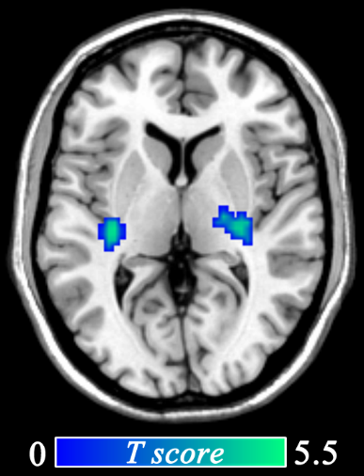

Figure S1: The effects of attentional bias modification training on functional connectivity strength changes seeded in the left inferior frontal gyrus (displayed at p _{corrected} < 0.05).

Supplementary Figures S2
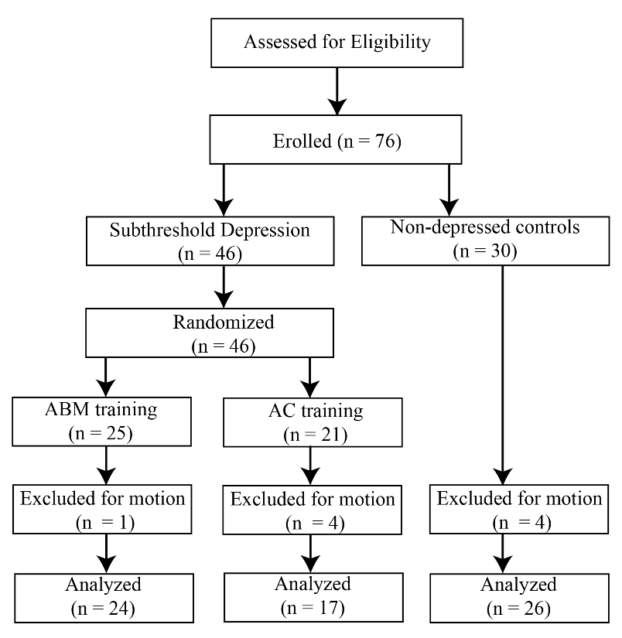

Figure S2: CONSORT diagram illustrating the flow of participants through the study

Reference
Beck AT, Steer RA, Brown G. (1996). Manual for the Beck Depression Inventory-II. San Antonio, TX: Psychological Corporation.
Biswal B, Zerrin Yetkin F, Haughton VM, Hyde JS (1995). Functional connectivity in the motor cortex of resting human brain using echo-planar mri. Magnet Reson Med 34: 537-541.
Browning M, Holmes E, Harmer C (2010). The modification of attentional bias to emotional information: A review of the techniques, mechanisms, and relevance to emotional disorders. Cogn Affect Behav Ne, 10: 8-20.
Chumbley J, Worsley K, Flandin G, Friston K (2010). Topological FDR for neuroimaging. Neuroimage 49: 3057-3064.
First MB, Spitzer RL, Gibbon M, Williams JB (2001). Structured Clinical Interview for DSM-IV-TR Axis I Disorders-Patient Edition (SCID-I/P. 2/2001 Revision):. New York: Biometrics Research Department, New York State Psychiatric Institute.
Friston KJ, Williams S, Howard R, Frackowiak RS, Turner R (1996). Movement-related effects in fMRI time-series. Magnet Reson Med 35: 346-355.
Hakamata Y, Lissek S, Bar-Haim Y, Britton JC, Fox NA, Leibenluft E, Ernst M, Pine DS (2010). Attention bias modification treatment: a meta-analysis toward the establishment of novel treatment for anxiety. Biol Psychiat 68: 982-990.
Li H, Li W, Wei DT, Chen QL, Jackson T, Qiu J, & Zhang QL (2014). Examining brain structures associated with perceived stress in a large sample of young adults via voxel-based morphometry. Neuroimage 92: 1-7.
MacLeod C, Rutherford E, Campbell L, Ebsworthy G, Holker L (2002). Selective attention and emotional vulnerability: assessing the causal basis of their association through the experimental manipulation of attentional bias. J Abnorm Psychol 111: 107-123.
Satterthwaite TD, Elliott MA, Gerraty RT, Ruparel K, Loughead J, Calkins ME, Eickhoff SB, Hakonarson H, Gur RC, Gur RE, Wolf DH (2013). An improved framework for confound regression and filtering for control of motion artifact in the preprocessing of resting-state functional connectivity data. Neuroimage 64: 240-256.
Spielberger CD, Gorsuch RL, Lushene R, Vagg PR, Jacobs GA. (1983). Manual for the state-trait anxiety inventory (STAI). Palo Alto,CA: Consulting Psychologists Press.
Sun C, Wu Z, Wu Z, Xu S (1994). Age differences in RAVEN test and the relation between the differences and memory training of “method of loci”. Acta Psychol Sin 26: 59-63.
Tottenham N, Tanaka JW, Leon AC, McCarry T, Nurse M, Hare TA, Marcus DJ, Westerlund A, Casey BJ, Nelson C (2009). The NimStim set of facial expressions: Judgments from untrained research participants. Psychiat Res 168; 242-249.
Tzourio-Mazoyer N1, Landeau B, Papathanassiou D, Crivello F, Etard O, Delcroix N, Mazoyer B, Joliot M (2002). Automated anatomical labeling of activations in SPM using a macroscopic anatomical parcellation of the MNI MRI single-subject brain. Neuroimage 15: 273-289.
Wells TT, Beevers CG (2010). Biased attention and dysphoria: Manipulating selective attention reduces subsequent depressive symptoms. Cognition Emotion 24: 719-728.
Yan CG, Cheung B, Kelly C, Colcombe S, Craddock RC, Di Martino A, Li Q, Zuo XN, Castellanos FX, Milham MP (2013). A comprehensive assessment of regional variation in the impact of head micromovements on functional connectomics. Neuroimage 76: 183-201.
Yan CG, Zang YF (2010). DPARSF: a MATLAB toolbox for" pipeline" data analysis of resting-state fMRI. Front Syst Neurosci 4: 13.
Zang YF, He Y, Zhu CZ, Cao QJ, Sui MQ, Liang M, Tian LX, Jiang TZ, Wang YF (2007). Altered baseline brain activity in children with ADHD revealed by resting-state functional MRI. Brain Dev 29: 83-91.
Zuo XN, Di Martino A, Kelly C, Shehzad ZE, Gee DG, Klein DF, Castellanos FX, Biswal BB, Milham MP (2010). The oscillating brain: Complex and reliable. Neuroimage 49: 1432-1445.

