Supplementary materials
Supplementary Table S1
Effect of task across groups
Reported are brain regions associated with significant BOLD signal increases for our contrasts of interest across groups.
Region | H | BA | MNI coordinates  (x, y, z) | k_{e} | Z | p-FWE
Negative emotional > scrambled
Occipital cortex | L | 19 | -45, -79, -8 | 1047 | Inf. | < 0.001ª
 | R | 19 | 48, -79, -5 |  | Inf. | < 0.001ª
Dorsomedial prefrontal cortex |  | 10 | 0, 62, 28 | 300 | 7.20 | < 0.001ª
Ventromedial prefrontal cortex |  | 11/12 | 0, 53, -20 | 46 | 6.91 | < 0.001ª
Orbitofrontal cortex | L | 11/12 | -39, 35, -14 | 9 | 5.76 | < 0.001
 | R | 11/12 | 42, 35, -14 | 5 | 6.29 | < 0.001
Ventrolateral prefrontal cortex | L | 47 | -42, 29, -14 | 39 | 7.64 | < 0.001
 | R | 45 | 54, 35, 4 | 59 | 5.83 | < 0.001
Amygdala | L |  | -24, -4, -23 | 51 | Inf. | < 0.001
 | R |  | 27, -1, -26 | 55 | Inf. | < 0.001
Dorsolateral prefrontal cortex | R | 9/46 | 48, 17, 25 | 92 | 7.27 | < 0.001
p-FWE = p value with family-wise error correction for the search volume.
BA, Brodmann area; FWE, family-wise error; H, hemisphere; K_{e,} cluster size; L, left; R, right; Z, Z score.
ª Significant at p < 0.05, whole-brain family-wise error corrected
Supplementary Table S2
Effect of task for each separate group
Reported are brain regions associated with significant BOLD signal increases for our contrasts of interest for each separate group.
Region | H | BA | MNI coordinates  (x, y, z) | k_{e} | Z | p-FWE
Healthy controls:
Negative emotional > scrambled
Occipital cortex | L | 19 | -45, -79, -8 | 5932 | Inf. | < 0.001ª
 | R | 19 | 45, -75, -8 |  | Inf. | < 0.001ª
Middle temporal cortex | R | 21 | 51, 2, -26 | 157 | 6.70 | < 0.001ª
Dorsomedial prefrontal cortex | R | 9 | 12, 59, 40 | 11 | 5.47 | 0.001ª
 |  | 10 | 0, 62, 28 | 18 | 5.06 | 0.005ª
Ventromedial prefrontal cortex |  | 11 | 0, 53, -20 | 7 | 4.92 | 0.010ª
Ventrolateral prefrontal cortex | L | 47 | -42, 29, -14 | 18 | 6.29 | < 0.001
 | R | 47 | 54, 35, 4 | 17 | 7.32 | < 0.001
Amygdala | L |  | -24, -4, -23 | 40 | 6.92 | < 0.001
 | R |  | 27, -1, -26 | 34 | 6.20 | < 0.001
OCD patients:
Negative emotional > scrambled
Occipital cortex | L | 19 | -45, -79, -8 | 5613 | Inf. | < 0.001ª
 | R | 19 | 48, -79, -5 |  | Inf. | < 0.001ª
Hippocampus | L |  | -24, -7, -20 | 350 | 5.93 | < 0.001ª
Dorsomedial prefrontal cortex |  | 10 | 0, 62, 25 | 123 | 5.77 | < 0.001ª
Ventromedial prefrontal cortex |  | 11 | 0, 44, -23 | 20 | 5.05 | 0.005ª
Superior parietal cortex | L | 5/7 | -24, -61, 55 | 13 | 4.89 | 0.011ª
 | R | 5/7 | 27, -55, 55 | 3 | 4.62 | 0.035ª
Inferior frontal cortex | L | 45 | -57, 26, 16 | 4 | 4.78 | 0.018ª
Dorsolateral prefrontal cortex | L | 9/46 | -54, 29, 19 | 2 | 4.54 | 0.003
 | R | 9/46 | 48, 20, 25 | 32 | 6.30 | < 0.001
Orbitofrontal cortex | L | 11/12 | -36, 35, -14 | 6 | 4.23 | 0.002
 | R | 11/12 | 42, 35, -14 | 2 | 5.07 | < 0.001
Ventrolateral prefrontal cortex | L | 47 | -42, -29, -14 | 5 | 5.15 | < 0.001
 | R | 47 | 54, 35, 4 | 19 | 6.42 | < 0.001
Amygdala | L |  | -30, -1, -26 | 33 | 6.28 | < 0.001
 | R |  | 30, 2, -26 | 38 | 6.23 | < 0.001
p-FWE = p value with family-wise error correction for the search volume.
BA, Brodmann area; FWE, family-wise error; H, hemisphere; K_{e,} cluster size; L, left; OCD, obsessive-compulsive disorder; R, right; Z, Z score.
ª Significant at p < 0.05, whole-brain family-wise error corrected

Supplementary Fig. S1
Diagram of the delayed working memory task. Subjects were instructed to encode the memoranda (3 faces) and maintain them into working memory while looking at distracters. Lastly, subjects were asked to respond whether the single face (as a probe) was one of the 3 faces in the memoranda or a new face. Three types of distracters (negative emotional, neutral, and scrambled) were presented during the working memory delay period. Each trial contained two distracters of the same type. The study design modified the previous design from Dolcos and McCarthy (Dolcos and McCarthy, 2006).
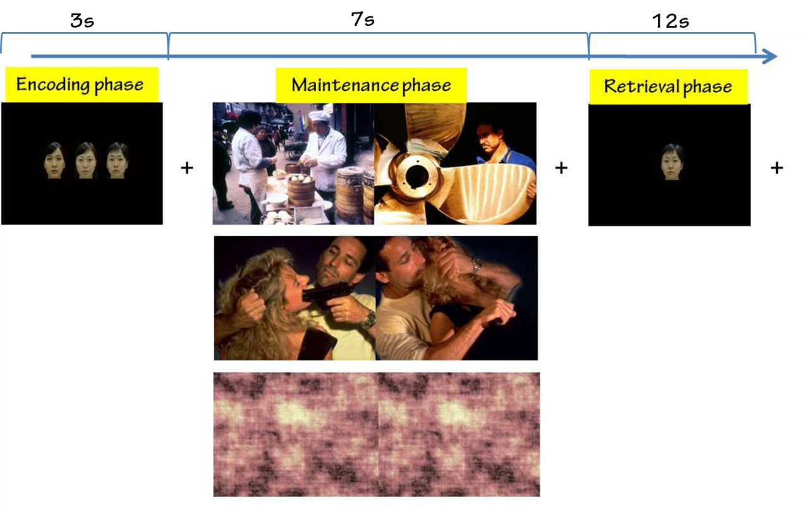

Supplementary Fig. S2
In the revised DCM model space, there were total 25 models according to the patterns of modulatory effects by negative emotional distraction on bidirectional connections among the right dorsolateral prefrontal cortex (DLPFC), amygdala, and orbitofrontal cortex (OFC). Each arrow indicates the intrinsic connectivity, and green dot indicates the modulatory effect.
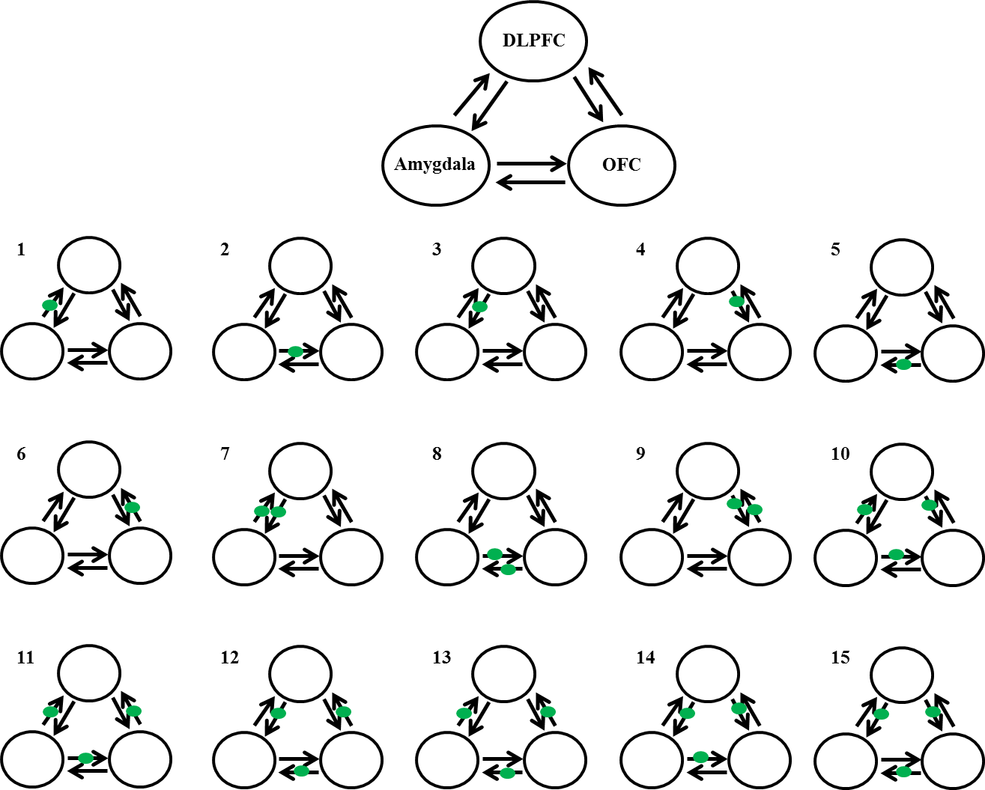
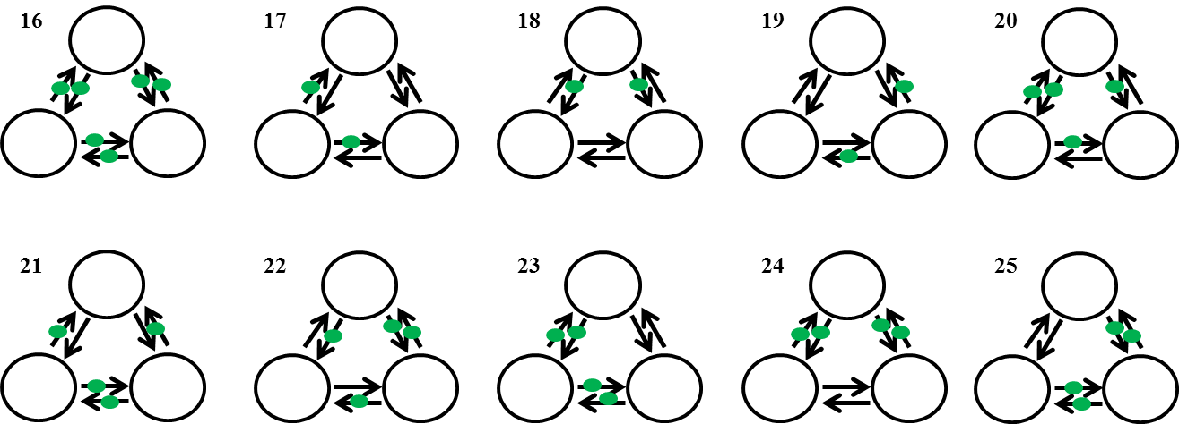

Supplementary Fig. S3
Bayesian model averaging yielded the intrinsic connectivity models in each group (first row). The connections significant in both healthy controls (HCs) and obsessive-compulsive disorder (OCD) patients were included further dynamic causal modeling (DCM) analysis (second row). Each arrow indicates intrinsic connectivity at p < 0.05, Bonferroni-corrected.

