Supplementary material
Text
S.1. fMRI Experiment
All the participants underwent an N-back working memory task in the scanner, which was conducted as previously described . Briefly, the task contained two conditions with a randomized sequence were arranged in a block design: the “0-back” condition, and the “2-back” condition. The experiment included a total of four 0-back and four 2-back blocks with 20 scans each, and these task blocks were separated by eight resting blocks with 10 scans each. Each letter was presented for 500 ms, followed by an inter-stimulus interval of 1500 ms. Each block preceded by an instruction shown for 2s presented 20 letters including 7 targets (35%) and 13 non-targets (65%). In the “0-back” condition, subjects were required to press the right button if the letter x appeared; and in the “2-back” condition, subjects were required to press the right button when the current letter matches the one presented two trials back (targets) and the left button whenever the letters do not match (non-targets). Subjects were instructed to fixate on the cross presented in the center of the screen for 20s during the resting periods. The experiment paradigm was thoroughly instructed to subjects before the scanning. The task performance (the reaction time and accuracy) of each subject was recorded electronically by the computer allied to the fMRI. In this paper, we focused on the 2-back-rest contrast only.

S.2. fMRI Data Acquisition and Preprocessing
Image acquisition, preprocessing, general linear modeling followed our published work . Scans were performed on a Philips Gyroscan Achieva 3.0 Tesla MRI scanner. Functional MRI images were collected in the axial location, using a gradient-echo echo-planar imaging (EPI) sequence: repetition time (TR) = 2000 ms, echo time (TE) = 30 ms, flip angle (FA) = 90°, matrix = 64×64, slice thickness = 4mm, gap = 4mm, slices = 36. Each functional task-state session lasted 8 minutes and 20 seconds, 250 volumes were obtained.
All functional images were processed on Statistical Parametric Mapping 8 (SPM8; http// www.fil.ion.ucl.ac.uk/spm) running on MATLAB 2009b (Mathworks lnc. Sherbon MA, USA). For each participant, the first two volumes of scanned data were discarded because of the magnetic saturation effects. The remaining images were corrected for slice acquisition times and realigned to the first volume for correcting head movement. An inclusion threshold of less than 1 mm of translation in x-, y-, or z-axis and 1° of rotation in each axis was used to reduce movement related artefacts. Thus, 6 patients and 4 healthy controls were excluded due to their severe head motions, and totally 29 patients and 26 healthy controls entered the further analysis. Head movements in any directions did not differ significantly (HC mean±SD of translation/rotation: 2.79±2.90/0.04±0.02, SCZ mean±SD of translation/rotation: 2.04±1.16/0.04±0.03, ns) between remaining patients and controls. The mean functional image from each participant was normalized with the EPI template to a standard anatomical space (MNI), with individual voxels resampled to 3×3×3 mm. All normalized images were then smoothed with an 8 mm Gaussian kernel.

S.3. fMRI Data Analysis
The first-level analysis (subject-specific analysis) was performed to identify regional activities for all brain voxels in each participant, and contrasts were created for each participant comparing 2-back task condition versus resting-state baseline condition. The subject-specific contrast images were then entered into a second-level analysis to make inferences at the group level. By using SPM-8, within-group effects were tested with independent sample t-tests with Family Wise Error (FWE) correction (p<0.05) on contrast images in each group separately, and between-group differences were tested with a two-sample t-test with False Discovery Rate (FDR) correction (p<0.05).
Additionally, to ensure comparable between-group signal-to-noise ratios (SNR), we computed the SNR in each subject and found no significant differences between the HC and SCZ groups (Mean±SD: 5.82±0.24[HC], 5.77±0.31[SCZ], ns). Following the suggestions reported in , the SNR were calculated by obtaining the mean signal and standard deviation for a given slice across the BOLD run, while excluding all non-brain voxels across all frames.

References:
Anticevic, A., Repovs, G. & Barch, D. M. (2013). Working memory encoding and maintenance deficits in schizophrenia: neural evidence for activation and deactivation abnormalities. Schizophr Bull 39, 168-78.
Pu, W., Li, L., Zhang, H., Ouyang, X., Liu, H., Zhao, J., Li, L., Xue, Z., Xu, K., Tang, H., Shan, B., Liu, Z. & Wang, F. (2012). Morphological and functional abnormalities of salience network in the early-stage of paranoid schizophrenia. Schizophr Res 141, 15-21.
Wu, G., Wang, Y., Mwansisya, T. E., Pu, W., Zhang, H., Liu, C., Yang, Q., Chen, E. Y., Xue, Z., Liu, Z. & Shan, B. (2014). Effective connectivity of the posterior cingulate and medial prefrontal cortices relates to working memory impairment in schizophrenic and bipolar patients. Schizophr Res 158, 85-90.

Figures

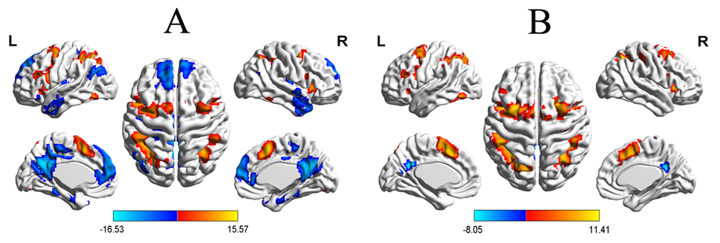
Fig. S1. BOLD activity during the 2-back WM task compared to resting-state baseline in controls (A) and schizophrenia patients (B) (FWE correction, p<0.05); Color bars indicate a scale of T values.

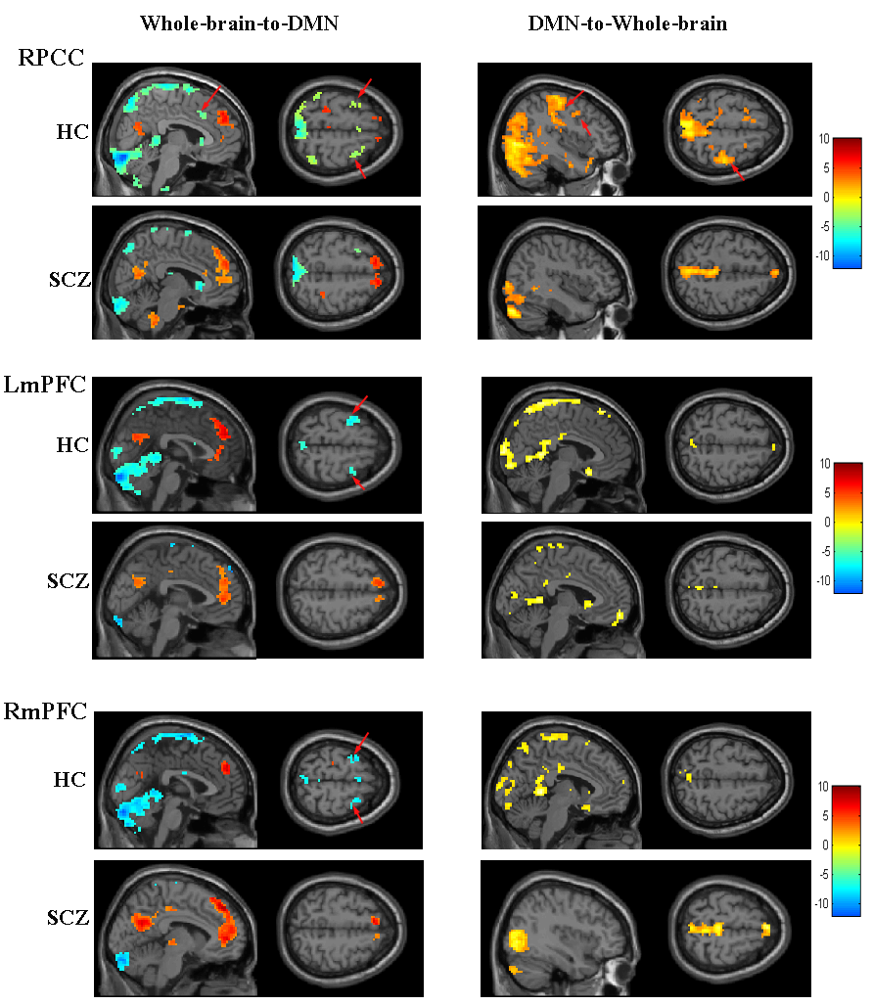
Fig. S2. Voxel-to-seed Granger-causal connectivity map from whole brain to DMN nodes and seed-to-voxel maps from DMN nodes to whole brain (One sample t-test, FWE correction, p<0.05). Consistent with the results observed in the LPCC Granger-causal connectivity map, while the EAS regions above exerted inhibitory influence on the three DMN seed regions in the HC group, only the RPCC in the DMN exerted excitatory influence on the EAS regions. In the SCZ group, the pattern of Granger-causal connectivity observed in HC was largely diminished. The arrows point to the EAS regions. Color bars indicate T values. L/RmPFC: left/right medial prefrontal cortex, PCC: posterior cingulated cortex.

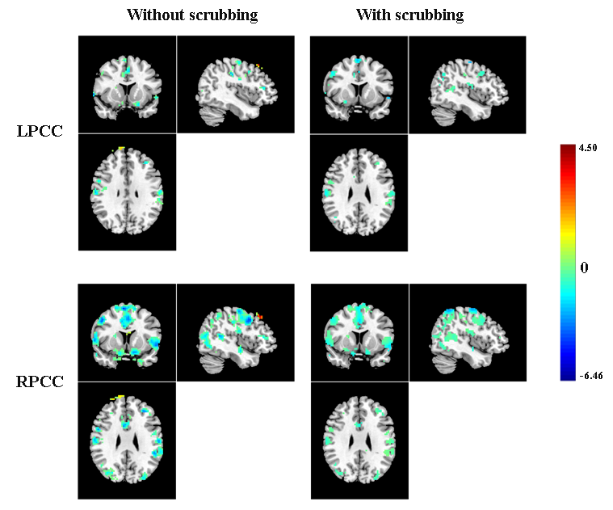
Fig. S3. Group differences of Granger causality connectivity from bilateral PCC to whole brain between schizophrenia patients and healthy controls with and without scrubbing (FDR correction, p<0.05). Except for the increased coupling from the PCC to right DLPFC, the results were very similar with and without motion scrubbing.

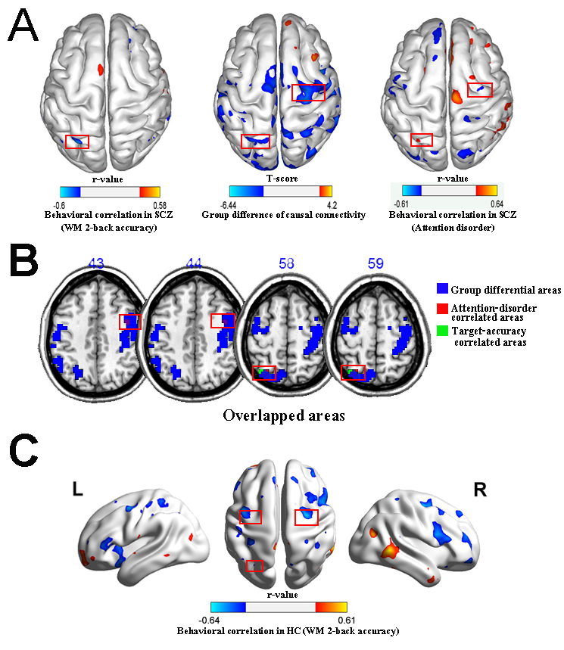
Fig. S4. Behavioral correlations of causal connectivity from right PCC (RPCC) to whole brain
Panel A: The middle figure shows the t-statistics of the between-group differences in the RPCC→whole brain causal connectivity (blue: SCZ<HC, red: SCZ>HC; Left: Correlation statistics of the relationship between 2-back accuracy and the RPCC→whole brain influence. Right: Correlation statistics of the relationship between Attention Disorder scores and the RPCC→whole brain influence. (red: positive correlation, blue: negative correlation). The reduced causal connectivity from the RPCC to right FEF was significantly related to more pronounced attentional impairment (r=0.475, p=0.006), and that from the RPCC to left IPS was related to better WM accuracy (r=-0.538, p=0.03) and milder attentional impairment (r=0.439, p=0.009) in the patients. All of the correlations survived after small volume correction (FDR correction, p<0.05).
Panel B: Overlapping areas of between-group difference (blue areas), attention-disorder (red areas) correlation and WM-accuracy correlation (green areas) of the RPCC→Whole brain effective connectivity. The red rectangles indicated the DAN regions including FEF and IPS.
Panel C: the behavioral correlation of the RPCC→whole brain causal connectivity with the WM accuracy in the HC group. Anterior DAN (FEF) and posterior DAN (IPS) regions highlighted within red boxes. Higher WM accuracy was associated with reduced influence from the RPCC to anterior DAN (left/right FEF: r=-0.576/-0.456, p=0.001/0.009) and posterior DAN (left IPS r=-0.492, p=0.005). FEF: frontal eye field, IPS: intra-parietal sulcus.

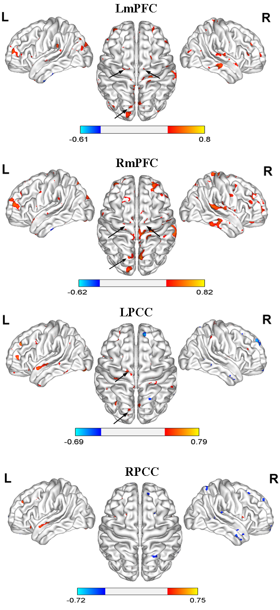
Fig. S5. Behavioral correlations of causal connectivity from Whole brain to the default network in healthy controls. The Granger-causal connectivity from the DAN regions (indicated by the black arrows), including the FEF and IPS, to the DMN regions such as the bilateral mPFC and left PCC, was positively correlated with working memory accuracy (p<0.05). All of the correlations survived after small volume correction (FDR correction, p<0.05). FEF: frontal eye field, IPS: intra-parietal sulcus.

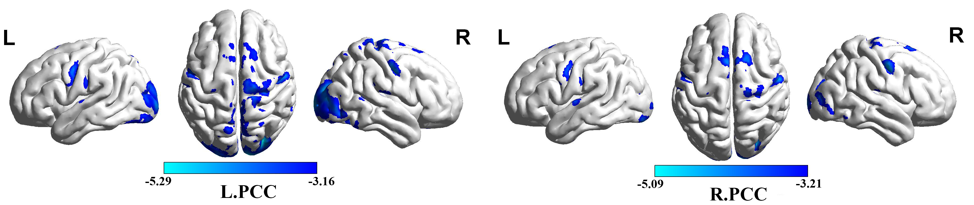Fig. S6. Differences of functional connectivity from left PCC and right PCC, respectively, to whole brain between HC and SCZ (FDR correction, p<0.05). Same to the GCA analysis, by using the DMN regions showing inefficient suppression during WM task as the seed regions (including bilateral mPFC and PCC/PCUN), FC was calculated from the seed regions to the whole brain. Compared to the HC group (FDR corrected, p<0.05), the result showed that the FC from the left PCC to the EAS regions including bilateral FEF and left IPS was significantly reduced in the SCZ group, and the FC from the right PCC to the bilateral FEF was also significantly reduced in patients. Moreover, the FC from the bilateral PCC to Supplementary Motor Area, sensory and visual cortices were found reduced in the patients. However, different to the GCA, the FC analysis did not find altered links between the DMN regions to the FPN (i.e., DLPFC) and SN (ACC), but showed reduced connection within DMN itself, such as the FC from the PCC to temproal cortex (also see the Supplementary Table S2).

Table S1. Heightened brain activation during 2-back working memory task in schizophrenia patients.

Regions | Peak Coordinates  (x y z) | T value | Cluster  size
Left posterior cingulate cortex/precuneusª | 0 -51 24 | 6.38 | 143
Right posterior cingulate cortex/precuneusª | 3 -63 24 | 5.95 | 61
Left medial prefrontal cortexª | -6 57 27 | 4.97 | 156
Right medial prefrontal cortexª | 3 51 6 | 4.79 | 58
Left middle frontal cortex (medial) | -21 27 33 | 6.45 | 118
Supplementary motor area | 3 -24 60 | 4.75 | 715
Left parahippocampus | -21 -6 -30 | 5.02 | 90
Left insula (posterior) | -36 -15 0 | 4.68 | 59
Left inferior parietal lobule | -63 -39 36 | 4.51 | 175
Right superior temporal gyrus | 48 -51 21 | 4.46 | 69
Note: ª The four regions within the default mode network were defined as the seed regions for further Granger causality analysis.

Table S2. Disrupted functional connectivity from bilateral PCC to the rest of the brain in schizophrenia patients.
L.PCC to |  |  |  | R.PCC to
Regions | Peak Coordinates  (x y z) | T value | Cluster  size | Regions | Peak Coordinates  (x y z) | T value | Cluster  size
Reduced functional connectivity
R.FEF | 54 -6 48 | -4.19 | 122 | R.FEF | 45 -6 45 | -4.57 | 209
L.FEF | -54 0 36 | -4.05 | 60 | L.FEF | -51 0 42 | -4.17 | 64
L.IPS | -24 -75 48 | -3.26 | 12 | Calcarine | 0 -96 3 | -5.09 | 806
R.MOG | 30 -84 21 | -5.29 | 2060 | R.SMA | -3 15 72 | -4.15 | 170
R.MTG | 48 -42 6 | -3.65 | 16 | L.Cerebelum | -12 -75 -45 | -3.55 | 60
L.Lingual | -21 -69 -12 | -3.75 | 31 | L.STG | -63 -12 6 | -3.73 | 25
R.SMG | 63 -21 27 | -3.87 | 53 | R.STG | -60 -21 15 | -3.80 | 26
R.SMA | 6 15 72 | -4.15 | 18 | R.ITG | 60 -57 15 | -5.09 | 11
R.Olfactory | 3 18 -18 | -3.82 | 143
Note: FEF: frontal eye field, IPS: intra-parietal sulcus, MOG: middle occipital gyrus, MTG: middle temporal gyrus, PreCG: precentral gyrus, SMG: supramarginal gyrus, SMA: supplementary motor area, STG: superior temporal gyrus, ITG: inferior temporal gyrus.

