Supplementary Method
DSI quality assurance
Head motion may occur during DSI acquisition due to a relatively long scanning time. In the presence of strong diffusion-sensitive gradients, jerky head motion typically induces signal loss in the DWI, especially in the images acquired at high b-values. For the diffusion-weighted images with severe signal loss, the signals could not be completely restored through post-processing methods and could contaminate the whole dataset in the subsequent data reconstructions. For this reason, each image of a DSI dataset, which contains 54 slices × 102 directions = 5508 images, were scrutinized by averaging the signals in the central square (20 × 20 pixels) of an image. If the average signal intensity after correcting for the b value was 2 standard deviations lower than the average signal intensity of all images, the image was considered to have signal loss. Previously, we found that the DSI dataset with more than 90 images of signal loss caused significant reduction of the GFA values. Therefore, DSI datasets were excluded if they showed more than 90 images of signal loss. Under this exclusion criterion, 8 ADHD patients and 8 controls were excluded, and a total of 45 ADHD patients and 45 controls remained in the final analysis.
Figure S1. The analysis workflow of template-based approach. ROIs, regions of interest; GFA, The generalized fractional anisotropy.
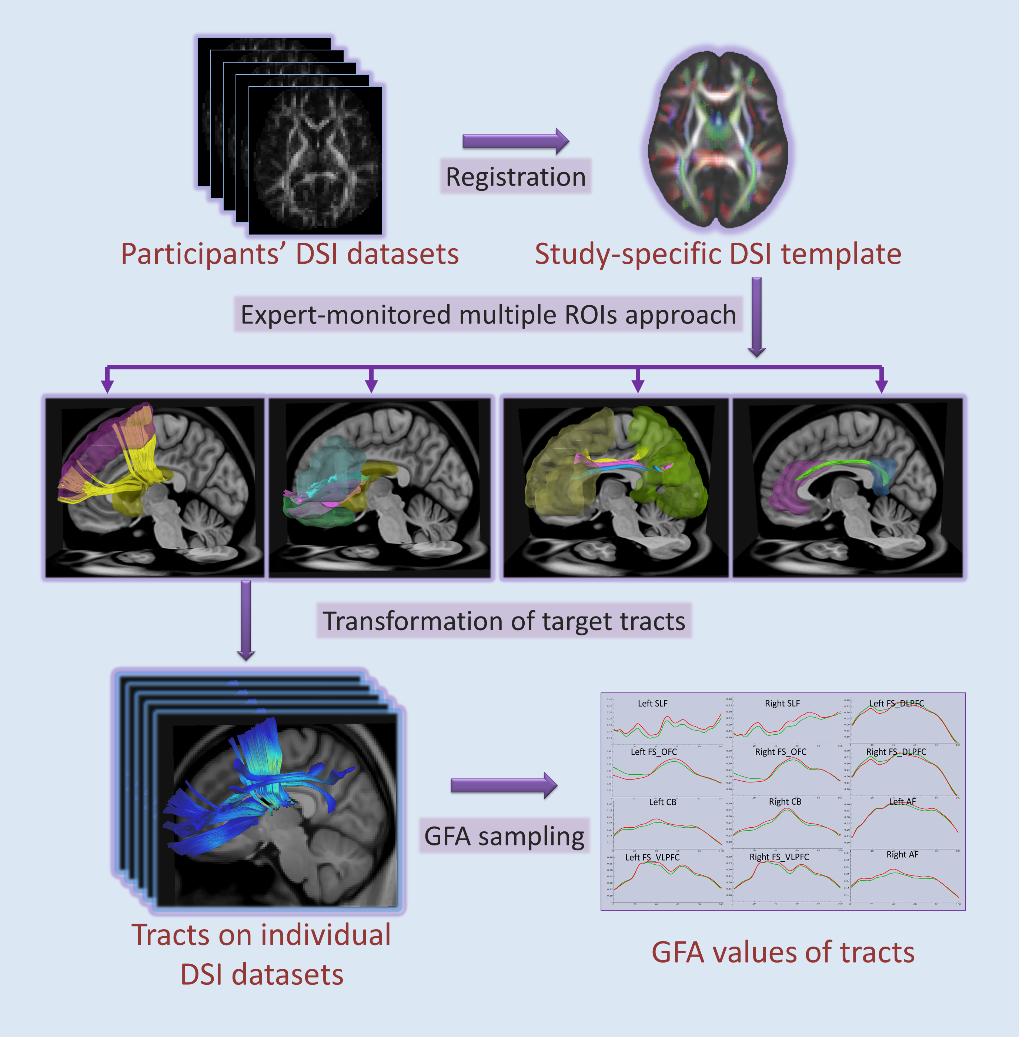
Table S1. Comparisons of fiber tract integrity between children with ADHD and typically developing children

Mean ± SD |  | ADHD (n=45) | TD (n=45) | t-values | p values | Cohen’s d
Striatum-Ventrolateral | Left | 0.235±0.016 | 0.242±0.014 | -2.83 | 0.007 | -0.466
 | Right | 0.235±0.019 | 0.239±0.017 | -1.14 | 0.261 | -0.222
Striatum-Dorsolateral | Left | 0.222±0.018 | 0.228±0.016 | -2.12 | 0.04 | -0.352
 | Right | 0.228±0.023 | 0.233±0.018 | -1.46 | 0.153 | -0.242
Striatum-Orbitofrontal | Left | 0.214±0.012 | 0.218±0.01 | -2.02 | 0.049 | -0.362
 | Right | 0.212±0.015 | 0.216±0.015 | -1.26 | 0.214 | -0.267
Superior longitudinal fasciculus | Left | 0.197±0.023 | 0.206±0.023 | -2.19 | 0.034 | -0.391
 | Right | 0.223±0.026 | 0.23±0.022 | -1.8 | 0.078 | -0.291
Arcuate fasciculus | Left | 0.267±0.021 | 0.277±0.019 | -2.61 | 0.012 | -0.499
 | Right | 0.265±0.027 | 0.272±0.024 | -1.48 | 0.146 | -0.274
Cingulum | Left | 0.301±0.028 | 0.307±0.024 | -1.15 | 0.257 | -0.230
 | Right | 0.278±0.03 | 0.287±0.02 | -2.08 | 0.043 | -0.353

SD, standard deviation; ADHD, attention-deficit/hyperactivity disorder; TD, typically developing children.
Table S2. Comparisons of executive functions between children with ADHD and typically developing children

Mean ± SD | ADHD(n=45) | TD(n=45) | t-values | p values | Cohen’s d
Intra-extra dimensional set shift
Total errors, adjusted | 34.02±31.5 | 22.07±17.64 | 2.37 | 0.022 | 0.468
Total trials, adjusted | 114.09±55.24 | 90.71±31.87 | 2.64 | 0.012 | 0.518
Rapid visual information processing
Probability of false alarm | 0.05±0.12 | 0.01±0.02 | 1.85 | 0.071 | 0.465
B”(response tendency) | 0.77±0.33 | 0.9±0.12 | -2.56 | 0.014 | -0.524
Mean latency, ms | 557.6±173.37 | 507.94±146.28 | 1.92 | 0.061 | 0.310
Spatial span
Span length | 6.44±1.78 | 7.04±1.41 | -1.94 | 0.058 | -0.374
Total usage errors | 1.8±1.97 | 1.51±1.41 | 0.9 | 0.375 | 0.169
Spatial working memory
Total errors | 26.44±19.39 | 21.35±14.57 | 1.75 | 0.087 | 0.297
Strategy utilization | 32.49±5.71 | 31.89±5.26 | 0.52 | 0.607 | 0.109
Stockings of Cambridge
Problems solved in minimum moves | 7.47±2.06 | 8.44±1.8 | -2.59 | 0.013 | -0.501
Total moves | 18.44±2.36 | 17.28±1.69 | 2.9 | 0.006 | 0.565
Mean initial thinking time, ms | 3100.13±1918.89 | 4789.22±2239.78 | -3.84 | <0.001 | -0.810
SD, standard deviation; ADHD, attention-deficit/hyperactivity disorder; TD, typically developing children.

Table S3. The interactions between group and mean GFA value of tracts with statistical significance
 |  | Tract | F-values | p values
Intra-extra dimensional set shift
Total errors, adjusted |  | R Striatum-VLPFC | 4.98 | 0.028
Total trials, adjusted |  | R Striatum-VLPFC | 5.51 | 0.021
Rapid visual information processing
Mean latency |  | L Striatum-VLPFC | 7.11 | 0.009
 |  | R Striatum-DLPFC | 4.25 | 0.042
 |  | L Striatum-OFC | 7.41 | 0.008
 |  | R SLF | 5.59 | 0.020
Spatial span
Span length |  | L Striatum-VLPFC | 4.06 | 0.047
 |  | R SLF | 8.51 | 0.005
Total usage errors |  | R SLF | 4.16 | 0.044
Spatial working memory
Total errors |  | R Striatum-OFC | 5.90 | 0.017
 |  | R SLF | 9.22 | 0.003
 |  | R Cingulum | 6.75 | 0.011
Strategy utilization |  | L SLF | 4.44 | 0.038
Stockings of Cambridge
Problems solved in minimum moves |  | L Striatum-VLPFC | 5.66 | 0.020
Problems solved in minimum moves |  | R Striatum-DLPFC | 4.68 | 0.033
 |  | L Striatum-OFC | 5.03 | 0.028
 |  | R Striatum-OFC | 12.01 | <0.001
Total moves |  | L Striatum-VLPFC | 8.32 | 0.005
 |  | R Striatum-DLPFC | 5.43 | 0.022
 |  | L Striatum-OFC | 5.70 | 0.019
 |  | R Striatum-OFC | 10.70 | 0.002
Mean initial thinking time |  | L SLF | 4.49 | 0.037
 |  | R Cingulum | 4.13 | 0.045

Note: L, left ; R, right; DLPFC, dorsolateral prefrontal cortex; OFC, orbitofrontal cortex; SLF, superior longitudinal fasciculus; VLPFC, ventolateral prefrontal cortex.

