Online Supplementary material

Continuity of Cannabis use and Violent Offending Over the Life Course

Includes

Supplementary Appendix S1. Study sample
Supplementary Appendix S2. Measures
Supplementary Appendix S3. Analysis
Supplementary Appendix S4. Supplementary Results, including
- Supplementary Fig. S1. Flow chart: Follow up assessments
- Supplementary Fig. S2. Structural equation: Reciprocal causation model
- Supplementary Table S1. Differences in demographics and violence data between completers and drop outs
- Supplementary Table S2. Temporal relationship between cannabis use and violence
- Supplementary Table S3. Multivariate logistic regression
- Supplementary Table S4. Multivariate logistic regression
- Supplementary Table S5. Fixed effects cross-lagged logistic regression
- Supplementary Table S6. Cross-lagged structural equation models
Supplementary Appendix S5. References

Supplementary Appendix S1. Study sample
The Cambridge Study of Delinquent Development (CSDD), originally designed by Donald J. West and directed since 1982 by David P. Farrington, is a prospective longitudinal study of the development of offending and antisocial behavior in a cohort of 411 boys born mostly in 1953 living in homogenous, working class urban area of South London [a review of major findings may be found in several books as well as in several in summary papers ]. The men represented the complete population of boys who were 8 years of age at that time (1961/62) and were attending one of six primary schools in a deprived area in South London. There were multiple waves (T1- T8) of data collection which included participants being interviewed in their school [at ages 8 (T1), 10 (T2), and 14 (T3)], in research offices (at ages of 16 (T4), 18 (T5), and 21 (T6)] or in their homes (at ages 32 (T7) and 48 (T8)] by social science graduates. Parents were interviewed (about once per year) and questionnaires were completed by the boys’ teachers (about once every two years) between ages 8 and 15 to complement information about troublesome/aggressive behavior in school and difficulties at home. 97% of the sample was white and all were raised in two-parent working class household .

Supplementary Appendix S2. Measures
Violent conviction: Criminal records
Conviction information was obtained for every follow-up year from age 10 to age 56 through searches at the central Criminal Record Office in London, a central repository containing records of all relatively serious offenses committed in Great Britain or Ireland, as well as minor juvenile offenses committed in the London area. ‘Violent conviction’ (VC) was defined as conviction for robbery, assault, threatening behavior, or possessing an offensive weapon. In the case of 18 males who had emigrated outside Great Britain and Ireland by age 32, applications were made to search their criminal records in the 8 countries where they had settled, and searches were carried out in five countries. We estimated 2 separate dependent variables :
- DV1_{VC} [cumulative number of (subsequent) VCs]: The variable was computed by calculating the cumulative mean number per year from age 10 to 56. For cannabis users, only convictions that were committed subsequent to cannabis use were counted, excluding those that happened prior to use.
- DV2_{VC} [risk of (subsequent) VC): This dichotomized dependent variable was coded as “yes” if at least one conviction was committed between age 10 and 56. For cannabis users, only convictions that were committed subsequent to cannabis use were counted.

Self-reported violence
Self-reported violence (SR-V) was measured based on report of the person’s involvement in assaults, fights, and use of a weapon in physical fights and also included two DVs as for violent convictions.
- DV1_{SR-V} [cumulative number of (subsequent) SR-V]: Data on violence (yes/no) was collected at three different time points, including T5: age 18 (violence between 15 and 18); T7: age 32 (involvement in fights between 27 and 32); and T8: age 48 (involvement in fights between 43 and 48).
- DV2_{SR-V} [risk of (subsequent) SR-V]: This dichotomized dependent variable was coded as “yes” if a subject admitted to violence at either T5, T7 or T8. Cannabis use was considered to have preceded SR-V if its use was reported either at the same or a time-point prior to the time-point under consideration for assessment of SR-V.

Cannabis use (Independent variable, IV)
At each face-to-face data collection, i.e. at ages 14 (T3), 16 (T4), 18 (T5), 32 (T7), and 48 (T8) years, the respondents were asked about their use of cannabis during the preceding 5 years.
- IV 1 (Ever cannabis use): Three dichotomized cannabis variables were computed, including (1) cannabis at T5 or before (yes/no if cannabis has been used at age 18 or before); (2) cannabis at T7 (yes/no if cannabis has been used at least once between the age 27 and 32); and (3) cannabis at T8 (yes/no if cannabis has been used at least once between the age 43 and 48). IV 1 was coded as “yes” if a subject was classified as a cannabis user in at least one of the three variables. No separate cannabis use variables were computed for T3 and T4 as very few individuals (n=2 and n=25 respectively) reported use at these assessment points, which were therefore all considered together while estimating use at the T5 assessment (cannabis at 18 or before).
- IV 2 (Continuity of cannabis use): An ordinal independent variable was computed based on three cannabis variables, classifying subjects either as (1) never cannabis user, (2) cannabis user at 1 time point only (e.g., at T5 only but not T7 or T8), (3) cannabis user at 2 time points (e.g., cannabis use at T5 and T7 but not T8), or (3) cannabis user at all 3 time points.

Covariates
- Antisocial traits were assessed at age 10 based on teachers, peers, or parents ratings using the antisocial personality scale (AP) as described in detail by and included: troublesomeness, conduct problems, difficult to discipline, dishonest, has stolen, gets angry, daring, lacks concentration/restlessness, impulsive, and truants.
- Alcohol use defined as presence of binge drinking (>13 units per evening in the last month yes/no) was assessed at T5, T7, and T8 and a continuous variable was computed with a score ranging from 0 = never binge drinker at T5, T7 or T8; 1= binge drinker 1 time-point only; 2= binge drinker at 2 time-points; and 3= binge drinker at all 3 time-points.
- Other drug use (yes/no) was assessed at T7 and was coded as yes if the subjects had tried drugs other than cannabis.

Childhood risk factors
Childhood risk factors that may independently contribute to both violence and drug use were included in this analysis :
- Social class (socioeconomic status): This variable was dichotomized, with 2 indicating that the family breadwinner (usually the father) had an unskilled manual job. All of the rest were coded as 1.
- Family history of criminal/delinquent behaviour was measured up to the boy’s tenth birthday and referred only to biological relatives, with 2 indicating the presence of delinquent sibling and/or criminal parent. All those without a delinquent sibling and/or parent were coded as 1.

Supplementary Appendix S3. Analysis
Data was analysed using R comprising four main statistical approaches:
- We used the Kruskal-Wallis Test followed by Bonferroni correction for multiple testing to make comparisons among the different cannabis trajectory groups (never use vs. use at 1 point vs. use at 2 points vs. use at 3 points) on the average number of total convictions committed by age 56/ average number of self-reported violence by age 48. This non-parametric test was chosen as the Shapiro-Wilk Normality Test statistic was highly significant for number of convictions (p<0.001) and SR-V (p<0.001).
- Secondly, univariate logistic regression analysis was employed to estimate the uncontrolled effect of cannabis use and other potential risk factors on violence outcome to identify those variables that are significantly associated with risk of VC/SR-V. The variables were chosen based on previous research (Farrington et al. 2006, Resnick et al. 2004). Subsequently, odds ratios (ORs) were computed using multiple logistic regression analysis to examine the relationship between cannabis use and violence outcome, while accounting for the covariates retained from the initial bivariate models (all factors with p<0.10 were included). The violence (yes/no) dichotomization based on conviction data and the self-reported violence served as the dependent variable.
- In the third stage, fixed-effects logistic regression models were fitted using the R package lme4 for binary outcome data in order to extend the ordinary logistic regression by adjusting for time-invariant non-observed fixed factors that vary across individuals, such as family background, genetic profile, personality or pre-existing violent traits. This approach allows the estimation of effect of within-person changes over time t for cannabis use [t=C₁(age 18), C₂(age 32), C₃(age 48)] on SR-V[t=V₁(age 18), V₂(age 32), V₃(age 48)] and VC[t=V₁(age 10-18), V₂(age 19-32), V₃(age 32-56)]. In order to minimize any effects that may be at play in the reverse direction (reverse causation, i.e. violence predisposing to cannabis use) we (i) implemented fixed-effects models that used lagged outcome, i.e. examined whether changes in cannabis use (C₁-C₂) were associated with subsequent changes in violence (V₂-V₃) and (ii) tested a competing reverse causation model in which we estimated the effects of changes in violence (V₁-V₂) on changes in cannabis use (C₂-C₃). Alcohol use and cigarette use were included as time-dynamic covariates in the models.
- Cross-lagged structural equation models were estimated using the lavaan package (Rosseel 2012). The cannabis (C₂-C₃) and violence variables (V₂-V₃) were treated as dependent variables, allowing to test for reciprocal changes in the association at different stages of the life span. We tested both an unconstrained model and a model in which the parameters (C_{t} and V_{t}) were constrained to be equal across time points. The models were fitted using the robust weighted least squares (WSL) approach. Model goodness of fit was assessed on the basis of a number of fit indices, including the model chi-squared goodness of fit statistic (non-significant or small chi-square value indicates that the model fits the data well), the root mean squared error of approximation (RMSEA, for which values of .05 indicate good fit and values up to .08 represent reasonable errors of approximation) and the Comparative Fit Index (for which values of .95 are acceptable and of .95 or higher are indicative of good fit . Cross-sectional correlations between violence and cannabis use at were included for t₂ and t_{3.} All models were fitted while controlling for time dynamic factors including alcohol and cigarette use and time invariant factors including antisocial personality.

Supplementary Appendix S4. Supplementary Results
Out of the 411 boys assessed at baseline, complete multi-wave cannabis and violence data (T1-T8) at follow up 48 years later was available for a total number of N=340 for SR-V and N=339 for VC. Comparing subjects that dropped out throughout follow up (n=71) to completers (n=340) in demographic variables and violence data revealed that there were no significant differences between the two groups, expect for self-reported violence at age 18, which was less likely to be reported (p=.04) in those who subsequently dropped out (see Supplementary Table S1).

Supplementary Fig. S1. Flow chart: Follow up assessments
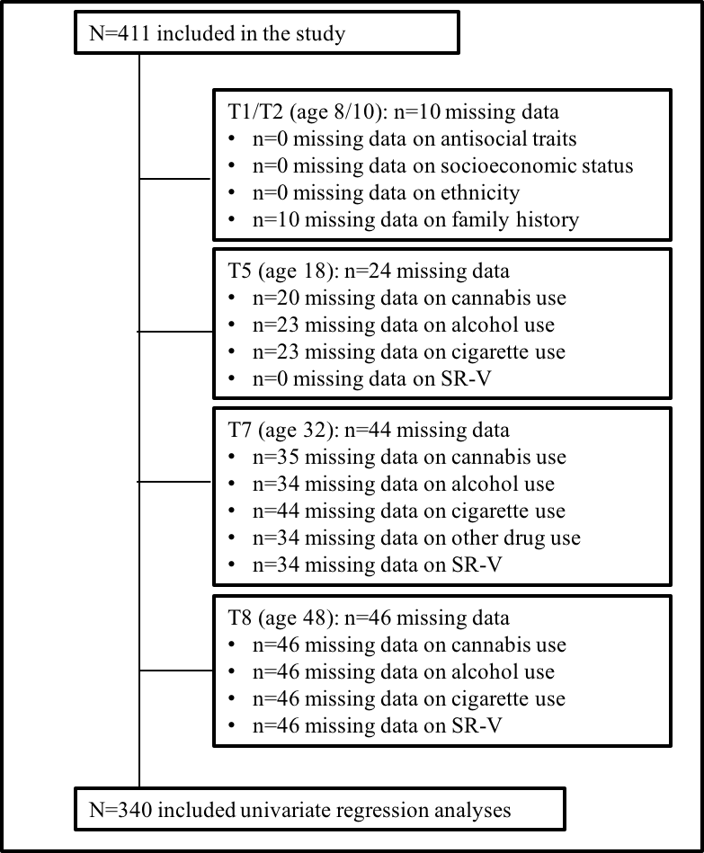
Supplementary Table S1. Differences in demographics and violence data between completers and drop outs
 | Completed n/N (%) | Drop out n/N (%) | p
Antisocial Personality (yes) | 77/340 (23%) | 21/71 (30%) | 0.27
Family history crime (yes) | 110/338 (33%) | 25/63 (40%) | 0.34
Low social class (yes) | 67/340 (20%) | 12/71 (17%) | 0.70
Alcohol at 18 (yes) | 69/339 (20%) | 12/49 (25%) | 0.63
Cigarette use at 18 (yes) | 94/339 (28%) | 10/49 (20%) | 0.36
Other illicit drug use (yes) | 32/340 (9%) | 4/37 (11%) | 1.00
Cannabis at 18 (yes) | 97/340 (29%) | 14/49 (29%) | 1.00
VC between age 10 and 56 (yes) | 57/339 (17%) | 13/71 (18%) | 0.90
SR-V at 18 (yes) | 72/340 (21%) | 7/71 (10%) | 0.04
Note. p= p-value for chi-square test; SR-V = Self-reported violence; VC = Violent conviction

Supplementary Table S2. Temporal relationship between cannabis use and violence: Sample distributions in % (n)
 | VC data ª | SR-V data
Never cannabis -> never violence | 55.5% (188) | 36.8% (125)
Cannabis -> never violence | 27.1% (92) | 14.4% (49)
Cannabis -> violence | 6.5% (22) | 22.4% (75)
Violence -> never cannabis | 6.5% (22) | 25.% (85)
Violence -> cannabis -> violence | 2.1% (7) | 1.2% (4)
Violence -> Cannabis | 1.2% (4) | 0.3% (1)
Note. Arrow (->) indicating “followed by”. SV-R = Self-reported violence; VC = Violent conviction.
ª n= 4 could not be classified since it was not possible to establish whether the conviction was a preceding event or subsequent to cannabis use.

Supplementary Table S3. Multivariate logistic regression for cannabis use (ever used) in predicting risk of violent conviction (VC) / risk of self-reported violence (SR-V)
Multivariate Logistic Regression | Risk of VC (N=327) ^{d} |  |  | Risk of SR-V (N=332)
 | OR | CI | p | OR | CI | p
Cannabis use (ever) ª | 1.73 | 0.81 – 3.68 | .155 | 1.56 | 0.92 – 2.65 | .097
Antisocial Personality (yes) ª | 3.37 | 1.60 - 7.17 | .001 | 2.14 | 1.20 - 3.88 | .011
Family history crime (yes) ^{a 2} | 2.50 | 1.23 - 5.10 | .011 | 1.42 | 0.85 - 2.37 | .180
Alcohol use ^{c 1} | 1.33 | 0.91 - 1.93 | .138 | 1.62 | 1.20 - 2.21 | .002
Cigarette use ^{c 3} | 1.41 | 1.02 - 1.95 | .038 | 1.41 | 1.11 - 1.80 | .005
Other illicit drug use (yes) ª | 3.60 | 1.32 - 9.76 | .012 | 1.75 | 0.73 - 4.49 | .222
Low social class (yes) ª | 2.03 | 0.91 - 4.40 | .078 | 1.35 | 0.73 - 2.50 | .339
Note. a = Dichotomized variable; b = Ordinal variable (reference group is never cannabis use); c = Continuous variable; d = some subjects (n=4) were excluded since it was not possible to establish whether the conviction was a preceding event or subsequent to cannabis use; SR-V = Self-reported violence; VC = Violent conviction.

Given the focus of the study, outcome in the uni- and multivariate analysis was defined as violence (yes/no) following cannabis use. As a result, for some subjects (n=4 for conviction data, n=1 for SR-V data) the outcome was coded as absence of violence since the violent act only preceded cannabis use (see Supplementary Table S2 above). The same multivariate analysis was carried out after recoding the outcome for those subjects (from absence of violence to presence of violence), which did not change the main results (see Supplementary Table S4 below).

Supplementary Table S4. Multivariate logistic regression predicting risk of violent conviction (VC) / risk of self-reported violence (SR-V)
Multivariate Logistic Regression | Risk of VC (N=327) ^{d} |  |  | Risk of SR-V (N=332)
 | OR | CI | p | OR | CI | p
Cannabis use 1 point ^{b} | 1.27 | 0.48 - 3.15 | .622 | 1.15 | 0.62 - 2.10 | .661
Cannabis use 2 points | 2.43 | 0.81 - 7.04 | .105 | 2.24 | 0.92 - 5.73 | .082
Cannabis use 3 points | 5.85 | 1.81 - 19.26 | .003 | 8.92 | 2.36 - 46.17 | .003
Antisocial Personality (yes) ª | 3.84 | 1.81 - 8.32 | .001 | 2.11 | 1.17 - 3.85 | .013
Family history crime (yes) ^{a 2} | 2.31 | 1.13 - 4.74 | .022 | 1.35 | 0.80 - 2.28 | .255
Alcohol use ^{c 1} | 1.28 | 0.87 - 1.86 | .208 | 1.66 | 1.22 - 2.29 | .002
Cigarette use ^{c 3} | 1.53 | 1.11 - 2.13 | .010 | 1.42 | 1.12 - 1.82 | .005
Other illicit drug use (yes) ª | 2.81 | 0.94 - 8.32 | .062 | 0.78 | 0.26 - 2.32 | .649
Low social class (yes) ª | 1.81 | 0.79 - 4.01 | .148 | 1.32 | 0.71 - 2.47 | .380
Note. a = Dichotomized variable; b = Ordinal variable (reference group is never cannabis use); c = Continuous variable; d = some subjects (n=4) were excluded since it was not possible to establish whether the conviction was a preceding event or subsequent to cannabis use; SR-V = Self-reported violence; VC = Violent conviction.

Supplementary Table S5. Fixed effects cross-lagged logistic regression
 | Univariate |  | Multivariate |  | Univariate |  | Multivariate
 | OR | 95% CI | OR | 95% CI | OR | 95% CI | OR | 95% CI
 | Regular causation: Cannabis on SR-V (V₂-V₃) |  |  |  | Regular causation: Cannabis on VC (V₂-V₃)
Cannabis (t₁-t₂) | 1.21 | (1.12 - 1.31) | 1.18 | (1.09 - 1.28) | 1.10 | (1.04 - 1.15) | 1.08 | (1.02 - 1.14)
Alcohol (t₁-t₂) | 1.13 | (1.04 - 1.23) | 1.10 | (1.02 - 1.20) | 1.09 | (1.03 - 1.15) | 1.08 | (1.02 - 1.14)
Cigarette (t₁-t₂) | 1.10 | (1.03 - 1.19) | 1.05 | (0.98 - 1.14) | 1.05 | (1.00 - 1.10) | 1.02 | (0.97 - 1.08)
 | Reverse causation SR-V on Cannabis (t₂-t₃) |  |  |  | Reverse causation VC and Cannabis (t₂-t₃)
Violence (t₁-t₂) | 1.06 | (1.01 - 1.12) | 1.06 | (1.00 - 1.12) | 1.02 | (0.93 - 1.12) | 1.01 | (0.92 - 1.12)
Alcohol (t₁-t₂) | 1.03 | (0.96 - 1.10) | 1.02 | (0.95 - 1.08) | 1.03 | (0.96 - 1.10) | 1.02 | (0.96 - 1.09)
Cigarette (t₁-t₂) | 1.05 | (0.99 - 1.11) | 1.04 | (0.98 - 1.10) | 1.05 | (0.99 - 1.11) | 1.04 | (0.98 - 1.11)
Note. N= 672 number of observations; SR-V = Self-reported violence; VC = Violent conviction
ª Presence of violence (yes/no) per time point t for SR-V[t=V₁(age 18), V₂(age 32), V₃(age 48)] and VC[t=V₁(age 10-18), V₂(age 19-32), V₃(age 32-56)].
^{b} t = Presence of cannabis/alcohol/cigarette use (yes/no) at time point t [t=t₁(age 18), t₂(age 32), t₃(age 48)]

Supplementary Fig. S2. Structural equation: Reciprocal causation model
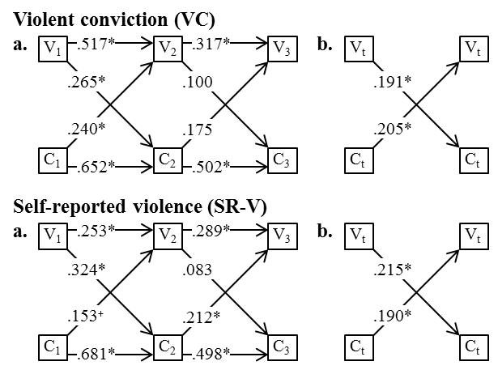
Note. a. = unconstrained model; b. = C_{t} and V_{t} were constrained to be equal across time points; C_{t} = Cannabis use at time point t [t=C₁(age 18), C₂(age 32), C₃(age 48)]; V_{t} = Violence at time point t for SR-V[t=V₁(age 18), V₂(age 32), V₃(age 48)] and VC[t=V₁(age 10-18), V₂(age 19-32), V₃(age 32-56)].
* p<0.05
⁺ p<0.10
Supplementary Table S6. Cross-lagged structural equation models ª
 |  | Model parameter |  |  |  |  |  |  | Goodness-of-Fit Indices
 |  | Est. |  | p |  | SE |  | 95% CI | x² | df | p | RMSEA | CFI
Violent conviction (VC) (n=312)
Reciprocal model (unconstrained) |  |  |  |  |  |  |  |  | 44.273 | 29 | 0.035 | 0.041 | 0.964
C₁ → V₂ | 0.240 |  | 0.049 |  | 0.122 |  | 0.001-0.479
C₂ → V₃ | 0.175 |  | 0.252 |  | 0.153 |  | -0.124-0.474
V₁ → C₂ | 0.265 |  | 0.014 |  | 0.107 |  | 0.055-0.476
V₂ → C₃ | 0.100 |  | 0.403 |  | 0.119 |  | -0.134-0.334
C₁ → C₂ | 0.652 |  | 0.000 |  | 0.073 |  | 0.509-0.794
C₂ → C₃ | 0.502 |  | 0.000 |  | 0.095 |  | 0.315-0.689
V₁ → V₂ | 0.517 |  | 0.000 |  | 0.119 |  | 0.284-0.750
V₂ → V₃ | 0.317 |  | 0.027 |  | 0.143 |  | 0.036-0.597
V₂ C₂ | 0.157 |  | 0.226 |  | 0.130 |  | -0.097-0.411
V₃ C₃ | 0.065 |  | 0.579 |  | 0.118 |  | -0.165-0.296
Reciprocal model (constrained) ^{b} |  |  |  |  |  |  |  |  | 45.475 | 31 | 0.045 | 0.039 | 0.966
C_{t} → V_{t} | 0.205 |  | 0.025 |  | 0.092 |  | 0.026-0.385
V_{t} → C_{t} | 0.191 |  | 0.023 |  | 0.084 |  | 0.026-0.356
Self-reported violence (SR-V) (n=333)
Reciprocal model (unconstrained) |  |  |  |  |  |  |  |  | 49.006 | 29 | 0.012 | 0.046 | 0.959
C₁ → V₂ | 0.153 |  | 0.090 |  | 0.090 |  | -0.024-0.329
C₂ → V₃ | 0.212 |  | 0.040 |  | 0.103 |  | 0.010-0.414
V₁ → C₂ | 0.324 |  | 0.002 |  | 0.105 |  | 0.118-0.530
V₂ → C₃ | 0.083 |  | 0.372 |  | 0.093 |  | -0.100-0.266
C₁ → C₂ | 0.681 |  | 0.000 |  | 0.066 |  | 0.553-0.809
C₂ → C₃ | 0.498 |  | 0.000 |  | 0.075 |  | 0.350-0.646
V₁ → V₂ | 0.253 |  | 0.005 |  | 0.090 |  | 0.078-0.429
V₂ → V₃ | 0.289 |  | 0.007 |  | 0.107 |  | 0.079-0.499
V₂ C₂ | 0.092 |  | 0.405 |  | 0.110 |  | -0.124-0.308
V₃ C₃ | 0.023 |  | 0.828 |  | 0.105 |  | -0.183-0.229
Reciprocal model (constrained) ^{b} |  |  |  |  |  |  |  |  | 52.245 | 31 | 0.010 | 0.045 | 0.956
C_{t} → V_{t} | 0.190 |  | 0.003 |  | 0.064 |  | 0.065-0.314
V_{t} → C_{t} | 0.215 |  | 0.005 |  | 0.077 |  | 0.065-0.366
Note. C_{t} = Presence of cannabis use (yes/no) at time point t [t=C₁(age 18), C₂(age 32), C₃(age 48)]; CFI = Comparative Fit Index; RMSEA = root mean squared error of approximation; Presence of violence (yes/no) at time point t for SR-V[t=V₁(age 18), V₂(age 32), V₃(age 48)] and VC[t=V₁(age 10-18), V₂(age 19-32), V₃(age 32-56)].
ª All models were fitted using the robust weighted least squares (WSL) approach using lavaan .
^{b} Model parameters (C_{t} and V_{t}) were constrained to be equal across time points. Chi-square difference tests revealed that these constraints did not significantly (p > 0.05) worsen the fit of the models.

Supplementary Appendix S5. References

Farrington, D, Coid, JW, Jolliffe, D, Soteriou, N, Turner, RE and West, DJ (2006) Criminal careers up to age 50 and life success up to age 48: New findings from the Cambridge Study in Delinquent Development, Home Office Research, Development and Statistics Directorate.

Farrington, D, Piquero, AR and Jennings, WG (2013) Offending from childhood to late middle age: Recent results from the Cambridge study in delinquent development, Springer Science & Business Media.

Farrington, DP (1991). 'Antisocial personality from childhood to adulthood', The Psychologist, 389-394.

Farrington, DP (1995). 'The development of offending and antisocial behaviour from childhood: Key findings from the Cambridge Study in Delinquent Development', Journal of Child Psychology and Psychiatry 6, 929-964.

Farrington, DP and West, DJ (1990) The Cambridge study in delinquent development: A long-term follow-up of 411 London males, Springer.

Hu, Lt and Bentler, PM (1999). 'Cutoff criteria for fit indexes in covariance structure analysis: Conventional criteria versus new alternatives', Structural equation modeling: a multidisciplinary journal 1, 1-55.

MacCallum, RC, Browne, MW and Sugawara, HM (1996). 'Power analysis and determination of sample size for covariance structure modeling', Psychological methods 2, 130.

Piquero, AR, Farrington, DP and Blumstein, A (2007) Key issues in criminal career research: New analyses of the Cambridge study in delinquent development, Cambridge University Press.

R Core Team (2015) 'R: A Language and Environment for Statistical Computing', [online], available: https://cran.r-project.org/doc/manuals/fullrefman.pdf [accessed

Rosseel, Y (2012). 'lavaan: An R package for structural equation modeling', Journal of Statistical Software 2, 1-36.

Seillier, A, Advani, T, Cassano, T, Hensler, JG and Giuffrida, A (2010). 'Inhibition of fatty-acid amide hydrolase and CB1 receptor antagonism differentially affect behavioural responses in normal and PCP-treated rats', The International Journal of Neuropsychopharmacology 03, 373-386.

West, DJ (1969) Present Conduct and Future Delinquency, London: Heinemann.

West, DJ (1982) Delinquency, its roots, careers, and prospects, Harvard University Press.

West, DJ and Farrington, DP (1973) Who becomes delinquent? Second report of the Cambridge Study in Delinquent Development, London: Heinemann.

West, DJ and Farrington, DP (1977) The delinquent way of life, London: Heinemann.

For the present analyses, each variable was dichotomized, as far as possible, into the “worst” quarter of males versus the remainder,with those most at risk coded as 2 and the remainder as 1

