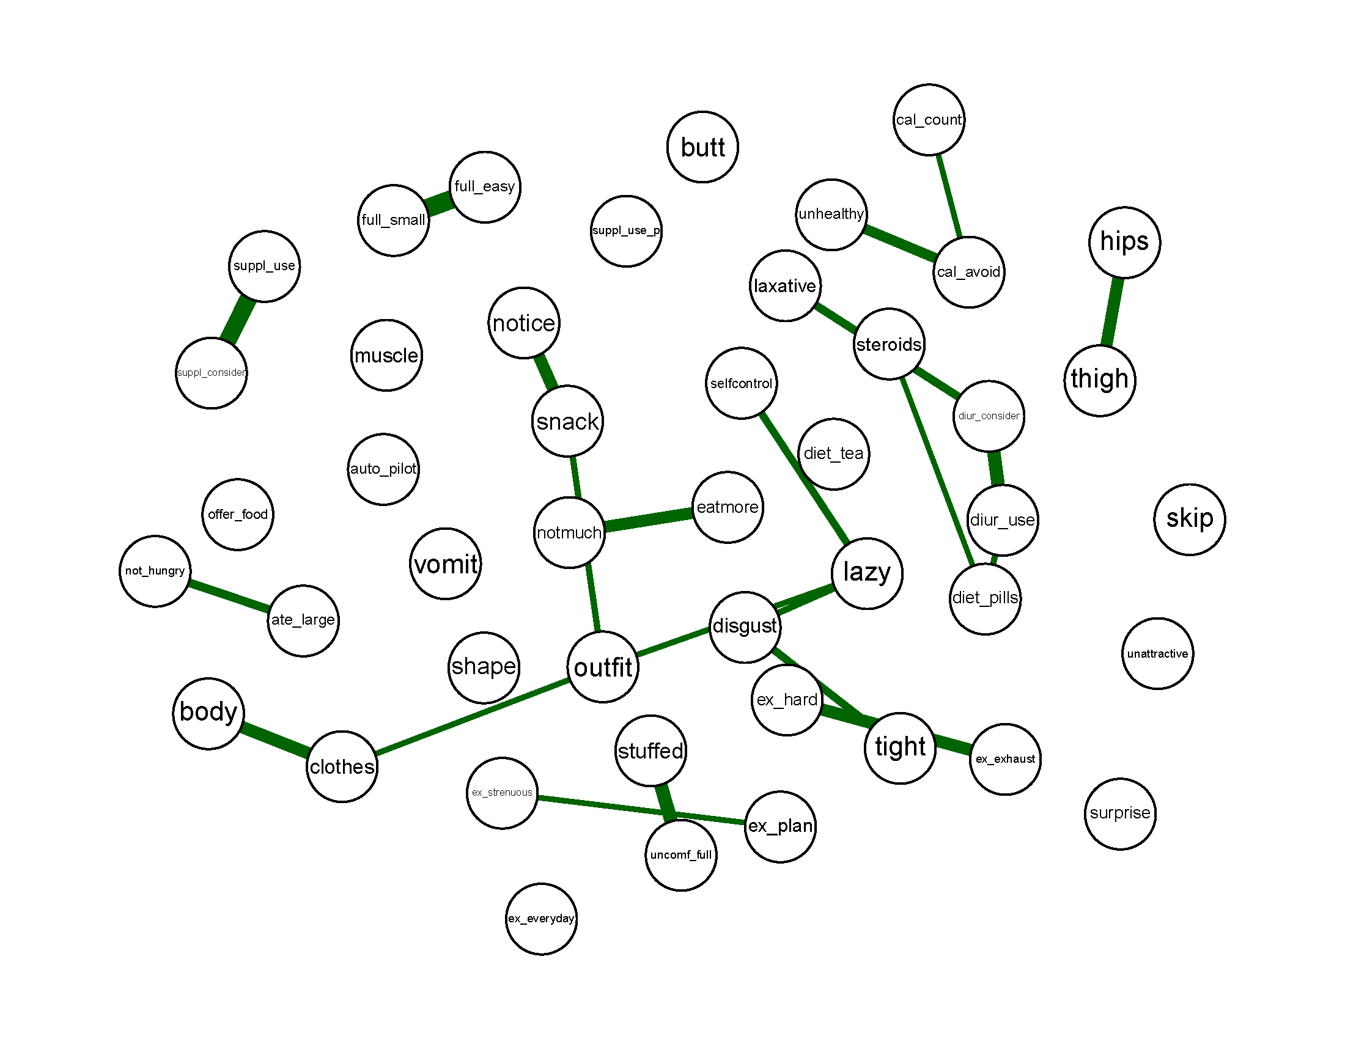
Supplementary Fig. S1. Eating disorder symptoms concentration (partial correlation) network in the eating disorder sample. Each node represents an item on the EPSI, and each link represents the partial Pearson’s correlation with edges >0.30 depicted. The thickness of a link represents the magnitude of the partial correlation.

