Supplementary material: Contents
2 Supplementary Method
- Magnetic resonance imaging data collection
- Skin conductance processing and analysis
2 Supplementary Results
- Skin conductance responses and self-reported anxiety: main task effects
- Skin conductance responses and self-reported anxiety: relationships with PTSD symptoms
- Anticipatory activation during temporally predictable trials: relationships with PTSD symptoms
4 Supplementary References
5 Supplementary Tables
- Supplementary Table S1: Sample characteristics
- Supplementary Table S2: Brain regions more active for unpredictable threat vs. safe anticipation
- Supplementary Table S3: Brain regions more active for unpredictable safe vs. threat anticipation
- Supplementary Table S4: Relationships between brain activation and skin conductance responses during unpredictable threat anticipation
11 Supplementary Figures
- Supplementary Fig. S1: PTSD symptom distribution
- Supplementary Fig. S2: Relationships between brain activation and skin conductance responses during unpredictable threat anticipation
- Supplementary Fig. S3: Regression of unpredictable threat activation on PTSD symptoms
- Supplementary Fig. S4: Relationships between brain activation during temporally predictable trials and PTSD symptoms
- Supplementary Fig. S5: Relationships between brain activation and PTSD symptoms in participants with elevated symptomatology
- Supplementary Fig. S6: Relationships between brain activation and PTSD symptoms in medication-free participants
- Supplementary Fig. S7: Relationships between brain activation and PTSD symptoms controlling for scores on the Beck Anxiety Inventory

Supplementary Method
Skin conductance processing and analysis
Electrodermal activity was recorded from the distal phalanges of participants’ third and fourth fingers using shielded Ag/AgCl electrodes prepared with isotonic paste. We acquired data at 1000 Hz using a Biopac MP-150 system. Data were subsequently down-sampled to 10 Hz, concatenated across runs, manually investigated for artifacts, and analyzed in Matlab using Ledalab (http://ledalab.de). We used Continuous Decomposition Analysis (Benedek & Kaernbach 2010) to isolate tonic and phasic drivers of the skin conductance response. The shortest cue+anticipation period was 6 seconds, and we thus analyzed phasic driver activity during a 5-second response period, from 1 to 6 seconds following cue onset, which gave us the largest window of anticipatory skin conductance activity uncontaminated by responses to shocks or tones. Individuals without detectable responses (greater than 0.01 μS) on at least 25% of trials were considered non-responders (N=4), and were excluded from further analysis. We calculated the integrated skin conductance response (ISCR) over the 5-second response window, corresponding to average phasic driver activity in response to the 2-second cue and the first 4 seconds of the anticipation period. These values were averaged for each trial type (uThreat, uSafe, pThreat, and pSafe) and log-transformed to correct for the skewed distribution of skin conductance responses (Boucsein et al. 2012). Tonic skin conductance activity was averaged across epochs and also log-transformed.
Log-transformed ISCR values were submitted to a repeated-measures Threat x Predictability ANOVA using SPSS version 21. We also calculated differential Threat – Safe responses for unpredictable and predictable trials, and used these differential responses as the dependent variable in linear regression analyses paralleling those used for the fMRI data. Analogous linear regression analyses were also implemented for self-reported anxiety ratings.
Supplementary Results
Skin conductance responses and self-reported anxiety: main task effects
For anxiety ratings, a repeated-measures ANOVA showed elevated anxiety on threat vs. safe trials (F(1,50) = 98.92, p < 0.001; partial η² = 0.66) and on predictable vs. unpredictable trials (F(1,50) = 4.66, p = 0.036; partial η² = 0.085; Figure 1B; for a similar behavioral effect, see Petry & Desiderato 1978, Figure 3). A Threat x Predictability interaction (F(1,50) = 12.18, p = 0.001; partial η² = 0.20) reflected greater anxiety ratings for pThreat vs. uThreat trials (t(50) = -3.64, p = 0.001), with equivalent ratings for pSafe and uSafe trials (t(50) = 0.83, p = 0.41).
The analogous ANOVA for phasic skin conductance responses showed a main effect of Threat (F(1,46) = 57.96, p < 0.001; partial η² = 0.56), with no effects involving Predictability (Fs < 0.2, ps > 0.66; Figure 1C).
Skin conductance responses and self-reported anxiety: relationships with PTSD symptoms
We found no relationships between overall symptom severity and ISCR values for the constrast of uThreat – uSafe (r(45) = -0.17, p = 0.26) or pThreat – pSafe (r(45) = -0.15, p = 0.33). There were also no significant relationships between ISCR values and any of the three CAPS symptom clusters (|ts| < 1.2, ps > 0.24). Similarly, we found no relationships between self-reported anxiety ratings for the contrast of (uThreat – uSafe) or (pThreat – pSafe) and overall symptom severity or any of the three CAPS symptom clusters (|ts| < 0.6, ps > 0.6).
Anticipatory activation during temporally predictable trials: relationships with PTSD symptoms
The regression of anticipatory activation during temporally predictable trials (pThreat vs. pSafe contrast) did not reveal any small-volume-corrected regions in which brain activation was associated with overall CAPS symptoms or any individual subscales. Re-experiencing symptoms were, however, associated with reduced pSafe – pThreat activation in an overlapping BA10 cluster that failed to meet small-volume-corrected significance (70 voxels at p < 0.005; center-of-gravity [10,61,-11]; Figure S4). In contrast, the regression of pSafe – pThreat activation on hyperarousal symptoms did not reveal any corrected or uncorrected clusters in the vicinity of the pACC. Thus, hyperarousal symptoms were related to altered pACC activation exclusively during conditions of uncertainty, whereas re-experiencing symptoms were related to altered threat processing irrespective of uncertainty in a more ventral aspect of the vmPFC.

Supplementary References
Benedek M, & Kaernbach C (2010). A continuous measure of phasic electrodermal activity. . Elsevier B.V. Journal of Neuroscience Methods 190, 80–91.
Boucsein W, Fowles DC, Grimes S, Ben-Shakhar G, Roth WT, Dawson ME, & Filion DL (2012). Publication recommendations for electrodermal measurements. Psychophysiology 49, 1017–1034.
Petry HM, & Desiderato O (1978). Changes in heart rate, muscle activity, and anxiety level following shock threat. Psychophysiology 15, 398–402.

Supplementary Table S1. Sample characteristics
Demographic and clinical variables, medications, and psychiatric diagnoses for all participants (N = 51). CAPS = Clinician Administered PTSD Scale; SCID = Structured Clinical Interview for DSM-IV Disorders.
 | Mean | SD | Range
Age | 30.7 | 6.6 | 22-48
Years since deployment | 5.0 | 2.8 | 1-10
Combat Exposure Scale | 19.0 | 8.9 | 1-40
CAPS | 33.6 | 26.1 | 0-90
CAPS B (re-experiencing) | 7.6 | 7.6 | 0-29
CAPS C (avoidance/numbing) | 11.4 | 11.6 | 0-43
CAPS D (hyperarousal) | 14.6 | 9.8 | 0-33
Beck Depression Inventory | 23.8 | 9.2 | 13-53
Beck Anxiety Inventory | 32.9 | 9.8 | 21-62
 | N/%
Participants on psychotropic medications | 12/24%
Monoamine reuptake inhibitor | 10/20%
Tricyclic/tetracyclic | 2/4%
Atypical antidepressant | 1/2%
Anxiolytic (buspirone) | 2/4%
Opioid pain medication | 2/4%
Sleep aid (zolpidem) | 2/4%
Prazosin | 1/2%
CAPS and SCID diagnoses
Posttraumatic stress disorder | 16/31%
Major depressive disorder | 6/12%
Dysthymia | 2/4%
Social phobia | 3/6%
Obsessive compulsive disorder | 3/6%
Generalized anxiety disorder | 2/4%
Alcohol abuse | 3/6%
Cannabis abuse | 1/2%
Binge eating | 3/6%
Bulimia | 1/2%

Supplementary Table S2. Anticipatory brain activation for unpredictable threat vs. safety
Significant clusters for the voxelwise contrast of unpredictable threat vs. unpredictable safe trials. Coordinates are presented in Montreal Neurological Institute (MNI) space. All clusters are whole-brain corrected at p < 0.05.

Region | N voxels | Peak voxel (x,y,z) | Peak Z value
Huge cortical/subcortical cluster | 25936 | (-28, 28, 2) | 7.05
L anterior insula | --- | (-28, 28, 2) | 7.05
Anterior mid-cingulate cortex | --- | (4, 20, 42) | 6.62
L anterior insula | --- | (-32, 20, 8) | 6.43
R anterior insula | --- | (46, 22, 4) | 6.42
R midbrain | --- | (4, -16, -10) | 6.39
L midbrain | --- | (-8, -16, -12) | 6.23
Left parietal cluster | 2013 | (-58, -50, 42) | 5.02
L supramarginal gyrus | --- | (-58, -50, 42) | 5.01
L angular gyrus | --- | (-46, -52, 44) | 4.96
L supramarginal gyrus | --- | (-64, -38, 28) | 4.86
L angular gyrus | --- | (-50, -56, 54) | 4.85
L supramarginal gyrus | --- | (-64, -36, 24) | 4.75
L parietal operculum | --- | (-52, -24, 20) | 4.59
Left dorsomedial prefrontal cluster | 1095 | (-28, 42, 28) | 4.39
L frontal pole/middle frontal gyrus | --- | (-28, 42, 28) | 4.39
L middle frontal gyrus | --- | (-36, 28, 32) | 4.33
L frontal pole | --- | (-34, 50, 18) | 3.99
L frontal pole/middle frontal gyrus | --- | (-34, 42, 26) | 3.98
L frontal pole | --- | (-34, 52, 10) | 3.92
L frontal pole/middle frontal gyrus | --- | (-28, 42, 38) | 3.9
Right parietal cluster | 1026 | (62, -36, 34) | 4.36
R supramarginal gyrus |  | (62, -36, 34) | 4.36
R supramarginal gyrus | --- | (58, -36, 34) | 4.28
R supramarginal gyrus | --- | (62, -42, 28) | 4.24
R supramarginal gyrus | --- | (52, -40, 38) | 4.14
R superior parietal lobule | --- | (38, -48, 46) | 3.76
R angular gyrus | --- | (48, -50, 42) | 3.73
Right occipital cluster | 381 | (20, -62, 42) | 4.24
R lateral occipital cortex/precuneus | --- | (20, -62, 42) | 4.24
R precuneus/lateral occipital cortex | --- | (16, -68, 42) | 4.17
R lateral occipital cortex | --- | (16, -72, 50) | 4.1
R lateral occipital cortex | --- | (20, -66, 48) | 4
R precuneus |  | (22, -56, 32) | 2.99
R lateral occipital cortex |  | (26, -70, 54) | 2.96
Left precuneus/occipital cluster | 230 | (-8, -74, 38) | 4.23
L precuneus | --- | (-8, -74, 38) | 4.23
L lateral occipital cortex | --- | (-12, -66, 50) | 3.73
Left precuneus/occipital cluster | 210 | (54, -22, -10) | 4.12
L precuneus | --- | (54, -22, -10) | 4.12
L lateral occipital cortex/precuneus | --- | (68, -24, -12) | 3.4

Supplementary Table S3. Anticipatory brain activation for unpredictable safety vs. threat
Significant clusters for the voxelwise contrast of unpredictable safe vs. unpredictable threat trials. Coordinates are presented in Montreal Neurological Institute (MNI) space. All clusters are whole-brain corrected at p < 0.05.

Region | N voxels | Peak voxel (x,y,z) | Peak Z value
Left parietal and temporal cluster | 20164 | (-20, -16, -22) | 7.28
Left parahippocampal gyrus | --- | (-20, -16, -22) | 7.28
L Precuneus | --- | (-4, -58, 20) | 7.08
L hippocampus | --- | (-26, -16, -18) | 7.05
L Precuneus | --- | (0, -60, 32) | 6.97
L Precuneus | --- | (-10, -58, 18) | 6.89
L Postcentral gyrus/precentral gyrus | --- | (0, -36, 60) | 6.73
Ventromedial prefrontal cortex cluster | 4622 | (-6, 48, -14) | 7.68
L medial orbitofrontal cortex | --- | (-6, 48, -14) | 7.68
R frontal pole/BA10 | --- | (4, 50, -16) | 7.64
L frontal pole/BA10 | --- | (-6, 56, -6) | 6.85
L subgenual anterior cingulate cortex | --- | (-6, 30, -16) | 6.55
L pregenual anterior cingulate cortex | --- | (-6, 40, -12) | 5.72
L medial orbitofrontal cortex | --- | (-10, 38, -12) | 5.64
Left postcentral gyrus/precentral gyrus/operculum/insula cluster | 1192 | (-60, -12, 36) | 6.17
L postcentral gyrus | --- | (-60, -12, 36) | 6.17
L precentral gyrus/postcentral gyrus | --- | (-54, -10, 26) | 5.39
L precentral gyrus/postcentral gyrus | --- | (-44, -12, 32) | 4.82
L central operculum/middle insula | --- | (-34, -10, 16) | 4.27
Left lateral occipital cluster | 1044 | (-42, -66, 28) | 6.25
L lateral occipital cortex | --- | (-42, -66, 28) | 6.25
L lateral occipital cortex | --- | (-46, -74, 30) | 5.73
L lateral occipital cortex | --- | (-50, -70, 28) | 5.55
L lateral occipital cortex | --- | (-40, -78, 44) | 4.46
L lateral occipital cortex | --- | (-30, -84, 44) | 3.41
L lateral occipital cortex | --- | (-24, -84, 46) | 3.11

Supplementary Table S4. Relationships between brain activation and skin conductance responses during unpredictable threat anticipation
Significant clusters for the voxelwise regression of unpredictable threat vs. unpredictable safe activation on skin conductance responses for the same contrast. Coordinates are presented in Montreal Neurological Institute (MNI) space. All clusters are whole-brain corrected at p < 0.05.

Region | N voxels | Peak voxel (x,y,z) | Peak Z value
Supplementary motor/anterior mid-cingulate cluster | 6773 | (6, 0, 58) | 5.36
R supplementary motor cortex | --- | (6, 0, 58) | 5.36
L supplementary motor cortex | --- | (-4, -6, 58) | 5.28
L supplementary motor cortex | --- | (-8, 2, 56) | 5.24
R anterior mid-cingulate cortex | --- | (4, 8, 38) | 5.12
R anterior mid-cingulate cortex | --- | (10, 4, 50) | 4.94
R superior parietal lobule | --- | (20, -54, 66) | 4.91
Cerebellum cluster | 3489 | (-36, -56, -58) | 4.65
L cerebellum | --- | (-36, -56, -58) | 4.65
R cerebellum | --- | (32, -54, -28) | 4.45
L cerebellum | --- | (-38, -46, -36) | 4.28
L cerebellum | --- | (-44, -52, -36) | 4.26
Cerebellum | --- | (0, -48, -24) | 4.22
R cerebellum | --- | (22, -54, -52) | 4.2
Right midbrain/brainstem/thalamus/ striatum/amygdala/insula cluster | 3361 | (14, 0, 14) | 5.55
R caudate | --- | (14, 0, 14) | 5.55
R frontal operculum | --- | (44, 14, 2) | 5.47
R central operculum | --- | (52, 4, 2) | 4.96
R anterior insula | --- | (34, 12, 6) | 4.92
R mid-insula/central operculum | --- | (42, 6, 2) | 4.73
Periaqueductal gray | --- | (0, -30, -2) | 4.67
Left insula/striatum/thalamus/amygdala cluster | 1538 | (-44, 8, 2) | 4.49
L frontal/central operculum |  | (-44, 8, 2) | 4.49
L mid-insula | --- | (-30, 6, 10) | 4.42
L putamen | --- | (-28, 10, -2) | 4.39
L precentral gyrus | --- | (-52, 2, 22) | 4.28
L anterior insula/frontal operculum | --- | (-30, 26, 6) | 4.2
L putamen | --- | (-32, 4, -8) | 4.12
Left parietal cluster | 1069 | (-52, -38, 22) | 5.16
L parietal operculum | --- | (-52, -38, 22) | 5.16
L parietal operculum | --- | (-58, -38, 20) | 4.98
L supramarginal gyrus | --- | (-56, -40, 30) | 4.17
L supramarginal gyrus | --- | (-64, -42, 28) | 4.15
L postcentral gyrus/central operculum |  | (-54, -18, 22) | 3.82
L parietal/central operculum |  | (-58, -24, 18) | 3.58
Right parietal cluster | 928 | (50, -22, 30) | 4.53
R supramarginal gyrus |  | (50, -22, 30) | 4.53
R supramarginal gyrus/parietal operculum |  | (56, -30, 30) | 4.41
R parietal operculum |  | (50, -22, 22) | 4.12
R parietal operculum |  | (60, -32, 22) | 3.8
R supramarginal gyrus | --- | (64, -32, 40) | 3.8
R supramarginal gyrus | --- | (58, -32, 38) | 3.77
Right dorsal prefrontal cortex cluster | 376 | (38, 34, 30) | 4.16
R middle frontal gyrus |  | (38, 34, 30) | 4.16
R frontal pole/middle frontal gyrus |  | (30, 38, 44) | 4.01
R middle frontal gyrus |  | (34, 34, 30) | 3.87
R middle frontal gyrus | --- | (40, 34, 46) | 3.43
R frontal pole/middle frontal gyrus | --- | (48, 40, 28) | 3.19

.

Left dorsal prefrontal cortex cluster | 314 | (-34, 24, 42) | 4.05
L middle frontal gyrus |  | (-34, 24, 42) | 4.05
L middle frontal gyrus |  | (-26, 32, 38) | 4.04
L frontal pole/middle frontal gyrus |  | (-32, 42, 34) | 3.83
L middle frontal gyrus |  | (-30, 24, 46) | 3.18
L frontal pole/superior frontal gyrus | --- | (-22, 40, 50) | 2.85
L inferior/middle frontal gyrus | --- | (-28, 18, 28) | 2.83

Right precentral gyrus cluster | 205 | (48, 0, 54) | 4.23
R precentral gyrus |  | (48, 0, 54) | 4.23
R precentral gyrus |  | (56, 8, 40) | 3.48
R precentral gyrus |  | (54, 2, 40) | 3.36
R precentral gyrus | --- | (40, -4, 52) | 2.98
R precentral gyrus | --- | (56, -2, 42) | 2.87

Supplementary Fig. S1. PTSD symptom distribution
Symptom count for total Clinician-Administered PTSD Scale for DSM-V (CAPS) scores (A) and each of its 3 composite symptom clusters: re-experiencing (B), emotional numbing and avoidance (C), and hyperarousal (D).

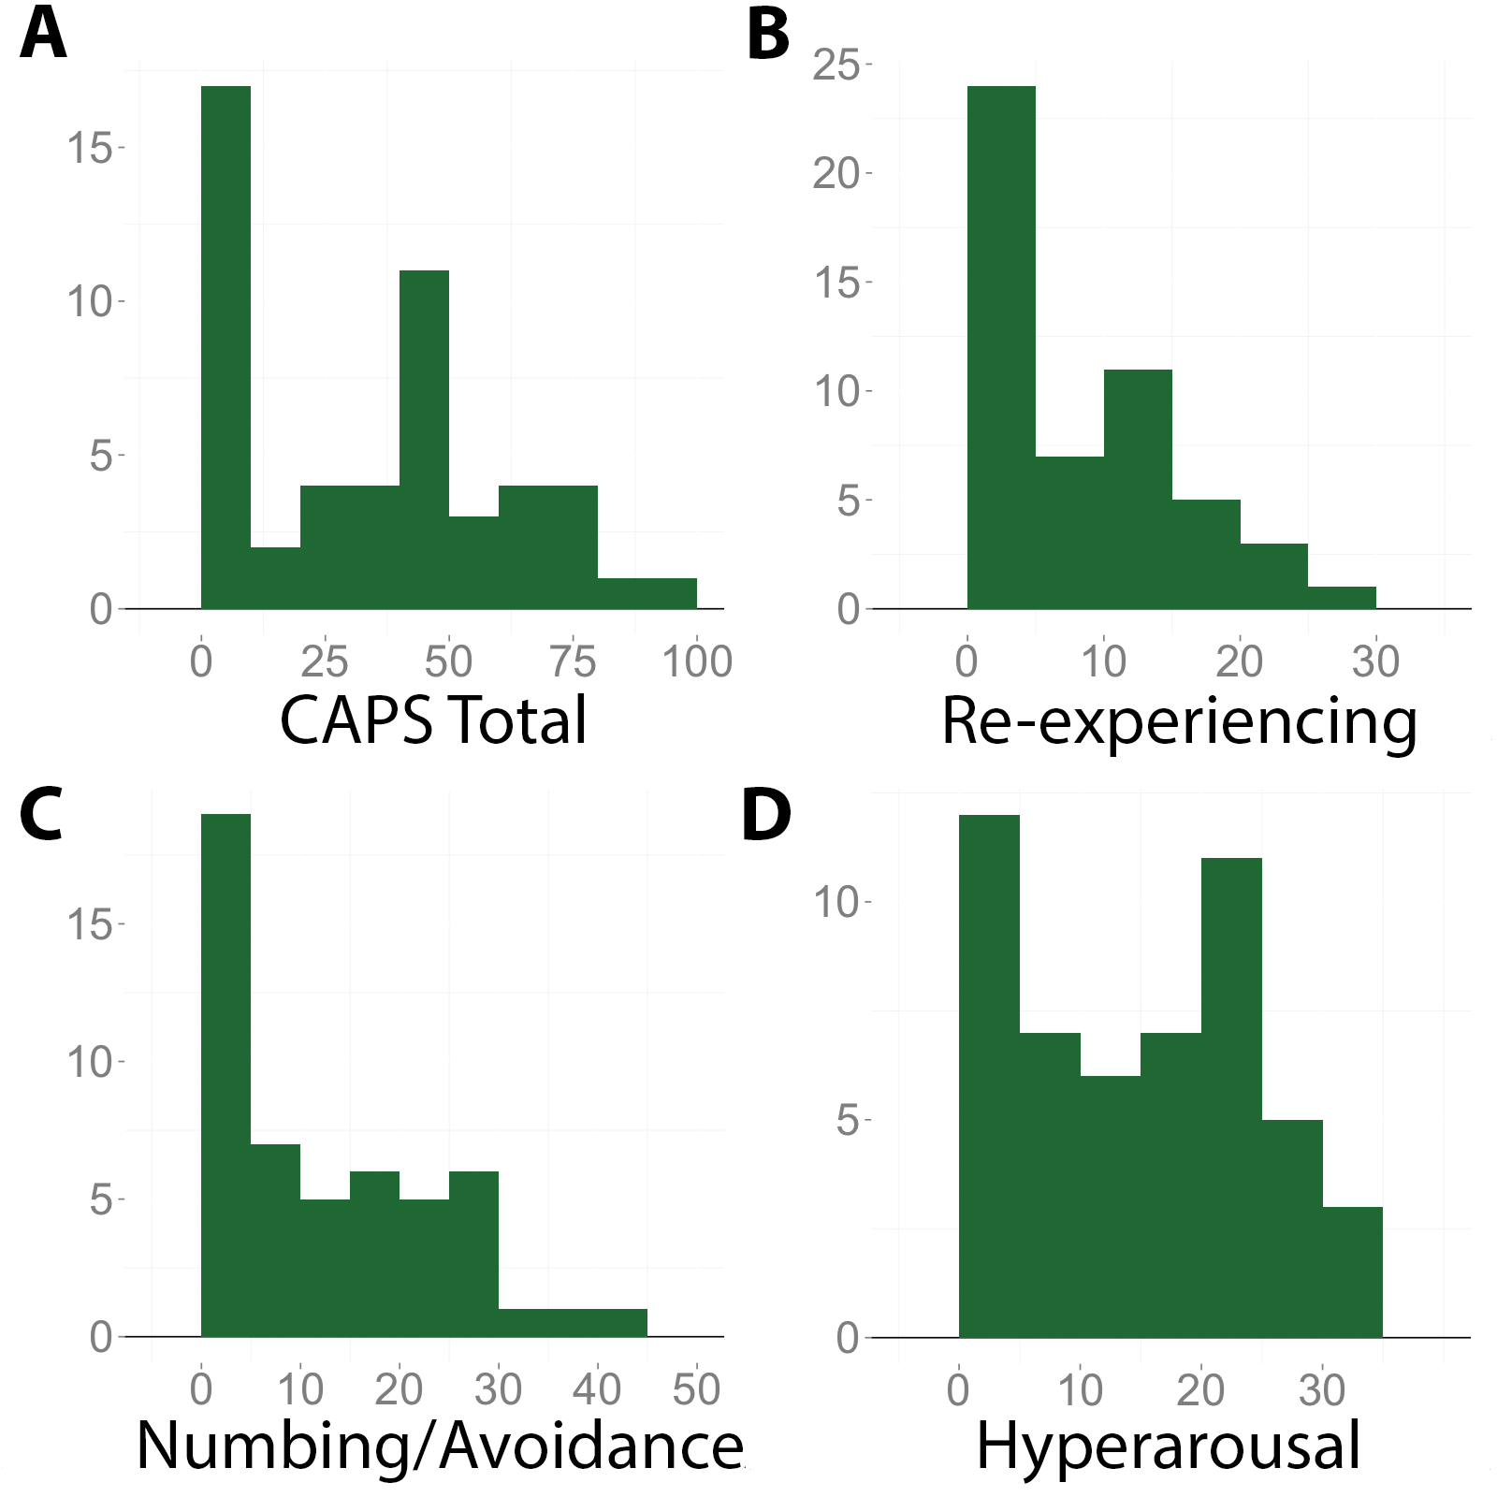

Supplementary Fig. S2. Relationships between brain activation and skin conductance responses during unpredictable threat anticipation
Significant clusters for the voxelwise regression of unpredictable threat (uThreat) vs. unpredictable safe (uSafe) activation on skin conductance responses (for the same contrast) are presented in green. Significant activation for the contrast of uThreat vs. uSafe is outlined in yellow for comparison. All clusters are whole-brain corrected at p < 0.05.

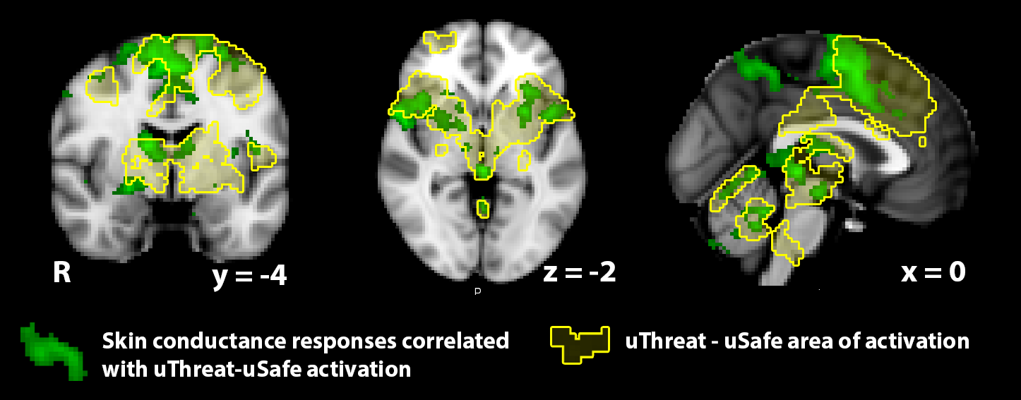

Supplementary Fig. S3. Regression of unpredictable threat activation on PTSD symptoms
Simultaneous regression of unpredictable threat (uThreat) activation on PTSD symptom subscales revealed a positive relationship between hyperarousal symptoms (A, in yellow) and activation in the left pregenual anterior cingulate cortex extending into the subgenual anterior cingulate cortex (p < 0.05, small-volume corrected). At an uncorrected threshold (p < 0.005 voxelwise), a relationship was observed between re-experiencing symptoms and increased BA10 activation (B, in yellow). Each of these clusters showed substantial overlap with the corresponding clusters (see Fig. 3) for the regression of uThreat vs. unpredictable safe (uSafe) activation on PTSD symptoms (in green). No relationships were observed for the uSafe regression analysis.

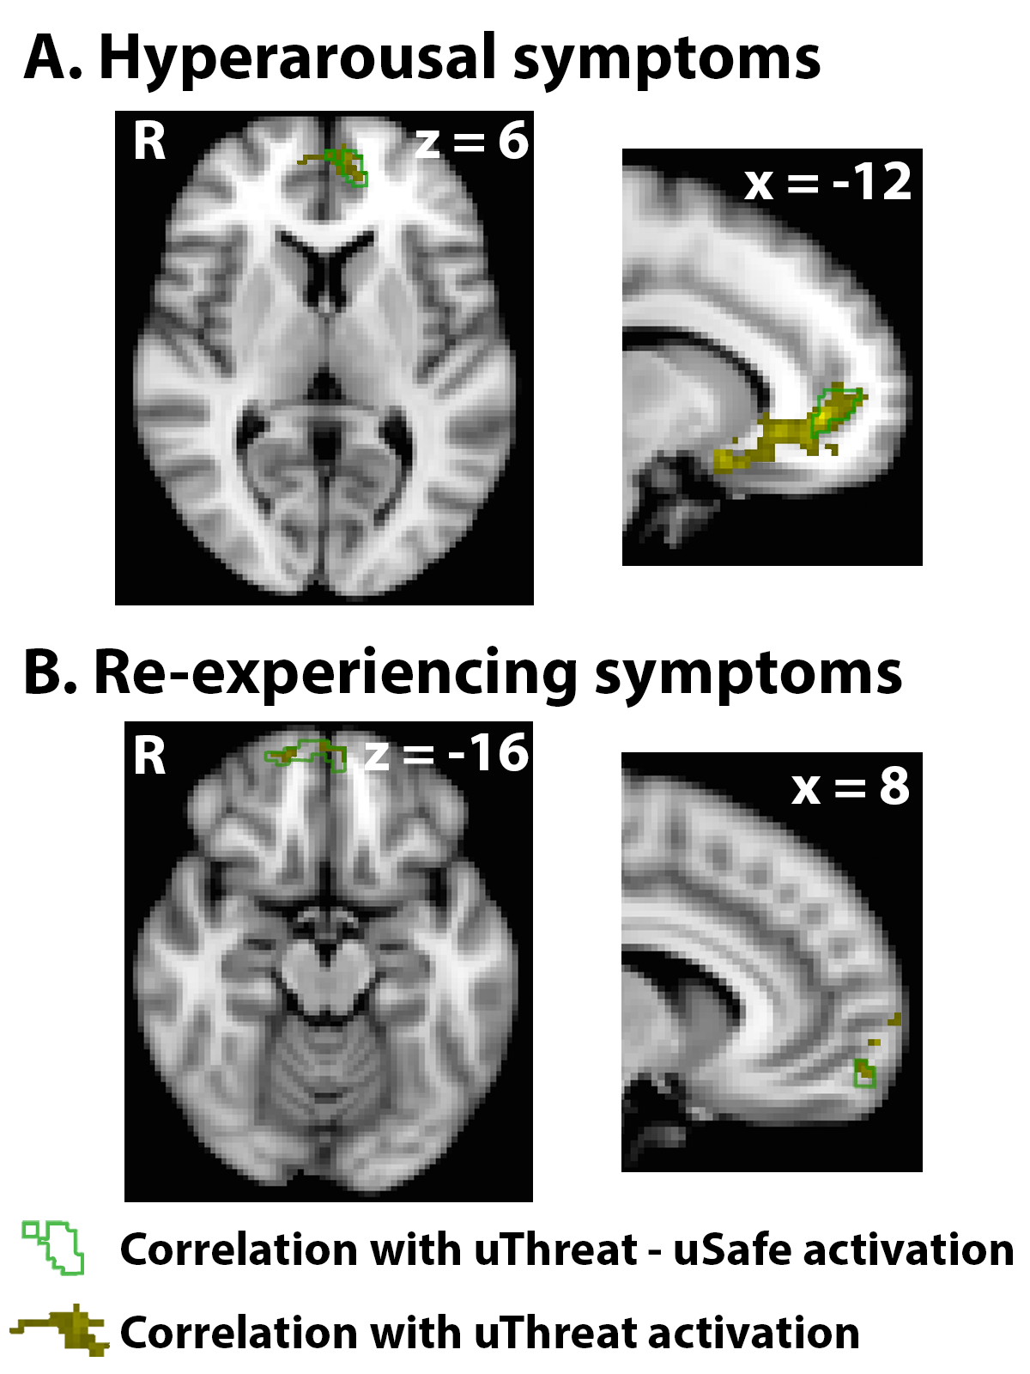

Supplementary Fig. S4. Relationships between brain activation on temporally predictable trials and PTSD symptoms
Simultaneous regression of predictable threat (pThreat) vs. predictable safe (pSafe) activation on PTSD symptom subscales revealed a subthreshold relationship (p < 0.005, uncorrected) between re-experiencing symptoms and increased BA10 activation (in red). This cluster overlapped with that showing a similar relationship for the regression of unpredictable threat (uThreat) vs. unpredictable safe (uSafe) activation on PTSD symptoms (in green).

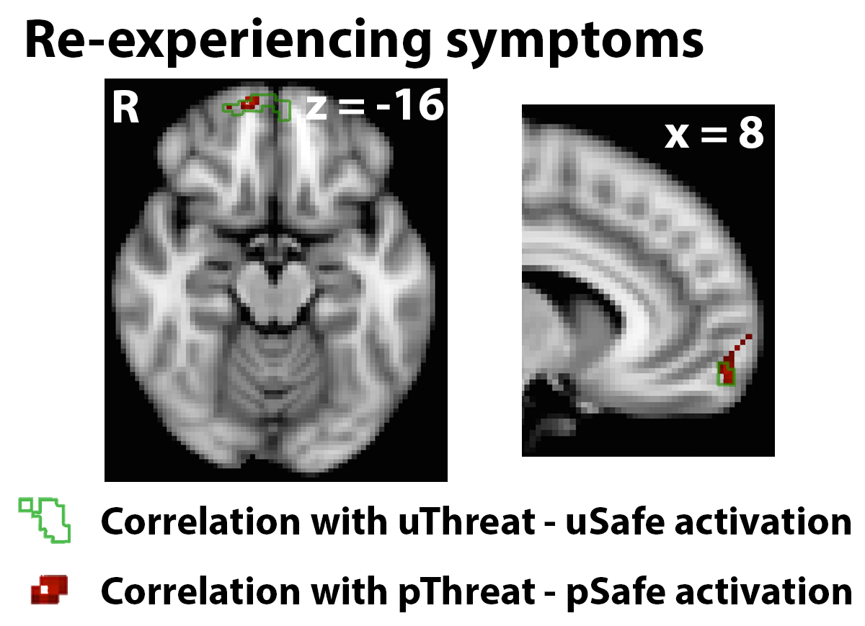

Supplementary Fig. S5. Relationships between brain activation and PTSD symptoms in participants with elevated symptomatology
Simultaneous multiple regression of unpredictable threat (uThreat) vs. unpredictable safe (uSafe) activation on each of the 3 PTSD symptom subscales was conducted within the 34 participants with elevated PTSD symptoms (PTSS group; see Methods: Participants). This regression revealed similar small-volume corrected (p < 0.05) relationships with (A) hyperarousal and (B) re-experiencing symptoms (red clusters) as were observed for the entire sample of 51 subjects (outlined in green).

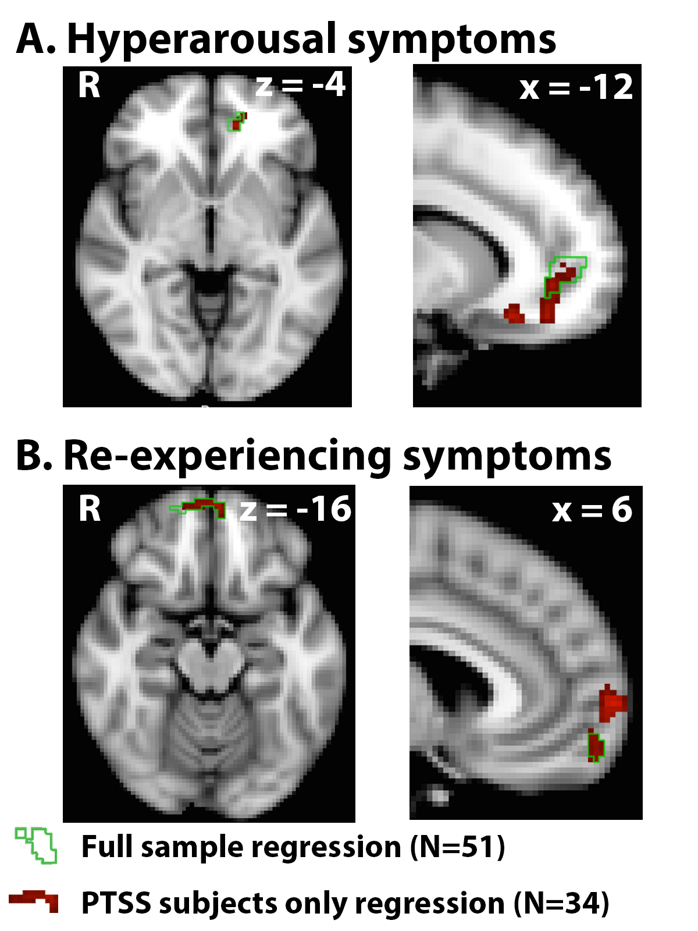

Supplementary Fig. S6. Relationships between brain activation and PTSD symptoms in medication-free participants
Simultaneous multiple regression of unpredictable threat (uThreat) vs. unpredictable safe (uSafe) activation on each of the 3 PTSD symptom subscales was conducted within the 39 participants who were not receiving psychotropic medications at the time of the scan. This regression revealed similar small-volume corrected (p < 0.05) relationships with (A) hyperarousal and (B) re-experiencing symptoms (red clusters) as were observed for the entire sample of 51 subjects (outlined in green).

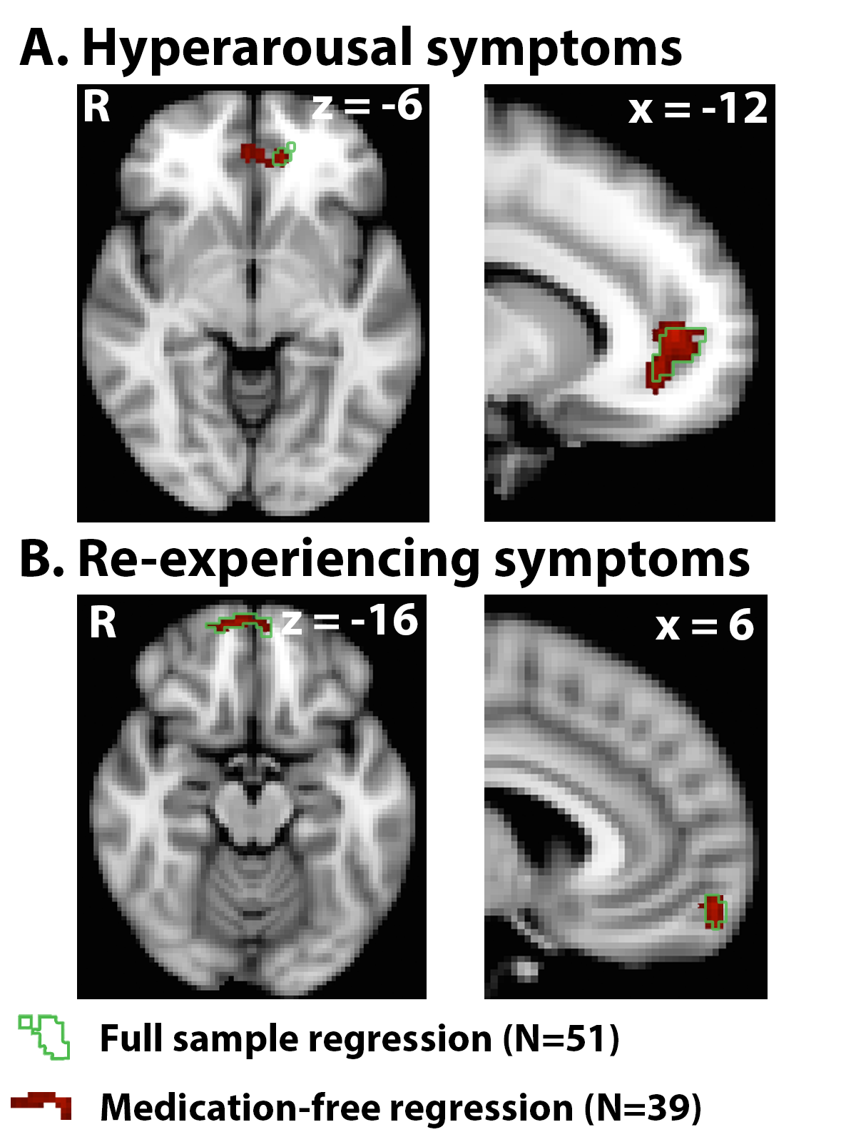

Supplementary Fig. S7. Relationships between brain activation and PTSD symptoms controlling for scores on the Beck Anxiety Inventory
(A) Regression of unpredictable threat (uThreat) vs. unpredictable safe (uSafe) activation on Beck Anxiety Inventory (BAI) scores revealed a cluster spanning dorsomedial and ventromedial prefrontal cortex (vmPFC) in which elevated BAI scores were associated with increased activation. When including BAI scores as a covariate, simultaneous multiple regression of uThreat vs. uSafe activation on each of the 3 PTSD symptom subscales revealed similar small-volume corrected (p < 0.05) relationships with (B) hyperarousal and (C) re-experiencing symptoms (red clusters) as were observed when not including BAI scores as a covariate (clusters outlined in green). This multiple regression analysis did not reveal any vmPFC clusters in which activation was associated with BAI scores, after accounting for PTSD symptomatology.

