SUPPLEMENTARY MATERIAL

Enhanced Neural Response to Anticipation, Effort and Consummation of Reward and Aversion during Bupropion Treatment.

Zola Dean (MSc), Stefanie Horndasch (MD), Panagiotis Giannopoulos (MD MRCPsych), Ciara McCabe (PhD)*

School of Psychology and Clinical Language Sciences, University of Reading, UK.

Figure S1. Visual depiction of a reward-hard trial- all ISI and ITI are jittered.

1. Cue (2 sec)
3. VAS 1: Wanting (5 sec)
5. Effort (6 sec)
9. VAS 2: Pleasantness (5 sec)
11. VAS 3: Intensity (5 sec)
7. Taste delivered (5 sec)
12. Grey image (2 sec)
14. Rinse delivered (5 sec)
2. Fixation cross (2 sec)
4. Fixation cross (2 sec)
6. Fixation cross (2 sec)
8. Swallow cue (2 sec)
10. Fixation cross (2 sec)
13. Fixation cross (2 sec)
Time
15. Swallow cue (2 sec)

Table S1. Regions showing main effect of task irrespective of treatment for all subjects.
 | MNI coordinates
Brain Region | X | Y | Z | Z score | Significance (p Value)
Anticipatory
Chocolate cue – grey image
Occipital Lobe | -18 | -94 | 8 | 6.46 | <0.001*
Caudate | 8 | 6 | 0 | 4.13 | 0.001
 | 6 | 12 | 6 | 4.05 | 0.001
lOFC | -42 | 46 | -4 | 5.03 | <0.001
Subgenual Cing Gyrus | -10 | 24 | -10 | 3.98 | 0.002
OFC | 18 | 36 | -16 | 4.92 | <0.001
mPFC | -6 | 54 | 10 | 5.06 | <0.001
Mid Cing | 0 | -16 | 40 | 5.20 | <0.001
ACC | 2 | 8 | 36 | 4.33 | 0.001
Midbrain | -2 | -32 | -14 | 4.60 | <0.001
Putamen | 28 | -8 | 4 | 3.66 | 0.005
Unpleasant cue – grey image
Occipital lobe | -16 | -92 | 6 | 7.00 | <0.001*
Caudate | 8 | 4 | 0 | 4.28 | <0.001
 | 6 | 10 | 6 | 3.93 | 0.002
lOFC | -42 | 46 | -4 | 4.57 | <0.001
Mid Cing | 0 | -16 | 40 | 5.08 | <0.001
ACC | 2 | 10 | 36 | 4.12 | <0.001
dmPFC | -18 | 54 | 10 | 4.79 | <0.001
Effort

Hard chocolate – easy chocolate
Precentral gyrus | -34 | -24 | 56 | 6.27 | <0.001*
Insula | 32 | 20 | 6 | 4.83 | <0.001
Parietal Operculum cortex | -44 | -28 | 22 | 4.59 | <0.001*
Mid Cing | 0 | -12 | 56 | 3.99 | 0.001
Putamen | -30 | -12 | 0 | 3.69 | 0.003

Easy chocolate – hard chocolate
Cuneal cortex | 12 | -84 | 24 | 4.76 | 0.014*

Easy unpleasant – hard unpleasant
Cuneal cortex/occipital pole | -6 | -72 | -2 | 4.48 | 0.046*

Hard unpleasant – easy unpleasant
lOFC | 30 | 28 | -12 | 3.68 | 0.004
Putamen | -22 | 12 | -4 | 3.43 | 0.008
Parietal Operculum cortex | -46 | -24 | 18 | 4.46 | <0.001*

Easy unpleasant – easy chocolate
Middle frontal gyrus | -28 | 12 | 34 | 3.82 | 0.001*
lOFC | -44 | 48 | -8 | 3.47 | 0.008
dACC | 4 | 40 | 38 | 3.31 | 0.001*
Consummatory
Chocolate taste - rinse
Ventral striatum | 6 | 4 | -6 | 3.33 | 0.01
Insula | -30 | 16 | 2 | 2.86 | 0.034
OFC/Frontal pole | 26 | 44 | -8 | 4.29 | 0.018*
Caudate | -14 | 14 | 14 | 3.34 | 0.01
Unpleasant taste - rinse
Bilateral amygdala | -20 | -4 | -20 | 3.14 | 0.017
 | 22 | -2 | -24 | 2.87 | 0.034
Insula | -36 | 10 | -14 | 3.47 | 0.007
lOFC | -32 | 36 | -12 | 3.56 | 0.005
p<0.05 FWE, indicating p values voxel level small volume corrected.
*Whole brain fully corrected
lOFC, lateral orbitofrontal cortex; Cing, cingulate; OFC, orbitofrontal cortex; mPFC, medial prefrontal cortex; Mid Cing, middle cingulate; ACC, anterior cingulate cortex; dACC, dorsal anterior cingulate cortex; dmPFC, dorsal medial prefrontal cortex.

Figure S2.

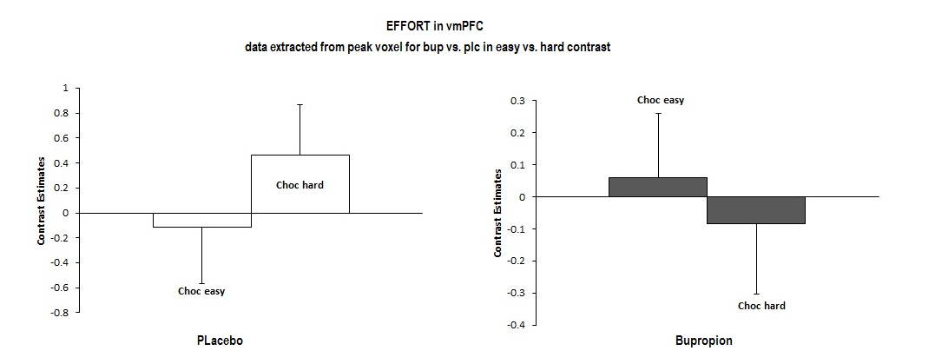
Table S2. Subjective state ratings pre- and post-scan after 7 days of treatment with bupropion and placebo, separated by a two-week washout phase. There were no significant effects of treatment condition on any of the measures.

Measure | Bupropion  Mean (SD) |  | Placebo  Mean (SD)
 | Pre-scan | Post-scan | Pre-scan | Post-scan
VAS
Alertness | 5.35(2.05) | 3.67 (2.66) | 6.18 (2.38) | 5.85 (7.56)
Disgust | 1.39 (1.27) | 1.79 (1.86) | 0.92 (1.22) | 1.69 (1.71)
Drowsiness * | 2.96 (2.49) | 3.89 (2.83) | 1.73 (1.56) | 4.03 (2.53)
Anxiety * | 2.05 (2.03) | 0.90 (0.74) | 1.34 (1.38) | 0.80 (0.89)
Happiness * | 6.18 (1.61) | 5.00 (2.68) | 6.65 (1.76) | 5.68 (2.29)
Nausea | 0.61 (0.76) | 1.29 (2.20) | 0.65 (0.90) | 1.28 (2.05)
Sadness | 0.91 (0.78) | 0.92 (1.35) | 0.67 (0.52) | 0.98 (1.90)
Withdrawn | 0.93 (0.92) | 1.55 (1.79) | 1.15 (1.26) | 1.15 (0.99)
Faint * | 0.54 (0.66) | 1.58 (1.95) | 0.87 (1.25) | 1.61 (1.95)
Total BFS score * | 18.20 (11.03) | 21.20 (12.63) | 12.33 (9.80) | 19.33 (12.51)

SD, standard deviation; VAS, visual analogue scale (n=17); BFS, the Befindlichkeit Scale (n=15); Repeated measure analyses of variance; p>0.05; *Significant main effect of time (pre/post scan) p<0.05.

Table S3. Frequencies of Adverse Effects Reported Under Bupropion (n=17) and Placebo (n=17).
Adverse Event | Placebo | Bupropion
Gastrointestinal symptoms
Diarrhoea | 2 | 1
Constipation | 1 | 0
Dry Mouth | 0 | 2
Nausea or vomiting | 1 | 1
Heart symptoms
Palpitations | 0 | 1
Dizziness when standing | 1 | 1
Chest pain | 0 | 1
Skin symptoms
Rash | 1 | 1
Increase perspiration | 0 | 0
Itching | 1 | 0
Dry skin | 2 | 1
Nervous system symptoms
Headache | 5 | 5
Tremors | 0 | 0
Poor coordination | 0 | 1
Dizziness | 0 | 4
Eye and ear symptoms
Blurred vision | 1 | 0
Ringing in the ears | 0 | 0
Genital and urinary symptoms
Difficulty urinating | 1 | 0
Painful urination | 0 | 1
Frequent urination | 0 | 1
Menstrual irregularity | 0 | 0
Sleep symptoms
Difficulty sleeping | 3 | 3
Sleeping too much | 3 | 0
Sexual functioning
Loss of sexual desire | 0 | 1
Trouble achieving orgasm | 0 | 0
Trouble with erections | 0 | 0
Other symptoms
Anxiety | 0 | 2
Fatigue | 3 | 5
Poor concentration | 1 | 1
Decreased energy | 1 | 3
General malaise | 0 | 1
Restlessness | 0 | 1
Other  Decreased appetite  Increase Energy  Irritable | 0  0  0 | 1  1  1

Data are frequencies.

Figure S3. Subjective pleasantness, wanting and intensity ratings of the pleasant and unpleasant stimuli in placebo and bupropion conditions. There were no significant effects of treatment condition on any of the measures.
Wanting
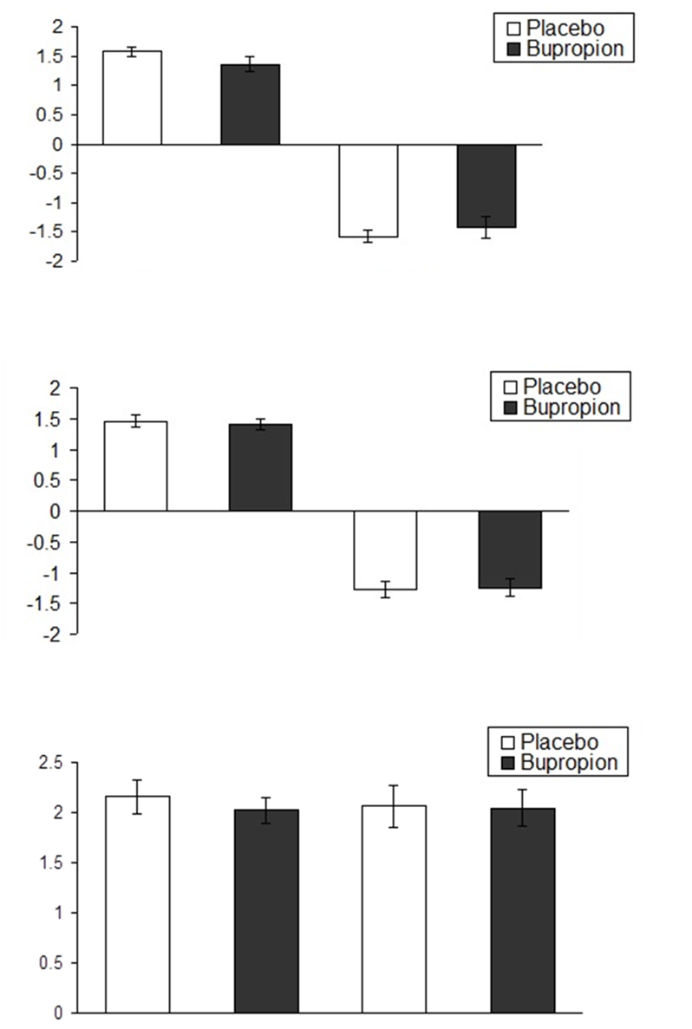
Pleasantness
Intensity
Pleasant Unpleasant
Pleasant Unpleasant
Pleasant Unpleasant

Figure S4. Average number of button presses and time taken to complete pleasant and unpleasant trials across bupropion and placebo conditions.
Button Presses

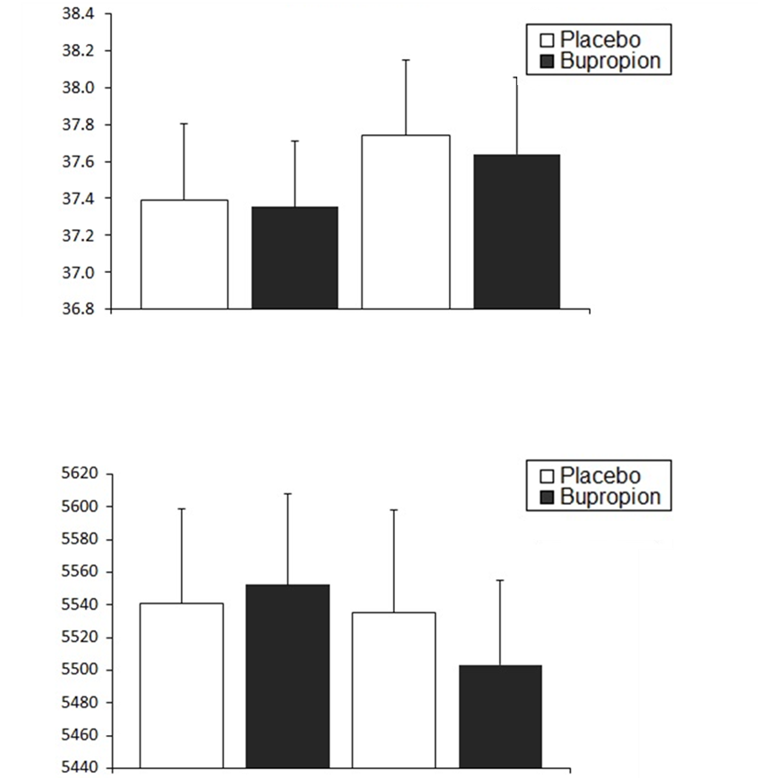
Milliseconds
Pleasant Unpleasant
Pleasant Unpleasant

