Supplementary Results
The following neuroimaging results were identified based on the cluster inference surviving at family-wise error (FWE) p < .05, using Random Field Theory, at a cluster-forming threshold p < .005, With regards to group comparisons between autism spectrum disorder (ASD) and typically developing (TD) male youths, whole-brain analysis showed male youths with ASD, relative to TD youths, had increased gray matter (GM) volumes at the left cerebellum Crus 1 (cluster surviving at FWE p=.010, MNI x=-48 y=-72 z=-41, cluster size 2001.375 mm³) (Supplementary Fig. 2A). There was no significant difference in white matter (WM) volume between ASD and TD groups.
Unaffected brothers had increased GM volumes at the mid-cingulate cortex (MCC) (cluster-level FWE corrected p=.004, MNI x=-3 y=-26 z=48, cluster size 2284.875 mm³), as compared to the TD group (Supplementary Fig. 2B). Whole brain analysis identified that the Brother group, relative to the TD group, had increased WM volumes at bilateral superior corona radiate (left: cluster-level FWE corrected p=.020, MNI x=-33 y=2 z=49, cluster size 1913.625 mm³; right: cluster-level FWE corrected p=.019, MNI x=26 y=0 z=40, cluster size 1920.375 mm³) (Supplementary Fig. 2C).
Considering the aim of the main analysis to directly link shared neurostructural atypicality to shared differences in intrinsic functional connectivity (iFC), the ASD-TD and Brother-TD group comparisons were still identified from iFC based on the MCC. Relative to the TD group, the ASD group had increased connectivity between the MCC and left anterior temporoparietal junction, alongside left middle occipital gyrus (L-MoG), whereas youths with ASD displayed reduced MCC-posterior cingulate cortex connectivity (Fig. 2D). Hyperconnectivity between the MCC and right MoG (R-MoG), and hypoconnectivity between the MCC and right inferior frontal gyrus (R-IFG), alongside right anterior temporoparietal junction, respectively, were identified in unaffected brothers, relative to TD male youths (Fig. 2E).
Besides post-hoc analysis of variance for brain measures extracted from the clusters surviving the conjunction analyses (as described in the main text), we also employed small-volume adjusted p-values using the anatomical clusters surviving the conjunction analyses at suggestion by Friston et al. (2005). These imaging testing based on small-volume correction were employed on the MCC cluster from the ASD-TD contrast of GM comparisons (small volume adjusted p .047); the left superior corona radiata cluster from the ASD-TD contrast of WM comparisons (small volume adjusted p .048); the R-IFG (small volume adjusted p .023) and the R-MoG clusters (small volume adjusted p .043) from the ASD-TD contrast of iFC comparisons; the L-MoG cluster from the Brother-TD contrast of iFC comparisons (small volume adjusted p .024).
Supplementary Fig. S2. Individual group comparisons for brain measures
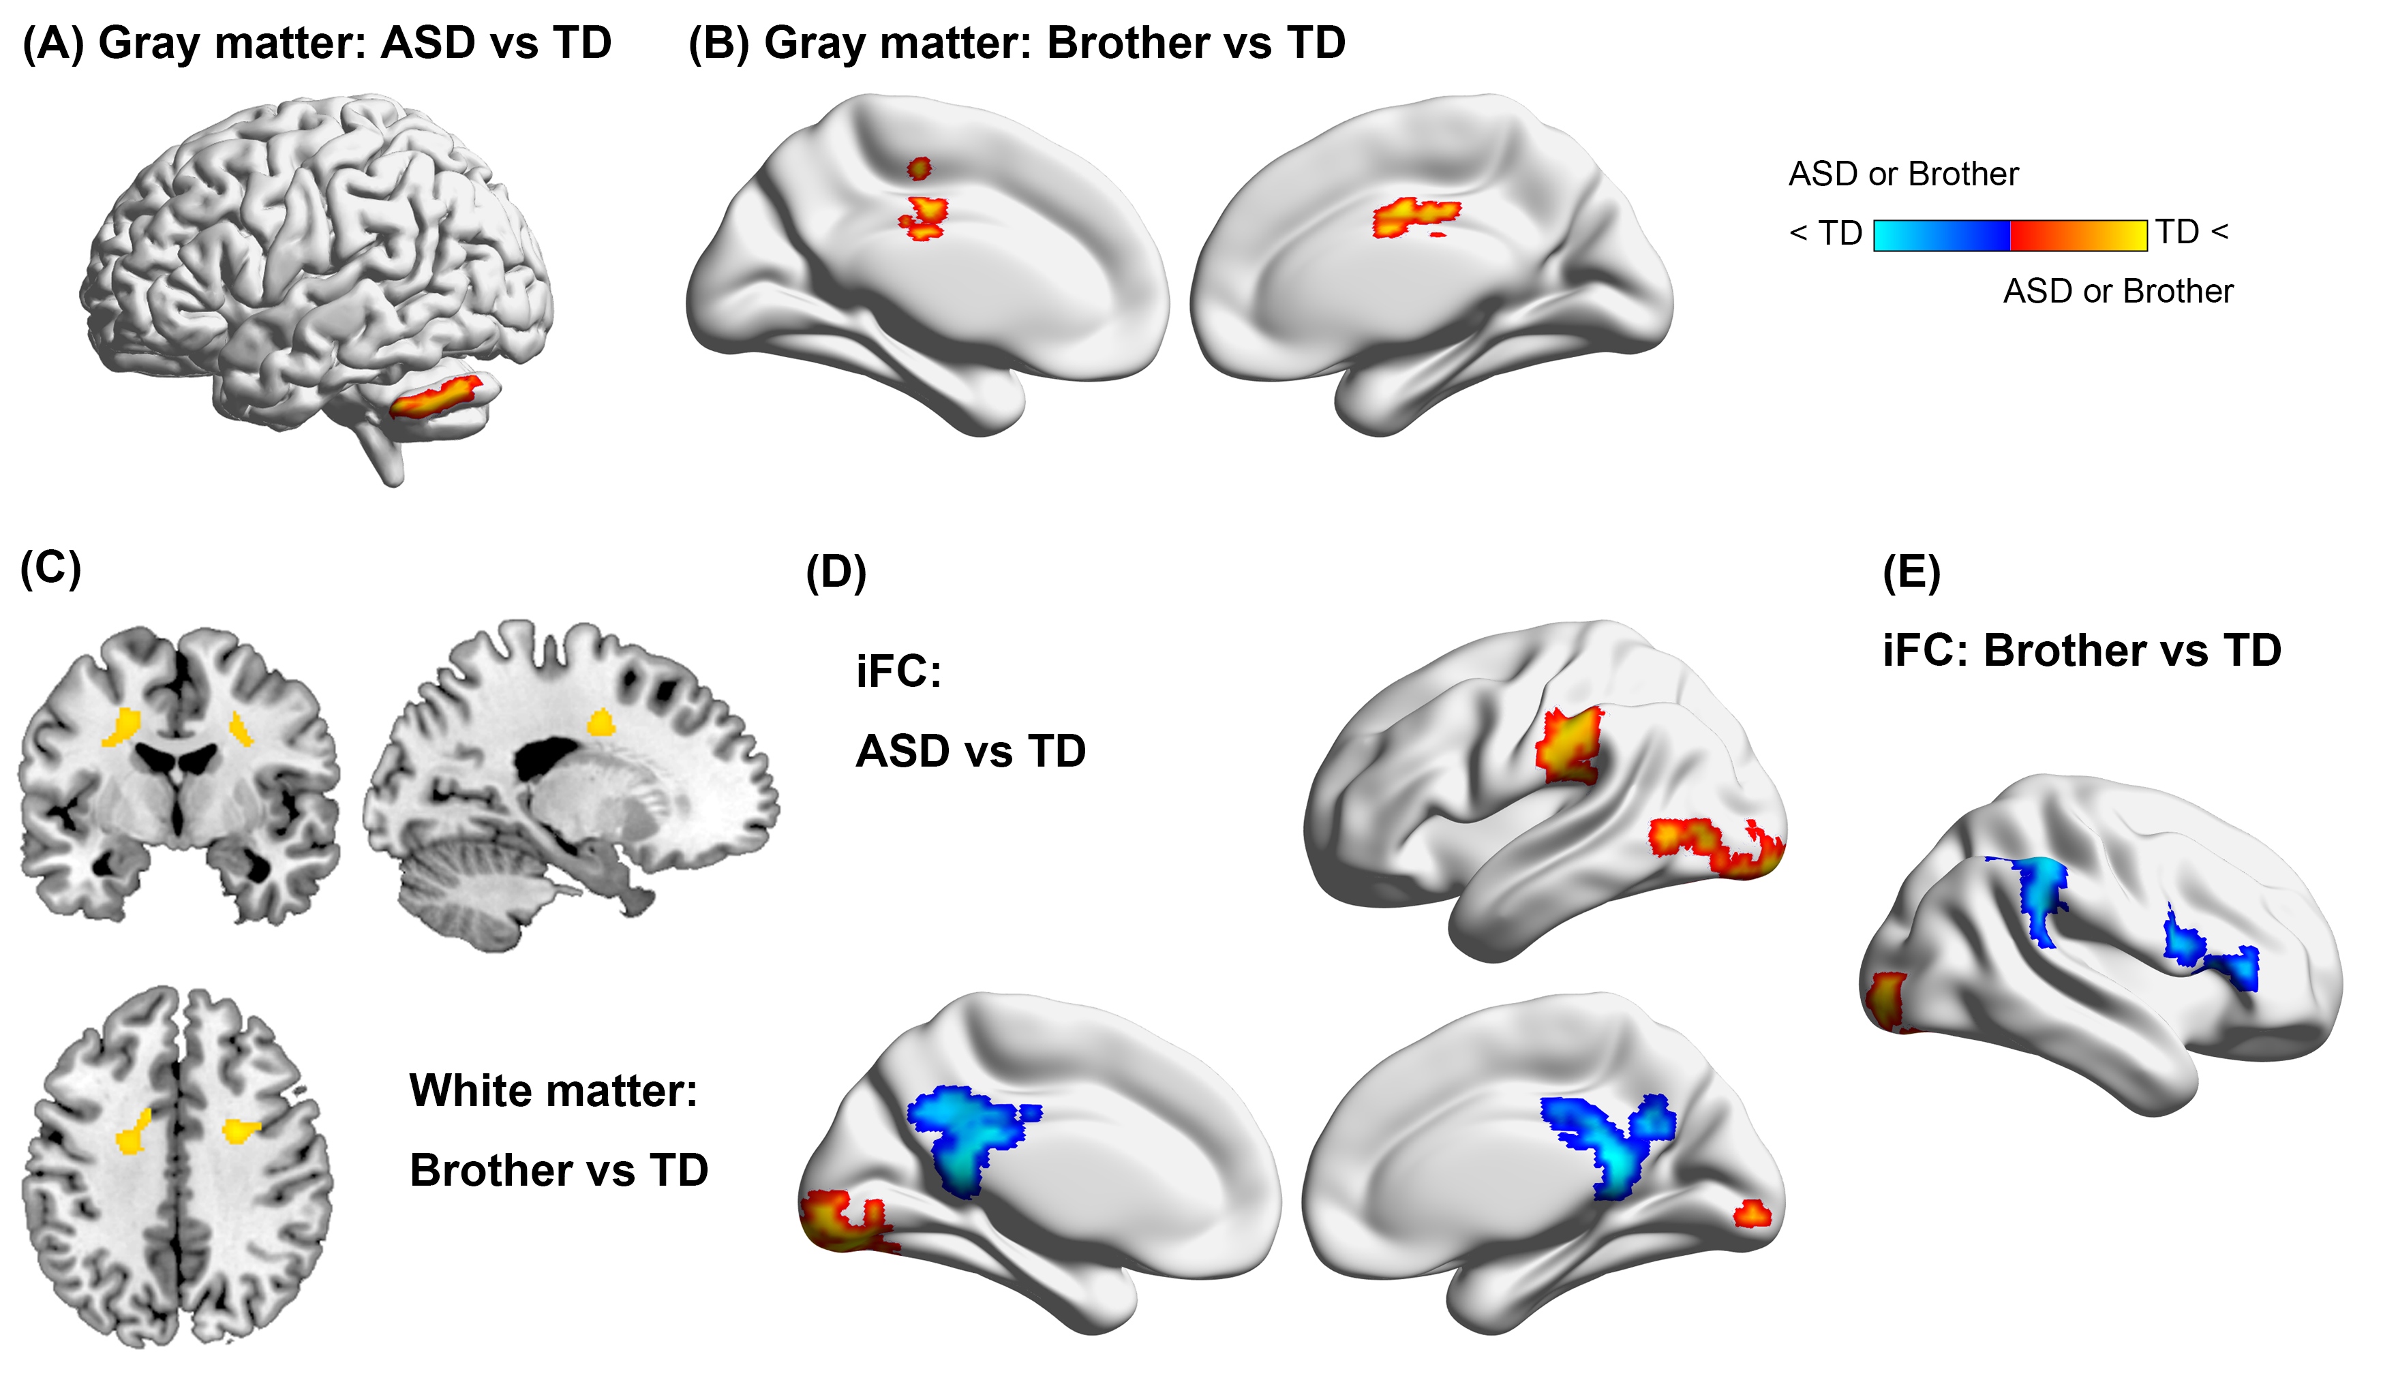

References
Friston, K. J., Penny, W. D. & Glaser, D. E. (2005). Conjunction revisited. NeuroImage 25, 661-667.

