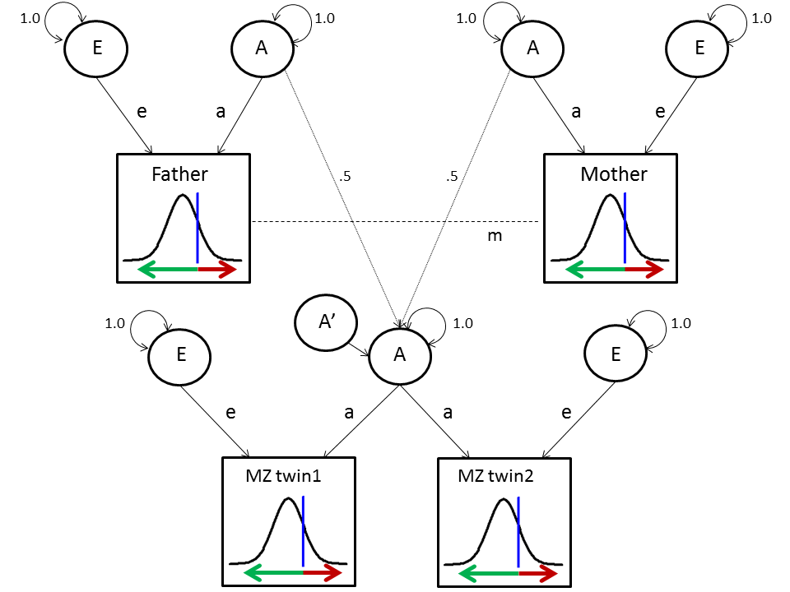

Supplementary Fig. S1. MZ structural equation model; for simplicity reasons siblings are not included; the model for siblings is the same as the model for DZ twins. A represents additive genetic effects, E represents unique environmental effects, and. A’ represents residual additive genetic factors; a and e are the path coefficients to be estimated, and m is the phenotypic correlation between parents. As shown by the liability threshold models in the squares, we assume that A and E influence the continuous latent liability; the person will be affected with a tic disorder when his/her liability lies above the threshold (indicated in red)

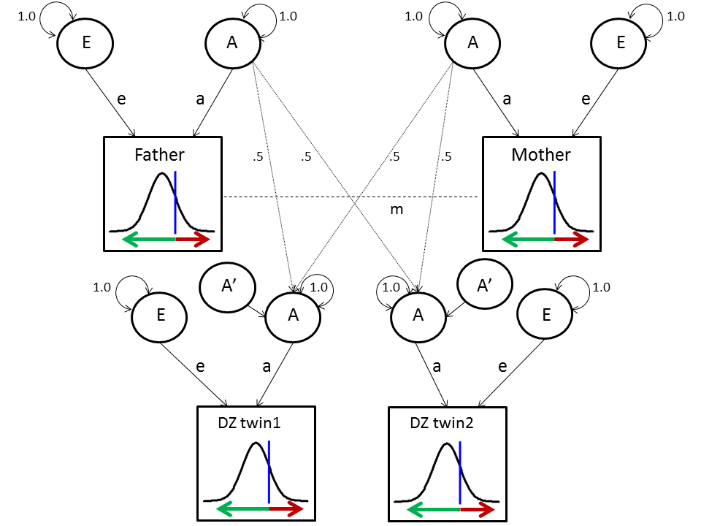

Supplementary Fig. S2. DZ structural equation model; for simplicity reasons siblings are not included; adding siblings is similar to adding more DZ twins

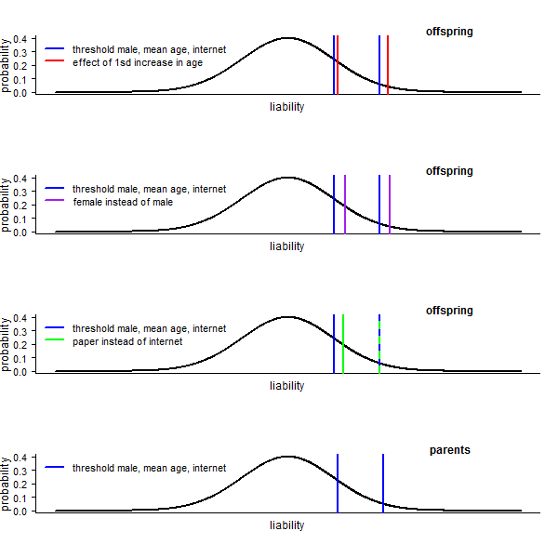Supplementary Fig. S3. Location of estimated thresholds (blue lines) and the effects of covariates (based on the model with twins, parents and siblings). Higher age predicted less tic disorders (with a stronger effect for more serious tic disorders). Females less often reported tic disorders. Participants who reported by paper less often reported tics (but this effect disappeared for more serious tic disorders). Covariate effects are similar in parents and offspring, but all thresholds are slightly higher for parents.

Supplementary Table S1. Frequencies of family members in the data
 | Male | Female
MZ twins (1st / 2nd) | 553/554 | 1446/1448
DZ twins (1st / 2nd) | 710/702 | 1332/1322
parents | 2211 | 3230
siblings (1st / 2nd) | 540/89 | 942/152

Supplementary Table S2. The STOBS-ABBRreviated, used to measure data on tics at the NTR

1 |  | Please indicate whether you have ever had any of the following involuntary sudden nervous tics. (several answers possible) | never | 0-1 years ago | 1-5 years ago | More than 5 years ago
a |  | Eye movements: e.g. blinking, rolling, squinting
b |  | Nose movements: e.g. nose twitching, broadening nostrils
c |  | Lip or mouth movements: e.g. chewing, licking, pouting
d |  | Head shaking
e |  | Shoulder or neck movements
f |  | Arm or hand movements: e.g. rapid ‘purposeless’ bending, stretching
g |  | Squeaking or whistling noises
h |  | Growling, throat clearing, coughing, sniffing
i |  | ‘Purposeless’ cursing or utterance of rude or obscene language
2 |  | If you have suffered from any of the above tics:
a |  | At what age did you first exhibit any of these phenomena? | _____ years (age)
b |  | Have you ever suffered from these tics for more than a year at a time? | ___ No___ Yes
c |  | How often did you have tics in the period that you suffered from them most?
 |  |  | ___ not daily
 |  |  | ___ daily, but tic-free for most of the day
 |  |  | ___ daily, but tic-free periods of 3 hours not uncommon
 |  |  | ___ daily, with tic-free periods of at most half an hour

Supplementary Table S3. Descriptive statistics: number of tics reported
 | Tic | N (%) | Male/Female
Number of participants reporting  specific tics | 1 eye movements | 774 (5.1%) | 321/453
Number of participants reporting  specific tics | 2 nose movements | 363 (2.4%) | 140/223
Number of participants reporting  specific tics | 3 mouth movements | 386 (2.6%) | 120/266
Number of participants reporting  specific tics | 4 head shaking | 183 (1.2%) | 92/91
Number of participants reporting  specific tics | 5 shoulder/neck movements | 229 (1.5%) | 108/121
Number of participants reporting  specific tics | 6 arm/hand movements | 236 (1.6%) | 104/132
Number of participants reporting  specific tics | 7 beep or whistle sounds | 295 (2.0%) | 152/143
Number of participants reporting  specific tics | 8 growling/coughing | 619 (4.1%) | 302/317
Number of participants reporting  specific tics | 9 shouting obscene words | 82 (0.5%) | 46/36

Supplementary Table S4. Tests of covariates sex, age and method of reporting (internet vs. paper)
 | 1) any probable tic |  |  | 2) Probable TS/probable chr.td |  |  | 3) Probable TS/probable chr.motor td.
 | B | SE | p | B | SE | p | B | SE | p
sex | -0.38 | 0.07 | <.001 | -0.66 | 0.18 | <.001 | -0.86 | 0.21 | <.001
age (z-scored) | -0.17 | 0.05 | <.001 | -0.36 | 0.11 | <.001 | -0.52 | 0.12 | <.001
method rrrrrrereportreporting | -0.16 | 0.08 | .045 | -0.20 | 0.20 | .31 | -0.23 | 0.22 | .30
age x method reporting | 0.008 | 0.05 | .87 | -0.33 | 0.15 | .03 | -0.17 | 0.17 | .31
Note. Age was standardized, so the Beta value is the difference per 1sd increase in age (mean age is 41.2 and sd is 16.2 years); Sex and method of reporting are coded as dummy variables with sex=0 for males, sex=1 for females; method of reporting=0 for internet, and method of reporting=1 for paper; so males are more often affected with a tic disorder, and participants who answered by internet more often reported a tic.

Supplementary Table S5. Polychoric correlations (se) between family members for each phenotype of tic disorder
 |  | twin1 | twin2 | father | mother | sibling1 | sibling2
1)  Any tic | twin1 | - | .28 (0.04) | .18 (0.07) | .15 (0.07) | .08 (0.09) | .11 (0.19)
1)  Any tic | twin2 |  | - | .04 (0.07) | .06 (0.07) | .12 (0.08) | .19 (0.21)
1)  Any tic | father |  |  | - | .10 (0.07) | .25 (0.10) | NA
1)  Any tic | mother |  |  |  | - | .19 (0.09) | NA
1)  Any tic | sibling1 |  |  |  |  | - | .11 (0.16)
1)  Any tic | sibling2 |  |  |  |  |  | -
 |  | twin1 | twin2 | father | mother | sibling1 | sibling2
2)  Tourette  /chr. td. | twin1 | - | .20 (0.15) | NA | NA | NA | NA
2)  Tourette  /chr. td. | twin2 |  | - | .55 (0.14) | .40 (0.17) | NA | NA
2)  Tourette  /chr. td. | father |  |  | - | .37 (0.21) | .34 (0.24) | NA
2)  Tourette  /chr. td. | mother |  |  |  | - | NA | NA
2)  Tourette  /chr. td. | sibling1 |  |  |  |  | - | NA
2)  Tourette  /chr. td. | sibling2 |  |  |  |  |  | -
 |  | twin1 | twin2 | father | mother | sibling1 | sibling2
3)  Tourette  /chr.  motor td. | twin1 | - | .25 (.15) | NA | NA | NA | NA
3)  Tourette  /chr.  motor td. | twin2 |  | - | NA | .51 (0.16) | NA | NA
3)  Tourette  /chr.  motor td. | father |  |  | - | .49 (0.21) | .46 (0.24) | NA
3)  Tourette  /chr.  motor td. | mother |  |  |  | - | NA | NA
3)  Tourette  /chr.  motor td. | sibling1 |  |  |  |  | - | NA
3)  Tourette  /chr.  motor td. | sibling2 |  |  |  |  |  | -
 |  | twin1 | twin2 | father | Mother | sibling1 | sibling2
4) Three levels* | twin1 | - | .27 (0.05) | .20 (0.07) | .17 (0.07) | .03 (0.10) | .10 (0.20)
4) Three levels* | twin2 |  | - | .10 (0.08) | .06 (0.08) | .09 (0.09) | .32 (0.20)
4) Three levels* | father |  |  | - | .09 (0.08) | .27 (0.10) | NA
4) Three levels* | mother |  |  |  | - | .19 (0.10) | NA
4) Three levels* | sibling1 |  |  |  |  | - | .16 (0.17)
4) Three levels* | sibling2 |  |  |  |  |  | -
Note. For these correlations only families were included for whom data of at least one twin with known zygosity was available (genetic analyses also include families for whom no twin data was available); in this table MZ and DZ twins are mixed; NA = tetrachoric correlation could not be calculated due to missingness (e.g. no families where both these family members are affected); * no tics vs. transient tic disorder vs. chronic tic disorder

