Supplementary material

- Measurement Model: Functioning – Life Skills Profile (LSP) only
- Alternative Final Model

Measurement Model: Functioning - Life skills Profile (LSP) only
The confirmatory factor analysis for the Functioning latent variable without the GAF showed that all measures of Functioning made a significant contribution to their latent variable (loading range: 0.41-0.62; P<0.01)

Alternative Final Model
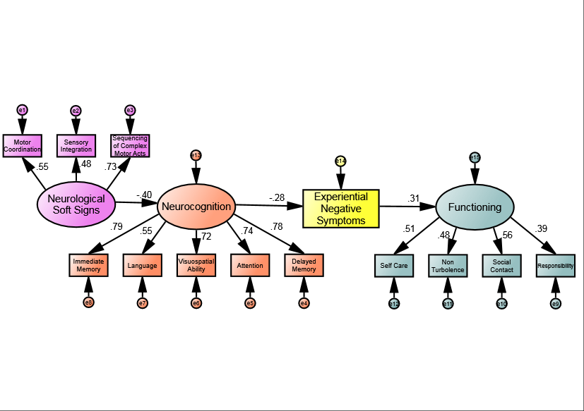
*
**
**
**
**
**
**
**
**
**
**
**
**
**
**
Alternative Final Model. A single path running through Neurological soft signs, Neurocognition, Experiential negative symptoms, and Functioning. *p < 0.05 , **p < 0.01
Differently from the Final Model depicted in the main manuscript, the variable “Functioning” has been built only on LSP-39 subscales.
Model fit indices: χ2 = 85.19; P = 0.03; CFI = 0.94; RMSEA = 0.05. NSS retained its significant influence on Functioning (Indirect Effect: β=0.035; 95% CI= 0.020 to 0.087; P=0.010).

