Supplementary material
Genetic Influences on Hormonal Markers of Chronic HPA Function in Human Hair
Tucker-Drob EM, Grotzinger A, Briley DA, Engelhardt LE, Mann FD, Patterson M, Kirschbaum

Results of Post-Hoc Analyses: Dichotomous Age and SES Moderation
Moderation by age. Inspection of age LOSEM results for cortisol and cortisone indicated one transition point at approximately 13 years of age. Two discrete groups were created with participants 13 years of age or younger coded as 0 and participants older than 13 coded as 1. The baseline model allowed for interactions between the dichotomized age or SES variable and ACE estimates for cortisol, cortisone and their association. All models also included mean sex and age differences and an age × sex interaction; age was entered as a continuous covariate. Model fit indices for dichotomous age moderation models are summarized in the top portion of Supplementary Table S3. Including moderation by age of the association between shared environmental factors prohibited model convergence and this interaction term was excluded from all models. As with the continuous moderation results, removing age moderation of the remaining ACE parameters for cortisol, cortisone, or the cross-trait correlations significantly decreased model fit relative to the baseline model. Removing age moderation entirely also significantly decreased model fit relative to the baseline model.
Moderation by SES. Inspection of SES LOSEM results revealed a transition point at approximately -0.5 SDs. Two discrete groups were created for participants with SES scores at or below -0.5 SDs and participants above -0.5 SDs. The baseline model also included SES as a continuous covariate. Model fit indices for dichotomous SES moderation models are summarized in the bottom portion of Supplementary Table S3. As with age, including moderation by SES of the association between shared environmental factors resulted in a series of models that failed to converge and, therefore, this interaction term was excluded for all analyses. Model comparisons revealed that removing SES moderation of remaining ACE parameters for cortisol, cortisone, or the cross-trait correlations did not significantly decrease model fit relative to the baseline mode. In addition, removing all moderation by SES did not significantly decrease model fit. Finally, allowing SES to moderate only shared environmental influences did not significantly increase model fit relative to a model that included no moderation.

Supplementary Table S1. Model fit indices and sex-specific parameter estimates for bivariate sex limitation models
 |  |  |  |  | Cortisol |  |  |  | Cortisone
Model | BIC | AIC | Model Fit Comparisons |  | a | c | e |  | a | c | e
Model 1a: Qualitative C; cortisol and cortisone quantitative differences; sex-specific age differences | 6010.51 | 5860.62 | Model 1a vs. 1c: Δχ2(5) = 5.60, p = .35 | M | .58 [.06, 1.10] | .64** [.27, 1.01] | .54*** [.38, .70] |  | .44  [-.13, 1.00] | .66*** [.37, .96] | .58*** [.46, .70]
 |  |  |  | F | .73*** [.61, .86] | .06 [-.83, .95] | .62*** [.55, .69] |  | .55  [-.05, 1.15] | .47  [-.12, 1.06] | .71***  [.59, .82]
Model 1b: Qualitative A, cortisol and cortisone quantitative differences; sex-specific age differences | 6011.09 | 5861.20 | Model 1b vs. 1c: Δχ2(5) = 7.46, p = .19 | M | .66** [.33, .98] | .58** [.27, .90] | .53*** [.41, .66] |  | .46* [.08, .85] | .65*** [.40, .89] | .59*** [.49, .68]
 |  |  |  | F | .73***  [.60, .86] | .09  [-.51, .69] | .62***  [.54, .69] |  | .70**  [.35, 1.06] | .22  [-.76, 1.19] | .69***  [.59, .79]
Model 1c: Cortisol and cortisone quantitative differences, sex-specific age differences | 5988.21 | 5860.36 |  | M | .64** [.28, .99] | .60** [.27, .93] | .53*** [.41, .66] |  | .41* [.10, .72] | .68*** [.51, .85] | .59*** [.51 .67]
 |  |  |  | F | .72*** [.61, .83] | .12 [-.19, .42] | .62*** [.55, .70] |  | .67***  [.49, .85] | .29  [-.01, .59] | .71***  [.61, .80]
Model 2a: Cortisone quantitative differences, mean sex differences | 5978.01 | 5863.39 | Model 1c vs. 2a: Δχ2(3) = 4.14, p = .25 | M | .79*** [.67, .91] | -.06 [-1.15, 1.03] | .58*** [.52, .65] |  | .65*** [.41, .89] | .44* [.13, .75] | .57***  [.49, .66]
 |  |  |  | F | .79*** [.67, .91] | -.06 [-1.15, 1.03] | .58*** [.52, .65] |  | .70*** [.54, .87] | .25 [-.08, .58] | .70*** [.61, .80]
Model 2b: Cortisol quantitative differences, sex-specific age differences | 5979.48 | 5864.86 | Model 1c vs. 2b: Δχ2(3) = 8.71, p = .03 | M | .76*** [.48, 1.03] | .45 [.05, .85] | .53*** [.42, .65] |  | .62*** [.38, .89] | .43* [.16, .70] | .66*** [.59, .74]
 |  |  |  | F | .70***  [.56, .83] | .18  [-.10, .47] | .63***  [.55, .71] |  | .62*** [.38, .89] | .43* [.16, .70] | .66*** [.59, .74]
Model 3: sex-specific age differences | 5968.97 | 5867.57 | Model 2a vs. 3: Δχ2(3) = 8.75, p = .03 |  | .77***  [.61, .93] | .19  [-.31, .69] | .59***  [.52, .65] |  | .64***  [.42, .87] | .39*  [.10, .69] | .66***  [.59, .74]
Model 4: No sex differences | 5993.57 | 5909.80 | Model 3 vs. 4: Δχ2(4) = 30.00, p < .001 |  | .80***  [.73, .88] | .03  [-.41, .47] | .59***  [.53, .65] |  | .70***  [.50, .90] | .33  [.00, .67] | .67***  [.59, .74]
Note. 95% confidence intervals are given in brackets. All models controlled for race and age as exogenous covariates. Estimates indicate unstandardized path estimates. Estimates in the M row are for males; estimates in the F row are for females. a, genetic path estimate; c, shared environment; e, non-shared environment ***significantly different than zero at p < .001; ** p < .01; * p < .05
Supplementary Table S2. Model fits for bivariate age and SES moderation models of genetic and environmental influences on cortisol and cortisone
Model | BIC | AIC | Model Fit Comparisons
Age Moderation
Model 1: age moderation cortisol, cortisone, and correlations | 5943.46 | 5802.38
Model 2a: age moderation cortisone and correlations | 5952.80 | 5824.96 | Model 1 vs. 2a: Δχ2(3) = 18.19, p < .001
Model 2b: age moderation cortisol and correlations | 5940.42 | 5812.57 | Model 1 vs. 2b: Δχ2(3) = 9.83, p = .02
Model 2c: age moderation cortisol and cortisone | 5940.84 | 5812.99 | Model 1 vs. 2c: Δχ2(3) = 11.54, p = .009
Model 3: no age moderation | 5968.97 | 5867.57 | Model 1 vs. 3: Δχ2(9) = 51.05, p < .001
SES Moderation
Model 1: SES moderation cortisol, cortisone, and correlations | 5589.90 | 5442.21
Model 2a: SES moderation cortisone and correlations | 5578.63 | 5443.97 | Model 1 vs. 2a: Δχ2(3) = 5.87, p = .12
Model 2b: SES moderation cortisol and correlations | 5578.98 | 5444.32 | Model 1 vs. 2b: Δχ2(3) = 7.42, p = .06
Model 2c: SES moderation cortisol and cortisone | 5574.31 | 5439.65 | Model 1 vs. 2c: Δχ2(3) = 2.42, p = .49
Model 3: no SES moderation | 5549.89 | 5441.29 | Model 1 vs. 3: Δχ2(9) = 11.67, p = .23

Note. 95% confidence intervals are given in brackets. All models controlled for race, sex, and sex-specific linear effects of age; all SES models also included a main effect of SES. Age and SES moderation was examined continuously. a, genetic path estimate; c, shared environment; e, non-shared environment ***significantly different than zero at p < .001; ** p < .01; * p < .05
Supplementary Table S3. Dichotomous age and SES moderation models
Model | BIC | AIC | Model Fit Comparisons
Age Moderation
Model 1: age moderation cortisol, cortisone, and genetic and non-shared environmental correlations | 5928.67 | 5792.00
Model 2a: age moderation cortisone and correlations | 5952.80 | 5824.96 | Model 1 vs. 2a: Δχ2(3) = 16.23, p = .001
Model 2b: age moderation cortisol and correlations | 5925.95 | 5802.51 | Model 1 vs. 2b: Δχ2(3) = 10.33, p = .02
Model 2c: age moderation cortisol and cortisone | 5927.95 | 5800.11 | Model 1 vs. 2c: Δχ2(2) = 8.21, p = .02
Model 3: no age moderation | 5968.97 | 5867.57 | Model 1 vs. 3: Δχ2(8) = 61.12, p < .001
SES Moderation
Model 1: SES moderation cortisol, cortisone, and correlations | 5592.40 | 5449.05
Model 2a: SES moderation cortisone and correlations | 5579.32 | 5449.01 | Model 1 vs. 2a: Δχ2(3) = 4.41, p = .22
Model 2b: SES moderation cortisol and correlations | 5576.01 | 5446.69 | Model 1 vs. 2b: Δχ2(3) = 1.97, p = .58
Model 2c: SES moderation cortisol and cortisone | 5581.12 | 5446.46 | Model 1 vs. 2c: Δχ2(2) = 1.10, p = .58
Model 3: no SES moderation | 5549.89 | 5441.29 | Model 1 vs. 3: Δχ2(8) = 5.17, p = .74
Model 4: SES moderation shared environment | 5562.09 | 5444.80 | Model 1 vs. 4: Δχ2(6) = 4.96, p = .55  Model 3 vs. 4: Δχ2(2) = 0.28, p = .87

Note. All models controlled for race, sex, and sex-specific linear effects of age; all SES models also included a main effect of SES.
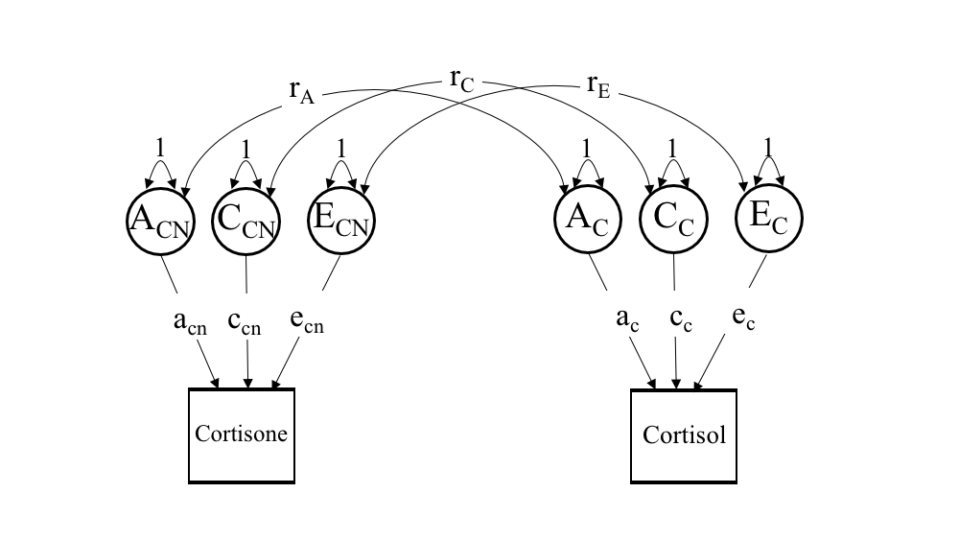

Supplementary Fig. S1. Path diagram for bivariate correlated factors model used in all parametric and nonparametric LOSEM analyses. For ease of presentation only one twin per pair is depicted.

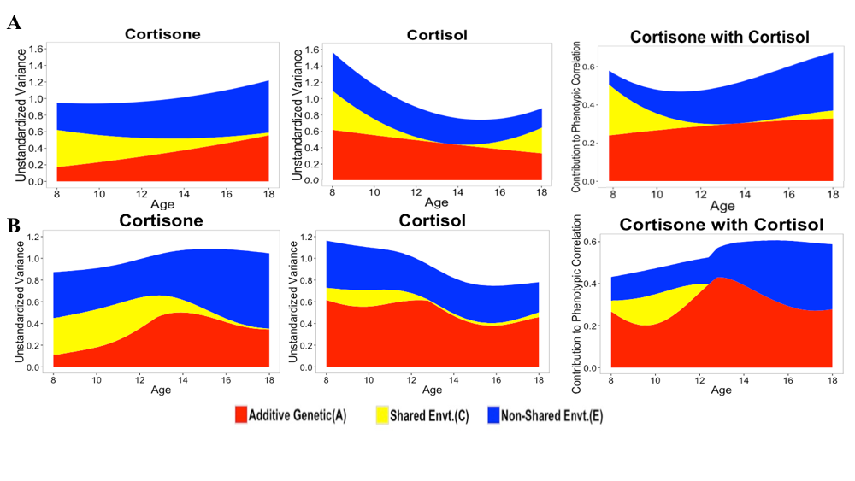Supplementary Fig. S2. Moderation by age of ACE contributions to unstandardized variance in cortisone and cortisol and their bivariate association from parametric moderation model (row A) and using nonparametric LOSEM (row B).

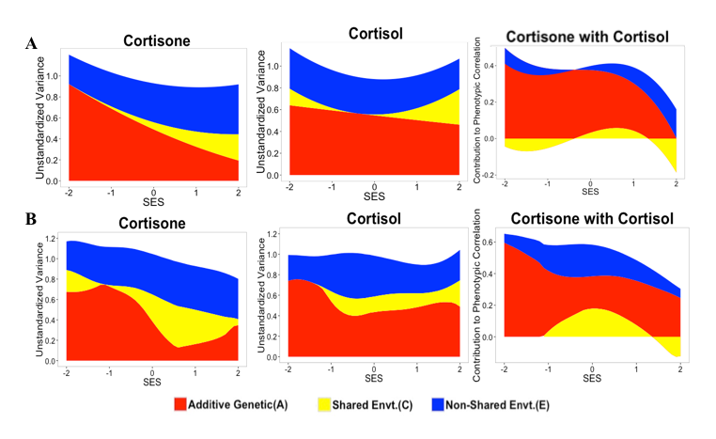
Supplementary Fig. S3. Moderation by SES of ACE contributions to unstandardized variance in cortisone and cortisol and their bivariate association from parametric moderation model (row A) and using nonparametric LOSEM (row B). For LOSEM estimates, shared environmental contributions to phenotypic correlations are not depicted when shared environmental variance was estimated at < 0.01 for cortisol or cortisone.

