Supplementary material

Supplementary Table S1. Global Graph Theory Measures

Metric | Healthy Control  Mean ± SD | Bipolar Disorder  Mean ± SD | F, p value
Betweenness Centrality | 64.75 ± 5.52 | 64.52 ± 6.93 | 0.060, 0.807
Clustering Coefficient | 0.23 ± 0.01 | 0.22 ± 0.02 | 4.083, 0.047*
Characteristic Path Length | 4.10 ± 0.16 | 4.21 ±0.26 | 5.975, 0.017*
Degree | 45.49 ± 2.45 | 45.27 ± 2.38 | 0.021, 0.885
Global Efficiency | 0.27 ± 0.01 | 0.26 ± 0.02 | 6.137, 0.015*

* Indicates significant p-value after multiple comparison correction. GLM model was applied, ANCOVA was carried out across global measures. Three of five global measures were deemed significant following at p<0.05.

Supplementary Fig. S1. Relationship between Global Efficiency and Rich-Club Density

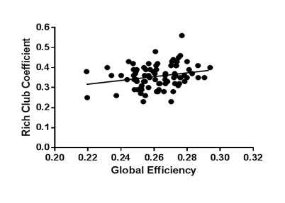
Positive relationship detected between increased rich club coefficient density and increased global efficiency(r=0.299, p<0.006). Differences in rich club connection density may relate to reduced global brain communication.

