Supplementary Fig. S1. Grand average MMN data of the MMN paradigm at baseline and follow-up (lead Fz), showing no significant differences between patients and controls.
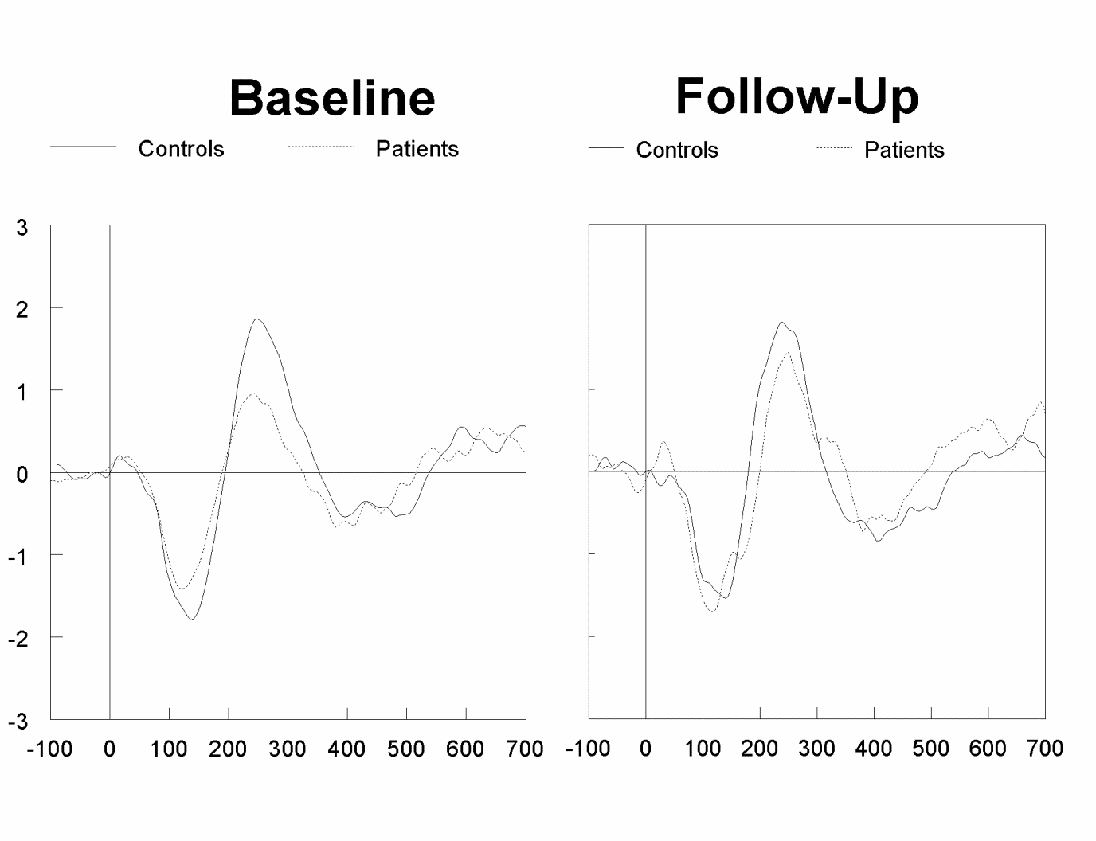
Supplementary Fig. S2. Grand average MMN data of the SA paradigm at baseline and follow-up (lead Fz). The insert shows a bar graph of MMN stratified for patients on high and low dosages of quetiapine. The data shows less MMN in patients at baseline compared to controls, and indicate significantly increased MMN in patients on higher dosages of quetiapine only.
* p<0.05
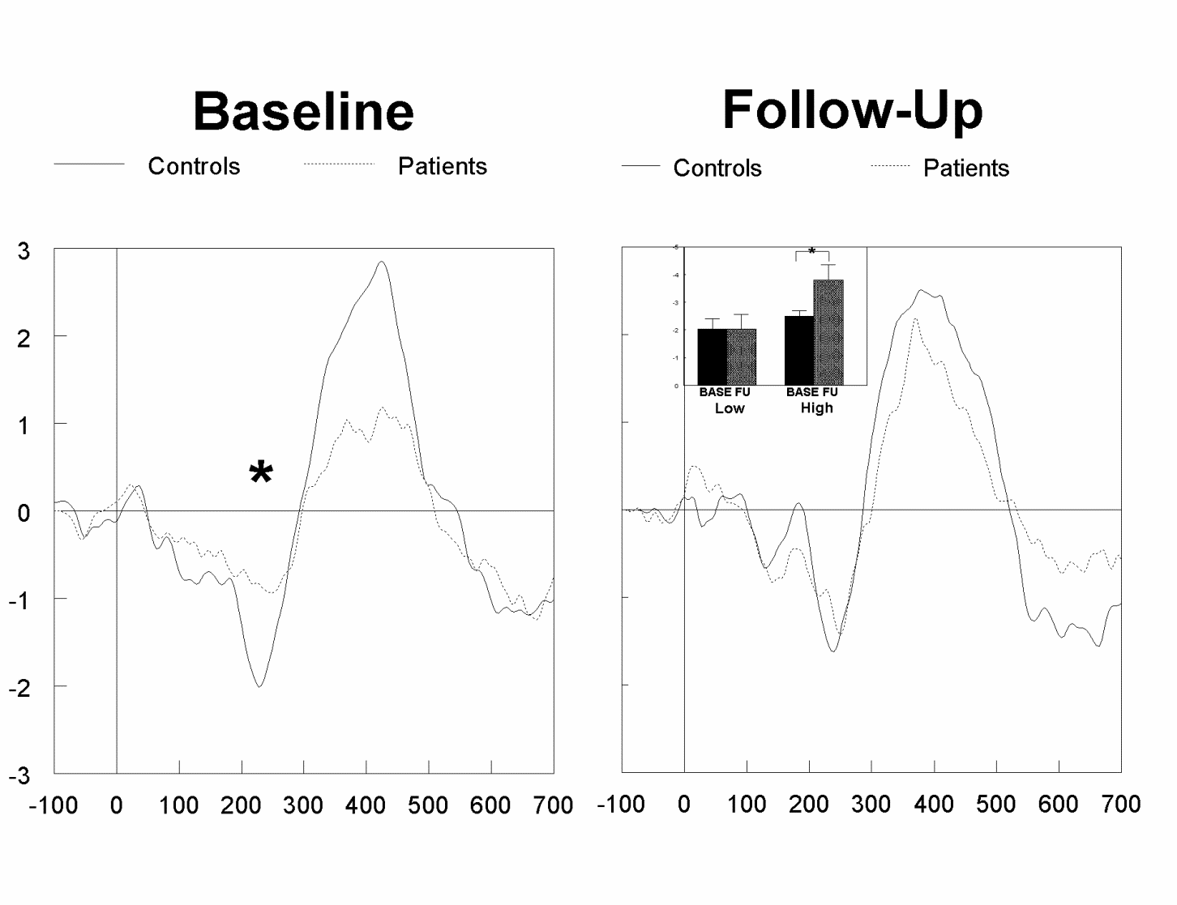
Supplementary Fig. S3. Grand average P3B amplitude to targets at baseline and follow-up (lead Pz), showing significantly lower amplitudes in patients at baseline as well as follow-up.
* p<0.005

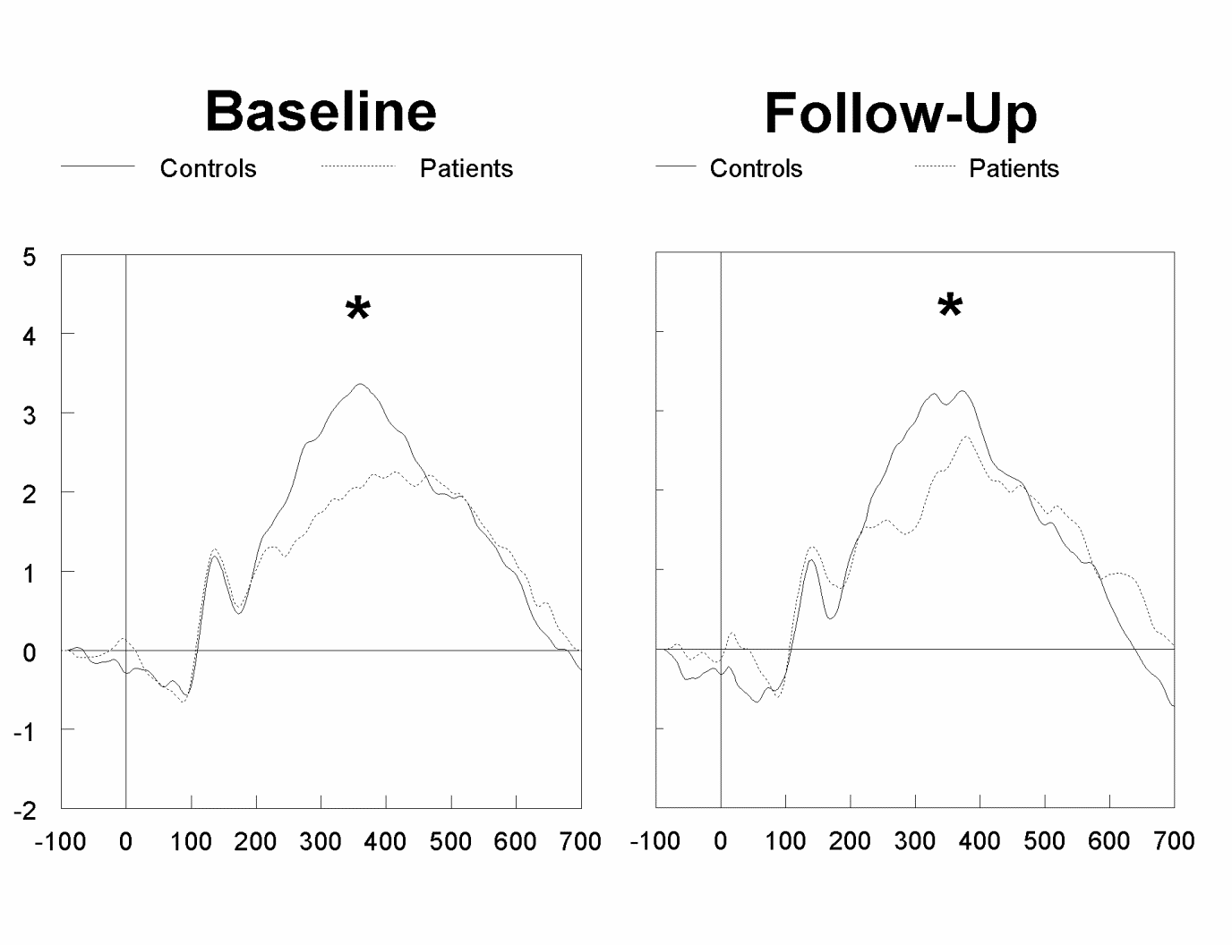
Supplementary Fig. S4. Grand average PN data at baseline and follow-up (lead Fz), showing on average less PN amplitude in patients compared to controls, but this did not reach statistical significance.

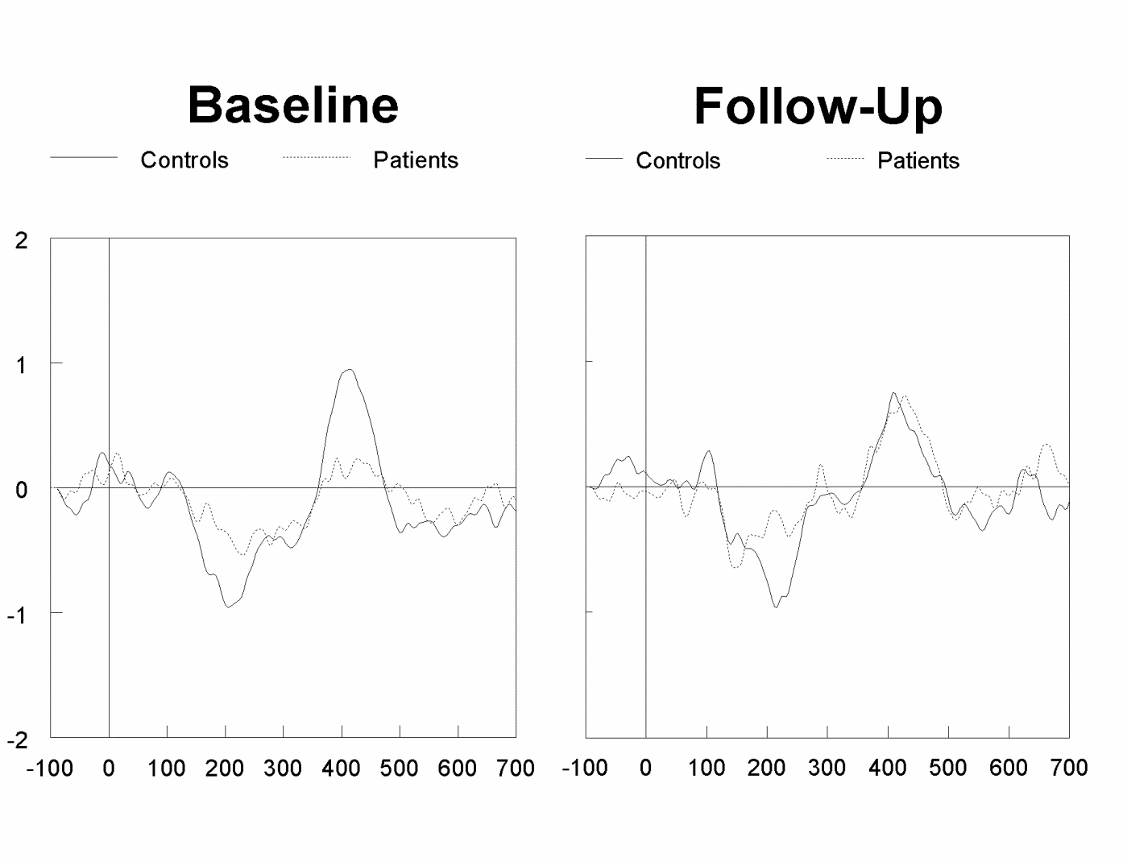

Supplementary Table S1. Correlations between electrophysiological measures at baseline

 | P3B |  | PN |  | sMMN |  | MMN
 | ctrls | pts | ctrls | pts | ctrls | pts | ctrls | pts
P3B | -- | -- | -0.324 (0.063) | 0.176 (0.354) | -0.307 (0.079) | -0.074 (0.7) | -0.425 (0.016) | 0.124 (0.517)
PN | -0.324 (0.063) | 0.176 (0.354) | -- | -- | 0.26 (0.138) | 0.337 (0.07) | 0.117 (0.527) | 0.322 (0.084)
sMMN | -0.307 (0.079) | -0.074 (0.7) | 0.26 (0.138) | 0.337 (0.07) | -- | -- | -0.086 (0.643) | 0.456 (0.012)
MMN | -0.425 (0.016) | 0.124 (0.517) | 0.117 (0.527) | 0.322 (0.084) | -0.086 (0.643) | 0.456 (0.012) | -- | --
N1AD | -0.457 (0.007) | 0.029 (0.881) | 0.286 (0.103) | -0.004 (0.987) | 0.299 (0.087) | 0.122 (0.524) | 0.413 (0.019) | 0.435 (0.017)
N1AS | -0.51 (0.003) | 0.002 (0.993) | 0.495 (0.003) | 0.223 (0.239) | 0.337 (0.052) | 0.35 (0.059) | 0.312 (0.084) | 0.335 (0.071)
N1ND | -0.473 (0.005) | -0.051 (0.793) | 0.409 (0.017) | 0.243 (0.197) | 0.407 (0.017) | 0.527 (0.003) | 0.399 (0.024) | 0.457 (0.012)
N1NS | -0.361 (0.036) | -0.006 (0.976) | 0.41 (0.016) | 0.033 (0.864) | 0.32 (0.066) | 0.117 (0.54) | 0.451 (0.01) | 0.204 (0.281)
P2AD | 0.383 (0.026) | 0.339 (0.068) | -0.141 (0.428) | -0.122 (0.523) | 0.278 (0.112) | 0.109 (0.567) | -0.124 (0.503) | 0.01 (0.96)
P2AS | 0.502 (0.003) | -0.006 (0.976) | -0.245 (0.164) | -0.047 (0.808) | -0.025 (0.892) | 0.23 (0.222) | -0.289 (0.109) | -0.174 (0.36)
P2ND | 0.411 (0.016) | 0.07 (0.717) | -0.552 (0.001) | -0.15 (0.431) | 0.05 (0.782) | 0.224 (0.236) | -0.076 (0.68) | -0.237 (0.208)
P2NS | 0.497 (0.003) | -0.081 (0.674) | -0.6 (0.001) | -0.244 (0.194) | -0.207 (0.242) | 0.162 (0.393) | -0.097 (0.601) | -0.177 (0.352)

Correlations are expressed as Pearson’s R, with p-levels in parentheses.
MMN: Mismatch negativity; sMMN: MMN derived from selective attention paradigm; PN: Processing negativity; Ctrls: controls; pts: patients; AD: Attended deviant stimuli; AS: attended standard stimuli; ND: Non-attended deviant stimul; NS: Non-attended standard stimuli
Bold: significant at <0.05

