Supplemental Table 1. GRADE Analyses: Adjunctive memantine for schizophrenia

Primary/secondary outcome | Studies (N) | Risk of bias | Inconsistency | Indirectness | Imprecision | Publication bias | Large effect | Overall quality of evidenceª
PANSS/BPRS total symptoms | 6 (335) | No | Serious^{b} | No | No | No | No | +/+/+/-/; moderate
PANSS/BPRS negative symptoms | 7 (381) | No | Serious^{b} | No | No | Serious^{c} | No | +/+/-/-/; Low
PANSS/BPRS positive symptoms | 7 (381) | No | No | No | No | Serious^{c} | No | +/+/+/-/; moderate
PANSS general symptoms | 4 (176) | No | No | No | No | Serious^{c} | No | +/+/+/-/; moderate
MMSE scores | 3 (93) | No | No | No | No | Serious^{c} | Large | +/+/+/+/; High
CGI-S scores | 3 (205) | No | No | No | No | Serious^{c} | No | +/+/+/-/; moderate
All cause discontinuation | 6 (362) | No | No | No | No | No | No | +/+/+/+/; High
Fatigue | 2 (176) | No | No | No | No | Serious^{c} | No | +/+/+/-/; moderate
Dizziness | 5 (283) | No | No | No | No | Serious^{c} | No | +/+/+/-/; moderate
Constipation | 5 (326) | No | No | No | No | No | No | +/+/+/+/; High
Anxiety | 2 (176) | No | No | No | No | Serious^{c} | No | +/+/+/-/; moderate
Headache | 4 (262) | No | No | No | No | Serious^{c} | No | +/+/+/-/; moderate
Diarrhea | 2 (162) | No | No | No | No | Serious^{c} | No | +/+/+/-/; moderate
Nausea | 4 (257) | No | No | No | No | Serious^{c} | No | +/+/+/-/; moderate
BPRS=Brief Psychiatric Rating Scale; CGI-S=the Clinical Global Impression Severity Scale; GRADE=grading of recommendations assessment, development, and evaluation; MMSE=the Mini-Mental State Examination; PANSS=Positive and Negative Syndrome Scale.
ªGRADE Working Group grades of evidence: High quality=further research is very unlikely to change our confidence in the estimate of effect. Moderate quality=further research is likely to have an important impact on our confidence in the estimate of effect and may change the estimate. Low quality=further research is very likely to have an important impact on our confidence in the estimate of effect and is likely to change the estimate. Very low quality=we are very uncertain about the estimate.
^{b}Meta-analytic results presented a serious inconsistency when I² values were greater than 50% or P<0.1 in the Q statistics.
^{c}For continuous outcomes, N<400. For dichotomous outcomes, N<300.
^{d} Studies with large effects (or even more with very large) provided increased quality of evidence. Large effects= 2<RR<0.5. Very large effects= 5<RR<0.2.

Supplement Figure 1: Risk of bias
 | Random sequence generation (selection bias) | Allocation concealment (selection bias) | Blinding of participants and personnel | Blinding of outcome assessment (Symptom reduction, response) | Incomplete outcome data addressed (attrition bias) | Selective reporting (reporting bias) | Other sources of bias
de Lucena 2009 | ? | ? | + | + | + | + | ?
Lieberman 2009 | ? | ? | + | + | + | + | ?
Gu 2012 | ? | ? | + | + | + | ? | ?
Lee 2012 | + | ? | + | + | + | + | ?
Mazinani 2016 | + | + | + | + | + | + | ?
Rezaei 2013 | + | + | + | + | + | + | ?
Omranifard 2015 | + | ? | + | + | + | + | ?
Veerman 2016 | + | + | + | + | + | + | ?
+ : Low risk of bias, - : High risk of bias, ? : Unclear risk of bias

Supplemental Figure 2. Meta-regression analysis: the effect of baseline total psychopathology scores on the effect size for negative symptoms
Supplemental Figure 3. Meta-regression analysis: the effect of baseline positive symptom scores on the effect size for negative symptoms
Supplemental Figure 4. Adjunctive memantine for schizophrenia: forest plot for the Clinical Global Impression Severity Scale (CGI-S) at endpoint

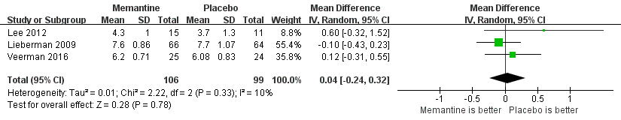
Supplemental Figure 5. Adjunctive memantine for schizophrenia: forest plot for all cause discontinuation
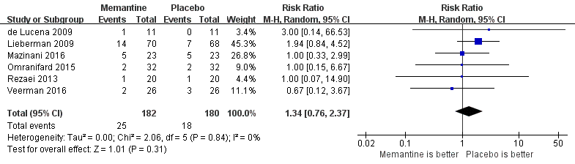
Supplemental Figure 6. Adjunctive memantine for schizophrenia: forest plot for adverse drug reactions (ADRs)
