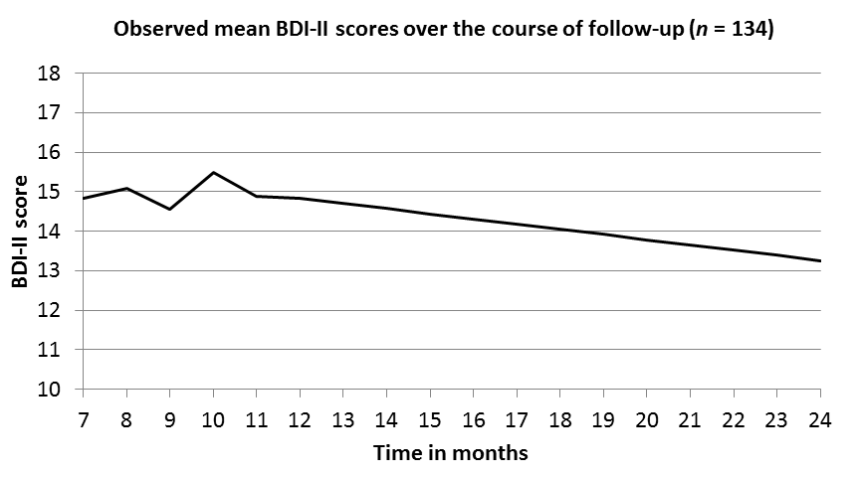

Data supplement. Observed mean scores on the Beck Depression Inventory-II (BDI-II) over the course
of follow-up (7 – 24 months) for the total sample (n = 134). Note: time in months starts the month after baseline (baseline = month 0).

