**SUPPLEMENTAL MATERIALS**

**Accelerated alcohol use across adolescence predicts early adult symptoms of alcohol use disorder via reward-related neural function**

**Rebecca Waller1,2,Laura Murray1, Daniel S. Shaw3, Erika E. Forbes4, and Luke W. Hyde1,5,6\***

**1**Department of Psychology, University of Michigan, Ann Arbor, USA

**2**Department of Psychiatry, University of Michigan, Ann Arbor, USA

**3**Department of Psychology, University of Pittsburgh, Pittsburgh, USA

**4**Department of Psychiatry, University of Pittsburgh Medical Center, Pittsburgh, USA

**5**Center for Human Growth and Development, University of Michigan, Ann Arbor, USA

**6**Survey Research Center of the Institute for Social Research, University of Michigan, Ann Arbor, USA

**\*Corresponding author**

Luke W. Hyde, Department of Psychology, 530 Church Street, University of Michigan, Ann Arbor, MI 48109, USA. Email: [lukehyde@umich.edu](mailto:lukehyde@umich.edu). Tel: 001 734 763-4132

**Supplemental Methods**

**Outcome measure - Symptoms of Alcohol Use Disorder (ages 20 and 22)**

To assess alcohol use disorder (AUD) at ages 20 and 22, we used interviewer assessments from the Structured Clinical Interview for DSM-IV Axis I (SCID-I) (American Psychiatric Association, 2000, First *et al.*, 1995). To establish reliability, clinical interviewers participated in an intensive training program by the training director of the onsite PhD clinical psychology training center who is a licensed clinical psychologist and teaches assessment courses to clinical psychology PhD students. This training was augmented by further supervision and training from advanced doctoral-level clinical psychology students. All examiners were tested for agreement on clinical training video tapes and observed multiple times by experienced examiners before administering the interview. In addition, every case in which a participant approached or met diagnostic criteria was discussed at regularly held consensus diagnosis meetings, which included all interviewers and the third and last authors, who are licensed clinical psychologists with decades of combined experience in structured clinical interviews (Hyde *et al.*, 2016).

**Adolescent comorbid psychiatric disorders**

To confirm that relationships between adolescent alcohol use and brain reward-related functioning were not due to earlier ADHD or Conduct Disorder, both well-established risk factors for Alcohol Use Disorder (van Emmerik-van Oortmerssen *et al.*, 2012), we included ADHD and Conduct Disorder diagnoses from the Schedule for Affective Disorders and Schizophrenia for School Age Children (K-SADS) (Kaufman *et al.*, 1997) Primary caregivers and their sons were administered the K-SADS by a trained examiner. The K-SADS is a semi-structured interview that assesses DSM-IV child psychiatric symptoms over the last year. The same examiner privately interviewed the primary caregiver and then the adolescent about both internalizing (e.g., depression) and externalizing disorders and made a clinical judgment about the presence or absence of each symptom. To establish reliability, clinical interviewers participated in an intensive training program at Western Psychiatric Institute and Clinics or were trained by doctoral-level clinical psychology students who had attended this training and had extensive experience with the measure. All examiners were observed multiple times by experienced examiners before administering the interview. In addition, every case in which a child approached or met diagnostic criteria was discussed at regularly held interviewing team meetings, which included all other interviewers and the third author, who is a licensed clinical psychologist with decades of experience using the K-SADS.

**Supplemental Table 1: Summary of available fMRI data for analyses**

|  |  |  |
| --- | --- | --- |
|  | **Number lost** | **Participants with data** |
| **Original sample** |  | **310** |
| **Sample with behavioral data at age 20**   * Parent requested drop out * Target youth requested drop out * Incarcerated * In the military * Deceased * Unable to locate * Hard to contact/probable drop outs   **Total lost**  **Total Remaining** | 10  3  10  5  1  11  12  52 | **258** |
| **Sample with imaging data at age 20**   * Concussion/head injury * Bullets/metal fragments * Braces * Phone interviews (out of the area) * Refused MRI portion of the visit * Living at home/treatment facility (too ill to participate – schizophrenia, autism, car accident) * Claustrophobic * Left before scan/wanted to stop scan * Did not physically fit in the bore * Reported being currently on drugs   **Total Lost**  **Total Remaining** | 25  15  2  5  7  4  8  4  1  1  72 | **186** |
| **Sample with usable imaging data at age 20**   * Psychosis/autism diagnosis * Artifact Detection (ART) >20% of TRs movement * fMRI reward task response rate <80% * Poor signal coverage in VS ROI (< 85%) * Corrupted scan images   **Total Lost**  **Total Remaining** | 6  2  24  9  1  42 | **144** |

**Note.** Of the 144 participants with available fMRI data, 5 were missing alcohol use data across adolescent assessments (i.e., even with maximum likelihood estimation, could not be included in trajectory analysis), producing a sample size of 139.

Supplemental Table 2. Frequency data for consumption of beer, wine, and liquor, marijuana smoking, and tobacco smoking across ages 11, 12, 15, and 17 used to derive trajectories for the subsample of men for whom imaging data were available (*n =* 139)

|  |  |  |  |  |  |  |  |  |
| --- | --- | --- | --- | --- | --- | --- | --- | --- |
|  | **Age 11** | | **Age 12** | | **Age 15** | | **Age 17** | |
|  | **N** | ***M (SD)*** | **N** | ***M (SD)*** | **N** | ***M (SD)*** | **N** | ***M (SD)*** |
| Beer consumption | 118 | .03 (.22) | 115 | .03 (.18) | 131 | .24 (.48) | 126 | .40 (.63) |
| Wine consumption | 119 | .01 (.09) | 115 | .02 (.13) | 131 | .21 (.44) | 126 | .25 (.51) |
| Liquor consumption | 119 | .00 (.00) | 115 | .00 (.00) | 131 | .17 (.41) | 126 | .48 (.63) |
| Smoked marijuana | 88 | .00 (.00) | 106 | .00 (.00) | 131 | .15 (.43) | 126 | .51 (.74) |
| Smoked Tobacco | 113 | .04 (.25) | 113 | .04 (.25) | 131 | .18 (.46) | 126 | .33 (.64) |

**Note.** We assessed alcohol, marijuana, and tobacco use across adolescence using youth self-report items on the Self-Report Delinquency Questionnaire (Elliott *et al.*, 2012), which assesses engagement in 53 antisocial activities via a three-point scale (0=never, 1=once/twice, 2=more often; α = .90). Three items assessing consumption of beer, liquor, or wine were summed to create alcohol frequency scores at each age, which were subjected to latent growth curve modeling to derive alcohol trajectories. A single item assessing whether boys had smoked marijuana and a single item assessing tobacco smoking at each age was separately subjected to latent growth curve modeling to derive co-morbid marijuana trajectories. Data are consistent with age of initiation and frequency reports of alcohol and marijuana use from large surveys of adolescents (Johnston *et al.*, 2015, Miech *et al.*, 2015).

Supplemental Table 3. Bivariate correlations between comorbid psychiatric disorders (symptom counts) and personality factors at ages 20 and 22 among the subsample of men for whom imaging data were available (*n =* 139)

|  |  |  |  |  |  |  |  |  |  |  |  |
| --- | --- | --- | --- | --- | --- | --- | --- | --- | --- | --- | --- |
|  | **MDD** | **GAD** | **SPD** | **APD** | **PTSD** | **Imp** | **Extr** | **AUD age 20** | **DUD age 20** | **AUD age 22** | **DUD age 22** |
| **Generalized Anxiety symptoms (age 20)** | .18* |  |  |  |  |  |  |  |  |  |  |
| **Social Phobia symptoms (age 20)** | .07 | .04 |  |  |  |  |  |  |  |  |  |
| **Antisocial Personality Disorder symptoms (age 20)** | .04 | -.04 | .08 |  |  |  |  |  |  |  |  |
| **Post-traumatic Stress Disorder symptoms (age 20)** | .29** | -.03 | .13 | .28** |  |  |  |  |  |  |  |
| **Impulsivity (age 20)** | .23** | .29** | .15 | .03 | -.01 |  |  |  |  |  |  |
| **Extraversion (age 20)** | -.20* | -.25** | -.07 | .10 | -.03 | -.15 |  |  |  |  |  |
| **Alcohol Use Disorder symptoms (age 20)** | .10 | .06 | .08 | .12 | .11 | .21* | .13 |  |  |  |  |
| **Drug Use Disorder symptoms (age 20)** | .09 | .03 | .23** | .31*** | .15 | .26** | .10 | .52*** |  |  |  |
| **Alcohol Use Disorder symptoms (age 22)** | .21* | .14 | .05 | .18* | .17 | .20* | -.03 | .46*** | .30*** |  |  |
| **Drug Use Disorder symptoms (age 22)** | .15 | .02 | .23** | .21* | .18* | .22* | .02 | .42*** | .49*** | .61*** |  |
| **Antisocial Personality Disorder (age 22)** | .21* | -.05 | .14 | .52*** | .31*** | .12 | .06 | .36*** | .35*** | .50*** | .54*** |

Note. \**p<*.05, \*\**p<*.01, \*\*\**p<*.001. AUD=alcohol use disorder; DUD=drug use disorder.

**Supplemental Figure 1. The fMRI Monetary Reward Paradigm**

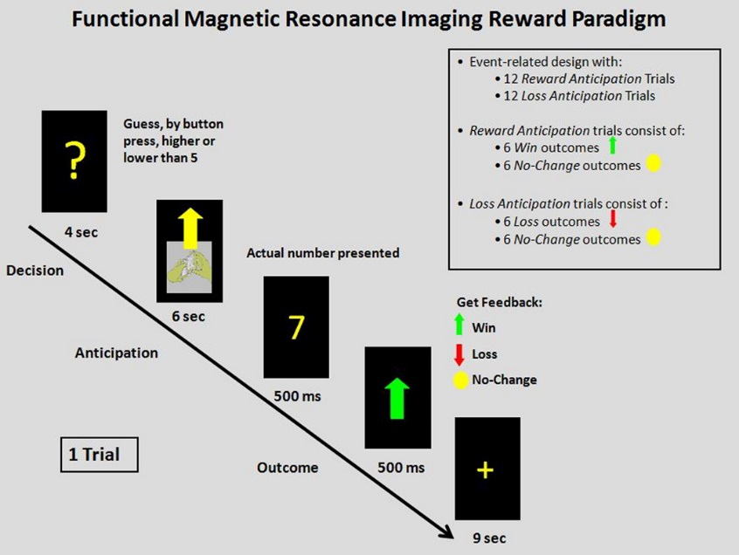

**Note.** The task was a slow event-related fMRI card-guessing paradigm designed to evaluate neural response during the anticipation and receipt of monetary reward and loss. During each trial, participants guessed via button press whether the value of visually represented cards were greater than or lesser than 5. Trials included a response or “guess” phase (4 sec), an anticipation phase in which participants learned whether the trial was a reward or loss trial (6 sec), the presentation of the correct number (500 ms), an outcome phase which indicated the receipt of monetary win, loss or no change (500 ms), and a cross-haired intertrial interval (9 sec). The anticipation phase involved either reward-anticipation or loss-anticipation. The outcome phase involved either win or no change following reward anticipation, or loss or no change following loss anticipation. Trials were presented in a single, 8-minute run with 24-trials. Analyses focused on reward anticipation and receipt (i.e., reward win trials).

**Supplemental Figure 2: Main effects of reward task for reward anticipation > baseline yield bilateral activity within the ventral striatum region of interest. **

Note. For reward anticipation > baseline, the reward task yielded robust bilateral activity within the right ventral striatum (t=8.17, k=130; x=14, y=20, z=-12, p<.001FWE) and left ventral striatum (t=5.78, k=25; x=-8, y=16, z=-2, p<.01FWE and t=4.78, k=16; x=-16, y=14, z=-14, p<.01FWE).

**Supplemental Figure 3: Main effects of reward task for reward receipt > baseline yield bilateral activity within the ventral striatum region of interest.**



Note. For reward receipt > baseline, the reward task yielded bilateral activity within the right ventral striatum (t=5.46, k=37; x=6, y=20, z=-6, p<.01FWE) and left ventral striatum (t=4.11, k=4; x=-12, y=22, z=-10, p<.05FWE; t=3.84, k=1; x=-14, y=16, z=-14, p<.05FWE; t=3.72, k=2; x=-8, y=20, z=-6, p<.05FWE; t=3.81, k=1; x=4, y=6, z=-14, p<.05FWE).

Supplemental References

Association, A. P. (2000). *Diagnostic and Statistical Manual of Mental Disorders, Fourth Edition (DSM-IV).* American Psychiatric Association: Washington, DC.

Elliott, D. S., Huizinga, D. & Menard, S. (2012). *Multiple problem youth: Delinquency, substance use, and mental health problems*. Springer Science & Business Media.

First, M. B., Spitzer, R. L., Gibbon, M. & Williams, J. B. (1995). Structured clinical interview for DSM-IV axis I disorders. *New York: New York State Psychiatric Institute*.

Hyde, L. W., Shaw, D. S., Murray, L., Gard, A., Hariri, A. R. & Forbes, E. E. (2016). Dissecting the role of amygdala reactivity in antisocial behavior in a sample of young, low-income, urban men. *Clinical psychological science* 4, 527-544.

Johnston, L. D., O’Malley, P. M., Bachman, J. G., Schulenberg, J. E., Patrick, M. E. & Miech, R. A. (2015). National Survey Results Monitoring The Future. In [*http://citeseerx.ist.psu.edu/viewdoc/citations?doi=10.1.1.719.6081*](http://citeseerx.ist.psu.edu/viewdoc/citations?doi=10.1.1.719.6081).

Miech, R., Johnston, L., O'Malley, P., Bachman, J. & Schulenberg, J. (2015). Monitoring The Future National Survey Results On Drug Use, 1975–2014: Volume I, Secondary School Students, Institute for Social Research. *Ann Arbor* [*http://monitoringthefutureorg/pubshtml-monographs*](http://monitoringthefutureorg/pubshtml-monographs).