### Supplementary Material

Figure S1: Screenshots of N-Back Game………………………………………………… 2

Figure S2: Screenshots of Multi Memory Game…………………………………………. 3

Figure S3: Screenshots of Moving Memory Game………………………………………. 4

Figure S4: Screenshots of Line It Up Game……...………………………………………. 5

Figure S5: Screenshots of Sliding Search Game…………………………………………. 6

Figure S6: Screenshots of Bubble Math Game…………………………………………… 7

Appendix A: Intent-to-Treat Analyses……………………………………………………. 8

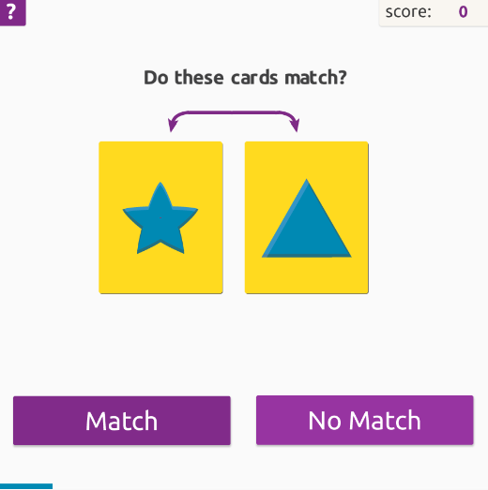 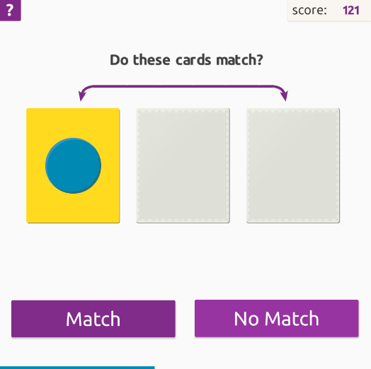

*Figure S1*. Screenshots of N-Back Game. In the *N Back* game, cards with various shapes and colors appeared on the screen and participants were asked to remember the shapes and colors. The goal of the exercise was to determine whether the current card matched with the card that was shown *n*-back cards before the current one. The difficulty level was increased by increasing the number of cards between the current card and the one it was being compared to (i.e., the “*n*”).

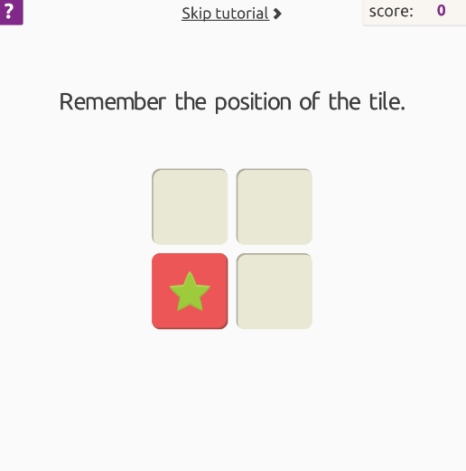 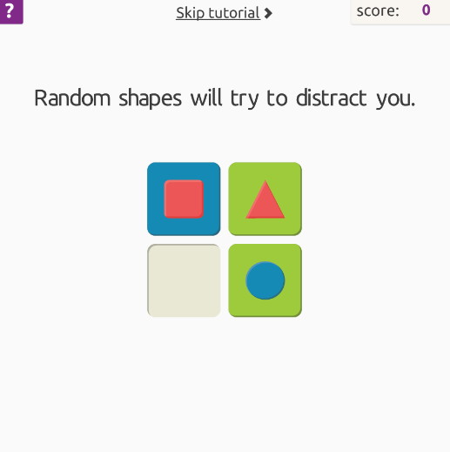 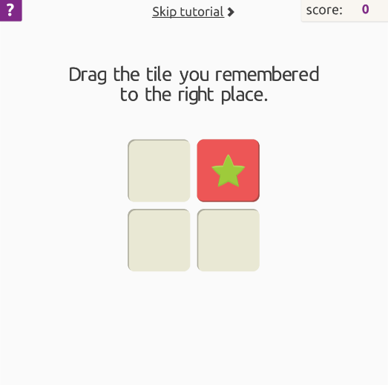

*Figure S2*. Screenshots of Multi Memory Game. In the *Multi Memory* game, tiles appeared in a grid and participants were asked to remember the shape, color, and position of the tiles to try to reproduce them after the display disappeared. The level of difficulty was increased by increasing the number of tiles, the size of the grid and the variety of different shapes on the tiles.

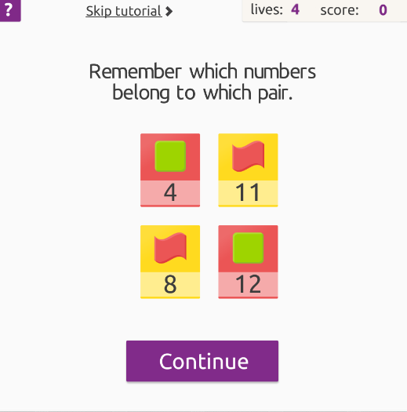 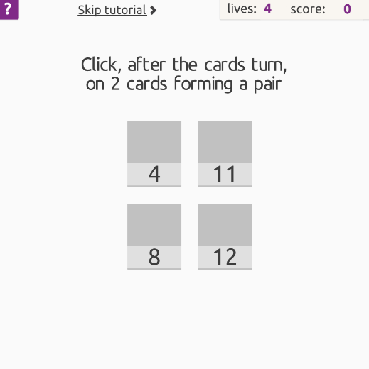 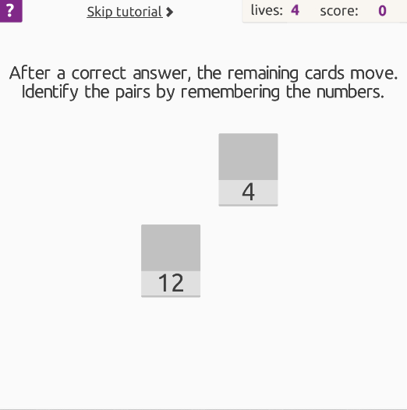

*Figure S3*. Screenshots of Moving Memory Game. In the *Moving Memory* game, tiles with colored shapes appeared on the screen, and each tile had a unique number written below. Participants were required to remember the numbers associated with each colored shape, in order to later choose a pair of numbers that were associated with matching shapes. Each time a correct matching pair was identified, the tiles moved to new positions, thus requiring participants to use the numbers, rather than spatial locations, to correctly match shape-pairs. Difficulty level was increased by increasing the number of card pairs to be matched, and by increasing the variety of background colors and shapes.

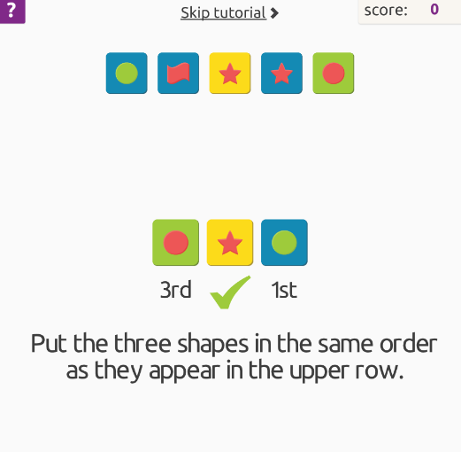 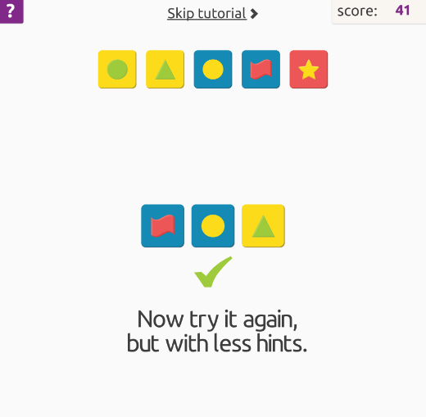 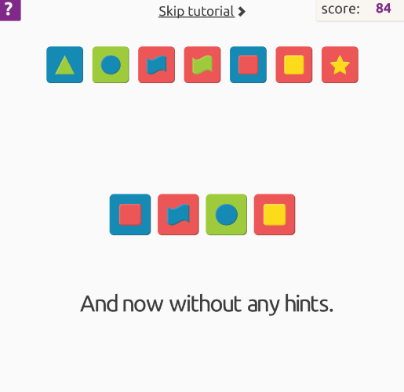

*Figure S4.* Screenshots of Line It Up Game. In the *Line It Up* game, colored tiles with different shapes appeared on the screen in a horizontal line (i.e., reference line). Participants were required to order a shorter line of colored tiles (i.e., target line) using the first line as a reference as quickly as possible. The target line contained only a portion of the tiles present in the reference line. Difficulty level was increased by increasing the lengths of the target and reference lines, with shapes and colors that began to look very similar.

 

*Figure S5.* Screenshots of Sliding Search Game. In the *Sliding Search* game, a grid of several reference images was presented at the top of the screen, and participants were required to choose which image matched the image shown at the bottom of the screen as quickly as possible. Difficulty was increased by increasing the speed at which the image was moved across the bottom of the screen (i.e., requiring a faster response), as well as changing the reference grid to include more similar, nuanced images.

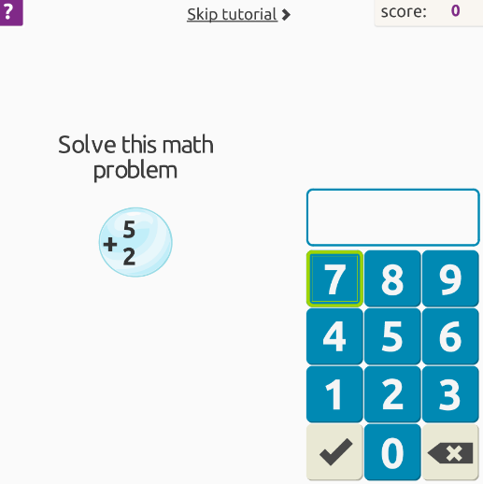 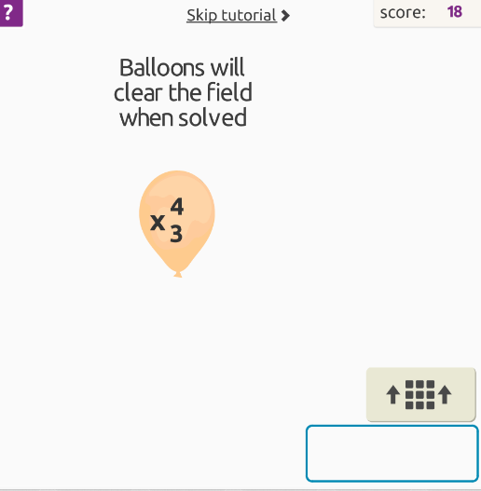 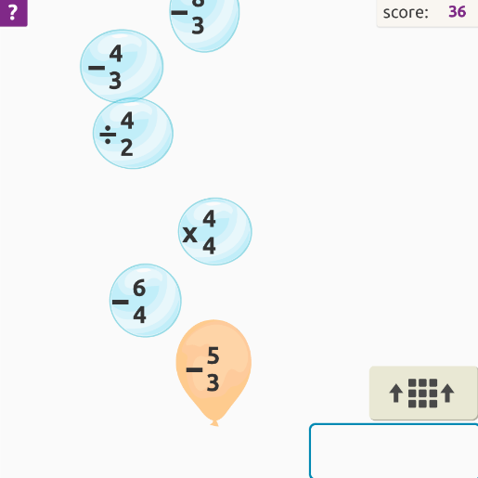

*Figure S6*. Screenshots of Bubble Math Game. In the *Bubble Math* game, participants were asked to complete simple math equations, which were moving across the screen, as quickly as possible. Difficulty was increased by increasing the number of questions asked per minute, as well as the range of numbers used in the problems.

**Appendix A: Intent-to-Treat Analyses**

The non-significant results from Little’s MCAR test [*χ2*(310) = 271.94, *p* = .94] demonstrate the neurocognitive, social cognitive, and daily functioning data were missing completely at random. Thus, a single imputation using the expectation algorithm was used. This method provides unbiased parameter estimates and improves statistical power of analyses when data are missing completely at random (Enders, 2001). 2x3 time by group repeated measures ANOVAs were conducted to test for significant group differences on each task. Follow-up 2x2 repeated measures ANOVAs were conducted to examine differences in training-related gains between each training group and the no-training control group and between the training groups, based on a priori study objectives (i.e., planned follow-up 2x2 ANOVAs for all WM, PS, and fluid intelligence measures, and follow-up analyses for significant 2x3 interactions in other domains). Bonferroni-corrected alpha levels were used to control for multiple tests within each domain.

**Working Memory**

Statistics for all planned analyses on the WM tasks can be seen in Table A1. On the 2x3 time by group repeated measures ANOVAs, there was a significant main effect of time on two of the three tasks (i.e., N-Back task and Digit Span), but no significant interaction effects or main effects of group. Planned follow-up analyses did not reveal any significant differences over time between any groups.

Table A1.

*Planned Repeated Measures ANOVAs for WM Measures Using Intent-to-Treat Sample*

|  |  |  |  |
| --- | --- | --- | --- |
|  | **N-Back** | **Maintenance and Manipulation** | **Digit Span** |
| **Main Effect of**  **Group** | *F*(2,80) = 0.10,  *p* = .904, ηp2 = .003 | *F*(2,80) = 2.02,  *p* = .139, ηp2 = .048 | *F*(2,80) = 1.77,  *p* = .178, ηp2 = .042 |
| **Main Effect of**  **Time** | ***F*(1,80) = 58.05,**  ***p* < .001, ηp2 = .420\*** | *F*(1,80) = 5.32,  *p* = .025, ηp2 = .059 | ***F*(1,80) = 162.10,**  ***p* < .001, ηp2 = .671\*** |
| **Time by Group**  **(2x3) Interaction** | *F*(2,80) = 1.47,  *p* = .237, ηp2 = .035 | *F*(2,80) = 1.57,  *p* = .215, ηp2 = .038 | *F*(2,80) = 2.58,  *p* = .082, ηp2 = .061 |
|  |  |  |  |
| ***2x2 Interactions*** |  |  |  |
| **WM vs. Control** | *F*(1,53) = 2.59,  *p* = .113, *d* = 0.45 | *F*(1,53) = 2.27,  *p* = .138, *d* = 0.40 | *F*(1,53) = 4.45,  *p* = .040, *d* = 0.57 |
| **PS vs. Control** | *F*(1,53) = 0.67,  *p* = .417, *d* = 0.22 | *F*(1,53) = 2.40,  *p* = .127, *d* = 0.42 | *F*(1,53) = 2.91,  *p* = .094, *d* = 0.46 |
| **WM vs. PS** | *F*(1,54) = 0.89,  *p* = .351, *d* = 0.26 | *F*(1,54) = 0.02,  *p* = .892, *d* = 0.04 | *F*(1,54) = 0.37,  *p* = .546, *d* = 0.16 |

*Note.* WM = working memory; PS = processing speed; ηp2 = partial eta squared effect size; *d* = Cohen’s d effect size.

*denotes significance after Bonferroni correction (α = .017).

**Processing Speed**

Statistics for all planned analyses on the PS tasks can be seen in Table A2. There was a significant 2x3 time by group interaction on the Symbol Search task, as well as a significant main effect of time, but no effect of group. Follow-up analyses revealed a significant interaction between the PS and no-training control groups, such that the PS group improved significantly more than the no-training control group. However, no differences were observed between the WM and no-training control groups or the WM and PS groups on the Symbol Search task.

There was a significant 2x3 time by group interaction on the Color Naming task, but this did not hold after Bonferroni correction. There was a significant main effect of time, but no main effect of group. Planned follow-up analyses revealed a significant interaction between the PS and no-training control groups, such that the PS group improved significantly more than the no-training control group over time. However, no differences were observed between the WM and no-training control groups or the WM and PS groups on the Color Naming task.

Table A2.

*Planned Repeated Measures ANOVAs for PS Measures Using Intent-to-Treat Sample*

|  |  |  |
| --- | --- | --- |
|  | **Symbol Search** | **Color Naming** |
| **Main Effect of Group** | *F*(2,68) = 2.10,  *p* = .129, ηp2 = .050 | *F*(2,80) = 3.55,  *p* = .033, ηp2 = .082 |
| **Main Effect of Time** | ***F*(1,80) = 21.41,**  ***p* < .001, ηp2 = .211\*** | ***F*(1,80) = 24.07,**  ***p* < .001, ηp2 = .231\*** |
| **Time by Group (2x3)**  **Interaction** | ***F*(2,80) = 4.37,**  ***p* = .016, ηp2 = .099\*** | *F*(2,80) = 3.42,  *p* = .037, ηp2 = .079 |
|  |  |  |
| ***2x2 Interactions*** |  |  |
| **WM vs. Control** | *F*(1,53) = 2.12,  *p* = .151, *d* = 0.39 | *F*(1,53) = 2.12,  *p* = .151, *d* = 0.40 |
| **PS vs. Control** | ***F*(1,53) = 8.80,**  ***p* = .005, *d* = 0.80\*** | ***F*(1,53) = 6.41,**  ***p* = .014, *d* = 0.71\*** |
| **WM vs. PS** | *F*(1,54) = 2.29,  *p* = .136, *d* = 0.40 | *F*(1,54) = 1.32,  *p* = .255, *d* = 0.31 |

*Note.* WM = working memory; PS = processing speed; ηp2 = partial eta squared effect size; *d* = Cohen’s d effect size.

*denotes significance after Bonferroni correction (α = .025).

**Fluid Intelligence**

Statistics for all planned analyses on the fluid intelligence tasks can be seen in Table A3. There were no significant 2x3 time by group interactions on either the RSPM or the CCFT. There were significant main effects of time on both tasks with scores generally increasing across all groups, but no main effects of group. Planned follow-up 2x2 repeated measures ANOVAs revealed no significant interactions between any groups on either task.

Table A3.

*Planned Repeated Measures ANOVAs for Fluid Intelligence Measures Using Intent-to-Treat Sample*

|  |  |  |
| --- | --- | --- |
|  | **RSPM** | **CCFT** |
| **Main Effect of Group** | *F*(2,80) = 1.30,  *p* = .279, ηp2 = .031 | *F*(2,80) = 3.58,  *p* = .032, ηp2 = .082 |
| **Main Effect of Time** | ***F*(1,80) = 57.26,**  ***p* < .001, ηp2 = .417\*** | ***F*(1,80) = 19.79,**  ***p* < .001, ηp2 = .198\*** |
| **Time by Group (2x3)**  **Interaction** | *F*(2,80) = 2.97,  *p* = .057, ηp2 = .069 | *F*(2,80) = 1.12,  *p* = .332, ηp2 = .027 |
|  |  |  |
| ***2x2 Interactions*** |  |  |
| **WM vs. Control** | *F*(1,53) = 2.04,  *p* = .160, *d* = 0.39 | *F*(1,53) = 2.24,  *p* = .141, *d* = 0.40 |
| **PS vs. Control** | *F*(1,53) = 5.19,  *p* = .028, *d* = 0.62 | *F*(1,53) = 1.24,  *p* = .271, *d* = 0.30 |
| **WM vs. PS** | *F*(1,54) = 1.11,  *p* = .298, *d* = 0.28 | *F*(1,54) = 0.04,  *p* = .836, *d* = 0.06 |

*Note.* WM = working memory; PS = processing speed; RSPM = Raven’s Standard Progressive Matrices; CCFT = Cattell’s Culture Fair Test; ηp2 = partial eta squared effect size; *d* = Cohen’s d effect size.

*denotes significance after Bonferroni correction (α = .025).

**Executive Functioning**

Statistics for all planned analyses on the EF tasks can be seen in Table A4. There was a significant 2x3 time by group interaction on the inhibition condition of the CWIT, though this did not hold at the corrected alpha level. There was a significant main effect of time, but no main effect of group. Planned follow-up analyses revealed a significant interaction between the PS and no-training control groups, such that the PS group improved significantly more than the no-training control group over time. However, no differences were observed between the WM and no-training control groups or the WM and PS groups.

On the switching condition of the CWIT, there was a significant 2x3 time by group interaction that did not hold at Bonferroni correction. There was a significant main effect of time, but no main effect of group. Planned follow-up analyses revealed a significant interaction between the PS and no-training control groups, such that the PS group improved significantly more than the no-training control group over time. However, no differences were observed between the WM and no-training control groups or the WM and PS groups.

Finally, there was a significant 2x3 time by group interaction, main effect of time, and main effect of group on the TMT. Follow-up analyses revealed a significant interaction between the WM and no-training control groups and between the PS and no-training control groups, such that the WM and PS groups improved significantly more than the no-training control group over time. However, no differences were observed between the WM and PS groups.

Table A4.

*Planned Repeated Measures ANOVAs for EF Measures Using Intent-to-Treat Sample*

|  |  |  |  |
| --- | --- | --- | --- |
|  | **CWIT Inhibition** | **CWIT Switching** | **TMT Switching** |
| **Main Effect of**  **Group** | *F*(2,80) = 4.23,  *p* = .018, ηp2 = .098 | *F*(2,80) = 3.76,  *p* = .027, ηp2 = .086 | ***F*(2,80) = 5.75,**  ***p* = .005, ηp2 = .126\*** |
| **Main Effect of**  **Time** | ***F*(1,80) = 29.09,**  ***p* < .001, ηp2 = .267\*** | ***F*(1,80) = 23.99,**  ***p* < .001, ηp2 = .231\*** | ***F*(1,80) = 25.67,**  ***p* < .001, ηp2 = .243\*** |
| **Time by Group**  **(2x3) Interaction** | *F*(2,80) = 3.67,  *p* = .030, ηp2 = .084 | *F*(2,80) = 3.90,  *p* = .024, ηp2 = .089 | ***F*(2,80) = 4.79,**  ***p* = .016, ηp2 = .097\*** |
|  |  |  |  |
| ***2x2 Interactions*** |  |  |  |
| **WM vs. Control** | *F*(1,53) = 4.48,  *p* = .039, *d* = 0.58 | *F*(1,53) = 2.59,  *p* = .113, *d* = 0.46 | ***F*(1,53) = 5.96,**  ***p* = .017, *d* = 0.65\*** |
| **PS vs. Control** | ***F*(1,53) = 7.48,**  ***p* = .008, *d* = 0.74\*** | ***F*(1,53) = 13.16,**  ***p* = .001, *d* = 0.98\*** | ***F*(1,53) = 7.25,**  ***p* = .009, *d* = 0.76\*** |
| **WM vs. PS** | *F*(1,54) = 0.13,  *p* = .721, *d* = 0.10 | *F*(1,54) = 0.87,  *p* = .356, *d* = 0.26 | *F*(1,54) = 0.34,  *p* = .565, *d* = 0.17 |

*Note.* WM = working memory; PS = processing speed; EF = executive functioning; CWIT = Color Word Interference Test; TMT = Trail Making Test; ηp2 = partial eta squared effect size; *d* = Cohen’s d effect size.

*denotes significance after Bonferroni correction (α = .017).

**Social Cognition**

Statistics for all planned analyses on the social cognition tasks can be seen in Table 10. There was a significant 2x3 time by group interaction on the Hinting Task, as well as a significant main effect of time, but not group. Follow-up analyses revealed a significant interaction between the WM and no-training control groups and between the PS and no-training control groups, such that the WM and PS groups improved significantly more than the no-training control group over time. However, no differences were observed between the WM and PS groups. On the 2x3 repeated measures ANOVA examining the GERT, there was no significant interaction, main effect of time, or main effect of group.

Table A5.

*Planned Repeated Measures ANOVAs for Social Cognition Measures Using Intent-to-Treat Sample*

|  |  |  |
| --- | --- | --- |
|  | **Hinting Task** | **GERT** |
| **Main Effect of Group** | *F*(2,80) = 0.16,  *p* = .855, ηp2 = .004 | *F*(2,80) = 0.21,  *p* = .812, ηp2 = .005 |
| **Main Effect of Time** | ***F*(1,80) = 66.44,**  ***p* < .001, ηp2 = .454\*** | *F*(1,80) = 3.39,  *p* = .069, ηp2 = .041 |
| **Time by Group (2x3)**  **Interaction** | ***F*(2,80) = 6.13,**  ***p* = .003, ηp2 = .133\*** | *F*(2,80) = 0.83,  *p* = .440, ηp2 = .020 |
|  |  |  |
| ***2x2 Interactions*** |  |  |
| **WM vs. Control** | ***F*(1,53) = 10.15,**  ***p* = .002, *d* = 0.86\*** | - |
| **PS vs. Control** | ***F*(1,53) = 6.39,**  ***p* = .014, *d* = 0.68\*** | - |
| **WM vs. PS** | *F*(1,54) = 1.03,  *p* = .314, *d* = 0.27 | - |

*Note.* WM = working memory; PS = processing speed; GERT = Geneva Emotion Recognition Test; ηp2 = partial eta squared effect size; *d* = Cohen’s d effect size.

*denotes significance after Bonferroni correction (α = .025).

**Daily Functioning and Symptoms**

Statistics for all planned analyses on the daily functioning and symptom measures can be seen in Table A6. There was a significant 2x3 time by group interaction on the CFQ, but no significant main effect of time or group. Follow-up analyses revealed a significant interaction between the WM and no-training control groups and between the PS and no-training control groups, such that the WM and PS groups reported fewer cognitive failures than the no-training control group over time. However, no differences were observed between the WM and PS groups. On the 2x3 time by group repeated measures ANOVAs examining the UPSA-Brief, SOFAS, and PANSS, there were no significant interaction effects. There were significant main effects of time on all three measures, but no main effects of group.

Table A6.

*Planned Repeated Measures ANOVAs for Daily Functioning and Symptom Measures Using Intent-to-Treat Sample*

|  |  |  |  |  |
| --- | --- | --- | --- | --- |
|  | **CFQ** | **UPSA-Brief** | **SOFAS** | **PANSS** |
| **Main Effect of**  **Group** | *F*(2,80) = 0.31,  *p* = .736, ηp2 = .008 | *F*(2,80) = 0.88,  *p* = .419, ηp2 = .021 | *F*(2,80) = 0.47,  *p* = .626, ηp2 = .012 | *F*(2,80) = 2.35,  *p* = .102, ηp2 = .055 |
| **Main Effect of**  **Time** | *F*(1,80) = 5.41,  *p* = .023, ηp2 = .063 | ***F*(1,80) = 39.40,**  ***p* < .001, ηp2 = .330\*** | ***F*(1,80) = 33.24,**  ***p* < .001, ηp2 = .294\*** | ***F*(1,80) = 13.44,**  ***p* < .001, ηp2 = .144\*** |
| **Time by Group**  **(2x3) Interaction** | ***F*(2,80) = 5.60,**  ***p* = .005, ηp2 = .123\*** | *F*(2,80) = 1.49,  *p* = .231, ηp2 = .036 | *F*(2,80) = 2.21,  *p* = .117, ηp2 = .052 | *F*(2,80) = 0.82,  *p* = .444, ηp2 = .020 |
|  |  |  |  |  |
| ***2x2 Interactions*** |  |  |  |  |
| **WM vs. Control** | ***F*(1,53) = 8.40,**  ***p* = .012, *d* = 0.72\*** | - | - | - |
| **PS vs. Control** | ***F*(1,53) = 11.05,**  ***p* = .002, *d* = 0.90\*** | - | - | - |
| **WM vs. PS** | *F*(1,54) = 1.09,  *p* = .301, *d* = 0.27 | - | - | - |

*Note.* WM = working memory; PS = processing speed; CFQ = Cognitive Failures Questionnaire; UPSA = UCSD Performance-Based Skills Assessment; SOFAS = Social and Occupational Functioning Assessment Scale; PANSS = Positive and Negative Syndrome Scale; ηp2 = partial eta squared effect size; *d* = Cohen’s d effect size.

*denotes significance after Bonferroni correction (α = .013).