Supplementary information

**Frontostriatal functional connectivity correlates with repetitive behaviour across autism spectrum disorder and obsessive-compulsive disorder**

**Sophie E.A. Akkermans, Nicole Rheinheimer, Muriel M.K. Bruchhage, Sarah Durston, Daniel Brandeis, Tobias Banaschewski, Regina Boecker-Schlier, Isabella Wolf, Steven C.R. Williams, Jan K. Buitelaar, Daan van Rooij, Marianne Oldehinkel, for the TACTICS consortium**

**Table S1. Scanning parameters per site**

|  |  |  |  |  |  |  |  |
| --- | --- | --- | --- | --- | --- | --- | --- |
| **Sequence** | **Site** | **TR/TE/TI (ms)** | **Flip angle** | **Field of view (mm)** | **Matrix RL/AP /slices** | **Voxel-size (mm)** | **Parallel Imaging** |
| T1* | Nijmegen  *(Siemens Prisma)* | 2300/2.98/900 | 9 | 256 | 212/256/176 | 1.0 × 1.0 × 1.2 | 2 |
|  | London  *(GE MR750)* | 7.31/3.02/400 | 11 | 270 | 256/256/196 | 1.1 × 1.1 × 1.2 | 1.75 |
| R-fMRI# | Nijmegen  *(Siemens Prisma)* | 2300/12/- | 80 | 240 | 240/240/33 | 3.8 × 3.8 × 3.8 | 2 |
|  | London  *(GE MR750)* | 2300/13/- | 80 | 240 | 240/240/33 | 3.8 × 3.8 × 3.8 | 2 |

*TR as provided by the manufacturer. Siemens defines TR as the time between inversion recovery pulses per volume, whereas GE defines a TR as the time an excitation pulse is given.

#Multi-echo resting state fMRI: TE2 is 31 ms for London and 28.41 for Nijmegen. TE3 is 48 for London and 44.82 for Nijmegen.

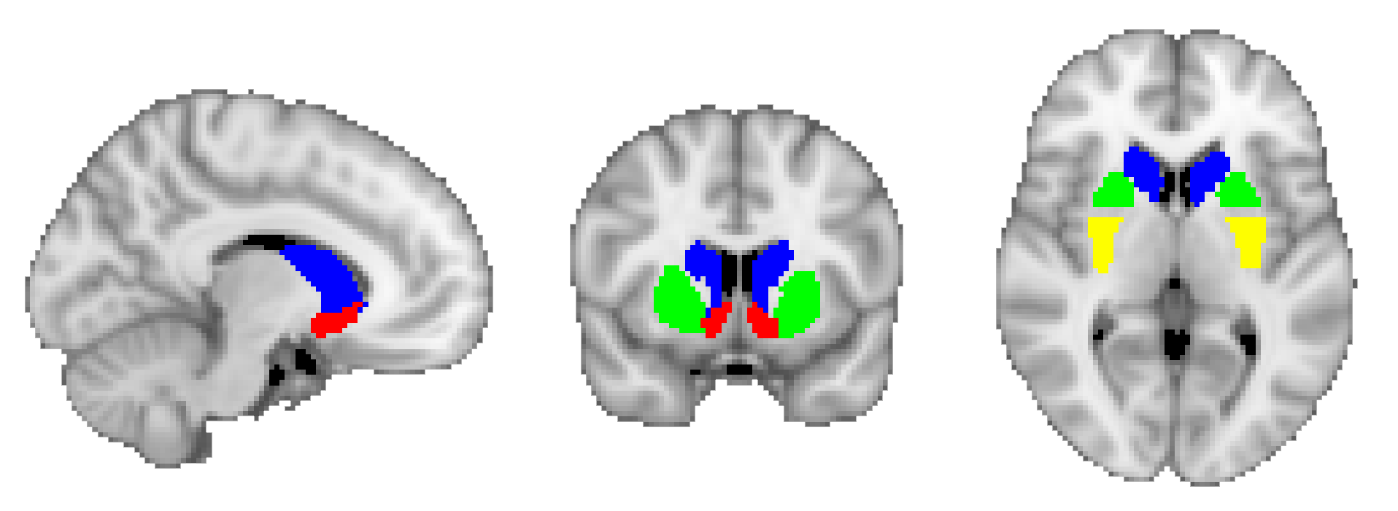

**Figure S1. Seed regions.** The seed regions displayed here are an example from one participant overlaid on an MNI152 template brain. Legend: blue – caudate nucleus, red – nucleus accumbens, green – anterior putamen, yellow – posterior putamen. Note that left and right volumes were analysed separately.

# Sensitivity analyses: influence of scan-site, sex, and age

In all instances full Spearman correlations are reported. As can been seen in Figure S2, age was not related to connectivity between the left nucleus accumbens and right premotor cortex (*r*s=0.10; *p*=.393). Figures S3 to S6 demonstrate that the association between repetitive behaviour and the connectivity estimates was significant in both males (*n*=47; *r*s=0.37; *p*=.010) and females (*n*=30; *r*s=0.47; *p*=.009); and either trend level in London (*n*=34; *r*s=0.30; *p*=.085) or significant in Nijmegen (*n*=43; *r*s=0.53; *p*<.001). These results suggest that the effect was not specific to males or females, or scan-site.

# Sensitivity analyses: influence of medication use and comorbidity

The association (uncorrected for age, sex, scan-site) between repetitive behaviour and the connectivity estimates was significant in participants who currently did not use medication (*n*=62; *r*s=0.35; *p*=.006) and in participants without comorbid disorders (*n*=63; *r*s=0.36; *p*=.003). These results suggest that the effect was not driven by participants with concurrent medication use or comorbid disorders (also see Figure S7 and S8).

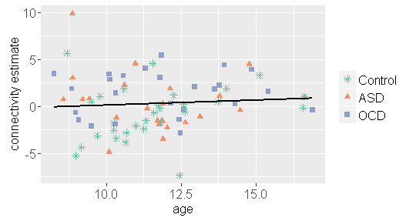

**Figure S2. No association was present between age and connectivity. Line represents linear association across all groups between age in years and extracted estimates of connectivity between left nucleus accumbens and right premotor cortex.**

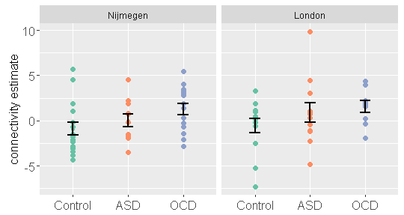

**Figure S3. Extracted estimates of connectivity between the left nucleus accumens and right premotor cortex represented for the diagnostic groups and scan-sites separately. Errorbars denote means +/- *SE*.**

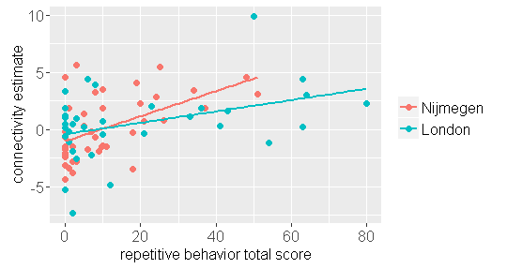

**Figure S4. A positive association between repetitive behaviour and connectivity was present in both Nijmegen and London**. **Lines represents linear associations between repetitive behavior (RBS-R total score) and extracted estimates of connectivity between the left nucleus accumbens and right premotor cortex, represented for Nijmegen and London separately.**

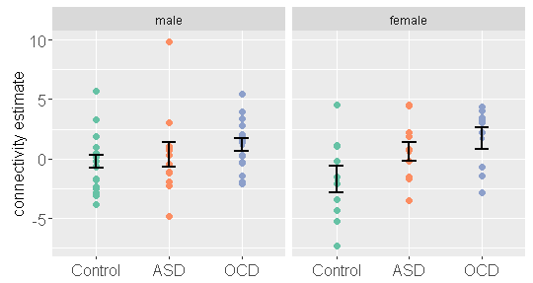

**Figure S5. Extracted estimates of connectivity between the left nucleus accumbens and right premotor cortex represented for the diagnostic groups and males and females separately. Errorbars denote means +/- *SE*.**

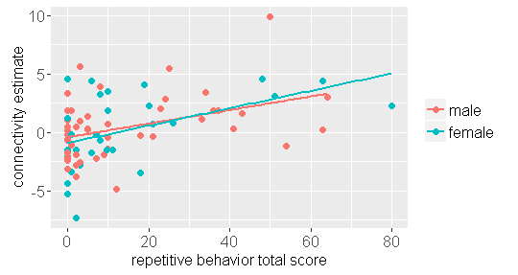

**Figure S6. A positive association between repetitive behaviour and connectivity was present in both males and females**. **Lines represents linear associations between repetitive behaviour (RBS-R total score) and extracted estimates of connectivity between the left nucleus accumbens and right premotor cortex, represented for males and females separately.**

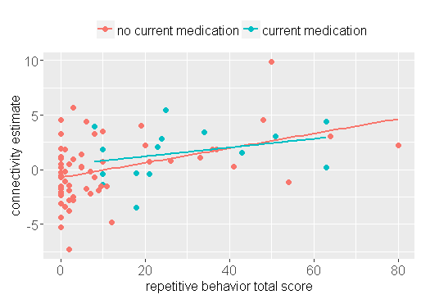

**Figure S7. A positive association between repetitive behaviour and connectivity was also present in those without current medication use. Lines represents linear associations between repetitive behaviour (RBS-R total score) and extracted estimates of connectivity between the left nucleus accumbens and right premotor cortex, represented for those with and without current medication use separately.**

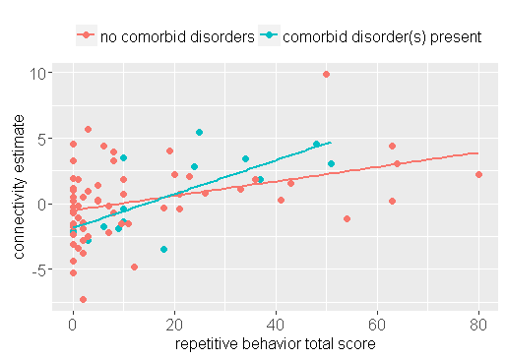

**Figure S8. A positive association between repetitive behaviour and connectivity was also present in those without current comorbid disorders. Lines represents linear associations between repetitive behaviour (RBS-R total score) and extracted estimates of connectivity between the left nucleus accumbens and right premotor cortex, represented for those with and without current comorbid disorders separately.**