Effect of selective serotonin reuptake inhibitor on prefrontal-striatal connectivity is dependent on the level of TNF-α in patients with major depressive disorder

Kai Liu^{1, 2, †}, Xiaohua Zhao^{1, †}, Xiaobing Lu^{3, †}, Xiaoxia Zhu¹, Hui Chen², Mengmeng Wang¹, Weixin Yan¹, Linlin Jing⁴, Yanjia Deng², Lin Yu³, Huawang Wu³, Ge Wen^{2, *}, Xuegang Sun^{1, 5, *}, Zhiping Lv^{1, *}

¹School of Traditional Chinese Medicine, Southern Medical University, Guangzhou, China
²Medical Imaging Department, Nanfang Hospital, Southern Medical University, Guangzhou, China
³The Affiliated Brain Hospital of Guangzhou Medical University (Guangzhou Huiai Hospital), Guangzhou, China
⁴TCM Integrated Hospital of Southern Medical University, Southern Medical University, Guangzhou, China
⁵Key Laboratory of Ministry of Education for TCM Viscera-State Theory and Applications, Liaoning University of Traditional Chinese Medicine, Shenyang, China

†These authors contributed equally to the manuscript

* Corresponding author: Zhiping Lv
School of Traditional Chinese Medicine, Southern Medical University, No.1023, South Shatai Road, Baiyun District, Guangzhou, Guangdong, China. Email: lzp48241@126.com;
* Corresponding author: Ge Wen
Medical Imaging Department, Nanfang Hospital, Southern Medical University, No.1023, South Shatai Road, Baiyun District, Guangzhou, China, 510515, Tel: +86-20-61642028, Email: m13360022166@163.com;
* Corresponding author: Xuegang Sun
School of Traditional Chinese Medicine, Southern Medical University, No.1023, South Shatai Road, Baiyun District, Guangzhou, Guangdong, China. Email: sxg_smu@126.com.

Supplementary Appendix
1. Data preprocessing
All the acquired rs-fMRI images were preprocessed utilizing the Statistical Parametric Mapping (SPM8, Wellcome Department of Cognitive Neurology, http://www.fil.ion.ucl.ac.uk/spm/). For each participant, the first 10 time points were discarded from the fMRI time series to avoid initial signal instability. The resulting 230 volumes were corrected for slice timing and for the head motion (a least squares approach and a six-parameter spatial transformation). Subjects with 1) head motion >1.5 mm in any dimension, 2) angular rotation >1.5°, or 3) a mean frame-wise displacement (FWD) >0.25 were excluded for further analysis. Then, all the resultant functional images were coregistered to the individual 3D-T1WI and spatially normalized to the Montreal Neurological Institute (MNI) template (resampled with a voxel size of 3×3×3 mm³) using the DARTEL (Diffeomorphic Anatomical Registration using Exponentiated Lie algebra) algorithm. Then, a spatial smoothing with an 8 mm full width at half maximum (FWHM) isotropic Gaussian kernel was performed to reduce the noise of the normalized functional images. Further processing respectively included voxel-wise detrending, filtering with a band pass filter of 0.01-0.08 Hz, and regression of the white matter signal, cerebrospinal fluid signal, mean global signal and six motion parameters.
2. Regression Analysis
To further assess the influences of the confounding factors on the MPFC-striatum connectivity, two linear regressions were established. The stepwise linear regression models were used, with the significance levels for entry and removal respectively being 0.05 and 0.10. Corresponding to the analysis of baseline FC difference between MDDs and controls in 3.2, the model (a) was constructed by adding the striatal FC value of MPFC cluster as the dependent variable and depression (i.e., MDDs or healthy controls) as independent variable; Corresponding to the result of treatment-related FC decrease in MDDs in 3.3, we added the pre- to post-treatment striatal FC difference of MPFC cluster as the dependent variable and the baseline TNF-α level as independent variable. The possible confounding factors of age, gender, education, BMI, daily cigarette use, brain volume, and head motion (i.e., FWD) were added as independent variables for both two models, and episode of disease (i.e., first episode or recurrent MDD) and duration of disease were added as independent variables additionally for model (b). After stepwise regression for model (a), the significant contributors of MPFC-striatum connectivity at baseline were head motion (standardized β = 0.250, P = 0.033) and depression (standardized β = 0.530, P < 0.001), and the final model was established as "FC = 0.004 + 0.097*depression + 0.514*FWD" with an adjusted R² of 0.261 (P < 0.001). For model (b), the baseline TNF-α level (standardized β = -0.595, P = 0.002) was the only significant predictor of MPFC-striatum connectivity decrease after treatment, and the final model was established as "FC_decrease = 0.148 - 0.154*TNF-α" with an adjusted R² of 0.326 (P = 0.002).
For a more comprehensive observation, here we performed the regression analyses using the "enter method" to show the contributions of all the factors in a full-variable model (see the following Table S1). As shown by the regression analyses results, the contributions of these confounding factors to the striatal connectivity changes are largely insignificant (except for age and head motion, which has been added as covariates of nuisance). Therefore, these data may support that the prefrontal-striatal connectivity findings in the current study are independent of these confounding factors.

Table S1. Regression analyses with full variables using the "enter method".
Dependent  Independent | Baseline MPFC-striatum FC |  | MPFC-striatum FC decrease after treatment
Dependent  Independent | Standardized β | P | Standardized β | P
Age | 0.333 | 0.037* | 0.007 | 0.976
Gender | 0.123 | 0.419 | 0.057 | 0.816
Education | 0.259 | 0.087 | -0.028 | 0.907
Body mass index | 0.100 | 0.422 | 0.344 | 0.092
Daily cigarette use | 0.023 | 0.839 | 0.065 | 0.732
Brain volume | 0.096 | 0.531 | -0.069 | 0.785
Head motion | 0.274 | 0.031* | 0.272 | 0.238
Episode of disease | - | - | -0.394 | 0.071
Duration of disease | - | - | -0.208 | 0.272
Depression | 0.627 | <0.001* | - | -
Baseline TNF-α level | - | - | -0.650 | 0.004*

Supplementary Figure
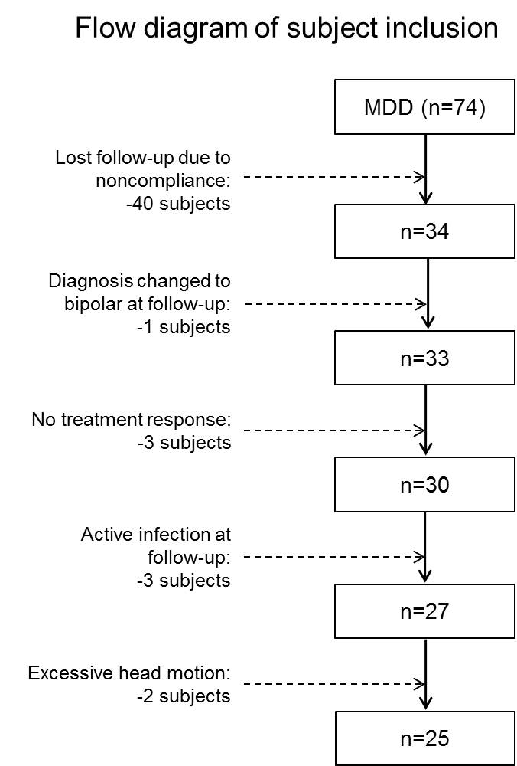
Figure S1. Flow diagram of subject inclusion of patients with major depressive disorder (MDD).

