Supplementary materials
Abnormal dynamic functional network connectivity in unmedicated bipolar and major depressive disorders based on the triple-network model
Materials and methods
To identify ICs of interests, we adopted “Discriminability Index-based Component Identification (DICI)”, an automatic IC identification method. The DICI uses the “discriminability index (DI)” (DeCarlo, 1998) to quantitatively evaluate the similarity of the spatial distribution of each IC to a predefined spatial template for IC identification (Huang et al., 2016, Zhang et al., 2013). In the current study, we selected the large-scale resting state network template provided by Shirer et al. (Shirer et al., 2012) as the reference template. Specifically, the t-maps for all the group-level independent components were first converted to binary maps (p < 0.01, FDR-corrected), and then the DICI value for each IC was calculated by comparing with the network template. DICI is given by
DICI = z (hit rate) - z (false alarm rate), (1)
where the hit rate or sensitivity is the number of correctly identified voxels within a given IC versus the total number of voxels in the network template, and false alarm rate (1-specificity) is the number of mistakenly identified voxels within a given IC versus the number of voxels outside the network template. DICI is calculated as the z transformed hit rate minus the z transformed false alarm rate. The IC with the biggest DICI value was selected as the IC of interest corresponding to the network template.
Results
Relationship between dFNC parameters and clinical variables
For the dFNC parameters showing significant between-group difference, we found that the reoccurrence fraction of State 3 was significantly positively correlated with the duration of illness in the BD patients (r = 0.285, p = 0.049), which is shown in Figure S2.

Figure S1 Spatial distribution of the triple networks determined in this study (p < 0.001, FDR corrected). Abbreviations: aDMN, anterior default mode network; pDMN, posterior default mode network; lCEN, left central executive network; rCEN, right central executive network; SN, salience network.
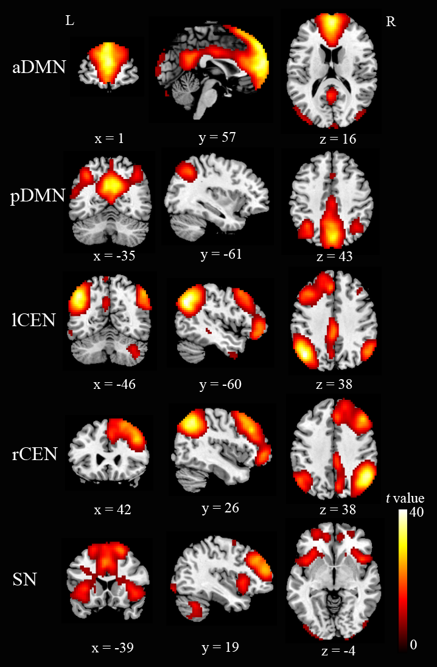

Figure S2 Relationship between the reoccurrence fraction of State 3 and the duration of illness in the patients with bipolar disorder (BD) (p < 0.05). Each dot represents a BD patient.
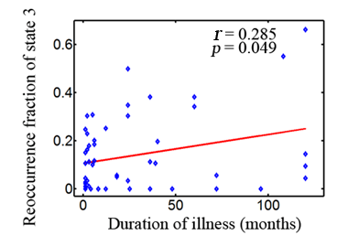

References
DeCarlo LT (1998). Signal detection theory and generalized linear models. Psychological methods 3, 186.
Huang H, Ding Z, Mao D, Yuan J, Zhu F, Chen S, Xu Y, Lou L, Feng X, Qi L, Qiu W, Zhang H & Zang Y-F (2016). PreSurgMapp: a MATLAB Toolbox for Presurgical Mapping of Eloquent Functional Areas Based on Task-Related and Resting-State Functional MRI. Neuroinformatics 14, 421-438.
Shirer W, Ryali S, Rykhlevskaia E, Menon V & Greicius M (2012). Decoding subject-driven cognitive states with whole-brain connectivity patterns. Cerebral Cortex 22, 158-165.
Zhang H, Jia W, Liao W & Zang Y (2013). Automatic component identification method based on normalized sensitivity/specificity measurement. In Oraganization ofHum Brain Mapp (OHBM): Seattle, USA.

