Supplementary Materials for:

Changes in the Dynamic Network Structure of PTSD Symptoms Pre-to-Post Combat

Figure S1. Network structures of PTSD symptoms (PCL) according to spinglass algorithm ‎for community detection in pre-deployment and post-combat networks.
The spinglass algorithm was conducted to empirically investigates communities in the networks. Results are based on the highest frequency of the communities’ number following 1000 times running of the algorithm. The communities in the networks differentiate from one another by the colors in the figure.
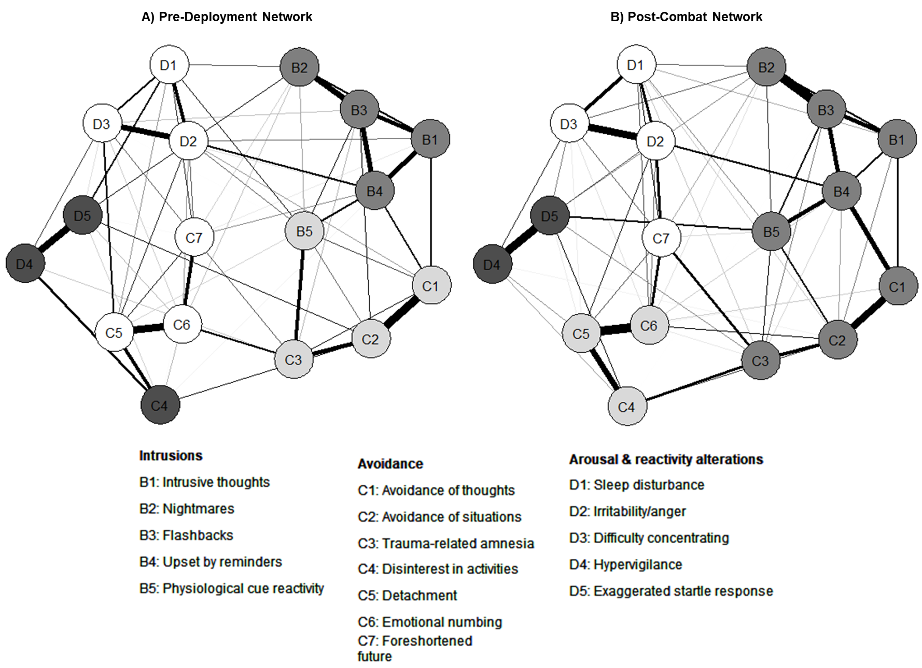

Figure S2. Edge weights difference test for pre-deployment and post-combat networks.
X and Y axis represent, from lowest to highest value, all non-zero edges in the network. ‎ The significant differences between edge weights are presented by black boxes, whereas non-significant difference is presented by grey box. The strength of the edge is reflected by the brightness of the grey color in the middle of the plot. ‎(A) pre-deployment; and (B) post-combat. ‎See Figure S1 for description of the shortcut names.
A)

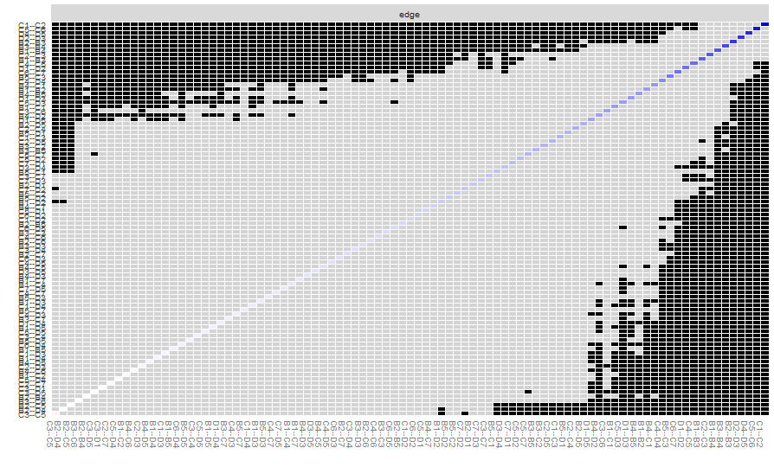

B)
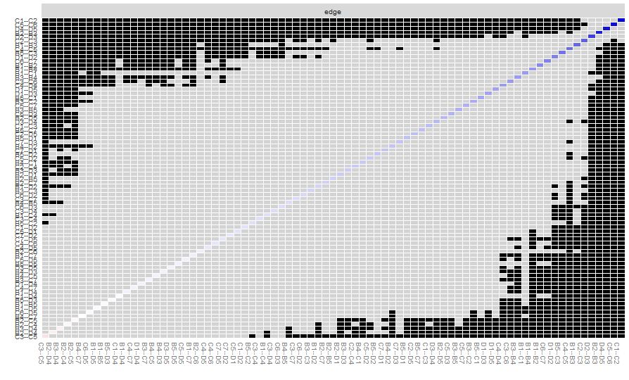

Figure S3. confidence intervals (Cis) of the edge weights for pre-deployment and post-combat networks based on the Bootstrapped model. The black line indicates the edge weight bootstrap and shows the edge values, the grey area shows the 95% CIs. Each horizontal line represents one CI’s edge, from the edge with the lowest edge ‎weight to the edge with the greatest edge weight. ‎(A) pre-deployment; and (B) post-combat. ‎See Figure S1 for description of the shortcut names.

A)
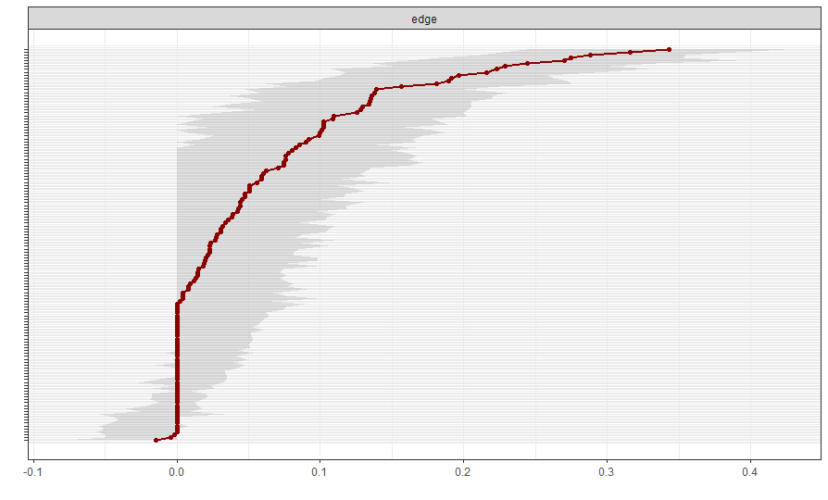

B)
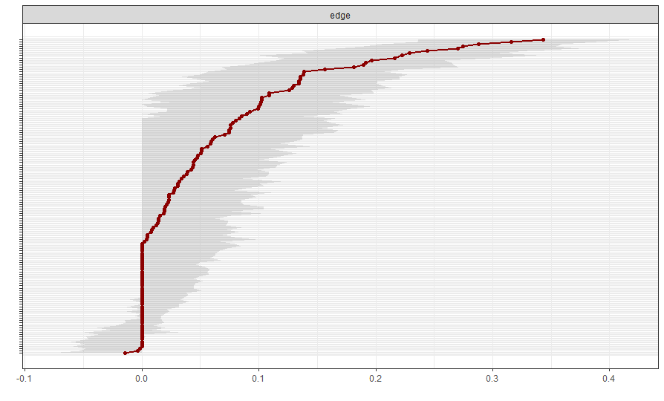

Figure S4. Subset bootstrapping for pre-deployment and post-combat networks. The subset bootstrapping presents the mean correlations between the centrality indices from the original networks and networks estimated on reduced samples. Lines indicate the means and areas the range from the 2.5th quantile to the 97.5th quantile. Values are considered ‎‎sufficient when they are at least 0.25, preferably above 0.5. ‎‎‎(A) pre-deployment; and (B) post-combat. ‎See Figure S1 for description of the shortcut names.
A)
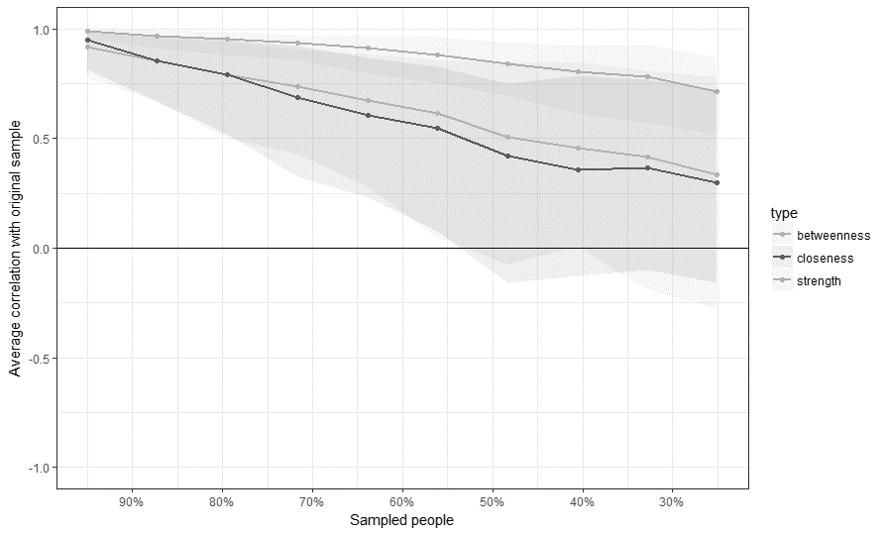

B)

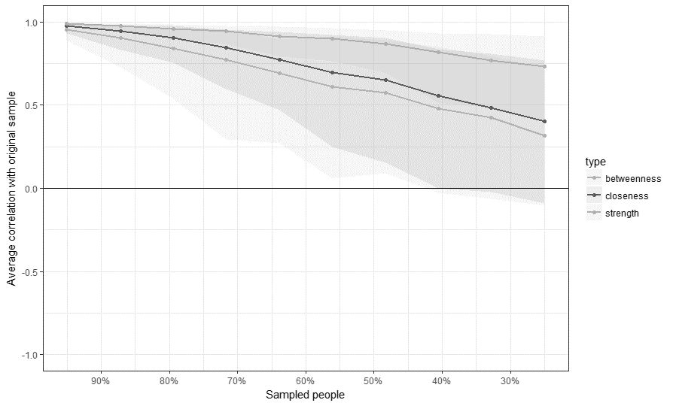

Figure S5. Degree centrality difference test for pre-deployment and post-combat networks. ‎ X and Y axis represent the degree of nodes’ strength estimates for the 17 PTSD symptoms. Statistical difference between two centrality estimates is represented with a black ‎box, and non-statistical difference is represented with a grey box. ‎‎‎‎(A) pre-deployment; and (B) post-combat. ‎See Figure S1 for description of the shortcut names.

A)
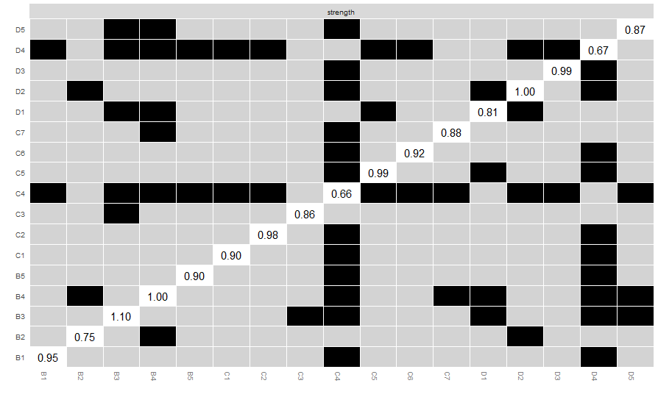

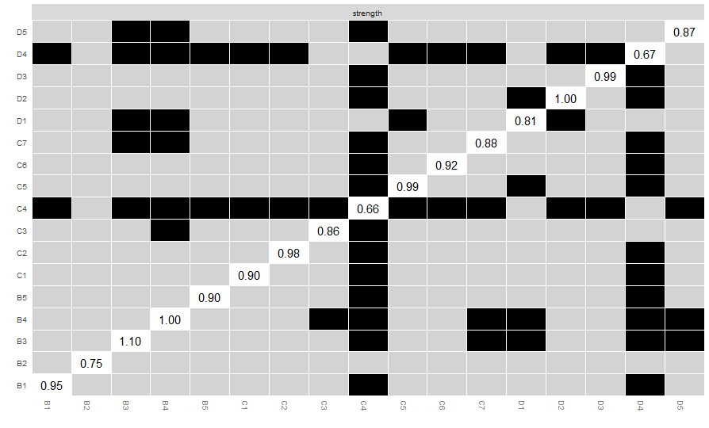
B)

