Longitudinal brain changes in MDD during emotional encoding: effects of presence and persistence of symptomatology

Supplement

Supplementary methods

fMRI data acquisition and processing. A SENSE-6 channel head coil was used at S1 in Amsterdam. A SENSE-8 channel head coil was used in Groningen and Leiden at both S1 and S2 and in Amsterdam at S2. In Groningen, echo planar imaging (EPI) volumes of 39 slices were acquired using a T2*- weighted gradient echo sequence (TR=2300 ms, TE=28 ms, matrix size: 64 × 64, plane resolution: 3 × 3 mm, slice thickness: 3 mm) at S1 and the EPI slice setting was changed into 35 slices at S2. In Leiden and Amsterdam, 35 axial slices were obtained using a T2*- weighted gradient echo sequence (TR=2300 ms, TE = 30 ms, matrix size: 96 × 96, plane resolution: 2.29 × 2.29 mm, slice thickness: 3 mm) at S1 and S2. Transversal slices were acquired parallel to the anterior commissure-posterior commissure plane (no gap) in interleaved order.
In addition, a high-resolution anatomical MRI was obtained with a sagittal 3D gradient-echo T1-weighted sequence for each participant (TR=9 ms, TE=3.5 ms, matrix size: 256 × 256, voxel size: 1 × 1 × 1 mm, 170 slices).
Before preprocessing, functional images were reoriented manually to the anterior-posterior commissure plane. Preprocessing consisted of slice timing, spatial realignment and co-registration of the anatomical image to the EPI image, spatial normalizing of the image to the standard Montreal Neurological Institute (MNI) space, reslicing to a 3 × 3 × 3 mm voxel size and spatial smoothing with an 8 mm full-width at half maximum Gaussian kernel. To remove low frequency noise, a high-pass filter with a cut-off of 128 s was applied to the fMRI time-series.
For the first-level analyses, two first-level models were set up for each participant, one for S1 and one for S2. To minimize the effect of motion, the absolute scan-to-scan difference for rotational and translational displacement after realignment was computed, and scans in which the displacement was larger than 0.9 mm compared to the previous scan were censored by modeling these as individual regressors ⁴⁰. Because we were interested in the valence effects and to be consistent with our previous reports ^{4,10}, we defined the following contrasts for each model: [successfully encoded positive words > successfully encoded neutral words; positive>neutral encoding] and [successfully encoded negative words > successfully encoded neutral words; negative>neutral encoding]. The difference between the two scan sessions was calculated for each contrast by subtracting the contrast image of the first scan from the second scan (S2-S1) for every participant using the ImCalc-option implemented in SPM8. Consequently, positive activation indicates an increase of activation from S1 to S2 and negative activation a decrease of activation from S1 to S2.

Post hoc group comparison. Because effects were observed during both positive and negative vs. neutral encoding, we decided to post-hoc evaluate the dependency of observed effects on changes in neutral or emotional word encoding. To this end, we built a full-factorial model with S2-S1 contrast maps as dependent variables, in which valence (positive/neutral/negative>baseline) was entered as within-subject factor (with three levels) and symptom change as interacting factor with valence. No correlation was found between brain activation during neutral>baseline and symptomatic change (Supplementary Figure S2), however neither for negative > baseline and positive > baseline. It appeared that the change of brain activation depended on the difference between emotional and neutral encoding, as contrasting change in relation to positive and neutral encoding (>baseline), and negative and neutral (> baseline) encoding again showed effects in the left hippocampus ([positive<neutral, MNI coordinates [x=-27, y=-16, z=-11], Z=4.00, p_{FWE} =.010; negative<neutral, MNI coordinates [x=-24, y=-16, z=-11], Z=3.63, p_{FWE}=.031).
In addition, to explore the change in HC group over time and to illustrate whether changes in patients reflect normalization, we built a group (HC, HI, LI) x valence (positive>neutral, negative>neutral) x time (S1, S2) model. Activation estimates from the left hippocampus/amygdala cluster from main correlational analysis for both time points for all participants were extracted from this model.

Supplementary results
Demographic characteristics. Within patients, symptom change was not associated with age (r=.28, p=.08), years of education (r=.14, p=.38) or sex (t=.39, p=.70). Moreover, symptom change was not associated with medication use (F(3, 39)=.89, p=.46) or psychotherapy use (F(3,39)=.61, p=.61) at S1 or S2. In addition, symptom change was not related to anxiety severity at S1 (BAI-score S1; r=-.03, p=.85) and depressive load in the five years before S1 (r=.20, p=.22), but trend-wise related to depression duration between S1 and S2 (r=.29, p=.07). Symptom change of depression was correlated to change in anxiety severity (BAI-scores) (r=.46, p=.003) and depression severity at baseline (MADRS-S1; r=-.34, p=.034).

fMRI results:

Post hoc group comparison: group (HC, HI, LI) x valence (positive>neutral, negative>neutral) x time (S1, S2) . Plotting of these estimates indicated no change in our main cluster in HC, and further indicated that changes followed a trend of normalization during positive but not negative word encoding (Supplementary Figure 3A & 3B). No interaction of time by valence or main effect of valence was observed in HC. A main effect of time in HC was observed subthreshold anterior ([x=-15,y=-10,z=-17], Z=3.49, p_{FWE} =.07).

Correlations with depression duration and course. To describe depression course in between two scan sessions, remitters (n=11), non-remitters (n=18) and recurrent group (n=10) was defined based on life chart interview. Patients who satisfied the following criteria were defined as remitters: 1) more than 3 months without symptoms or symptoms without burden within 1 year after S1, 2) without recurrence in the follow-up period. Patients who have a recurrence of symptoms for at least 1 month with burden after firstly obtaining remission were classified into recurrent group. Patients who had symptoms with burden in every month following S1 during the entire follow-up period were defined as non-remitters.
To explore whether changes in brain activation correlated with depressive course in between measurements, we divided our patients into remitters (n=11), non-remitters (n=18) and recurrent group (n=10) based on the pattern of presence of symptomatology between two scan sessions. However, course trajectory was not related to activation change during both positive and negative (>neutral) word encoding.

Quality assurance analysis. To control for possible bias or systematic effects across the scanning sites, we conducted a quality assurance analysis using MRI Quality Control tool (MRIQC) (Esteban et al 2017). From these reports, we specifically focused on the signal-to-noise ratio on source data from subjects, whom did not change scanning site (n=34). We built a repeated measures ANOVA with site (3; AMC, LUMC, UMCG) as a between-subject factor and scanning time (2; S1, S2) as a within-subject factor. We found a significant interaction between site and time (F_{2,57}=3.88, p=.03) and a significant main effect of site (F_{2,57}=4.80, p=.01). No main effect of time was found (Figure S4). Post-hoc analysis showed the site effect was significant at S1 but the difference was not significant at S2. The time effect was found in UMCG participants but not at the other two sites. Consequently, we performed a second test by excluding participants from UMCG (n=11). The main results did not change during positive words encoding (P_{FWE}=.032, t=4.00, Z=3.70, MNI coordinates [x=-27, y=-13, z=-11]) but became sub-threshold during negative words encoding (P_{FWE}=.120, t=3.47, Z=3.26, MNI coordinates [x=-24, y=-13, z=-11]).

Control for site effects. To test if the results were influenced by changes of scanner sites, we repeated the analyses after excluding all participants who switched scanning site at S2 (n=5). The results showed that the correlation between changes of depressive state and brain activation change during positive emotional words encoding did not change (P_{FWE}=.028, t=3.97, Z=3.73, MNI coordinates [x=-27, y=-13, z=-11]), indicating that reported effects were not affected by changing scanning site. The correlation during negative words encoding became sub-threshold (P_{FWE}=.099, t=3.49, Z=3.32, MNI coordinates [x=-30, y=-16, z=-23]).

References
Esteban O, Birman D, Schaer M, Koyejo OO, Poldrack RA, Gorgolewski KJ (2017). MRIQC: Advancing the automatic prediction of image quality in MRI from unseen sites. PLoS ONE 12, 1-21. https://doi.org/10.1371/journal.pone.0184661

Supplementary Table S1. Use of medication between two scan sessions.
 | High-improved | Low-improved | Likelihood ratio | p
Benzodiazepine(yes/no) | 3/16 | 5/15 | .07 | .79
Anti-depressants | 1/18 | 0/20 | 1.52 | .48
SSRIs | 2/17 | 3/17 | .13 | .71
SNRI | 0/18 | 3/17 | 4.08 | .23

Supplementary Table S2. Main effect of task of emotional memory task with an initial threshold of p<.005 uncorrected.
MNI Coordinate
Regions | k |  | Side | BA | x | y | z | F | Z | p_{uncorrected}
Main effect of task
Inferior frontal gyrus | 488 |  | L |  | -51 | 32 | 16 | 17.40 | 5.05 | <.001
Medial frontal gyrus | 38 |  | L |  | -3 | 29 | 46 | 7.17 | 3.05 | <.001
Superior frontal gyrus | 60 |  | L |  | -21 | 47 | 40 | 11.19 | 3.98 | <.001
Middle temporal gyrus | 17 |  | L |  | -60 | -43 | -2 | 10.12 | 3.76 | <.001
Middle temporal gyrus |  |  | R |  | 48 | -1 | -16 | 8.29 | 3.34 | <.001
Temporal pole | 22 |  | L |  | -48 | 11 | -23 | 11.26 | 3.99 | <.001
Lingual gyrus | 60 |  | L |  | -12 | -40 | -5 | 9.75 | 3.68 | <.001
Lingual gyrus | 58 |  | R |  | 9 | -34 | -8 | 9.58 | 3.64 | <.001
Hippocampus | 23 |  | R |  | 18 | -23 | -8 | 8.68 | 3.43 | <.001
Hippocampus | 7 |  | L |  | -18 | -10 | -11 | 7.67 | 3.18 | <.001

Supplementary Table S3. Main effect of valence and symptom change in main analysis
MNI Coordinate
Regions | kª | k^{b} | Side | BA | x | y | z | T | Z | p_{FWE_SVC}
Main effect of valence
Inferior frontal gyrus | 143 | - | L | 45 | -51 | 32 | 19 | 28.62 | 4.74 | .027*
Main effect of symptom change
Hippocampus/amygdala | 17 | 5 | L | 20 | -24 | -13 | -11 | 17.79 | 3.80 | .026*
^{a.} Cluster size in whole-brain analysis; ^{b.} Cluster size after small volume correction.
* Significant at p<.05 FWE corrected, voxel-level after small volume correction (SVC).

Supplementary Table S4. Effects from group × time × valence model
MNI Coordinate
Regions | k |  | Side | BA | x | y | z | F | Z | P_{uncorrected}
Interaction of group x time
Inferior frontal gyrus | 11 |  | R | 44 | 57 | 17 | 31 | 10.10 | 3.84 | <.001
Hippocampus/amygdala | 19 |  | R | 35 | 18 | -10 | -17 | 9.46 | 3.70 | <.001
Interaction of group x time x valence
Inferior frontal gyrus | 7 |  | R | 45 | 56 | 26 | 25 | 8.31 | 3.41 | <.001
Lingual gyrus | 6 |  | R | 18 | 12 | -49 | 4 | 8.29 | 3.41 | <.001

Supplementary Figure S1. Flow chart of recruitment and sample selection of participants. At baseline measurement (S1), 117 MDD patients and 52 healthy controls had valid scans during emotional words encoding task. From 53 of these patients and 13 of healthy controls the second measurement data (S2) could not be included because of loss to follow-up or missing behavioral data. Moreover, at S1 25 patients were not depressed at time of scanning (MADRS ≤10), one patients with too high MADRS score and 11 healthy controls were excluded to obtain a good match with the included patients. One patient was excluded based on the relative change of depressive symptom exceeded 3 standard deviation. In total, 21 symptom-improved patients, 19 non-improved patients and 29 healthy controls were included in the final analysis.
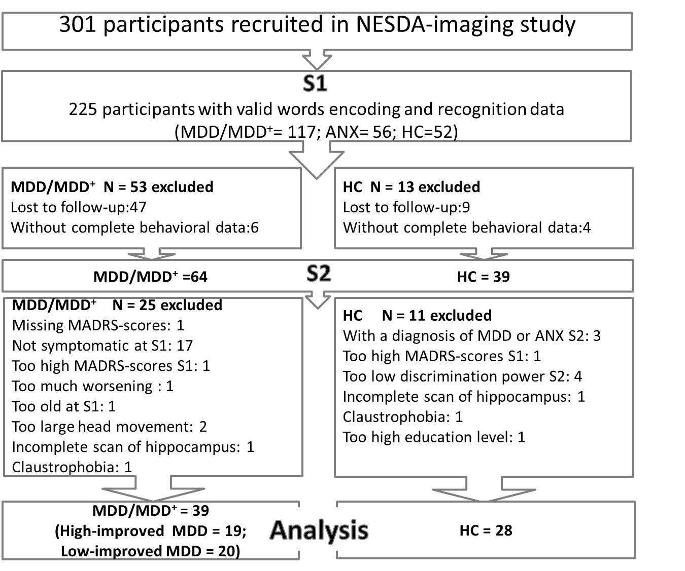
MDD: major depressive disorder; MDD⁺: depression combined with an additional diagnosis of social anxiety disorder, panic disorder and/or generalized anxiety disorder; ANX, anxiety; S1, baseline measurement; S2, second measurement; MADRS, Montgomery–Åsberg Depression Rating Scale; HC, healthy control; S-R: symptomatic-remitted MDD patients; S-S: symptomatic-symptomatic MDD patients.
Supplementary Figure S2. No correlation of change in the hippocampus/amygdala and symptom change in MDD was found between brain activation during neutral>baseline and symptomatic change.
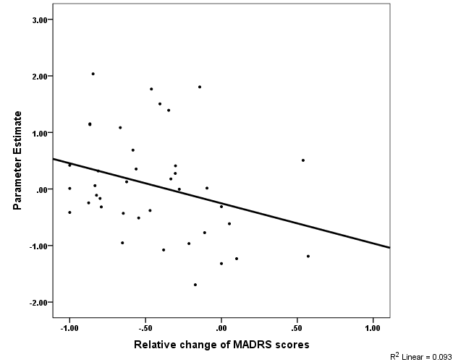

Supplementary Figure S3. Activation of the left hippocampal/amygdala extracted from correlation analysis during A) positive (peak MNI coordinate: x=-28, y=-13, z=-11), and B) negative word encoding at S1 and S2 (peak MNI coordinate: x=-23, y=-13, z=-11).

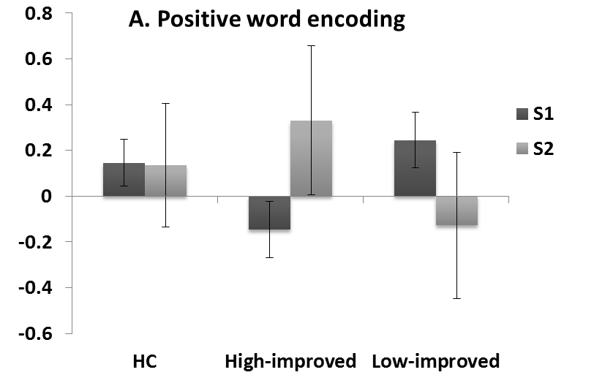
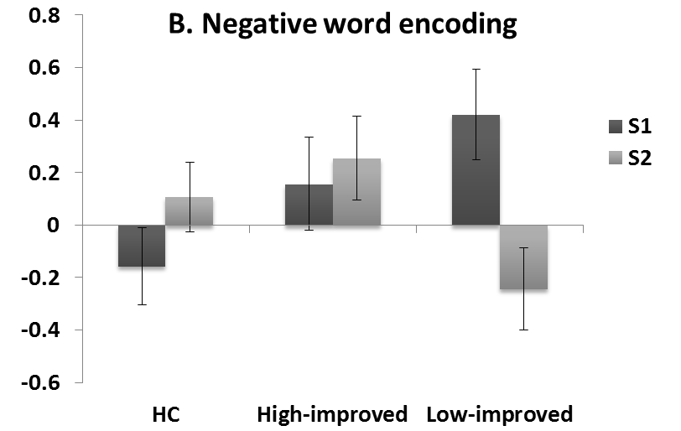
Supplementary Figure S4. No main effect of time was found in signal-to-noise ratio over time.

