Supplementary Methods
Brain imaging data
Acquisition: All brain magnetic resonance imaging (MRI) data were acquired at the same site, using the same Siemens (Berlin/Munich, Germany) Skyra 3T scanner and 32-channel head coil, and the same protocol (Miller et al., 2016). Briefly, T1 structural data were acquired using a 3D magnetization-prepared rapid acquisition gradient-echo (MPRAGE) sequence, at 1mm isotropic resolution, and diffusion imaging data were acquired using a standard monopolar Stejskal-Tanner sequence, at 2mm spatial resolution, with two b-values of 1000 and 2000 s/mm². Raw imaging data were processed and quality-assessed using an automated pipeline by the UK Biobank imaging team (Alfaro-Almagro et al., 2018) and resulting imaging-derived phenotypes were made available to approved researchers.
Cortical regions: Cortical measures were derived locally using FreeSurfer version 5.3 (Dale et al., 1999; Fischl et al., 1999; Fischl et al., 2004) to segment the cortex according to the Desikan-Killany atlas (Desikan et al., 2006) into 34 regions per hemisphere. Output data were visually assessed, excluding data for subjects with major errors (~10%) and for regions with localised errors (~2%). Metrics for 11 regions per hemisphere were weighted-averaged (mean thickness) or summed (surface area and volume) to produce metrics for four larger and more commonly studied regions – dorsolateral prefrontal cortex, inferior frontal gyrus, superior temporal gyrus, and medial occipital cortex – as in previous studies (Cox et al., 2018). After ruling out hemispheric effects, left and right metrics for each region were also combined, resulting in 27 bilateral regions. At the time of the present study, FreeSurfer processing and quality control had been completed for only a subset of the available neuroimaging sample (N=2,966).
Subcortical structures: T1 images were processed by the UK Biobank imaging team, which included the segmentation of the left and right caudate nucleus, thalamus, putamen, pallidum, hippocampus, amygdala and nucleus accumbens using FIRST (Patenaude et al., 2011). Volumes of subcortical structures were available for all 7,536 subjects and were summed bilaterally prior to further analysis.
White matter tracts: The diffusion tensor imaging (DTI) model, fitted voxel-wise during acquisition of diffusion images, provided measures of fractional anisotropy (FA) and mean diffusivity (MD). As per the automated processing pipeline (Alfaro-Almagro et al., 2018), within-voxel modelling and probabilistic tractography were performed using bedpostx and probtrackx (Behrens et al., 2007), generating measures for 27 specific tracts defined using AutoPtx (de Groot et al., 2013), 24 of which were combined bilaterally prior to further analysis. These tract-averaged measures of white matter microstructural integrity were available for 6,677 subjects.
Figure S1 – Clusters derived from SCZ PRS and rostral anterior cingulate cortex mean thickness for the two significant SCZ PRS by MDD interactions.

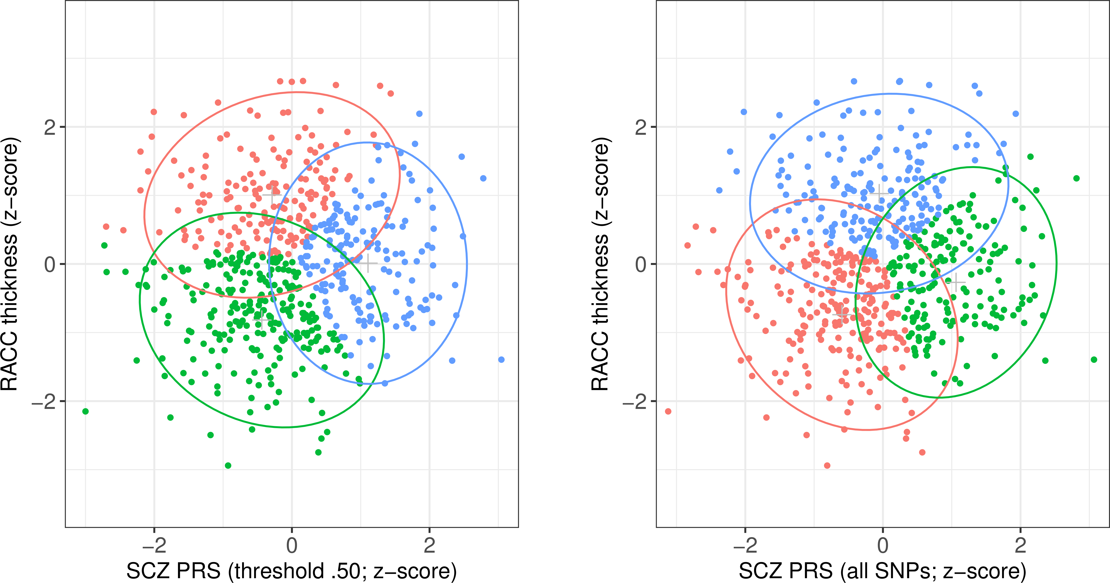

Notes. SCZ = schizophrenia; PRS = polygenic risk score; MDD = major depressive disorder; RACC = rostral anterior cingulate cortex. Red/green/blue points represents subjects included in each of the three derived clusters; surrounding ellipses represent 95% confidence intervals. Plots illustrate clusters derived from data relating to the two significant interactions between SCZ PRS at threshold 0.5 (left) or including all SNPs (right), and MDD status on RACC mean thickness.

Figure S2 – Mean rostral anterior cingulate cortex thickness by SCZ PRS and MDD group for the two significant SCZ PRS by MDD interactions in the replication sample.

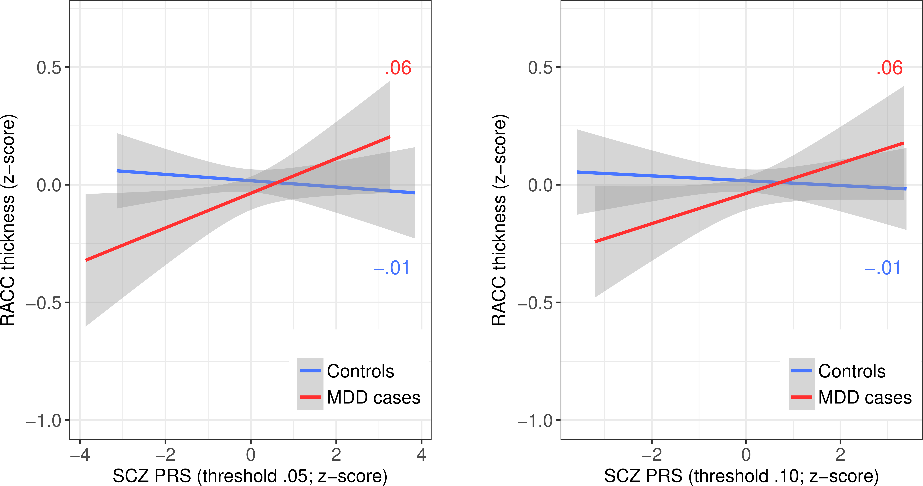

Notes. SCZ = schizophrenia; PRS = polygenic risk score; MDD = major depressive disorder; RACC = rostral anterior cingulate cortex. Lines represent least-squares regression lines (red/darker grey = MDD cases; blue/lighter grey = controls); shaded areas represent 95% confidence intervals. Plots illustrate the two significant interactions between SCZ PRS at threshold 0.5 (left) or including all SNPs (right), and MDD status on RACC mean thickness in the replication sample.

Table S1 – Interactive effects between SCZ PRS and MDD status on cortical surface area by region.

 | PRS threshold .01 |  |  | PRS threshold .05 |  |  | PRS threshold .10 |  |  | PRS threshold .50 |  |  | PRS all SNPs
 | β | SE | p | β | SE | p | β | SE | p | β | SE | p | β | SE | p
Dorsolateral PFC | -.003 | .026 | .918 | .011 | .026 | .661 | .015 | .026 | .570 | .018 | .026 | .484 | .019 | .026 | .462
Caudal MFG | -.061 | .038 | .106 | -.050 | .038 | .186 | -.060 | .038 | .120 | -.049 | .038 | .198 | -.047 | .038 | .213
IFG | -.063 | .037 | .086 | -.091 | .037 | .014 * | -.099 | .038 | .008 ** | -.105 | .037 | .005 ** | -.105 | .037 | .005 **
Lateral OFC | -.045 | .033 | .178 | -.048 | .033 | .148 | -.033 | .034 | .334 | -.045 | .033 | .181 | -.047 | .033 | .157
Medial OFC | -.024 | .034 | .471 | -.009 | .034 | .803 | .017 | .035 | .627 | .024 | .034 | .485 | .022 | .034 | .524
Frontal pole | -.027 | .045 | .542 | -.006 | .045 | .889 | -.005 | .046 | .909 | -.006 | .045 | .900 | -.001 | .045 | .991
Rostral ACC | .010 | .039 | .788 | .011 | .039 | .781 | .032 | .039 | .422 | .040 | .039 | .305 | .041 | .039 | .287
Caudal ACC | .057 | .043 | .183 | .044 | .043 | .301 | .055 | .043 | .205 | .073 | .043 | .090 | .069 | .043 | .107
Posterior cingulate | .033 | .037 | .377 | -.001 | .037 | .970 | .005 | .038 | .896 | .021 | .037 | .575 | .017 | .037 | .655
Isthmus cingulate | -.013 | .036 | .716 | -.018 | .036 | .623 | -.017 | .036 | .636 | -.048 | .036 | .181 | -.041 | .036 | .251
Precentral | -.012 | .032 | .709 | -.005 | .032 | .870 | -.005 | .032 | .876 | .005 | .032 | .875 | -.002 | .032 | .938
Postcentral | -.044 | .034 | .193 | -.024 | .034 | .488 | -.022 | .034 | .520 | -.023 | .034 | .492 | -.020 | .034 | .548
Paracentral | .025 | .040 | .521 | .015 | .040 | .700 | -.002 | .040 | .964 | .003 | .040 | .944 | -.003 | .040 | .931
Precuneus | -.026 | .033 | .430 | -.026 | .033 | .434 | .000 | .033 | .991 | -.004 | .033 | .915 | -.004 | .033 | .899
Superior parietal | -.010 | .036 | .783 | .007 | .037 | .840 | .012 | .037 | .742 | -.011 | .036 | .766 | -.010 | .037 | .783
Inferior parietal | -.047 | .035 | .183 | -.058 | .035 | .101 | -.073 | .036 | .040 * | -.066 | .035 | .062 | -.061 | .035 | .085
Supramarginal | -.027 | .035 | .445 | -.031 | .035 | .374 | -.047 | .036 | .186 | -.062 | .035 | .078 | -.063 | .035 | .074
Insula | .042 | .034 | .217 | .023 | .034 | .511 | .012 | .035 | .729 | .018 | .034 | .599 | .017 | .034 | .628
STG | -.023 | .031 | .454 | -.035 | .031 | .260 | -.053 | .032 | .095 | -.035 | .031 | .263 | -.035 | .031 | .257
MTG | -.030 | .035 | .399 | -.063 | .036 | .080 | -.064 | .036 | .079 | -.049 | .036 | .166 | -.046 | .036 | .194
ITG | -.027 | .039 | .493 | -.062 | .039 | .112 | -.058 | .040 | .144 | -.067 | .040 | .092 | -.063 | .040 | .113
Fusiform | .020 | .040 | .605 | -.007 | .040 | .858 | -.020 | .040 | .619 | -.014 | .040 | .732 | -.014 | .040 | .719
Entorhinal | .038 | .049 | .432 | .034 | .049 | .486 | .042 | .050 | .395 | .019 | .049 | .697 | .023 | .049 | .645
Parahippocampal | .015 | .041 | .718 | -.008 | .042 | .848 | -.008 | .042 | .856 | -.020 | .042 | .630 | -.018 | .042 | .661
Temporal pole | .010 | .044 | .826 | -.007 | .045 | .879 | .016 | .045 | .718 | .002 | .045 | .965 | .010 | .045 | .825
Lateral occipital | -.031 | .036 | .387 | -.023 | .036 | .523 | -.038 | .036 | .291 | -.033 | .036 | .350 | -.024 | .036 | .502
Medial occipital | -.028 | .038 | .470 | -.002 | .038 | .965 | -.014 | .039 | .715 | .006 | .038 | .877 | .010 | .038 | .800

Notes. SCZ = schizophrenia; PRS = polygenic risk score; MDD = major depressive disorder; PFC = prefrontal cortex; MFG = middle frontal gyrus; IFG = inferior frontal gyrus; OFC = orbitofrontal cortex; ACC = anterior cingulate cortex; STG = superior temporal gyrus; MTG = middle temporal gyrus; ITG = inferior temporal gyrus. Reported results are for interactive effects between SCZ PRS and MDD status on regional cortical surface area, controlling covariates. * and ** represent significant results at p<.05 and p<.01, respectively, before correcting for multiple comparisons. No results remained significant after FDR correction.
Table S2 – Interactive effects between SCZ PRS and MDD status on cortical volume by region.

 | PRS threshold .01 |  |  | PRS threshold .05 |  |  | PRS threshold .10 |  |  | PRS threshold .50 |  |  | PRS all SNPs
 | β | SE | p | β | SE | p | β | SE | p | β | SE | p | β | SE | p
Dorsolateral PFC | .036 | .027 | .196 | .029 | .028 | .293 | .038 | .028 | .177 | .038 | .028 | .173 | .038 | .028 | .171
Caudal MFG | -.028 | .039 | .467 | -.020 | .039 | .606 | -.032 | .040 | .413 | -.022 | .039 | .573 | -.022 | .039 | .576
IFG | -.028 | .038 | .453 | -.068 | .038 | .072 | -.064 | .038 | .093 | -.088 | .038 | .020 * | -.090 | .038 | .017 *
Lateral OFC | -.026 | .036 | .474 | -.043 | .036 | .228 | -.018 | .036 | .616 | -.034 | .036 | .339 | -.036 | .036 | .320
Medial OFC | .009 | .038 | .806 | .005 | .038 | .893 | .026 | .038 | .506 | .036 | .038 | .338 | .033 | .038 | .381
Frontal pole | .069 | .048 | .151 | .015 | .049 | .764 | .030 | .049 | .543 | .042 | .048 | .390 | .047 | .048 | .336
Rostral ACC | .044 | .042 | .297 | .045 | .042 | .288 | .074 | .043 | .081 | .091 | .042 | .029 * | .094 | .042 | .026 *
Caudal ACC | .110 | .046 | .017 * | .078 | .047 | .095 | .092 | .047 | .051 | .107 | .046 | .021 * | .098 | .046 | .035 *
Posterior cingulate | .038 | .040 | .342 | -.002 | .040 | .954 | .014 | .040 | .737 | .032 | .040 | .417 | .032 | .040 | .425
Isthmus cingulate | -.050 | .038 | .187 | -.074 | .038 | .052 | -.052 | .038 | .173 | -.084 | .038 | .027 * | -.068 | .038 | .073
Precentral | .031 | .036 | .392 | .024 | .037 | .518 | .037 | .037 | .324 | .037 | .036 | .308 | .035 | .036 | .338
Postcentral | .025 | .039 | .523 | .022 | .039 | .573 | .037 | .039 | .353 | .026 | .039 | .503 | .034 | .039 | .375
Paracentral | .079 | .041 | .055 | .062 | .041 | .137 | .053 | .042 | .204 | .046 | .041 | .264 | .045 | .041 | .280
Precuneus | -.019 | .033 | .555 | -.019 | .033 | .572 | .006 | .033 | .865 | .001 | .033 | .985 | -.002 | .033 | .947
Superior parietal | .008 | .037 | .830 | .031 | .038 | .404 | .047 | .038 | .218 | .015 | .037 | .682 | .018 | .038 | .632
Inferior parietal | -.013 | .036 | .719 | -.021 | .036 | .558 | -.027 | .037 | .468 | -.027 | .036 | .459 | -.024 | .036 | .515
Supramarginal | .015 | .036 | .679 | -.005 | .037 | .896 | -.005 | .037 | .899 | -.020 | .037 | .583 | -.019 | .037 | .603
Insula | .040 | .036 | .265 | .016 | .036 | .667 | .020 | .037 | .595 | .019 | .036 | .605 | .020 | .036 | .574
STG | .032 | .035 | .356 | .026 | .036 | .473 | .018 | .036 | .620 | .022 | .035 | .544 | .022 | .036 | .543
MTG | -.001 | .038 | .983 | -.010 | .038 | .794 | -.008 | .038 | .845 | .011 | .038 | .779 | .012 | .038 | .760
ITG | -.012 | .042 | .780 | -.030 | .043 | .474 | -.020 | .043 | .650 | -.027 | .043 | .535 | -.023 | .043 | .585
Fusiform | -.008 | .043 | .851 | -.042 | .043 | .332 | -.039 | .044 | .374 | -.035 | .043 | .419 | -.036 | .043 | .409
Entorhinal | .042 | .051 | .406 | .060 | .052 | .247 | .065 | .052 | .213 | .044 | .052 | .393 | .050 | .052 | .337
Parahippocampal | -.046 | .046 | .314 | -.045 | .046 | .328 | -.015 | .047 | .751 | -.021 | .046 | .653 | -.017 | .046 | .719
Temporal pole | .023 | .049 | .636 | .046 | .050 | .355 | .090 | .050 | .074 | .088 | .049 | .074 | .093 | .049 | .059
Lateral occipital | -.027 | .037 | .466 | -.026 | .037 | .482 | -.019 | .037 | .613 | -.028 | .037 | .440 | -.020 | .037 | .591
Medial occipital | -.040 | .039 | .308 | -.029 | .039 | .465 | -.037 | .040 | .360 | -.019 | .039 | .635 | -.016 | .039 | .692

Notes. SCZ = schizophrenia; PRS = polygenic risk score; MDD = major depressive disorder; PFC = prefrontal cortex; MFG = middle frontal gyrus; IFG = inferior frontal gyrus; OFC = orbitofrontal cortex; ACC = anterior cingulate cortex; STG = superior temporal gyrus; MTG = middle temporal gyrus; ITG = inferior temporal gyrus. Reported results are for interactive effects between SCZ PRS and MDD status on regional cortical volume, controlling covariates. * represents significant results at p<.05 before correcting for multiple comparisons. No results remained significant after FDR correction.
Table S3 – Interactive effects between SCZ PRS and MDD status on volumes of subcortical structures.

 | PRS threshold .01 |  |  | PRS threshold .05 |  |  | PRS threshold .10 |  |  | PRS threshold .50 |  |  | PRS all SNPs
 | β | SE | p | β | SE | p | β | SE | p | β | SE | p | β | SE | p
Caudate volume | .003 | .025 | .905 | -.001 | .025 | .972 | .004 | .025 | .863 | .005 | .025 | .831 | .003 | .025 | .898
Thalamus volume | .047 | .019 | .016 * | .029 | .019 | .131 | .024 | .019 | .225 | .012 | .019 | .536 | .012 | .019 | .546
Putamen volume | .006 | .023 | .802 | -.012 | .023 | .597 | .004 | .023 | .849 | -.002 | .023 | .943 | -.003 | .023 | .892
Pallidum volume | -.014 | .026 | .584 | -.038 | .026 | .138 | -.033 | .026 | .205 | -.033 | .026 | .203 | -.037 | .026 | .149
Amygdala volume | .006 | .028 | .832 | .009 | .028 | .749 | .012 | .028 | .664 | .031 | .028 | .264 | .034 | .028 | .221
Accumbens volume | .004 | .026 | .892 | -.005 | .027 | .837 | -.003 | .027 | .921 | -.004 | .026 | .885 | -.007 | .026 | .800
Hippocampus volume | -.009 | .027 | .731 | -.022 | .027 | .421 | -.033 | .027 | .215 | -.008 | .027 | .754 | -.010 | .027 | .716

Notes. SCZ = schizophrenia; PRS = polygenic risk score; MDD = major depressive disorder. Reported results are for interactive effects between SCZ PRS and MDD status on subcortical volumes, controlling covariates. * represents a significant result at p<.05 before correcting for multiple comparisons. No results remained significant after FDR correction.
Table S4 – Interactive effects between SCZ PRS and MDD status on FA by white matter tract.

 | PRS threshold .01 |  |  | PRS threshold .05 |  |  | PRS threshold .10 |  |  | PRS threshold .50 |  |  | PRS all SNPs
 | β | SE | p | β | SE | p | β | SE | p | β | SE | p | β | SE | p
Superior longitudinal | .000 | .031 | .999 | -.006 | .031 | .846 | .002 | .031 | .958 | .002 | .031 | .945 | -.001 | .031 | .966
Inferior longitudinal | -.007 | .031 | .818 | -.018 | .031 | .575 | -.005 | .031 | .874 | .001 | .031 | .965 | -.001 | .031 | .975
Cingulum cingulate | .013 | .032 | .685 | -.044 | .031 | .158 | -.017 | .031 | .591 | -.013 | .031 | .685 | -.016 | .031 | .600
Cingulum parahip. | .014 | .031 | .646 | .007 | .031 | .810 | -.003 | .031 | .920 | .006 | .031 | .841 | .005 | .031 | .878
Inferior fronto-occipital | -.008 | .032 | .790 | -.021 | .032 | .516 | .002 | .032 | .944 | .014 | .031 | .661 | .011 | .031 | .729
Uncinate | -.013 | .031 | .681 | -.015 | .031 | .631 | -.023 | .031 | .455 | -.030 | .031 | .323 | -.031 | .031 | .305
Superior thalamic | -.013 | .032 | .672 | .005 | .032 | .866 | .016 | .032 | .606 | .021 | .031 | .500 | .021 | .031 | .513
Anterior thalamic | .007 | .031 | .816 | .004 | .031 | .904 | .018 | .031 | .561 | .026 | .031 | .404 | .022 | .031 | .478
Posterior thalamic | .011 | .031 | .725 | .009 | .031 | .762 | .028 | .031 | .365 | .037 | .031 | .236 | .035 | .031 | .263
Corticospinal | -.045 | .031 | .144 | -.017 | .031 | .588 | -.023 | .031 | .459 | -.009 | .031 | .765 | -.008 | .031 | .805
Forceps major | -.023 | .032 | .474 | -.045 | .032 | .151 | -.032 | .032 | .307 | -.020 | .031 | .531 | -.018 | .031 | .559
Forceps minor | .017 | .032 | .591 | .007 | .031 | .833 | .024 | .031 | .451 | .016 | .031 | .605 | .014 | .031 | .661
Acoustic | .024 | .031 | .449 | .001 | .031 | .982 | .006 | .031 | .847 | -.010 | .031 | .743 | -.015 | .031 | .638
Medial lemniscus | .006 | .031 | .855 | .001 | .031 | .967 | .003 | .031 | .934 | -.005 | .031 | .867 | -.007 | .031 | .815
Middle cerebellar | -.033 | .032 | .305 | -.025 | .032 | .440 | -.019 | .032 | .549 | .006 | .032 | .859 | .005 | .032 | .864

Notes. SCZ = schizophrenia; PRS = polygenic risk score; MDD = major depressive disorder; FA = fractional anisotropy. Reported results are for interactive effects between SCZ PRS and MDD status on tract FA, controlling covariates. No results were significant, even before correcting for multiple comparisons.

Table S5 – Interactive effects between SCZ PRS and MDD status on MD by white matter tract.

 | PRS threshold .01 |  |  | PRS threshold .05 |  |  | PRS threshold .10 |  |  | PRS threshold .50 |  |  | PRS all SNPs
 | β | SE | p | β | SE | p | β | SE | p | β | SE | p | β | SE | p
Superior longitudinal | .010 | .030 | .753 | .022 | .030 | .459 | .010 | .030 | .734 | .014 | .030 | .638 | .017 | .030 | .563
Inferior longitudinal | .028 | .030 | .354 | .041 | .030 | .168 | .028 | .030 | .345 | .027 | .030 | .370 | .032 | .030 | .285
Cingulum cingulate | .025 | .029 | .398 | .032 | .029 | .266 | .022 | .029 | .451 | .030 | .029 | .292 | .032 | .029 | .268
Cingulum parahip. | .000 | .032 | .989 | -.001 | .032 | .965 | .004 | .032 | .896 | -.009 | .032 | .773 | -.007 | .032 | .821
Inferior fronto-occipital | .021 | .031 | .499 | .019 | .031 | .525 | .004 | .030 | .899 | .004 | .030 | .883 | .009 | .030 | .755
Uncinate | .027 | .029 | .348 | .042 | .029 | .140 | .051 | .029 | .076 | .058 | .028 | .040 * | .062 | .028 | .029 *
Superior thalamic | -.004 | .027 | .875 | .014 | .027 | .603 | -.003 | .027 | .897 | -.010 | .027 | .708 | -.007 | .027 | .779
Anterior thalamic | .012 | .028 | .672 | .031 | .028 | .274 | .018 | .028 | .526 | .017 | .028 | .535 | .021 | .028 | .456
Posterior thalamic | -.012 | .029 | .678 | -.001 | .029 | .961 | -.020 | .029 | .485 | -.021 | .029 | .472 | -.017 | .029 | .550
Corticospinal | .008 | .032 | .797 | .028 | .032 | .375 | .019 | .032 | .549 | .012 | .032 | .695 | .013 | .032 | .693
Forceps major | .020 | .032 | .519 | .041 | .031 | .195 | .052 | .031 | .095 | .049 | .031 | .120 | .046 | .031 | .141
Forceps minor | -.001 | .030 | .977 | .016 | .030 | .598 | .002 | .030 | .940 | .020 | .030 | .501 | .024 | .030 | .423
Acoustic | .049 | .032 | .125 | .057 | .032 | .077 | .048 | .032 | .133 | .055 | .032 | .086 | .059 | .032 | .065
Medial lemniscus | -.037 | .033 | .257 | -.013 | .033 | .697 | -.028 | .033 | .396 | -.008 | .032 | .813 | -.007 | .032 | .819
Middle cerebellar | .001 | .032 | .979 | .017 | .032 | .589 | .023 | .032 | .482 | .033 | .032 | .306 | .033 | .032 | .298

Notes. SCZ = schizophrenia; PRS = polygenic risk score; MDD = major depressive disorder; MD = mean diffusivity. Reported results are for interactive effects between SCZ PRS and MDD status on tract MD, controlling covariates. * represents significant results at p<.05 before correcting for multiple comparisons. No results remained significant after FDR correction.

Reference

Cox SR, Bastin ME, Ritchie SJ, Dickie DA, Liewald DC, Muñoz-Maniega S, Redmond P, Royle NA, Pattie A, Valdés Hernández M, Corley J, Aribisala BS, McIntosh AM, Wardlaw JM and Deary IJ (2018) Brain cortical characteristics of lifetime cognitive ageing. Brain Structure and Function 223, 509–518.

