Supplementary information for
Kou et al., “A randomized trial shows dose-frequency and genotype may determine the therapeutic efficacy of intranasal oxytocin”

Supplementary Methods
Supplementary Tables
Supplementary Figures

Supplementary Methods

Participants

150 healthy, right-handed healthy adult subjects were recruited by local advertisement. All subjects had normal or corrected to normal vision and no history of or current neurological or psychiatric disorders. We used Webpower (Zhang and Yuan, 2018) to estimate power for behavioral analyses using 3- way ANOVAs with an expected medium effect size and α = 0.05,which revealed around 60% power for observed interactions. For 2-way ANOVA interactions between treatment and time point 78% power was achieved and 80% power for main effect of treatment. For post-hoc comparisons independent t-tests achieve 65 % power for an expected medium effect size (d = 0.5) and 93% for paired t-tests. Participants were free from current (one month before the experiment) or regular use of medication and were required to abstain from caffeine, alcohol and tobacco at least 24 hours before the experiment. 3 subjects failed to meet inclusion criteria (were currently taking medications). Four subjects were not able to attend all study appointments and 5 were excluded due to head movement during the fMRI assessment (motion > 3.0mm translation or 3° and mean frame-wise displacement (FD < 0.5 mm) (Power et al., 2012), Pre-treatment levels of anxiety, depression, trait autism and empathy were assessed using validated scales (State-Trait Anxiety Inventory (STAI) (Kvaal et al., 2005), Beck Depression Inventory (Beck et al., 1988), Autism-Spectrum Quotient (AQ) (Baron-Cohen et al., 2001), and Interpersonal Reactivity Index (IRI) (Siu and Shek, 2005).

fMRI face and resting state processing paradigm
208 gray scaled facial stimuli displaying happy, neutral, angry or fearful facial expressions (n = 26 per category, 50% female) were employed for the implicit emotional face processing task. Stimuli were initially rated with respect to arousal and valence by an independent group of participants (n = 24 participants, 10 females, age, M ± SD, 21.3 ± 1.9 years). Based on these valence and arousal ratings two independent sets of stimuli for the 1st day and 5th day were constructed with matched arousal and valence (all ps > 0.3, see Table S5) and the order of the two sets are counter balanced in the treatment and control groups.
Subject were required to lie still in the scanner and open their eyes looking at the black screen for 8.5 minutes (49 minutes after intranasal OT/PLC) during the resting state data acquisition. After that subjects were instructed to attentively process the presented facial stimuli and were required to indicate the gender of the actor after presentation (left button press for male, right button press for female face) to ensure attentive processing. Stimuli were presented for 3s followed by a jittered fixation (1.5-2.1s) followed by the gender discrimination task presented for 2s (2s) and followed by a jittered inter-trial interval (4.5-6s) that served as low level baseline. Order of gender and emotion was pseudo-randomized (see also Fig. S4). The total duration of the fMRI task was 34.5 minutes (including 4 minutes -T1-weighted high-resolution anatomical images, 8.5 minutes -resting state, 22 minutes -face task).

MRI data acquisition
fMRI data employing blood oxygenation level-dependent (BOLD) contrast imaging was acquired on a 3T GE MR750 system. Functional images for task-based and resting state data assessments were acquired using EPI sequences (TR=2000ms, echo time=30ms, ﬂip angle=90°, FOV=240mm × 240mm, voxel size= 3.75 × 3.75 ×4 mm, resolution=64 × 64, the number of slices=39). T1-weighted anatomical images were additionally acquired to improve normalization of the functional images and explore potential structural changes related to OT treatment (TR=6ms, echo time=2ms, flip angle=9°, FOV=256mm × 256mm, voxel size =1×1×1mm, number of slices=156).
fMRI data preprocessing – task fMRI
Task-related fMRI data analyzed using SPM12 (Friston et al., 1994) (Statistical Parametric Mapping; http://www.fil.ion.ucl.ac.uk/spm). The first 5 volumes were discarded to allows T1 equilibration and the remaining images were corrected for temporal slice acquisition differences and then realigned and unwarped to correct for head motion (six-parameter rigid body algorithm). Tissue segmentation and bias-correction were applied to the high-resolution structural images. After co-registration of the functional time-series with the skull-stripped anatomical scan the transformation matrix was applied to normalize the functional images to MNI standard space with a voxel size of 3 × 3 ×3 mm. Normalized images were spatially smoothed using a Gaussian kernel with full-width at half-maximum (FWHM) of 5 mm. Participants with head motion exceeding 3.0mm translation or 3° rotation and mean frame-wise displacement (FD > 0.5 mm) were excluded. Mean frame-wise displacement (FD) was additionally controlled for between OT treatment group and PLC control group (see Table S6)
fMRI data preprocessing – resting state fMRI
Resting state data was analyzed using SPM12 (Statistical Parametric Mapping; http://www.fil.ion.ucl.ac.uk/spm) and Data Processing Assistant for Resting-State fMRI(Yan, 2010) (DPARSFA; http://rfmri.org/DPARSF). After discarding the first 5 scans, preprocessing included slice-time correction, head motion correction using six-parameter rigid body algorithm. Then they were co-registered with the anatomical scan and normalized to MNI space with a voxel size of 3 × 3 ×3 mm. Normalized images were then spatially smoothed using a Gaussian kernel with full-width at half-maximum (FWHM) of 5mm. As for nuisance signal correction, the following nuisance parameters were included as regressors: 6 head motion parameters, 6 head motion parameters one time point before, and their squares, white matter (WM) and cerebrospinal fluid (CSF). After filtering with the band pass filter (0.01-0.1HZ) and linear detrending, the seed to whole brain functional connectivity maps of the right amygdala (peak coordinates of right amygdala as determined by the three way interaction (treatment × time point × valence) BOLD level analysis of the effects of OT on amygdala responsivity) were computed. Participants with head motion exceeding 3.0mm translation or 3° rotation and mean frame-wise displacement (FD > 0.5 mm) were excluded. Mean frame-wise displacement (FD) was controlled between OT treatment and PLC control groups (see Table S6).
MRI data preprocessing – brain structure
To further control for potential confounding effects of single- and repeated dose administration of OT on brain structure a voxel-based morphometry (VBM) analysis was performed on the T1-weighted images acquired on both testing days. Processing for longitudinal effects included unified segmentation, DARTEL preprocessing, and Pairwise Longitudinal Registration (Ashburner, 2013) using in SPM12 according to standard procedures(Ashburner, 2007; Ashburner and Friston, 2005). Repeated administration effects on gray matter (GM) were assessed using whole-brain analysis across groups. For the acute effect identical preprocessing was applied without the longitudinal registration step including T1 images from the 1st day and an independent samples t test to compare OT and PLC treated participants.

Genotyping
A total of 120 subjects (samples could not be analyzed from 27 subjects either due to problems with buccal cell sampling or equivocal genotyping results) were successfully genotyped from buccal cell swabs. DNA was extracted by a MagNa Pure 96 robot (Roche Diagnostics, Mannheim, Germany) with a commercial Viral NA Small Volume Kit (Roche Diagnostics, Mannheim, Germany). Polymorphisms were analyzed by means of a real time quantitative polymerase chain reaction (PCR) and subsequent high resolution melting detection analysis with a LightCycler Cobas z480 (Roche Diagnostics, Mannheim, Germany). Simple probe assay designs provided by TibMolBiol (Berlin, Germany) were conducted. The following SNPs were investigated for participants in the present study: OXTR rs2254298, rs53576 (see Tables S1 and S2 for distribution and Hardy Weinberg details).

Table S1 The number of A carriers (A+) and A non-carriers (A-) of rs2254298, G carriers (G+) and G non-carriers (G-) of rs53576 in each treatment group
Genotypes | PLC | OT₃ | OT₅ | In total | χ2 | P | η²
rs2254298(A+) | 20 | 23 | 20 | 63 | 0.088 | 0.957 | 0.025
rs2254298(A-) | 16 | 18 | 14 | 48 | 0.088 | 0.957 | 0.025
rs53576(G+) | 15 | 17 | 20 | 52 | 2.824 | 0.244 | 0.124
rs53576(G-) | 21 | 24 | 14 | 59 | 2.824 | 0.244 | 0.124

Table S2 Distribution of Genotypes in the Sample of N=120 participants
 | Genotypes |  |  |  | HWE
rs2254298 | AA:  15 | AG:  53 | GG:  52 | Total:  120 | Chi² = 0.07,  p = .794
rs53576 | AA:  60 | AG:  45 | GG:  15 | Total:  120 | Chi² = 1.94,  p = .163

Table S3 Anxiety, depression, autism and empathy scores in all three groups on both days
Questionnaire | Day | PLC | OT₃ | OT₅ | F | P
STAI, state | 1  5 | 38.78±11.53  38.00±11.61 | 35.49±10.69  36.54±10.21 | 37.14±8.92  35.76±9.25 | 1.13  0.57 | 0.33  0.57
STAI, trait | 1  5 | 41.67±11.60  42.48±11.62 | 40.28±10.51  40.67±10.47 | 39.20±8.94  35.74±9.25 | 0.81  1.50 | 0.15  0.23
BDI | 1  5 | 9.84±9.13  9.82±8.72 | 8.93±8.08  8.51±7.94 | 8.00±7.45  8.44±8.09 | 0.57  0.39 | 0.57  0.68
AQ | 1  5 | 20.91±5.57  20.15±6.29 | 20.35±5.91  20.72±6.22 | 19.47±4.57  19.35±5.71 | 0.88  0.60 | 0.42  0.55
IRI | 1  5 | 50.59±9.84  48.35±9.52 | 53.02±8.74  51.53±10.60 | 49.39±9.81  46.49±8.70 | 1.72  3.21 | 0.18  0.04

Table S4 Chi Squared Test of post-experiment interviews where subjects were required to identify which treatment they received. In all cases subjects were unable to guess better than chance.
Day | PLC | OT₃ | OT₅ | In total | χ2 | P | η²
1 | 24 | 20 | 22 | 66 | 0.547 | 0.76 | 0.062
2 | 20 | 15 | 17 | 52 | 0.988 | 0.61 | 0.078
3 | 24 | 28 | 24 | 76 | 2.645 | 0.27 | 0.014
4 | 19 | 18 | 20 | 57 | 0.01 | 0.99 | 0.003
5 | 25 | 25 | 24 | 74 | 0.787 | 0.68 | 0.039

Table S5 Ratings for each of the two sets of different face emotion stimuli used on the 1st day and 5th day in a counterbalanced design. There were no significant differences between the two sets for valence and arousal ratings.
 | Valence |  |  |  |  | Arousal
 | Set A | Set B | t | p | Set A |  | Set B | t | p
 | On the 1st day | On the 5th day | t | p | On the 1st day |  | On the 5th day | t | p
Happy | 6.26±0.94 | 6.25±0.97 | 0.04 | 0.97 | 5.50±0.59 |  | 5.52±0.44 | 0.12 | 0.90
Neutral | 5.67±0.17 | 5.61±0.16 | 1.06 | 0.30 | 3.03±0.36 |  | 2.98±0.32 | 0.55 | 0.59
Fear | 6.40±1.02 | 6.31±0.17 | 0.34 | 0.74 | 6.71±0.70 |  | 6.70±0.63 | 0.03 | 0.98
Angry | 6.16±0.98 | 6.04±1.04 | 0.48 | 0.64 | 5.66±0.84 |  | 5.83±0.99 | 0.82 | 0.42

Table S6 Group Comparison of Mean frame-wise displacement
fMRI tasks | t _{OT3 VS PLC} | P _{OT3 VS PLC} | t _{OT5 VS PLC} | P _{OT5 VS PLC}
Day1-Face task | 0.588 | 0.558 | 0.261 | 0.795
Day5-Face task | 1.056 | 0.294 | 0.097 | 0.923
Day1-rs-fMRI-1 | 1.841 | 0.069 | 1.025 | 0.308
Day5-rs-fMRI-1 | 0.739 | 0.462 | 1.305 | 0.195

Table S7 Detailed overview of the post-hoc analysis of the ROI analysis of 3-way interaction on amygdala response to emotional faces. Post-hoc tests were computed on extracted parameter estimates from the right amygdala mask (from the Brainnetome atlas, Fan et al., 2016).
Amygdala activity  （Right amygdala） | Treatment*time point * face emotion  F_{(6,405)}=2.563;P<0.019 ;η²p= 0.037 | Post-hoc P-values
d1  (fear) | OT₃ vs PLC | p=0.015
d1  (fear) | OT₅ vs PLC | p=0.002
d1  (fear) | OT₅ vs OT₃ | p=0.569
d5  (fear) | OT₃ vs PLC | p=0.003
d5  (fear) | OT₅ vs PLC | p=0.426
d5  (fear) | OT₅ vs OT₃ | p=0.021
d1 vs d5  (fear) | within PLC | p=0.356
d1 vs d5  (fear) | within OT₃ | p=0.538
d1 vs d5  (fear) | within OT₅ | p=0.035
d1  (angry) | OT₃ vs PLC | p=0.016
d1  (angry) | OT₅ vs PLC | p=0.021
d1  (angry) | OT₅ vs OT₃ | p=0.860
d5  (angry) | OT₃ vs PLC | p=0.008
d5  (angry) | OT₅ vs PLC | p=0.315
d5  (angry) | OT₅ vs OT₃ | p=0.082
d1 vs d5  (angry) | within PLC | p=0.007
d1 vs d5  (angry) | within OT₃ | p=0.006
d1 vs d5  (angry) | within OT₅ | p=0.699
d1  (happy) | OT₃ vs PLC | p=0.041
d1  (happy) | OT₅ vs PLC | p=0.037
d1  (happy) | OT₅ vs OT₃ | p=0.982
d5  (happy) | OT₃ vs PLC | p=0.028
d5  (happy) | OT₅ vs PLC | p=0.242
d5  (happy) | OT₅ vs OT₃ | p=0.272
d1 vs d5  (happy) | within PLC | p=0.895
d1 vs d5  (happy) | within OT₃ | p=0.712
d1 vs d5  (happy) | within OT₅ | p=0.392
d1  (neutral) | OT₃ vs PLC | p=0.001
d1  (neutral) | OT₅ vs PLC | p=0.017
d1  (neutral) | OT₅ vs OT₃ | p=0.330
d5  (neutral) | OT₃ vs PLC | p=0.052
d5  (neutral) | OT₅ vs PLC | p=0.472
d5  (neutral) | OT₅ vs OT₃ | p=0.203
d1 vs d5  (neutral) | within PLC | p=0.028
d1 vs d5  (neutral) | within OT₃ | p=0.872
d1 vs d5  (neutral) | within OT₅ | p=0.951

Table S8 Post-hoc analysis of 3-way interaction for post-scan behavioral rating responses to emotional faces (treatment × time point × face emotion).
Intensity rating | treatment*timepoint*face emotion  F_{(6,405)}=3.327;P=0.004 ;η²p= 0.05 | Post-hoc P-values | Arousal rating | treatment*timepoint*face emotion  F_{(6,405)}=1.83;P=0.093 ;η²p= 0.03 | Post-hoc P-values | Valence rating | treatment*timepoint*face emotion  F_{(6,405)}=2.63;P=0.016 ;η²p= 0.04 | Post-hoc P-values
d1  (fear) | OT₃ vs PLC | p=0.101 | d1  (fear) | OT₃ vs PLC | p=0.015 | d1  (fear) | OT₃ vs PLC | p=0.809
d1  (fear) | OT₅ vs PLC | p=0.376 | d1  (fear) | OT₅ vs PLC | p=0.355 | d1  (fear) | OT₅ vs PLC | p=0.459
d1  (fear) | OT₅ vs OT₃ | p=0.423 | d1  (fear) | OT₅ vs OT₃ | p=0.114 | d1  (fear) | OT₅ vs OT₃ | p=0.331
d5  (fear) | OT₃ vs PLC | p=0.004 | d5  (fear) | OT₃ vs PLC | p=0.001 | d5  (fear) | OT₃ vs PLC | p=0.410
d5  (fear) | OT₅ vs PLC | p=0.212 | d5  (fear) | OT₅ vs PLC | p=0.172 | d5  (fear) | OT₅ vs PLC | p=0.624
d5  (fear) | OT₅ vs OT₃ | p=0.088 | d5  (fear) | OT₅ vs OT₃ | p=0.033 | d5  (fear) | OT₅ vs OT₃ | p=0.722
d1 vs d5  (fear) | within PLC | p=0.396 | d1 vs d5  (fear) | within PLC | p=0.484 | d1 vs d5  (fear) | within PLC | p=0.363
d1 vs d5  (fear) | within OT₃ | p<0.001 | d1 vs d5  (fear) | within OT₃ | p=0.001 | d1 vs d5  (fear) | within OT₃ | p=0.129
d1 vs d5  (fear) | within OT₅ | p=0.077 | d1 vs d5  (fear) | within OT₅ | p=0.056 | d1 vs d5  (fear) | within OT₅ | p=0.314
d1  (angry) | OT₃ vs PLC | p=0.849 | d1  (angry) | OT₃ vs PLC | p=0.244 | d1  (angry) | OT₃ vs PLC | p=0.499
d1  (angry) | OT₅ vs PLC | p=0.398 | d1  (angry) | OT₅ vs PLC | p=0.428 | d1  (angry) | OT₅ vs PLC | p=0.200
d1  (angry) | OT₅ vs OT₃ | p=0.306 | d1  (angry) | OT₅ vs OT₃ | p=0.051 | d1  (angry) | OT₅ vs OT₃ | p=0.053
d5  (angry) | OT₃ vs PLC | p=0.356 | d5  (angry) | OT₃ vs PLC | p=0.053 | d5  (angry) | OT₃ vs PLC | p=0.510
d5  (angry) | OT₅ vs PLC | p=0.610 | d5  (angry) | OT₅ vs PLC | p=0.671 | d5  (angry) | OT₅ vs PLC | p=0.751
d5  (angry) | OT₅ vs OT₃ | p=0.151 | d5  (angry) | OT₅ vs OT₃ | p=0.018 | d5  (angry) | OT₅ vs OT₃ | p=0.327
d1 vs d5  (angry) | within PLC | p=0.050 | d1 vs d5  (angry) | within PLC | p=0.146 | d1 vs d5  (angry) | within PLC | p=0.012
d1 vs d5  (angry) | within OT₃ | p=0.001 | d1 vs d5  (angry) | within OT₃ | p=0.001 | d1 vs d5  (angry) | within OT₃ | p=0.013
d1 vs d5  (angry) | within OT₅ | p=0.006 | d1 vs d5  (angry) | within OT₅ | p=0.023 | d1 vs d5  (angry) | within OT₅ | p=0.552
d1  (happy) | OT₃ vs PLC | p=0.383 | d1  (happy) | OT₃ vs PLC | p=0.066 | d1  (happy) | OT₃ vs PLC | p=0.370
d1  (happy) | OT₅ vs PLC | p=0.647 | d1  (happy) | OT₅ vs PLC | p=0.274 | d1  (happy) | OT₅ vs PLC | p=0.200
d1  (happy) | OT₅ vs OT₃ | p=0.418 | d1  (happy) | OT₅ vs OT₃ | p=0.004 | d1  (happy) | OT₅ vs OT₃ | p=0.100
d5  (happy) | OT₃ vs PLC | p=0.885 | d5  (happy) | OT₃ vs PLC | p=0.227 | d5  (happy) | OT₃ vs PLC | p=0.353
d5  (happy) | OT₅ vs PLC | p=0.177 | d5  (happy) | OT₅ vs PLC | p=0.130 | d5  (happy) | OT₅ vs PLC | p=0.445
d5  (happy) | OT₅ vs OT₃ | p=0.141 | d5  (happy) | OT₅ vs OT₃ | p=0.007 | d5  (happy) | OT₅ vs OT₃ | p=0.092
d1 vs d5  (happy) | within PLC | p<0.001 | d1 vs d5  (happy) | within PLC | p=0.005 | d1 vs d5  (happy) | within PLC | p=0.001
d1 vs d5  (happy) | within OT₃ | p=0.050 | d1 vs d5  (happy) | within OT₃ | p=0.183 | d1 vs d5  (happy) | within OT₃ | p=0.002
d1 vs d5  (happy) | within OT₅ | p=0.076 | d1 vs d5  (happy) | within OT₅ | p=0.103 | d1 vs d5  (happy) | within OT₅ | p=0.935
d1  (neutral) | OT₃ vs PLC | p=0.863 | d1  (neutral) | OT₃ vs PLC | p=0.194 | d1  (neutral) | OT₃ vs PLC | p=0.403
d1  (neutral) | OT₅ vs PLC | p=0.062 | d1  (neutral) | OT₅ vs PLC | p=0.051 | d1  (neutral) | OT₅ vs PLC | p=0.581
d1  (neutral) | OT₅ vs OT₃ | p=0.050 | d1  (neutral) | OT₅ vs OT₃ | p=0.001 | d1  (neutral) | OT₅ vs OT₃ | p=0.758
d5  (neutral) | OT₃ vs PLC | p=0.755 | d5  (neutral) | OT₃ vs PLC | p=0.277 | d5  (neutral) | OT₃ vs PLC | p=0.173
d5  (neutral) | OT₅ vs PLC | p=0.086 | d5  (neutral) | OT₅ vs PLC | p=0.099 | d5  (neutral) | OT₅ vs PLC | p=0.828
d5  (neutral) | OT₅ vs OT₃ | p=0.169 | d5  (neutral) | OT₅ vs OT₃ | p=0.007 | d5  (neutral) | OT₅ vs OT₃ | p=0.241
d1 vs d5  (neutral) | within PLC | p=0.003 | d1 vs d5  (neutral) | within PLC | p=0.605 | d1 vs d5  (neutral) | within PLC | p=0.044
d1 vs d5  (neutral) | within OT₃ | p=0.069 | d1 vs d5  (neutral) | within OT₃ | p=0.103 | d1 vs d5  (neutral) | within OT₃ | p=0.101
d1 vs d5  (neutral) | within OT₅ | p=0.001 | d1 vs d5  (neutral) | within OT₅ | p=0.546 | d1 vs d5  (neutral) | within OT₅ | p=0.007

Table S9 Post-hoc analysis of 2-way significant interaction between genotype and treatment for amygdala responses (extracted parameter estimates from the right amygdala mask from the Brainnetome atlas, Fan et al., 2016).
Amygdala response | Treatment*Genotype  F_{(2,105)}=3.169;P<0.046 ;η²p= 0.057 | Post-hoc P-values
rs2254298  (A-) | OT₃ vs PLC | p=0.587
rs2254298  (A-) | OT₅ vs PLC | p=0.914
rs2254298  (A-) | OT₅ vs OT₃ | p=0.679
rs2254298  (A+) | OT₃ vs PLC | p<0.001 d=6.34
rs2254298  (A+) | OT₅ vs PLC | p=0.009 d=3.89
rs2254298  (A+) | OT₅ vs OT₃ | p=0.116
Amygdala response | Treatment*Genotype  F_{(2,105)}=3.230;P<0.044 ;η²p= 0.058 | Post-hoc P-values
rs53576  (G-) | OT₃ vs PLC | P<0.001 d=5.25
rs53576  (G-) | OT₅ vs PLC | p=0.002 d=4.82
rs53576  (G-) | OT₅ vs OT₃ | p=0.925
rs53576  (G+) | OT₃ vs PLC | p=0.196
rs53576  (G+) | OT₅ vs PLC | p=0.720
rs53576  (G+) | OT₅ vs OT₃ | p=0.080

Table S10 Post-hoc analysis for behavioral ratings for interaction between genotype and treatment
Intensity rating | Treatment*Genotype  F_{2, 105}= 3.85, p = 0.024, η2p = 0.07 | Post-hoc P-values | Arousal rating | Treatment*Genotype  F2, 105= 6.60, p = 0.002, η2p = 0.11 | Post-hoc P-values
rs2254298  (A-) | OT₃ vs PLC | p=0.268 | rs2254298  (A-) | OT₃ vs PLC | p=0.449
rs2254298  (A-) | OT₅ vs PLC | p=0.575 | rs2254298  (A-) | OT₅ vs PLC | p=0.871
rs2254298  (A-) | OT₅ vs OT₃ | p=0.621 | rs2254298  (A-) | OT₅ vs OT₃ | p=0.573
rs2254298  (A+) | OT₃ vs PLC | p=0.021 | rs2254298  (A+) | OT₃ vs PLC | p=0.002
rs2254298  (A+) | OT₅ vs PLC | p=0.003 | rs2254298  (A+) | OT₅ vs PLC | p=0.212
rs2254298  (A+) | OT₅ vs OT₃ | p=0.255 | rs2254298  (A+) | OT₅ vs OT₃ | p<0.001

Table S11 Association between right amygdala responses (extracted parameter estimates from the right amygdala mask from the Brainnetome atlas, Fan et al., 2016) and behavioral ratings to angry and fear faces.
Association between  amydala response & behavioral rating  (Pearson correlation) | Amygdala_response(Fear faces)  &  Arousal ratings | Amygdala_response(Fear faces)  &  Intensity ratings | Amygdala_response(Angry faces)  &  Arousal ratings | Amygdala_response(Angry faces)  &  Intensity ratings
Day1 | PLC: r=0.295; P=0.023 | PLC: r=0.455; P=0.001 | PLC: r=0.107; P=0.240 | PLC: r=0.297; P=0.023
Day1 | OT3:r=0.041; P=0.398; | OT3:r=0.098; P=0.265; | OT3:r=0.131; P=0.202; | OT3:r=0.081; P=0.303;
Day1 | OT5:r=0.050; P=0.366 | OT5:r=0.164; P=0.130 | OT5:r=0.038; P=0.397 | OT5:r=0.130; P=0.187;
Day5 | PLC: r=0.306 P=0.019 | PLC: r=0.212; P=0.079 | PLC: r=0.008; P=0.478 | PLC: r=-0.060; P=0.345
Day5 | OT3:r=-0.011; P=0.471; | OT3:r=-0.108; P=0.246 | OT3:r=-0.071;P=0.327; | OT3:r=-0.179; P=0.125
Day5 | OT5:r=-0.120; P=0.206; | OT5:r=-0.043; P=0.385; | OT5:r=0.101; P=0.245; | OT5:r=0.204; P=0.080;

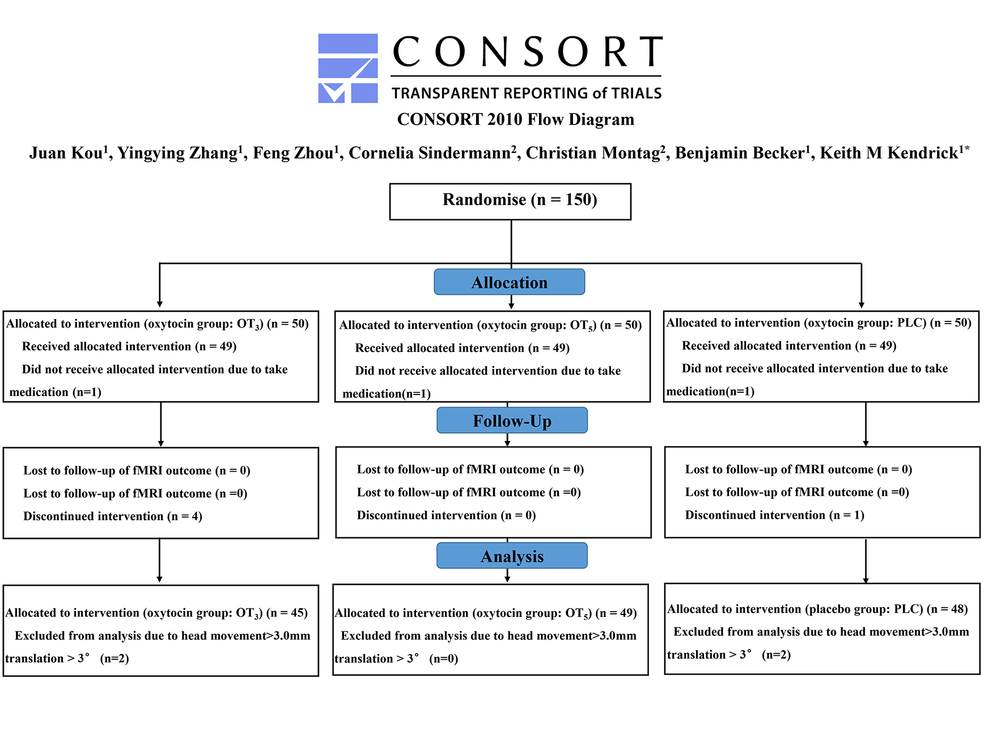
Fig.S1 CONSORT flow diagram of the clinical trial.

Fig.S2 Data analysis flow chart.
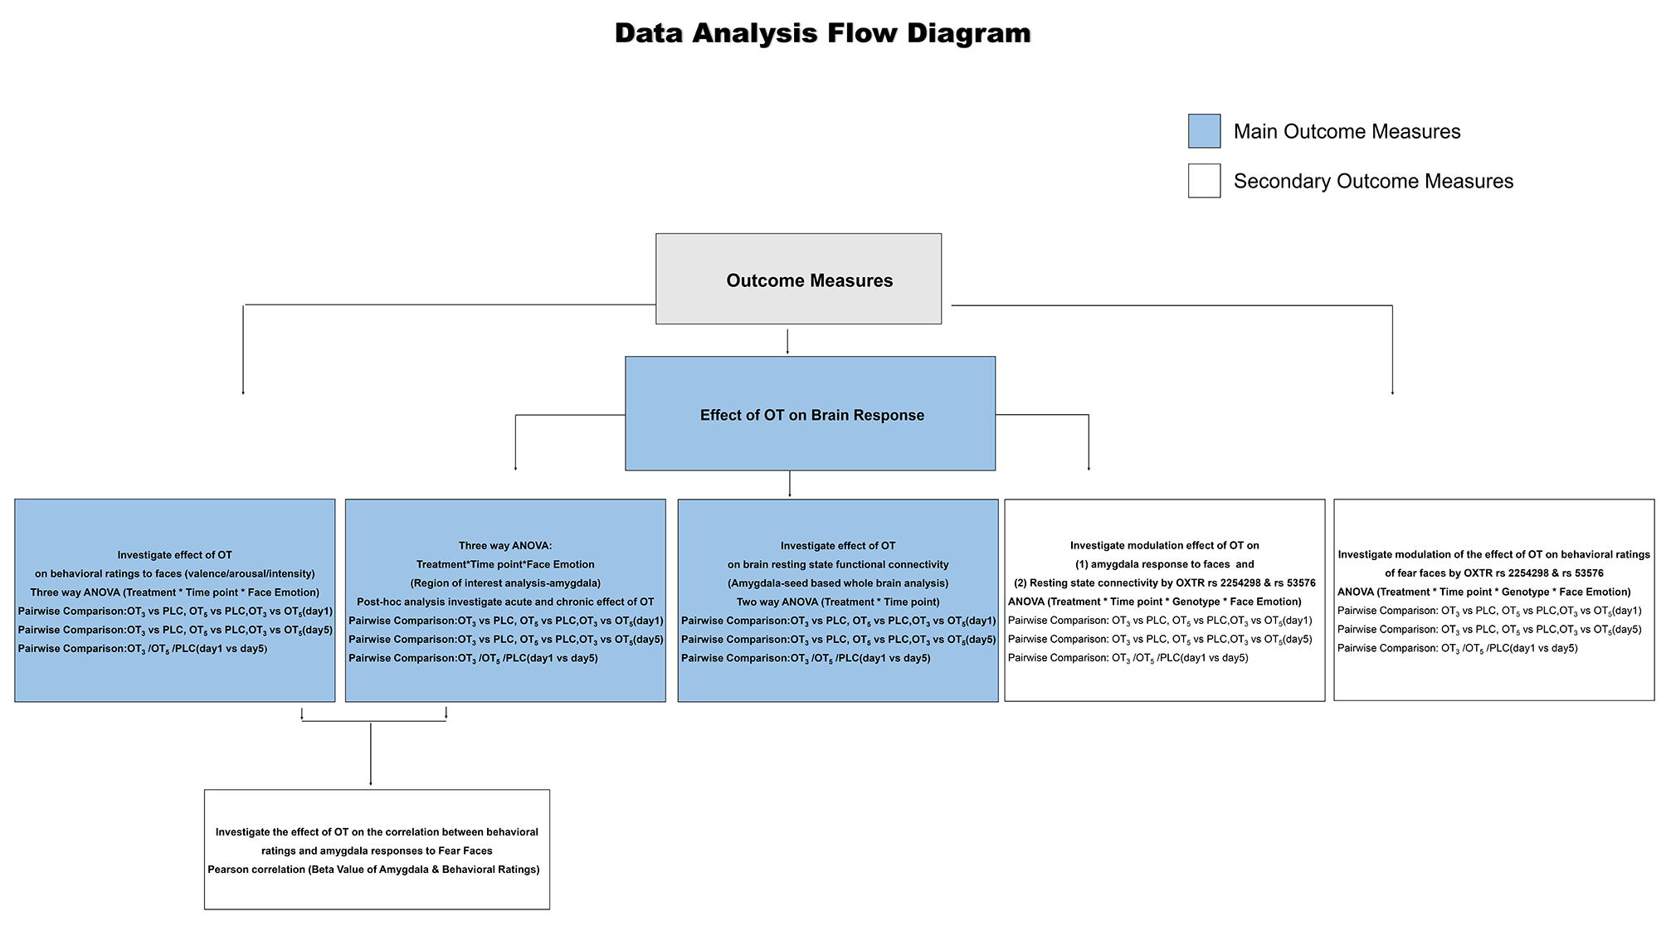

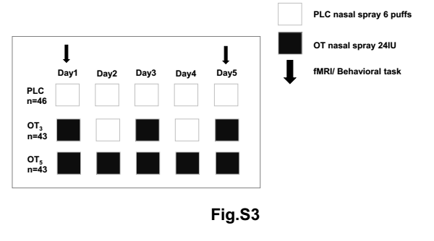
Fig.S3 Treatment protocol. Participants were randomly assigned to have nasal spray of oxytocin (OT) for 5 days 24 IU per day (OT₅ group) or have OT or placebo nasal spray on alternate days during the 5 days (OT on the 1st, 3rd and 5th day), 24 IU per day (OT₃ group) or have daily nasal spray of PLC for 5 days (PLC group).
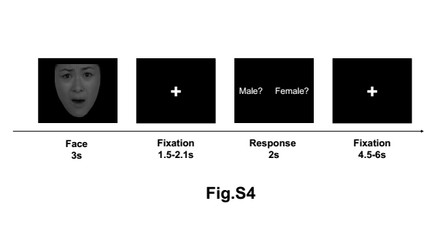
Fig.S4. Face emotion task procedure. Face stimuli appeared on the screen for 3 seconds, and then on the subsequent response screen participants were required to press the left or right response key to identify the gender of the face they had seen.
References
Ashburner, J. (2007). A fast diffeomorphic image registration algorithm. Neuroimage, 38(1), 95-113.
Ashburner, J., & Friston, K. J. (2005). Unified segmentation. Neuroimage, 26(3), 839-851.
Ashburner, J., & Ridgway, G. R. (2013). Symmetric diffeomorphic modeling of longitudinal structural MRI. Frontiers in Neuroscience, 6, 197.
Baron-Cohen, S., Wheelwright, S., Skinner, R., Martin, J., & Clubley, E. (2001). The autism-spectrum quotient (AQ): Evidence from asperger syndrome/high-functioning autism, males and females, scientists and mathematicians. Journal of Autism and Developmental Disorders, 31(1), 5-17.
Beck, A. T., Steer, R. A., & Carbin, M. G. (1988). Psychometric properties of the Beck Depression Inventory: Twenty-five years of evaluation. Clinical Psychology Review, 8(1), 77-100.
Chao-Gan, Y., & Yu-Feng, Z. (2010). DPARSF: a MATLAB toolbox for “pipeline” data analysis of resting-state fMRI. Frontiers in Systems Neuroscience, 4.
Friston, K. J., Holmes, A. P., Worsley, K. J., Poline, J. P., Frith, C. D., & Frackowiak, R. S. (1994). Statistical parametric maps in functional imaging: a general linear approach. Human Brain Mapping, 2(4), 189-210.
Kvaal, K., Ulstein, I., Nordhus, I. H., & Engedal, K. (2005). The Spielberger state‐trait anxiety inventory (STAI): the state scale in detecting mental disorders in geriatric patients. International Journal of Geriatric Psychiatry: A Journal of the Psychiatry of Late Life and Allied Sciences, 20(7), 629-634.
Power, J. D., Barnes, K. A., Snyder, A. Z., Schlaggar, B. L., & Petersen, S. E. (2012). Spurious but systematic correlations in functional connectivity MRI networks arise from subject motion. Neuroimage, 59(3), 2142-2154.
Siu, A. M., & Shek, D. T. (2005). Validation of the interpersonal reactivity index in a Chinese context. Research on Social Work Practice, 15(2), 118-126.
Wang, D., Yan, X., Li, M., & Ma, Y. (2017). Neural substrates underlying the effects of oxytocin: a quantitative meta-analysis of pharmaco-imaging studies. Social Cognitive and Affective Neuroscience, 12(10), 1565-1573.
Zhang, Z., & Yuan, K.H. (2018). Practical Statistical Power Analysis Using Webpower and R (Eds). Granger, IN: ISDSA Press.

