Supplementary Materials
Results
Demographic and clinical features
In brief, female patients and controls did not differ in age (two-sample t-test, t = 0.061, P = 0.952), BMI (t = -1.076, P = 0.284), and FD (t = -0.003, P = 0.998); however, female patients with MDD had lower SCVD (t = -5.940, P < 0.001), years of education (t = -4.100, P < 0.001), EBPM (t = -7.638, P < 0.001), TBPM (t = -11.482, P < 0.001), CPT-IP-2 (t = -6.559, P < 0.001), CPT-IP-3 (t = -4.954, P < 0.001) and CPT-IP-4 (t = -3.273, P = 0.001), and higher HAMD (t = 22.244, P < 0.001) and HAMA (t = 21.287, P < 0.001) than female HC.
Table S1. fALFF alterations in patients with major depressive disorder
References | Sample size | Main findings | Minimum t | Effect size*
Wang et al.,  2012 | Patients: 18  Controls: 18 | Patients had increased fALFF in the right precentral gyrus, right inferior temporal gyrus, bilateral fusiform gyrus, and bilateral anterior and posterior lobes of the cerebellum, and decreased fALFF in the left dorsolateral prefrontal cortex, bilateral medial orbitofrontal cortex, bilateral middle temporal gyrus, left inferior temporal gyrus and right inferior parietal lobule | 2.71 | 0.93
Guo et al.,  2013 | Patients: 24  Controls: 24 | Patients had increased fALFF in the left dorsal medial prefrontal cortex, and decreased fALFF in the left parahippocampal gyrus | 3.30 | 0.97
Liu et al.,  2013 | Patients: 22  Controls: 19 | Patients had increased fALFF in left superior occipital gyrus/cuneus, and decreased fALFF in right cerebellum posterior lobe, left parahippocampal gyrus and right middle frontal gyrus | 3.84 | 1.23
Liu et al.,  2013 | Patients: 22  Controls: 26 | Patients had increased fALFF in the right dorsal medial frontal gyrus, left middle frontal gyrus, right ventrolateral inferior frontal gyrus, left precentral gyrus, right inferior parietal lobe, right precuneus and left angular gyrus, and decreased right precentral gyrus, bilateral postcentral gyrus, left middle occipital gyrus, left precuneus, bilateral lingual gyrus and left occipital gyrus | 3.60 | 1.06
Shen et al.,  2014 | Patients: 16  Controls: 14 | Patients had decreased fALFF in the right angular gyrus, left middle temporal gyrus, left superior temporal gyrus, right putamen, right precuneus and the right superior temporal gyrus | 3.76 | 1.42
Guo et al.,  2015 | Patients: 44  Controls: 44 | Patients had decreased fALFF in the right middle frontal gyrus | 4.05 | 0.87
Lai et al.,  2015 | Patients: 44  Controls: 27 | Patients had increased fALFF in left temporal subgyral region, and decreased fALFF in right frontal subcallosal gyrus and right parietal postcentral gyrus | 4.20 | 1.01
Cheng et al.,  2016 | Patients: 74  Controls: 74 | Patients had increased fALFF in the bilateral temporal lobe, and decreased fALFF in the bilateral dorsomedial prefrontal cortex, bilateral dorsolateral prefrontal cortex, bilateral precuneus and right angular gyrus | 3.28 | 0.54
Du et al.,  2016 | Patients: 16  Controls: 18 | Patients had increased fALFF in bilateral post cingulum/thalamus, right orbital gyrus and right inferior frontal gyrus, and decreased fALFF in the left fusiform gyrus and right middle frontal gyrus | 4.41 | 1.56
Yamamura et al., 2016 | Patients: 16  Controls: 26 | Patients had increased fALFF in left middle occipital gyrus, left precuneus and right angular gyrus, and decreased fALFF in left pre- and postcentral gyri | 3.01 | 0.95
Huang et al.,  2017 | Patients: 25  Controls: 26 | Patients had increased fALFF in the left inferior temporal gyrus, bilateral parahippocampal gyrus and the right caudate, and decreased fALFF in the left superior frontal gyrus, left middle frontal gyrus and left inferior frontal gyrus | 3.33 | 0.95
Liu et al.,  2017 | Patients: 24  Controls: 69 | Patients had increased fALFF in the left ventral anterior cingulate cortex, left oribtal frontal gyrus, left dorsomedial prefrontal gyrus and right middle temporal gyrus, and decreased fALFF in right posterior insula, right precuneus, left postcentral gyrus, left fusiform, left inferior occipital lobe and left middle occipital lobe | 3.34 | 0.70
Li et al.,  2018 | Patients: 27  Controls: 27 | Patients had decreased fALFF in bilateral precuneus | 4.31 | 1.20
Qiu et al.,  2019 | Patients: 24  Controls: 14 | Patients had increased fALFF in the cerebellum lobe, limbic lobe, parahippocampal gyrus, fusiform gyrus, anterior cingulate gyrus and thalamus | 3.38 | 1.13
Shu et al.,  2020 | Patients: 21  Controls: 38 | Patients had increased fALFF left posterior cerebellar lobe, right anterior cingulate cortex, left superior frontal cortex and left caudate nucleus | 4.08 | 1.08
Liu et al.,  2021 | Patients: 23  Controls: 40 | Patients had decreased fALFF in the right cerebellar lobule IV/V | 3.77 | 0.97
Abbreviations: fALFF, fractional amplitude of low-frequency fluctuations.
*The minimum effect size of fALFF changes in these prior studies was described using Cohen’s d that was calculated based on the equation (Cohen, 1992):
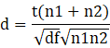
where t and df are the minimum t value and the degree of freedom in the comparison analysis, n1 and n2 are the sample sizes of patients and controls.
Table S2. Demographic and clinical data of all participants
Characteristics | MDD (122) | HC (119) | Statistics | P value
Gender (female/male) | 82/40 | 82/37 | χ² = 0.080 | 0.778
Age (years) | 42.77 ± 11.50  (18 - 62) | 43.81 ± 13.85  (21 - 65) | t = -0.641 | 0.522
Education (years) | 8.86 ± 3.64  (0 - 16) | 11.52 ± 4.69  (0 - 20) | t = -4.902 | < 0.001
BMI (kg/m² ) | 22.91 ± 3.80  (13.93 - 34.60) | 23.23 ± 2.76  (15.98 - 31.56) | t = -0.752 | 0.453
HAMD | 28.87 ± 11.31  (1 - 55) | 1.13 ± 2.54  (0 - 19) | t = 26.418 | < 0.001
HAMA | 19.88 ± 7.38  (2 - 35) | 1.41 ± 2.86  (0 - 21) | t = 25.729 | < 0.001
EBPM | 2.66 ± 2.81  (0 - 8) | 5.71 ± 2.71  (0 - 8) | t = -8.561 | < 0.001
TBPM | 2.17 ± 2.24  (0 - 6) | 5.37 ± 1.35  (0 - 6) | t = -13.435 | < 0.001
CPT-IP-2 | 2.23 ± 1.03  (-0.12 - 4.24) | 3.14 ± 0.97  (0.27 - 4.24) | t = -7.087 | < 0.001
CPT-IP-3 | 1.68 ± 0.95  (-0.26 - 4.24) | 2.38 ± 1.13  (-0.11 - 4.24) | t = -5.268 | < 0.001
CPT-IP-4 | 0.93 ± 0.73  (-0.41 - 3.12) | 1.34 ± 0.87  (-0.44 - 3.62) | t = -3.933 | < 0.001
SCVD (nmol/L) | 42.62 ± 14.38  (15.95 - 96.34) | 52.70 ± 16.92  (21.50 - 105.75) | t = -4.986 | < 0.001
FD (mm) | 0.13 ± 0.09  (0.04 - 0.60) | 0.14 ± 0.08  (0.05 - 0.40) | t = -0.995 | 0.321
Illness duration (months) | 63.18 ± 71.33  (0.30 - 306) | - | - | -
Onset age (years) | 37.16 ± 11. 29  (12 - 55) | - | - | -
Episode number | 2.53 ± 2.23  (1 - 21) | - | - | -
Antidepressant medications
SSRIs | 82 | - | - | -
SNRIs | 33 | - | - | -
NaSSA | 7 | - | - | -
Except for gender designation, data are expressed as means ± standard deviations. Numbers in parentheses are the range. Abbreviations: MDD, major depressive disorder; HC, healthy controls; BMI, body mass index; HAMD, Hamilton Rating Scale for Depression; HAMA, Hamilton Rating Scale for Anxiety; EBPM, event-based prospective memory; TBPM, time-based prospective memory; CPT-IP, Continuous Performance Task-Identical Pairs; SCVD, serum concentration of vitamin D; FD, frame-wise displacement; SSRIs, selective serotonin reuptake inhibitors; SNRIs, serotonin norepinephrine reuptake inhibitors; NaSSA, noradrenergic and specific serotonergic antidepressant.
Table S3. Correlations between SCVD and clinical variables in females
Clinical variables | SCVD (nmol/L)
Clinical variables | pr | P
EBPM | 0.267 | < 0.001#
TBPM | 0.355 | < 0.001#
CPT-IP-2 | 0.215 | 0.006#
CPT-IP-3 | 0.121 | 0.126
CPT-IP-4 | 0.087 | 0.273
HAMD* | -0.074 | 0.516
HAMA* | -0.071 | 0.529
Abbreviations: SCVD, serum concentration of vitamin D; EBPM, event-based prospective memory; TBPM, time-based prospective memory; CPT-IP, Continuous Performance Task-Identical Pairs; HAMD, Hamilton Rating Scale for Depression; HAMA, Hamilton Rating Scale for Anxiety; pr, partial correlation coefficient.
# means P < 0.05 with false discovery rate correction for multiple comparisons.
* Correlation analyses were performed in 82 female patients with major depressive disorder.
Table S4. Correlations between fALFF and clinical variables in females
fALFF | EBPM | TBPM | CPT-IP-2 | CPT-IP-3 | CPT-IP-4 | HAMD* | HAMA*
Right MTG | -0.194# | -0.336# | -0.214# | -0.128 | -0.055 | -0.193 | -0.228
Left precuneus | -0.137 | -0.278# | -0.301# | -0.185 | -0.154 | -0.184 | -0.232
Right ANG | -0.232# | -0.269# | -0.218# | -0.104 | -0.003 | 0.121 | 0.133
Right precuneus | -0.177# | -0.173# | -0.204# | -0.135 | -0.035 | 0.035 | 0.014
Bilateral MCC | -0.183# | -0.295# | -0.315# | -0.196 | -0.183 | -0.094 | 0.028
Right cuneus | -0.203# | -0.321# | -0.279# | -0.127 | -0.083 | -0.111 | -0.200
Left MFG | 0.227# | 0.319# | 0.057 | -0.036 | 0.007 | 0.011 | 0.092
Abbreviations: fALFF, fractional amplitude of low-frequency fluctuations; MTG, middle temporal gyrus; ANG, angular gyrus; MCC, middle cingulate cortex; MFG, middle frontal gyrus; EBPM, event-based prospective memory; TBPM, time-based prospective memory; CPT-IP, Continuous Performance Task-Identical Pairs; HAMD, Hamilton Rating Scale for Depression; HAMA, Hamilton Rating Scale for Anxiety.
# means P < 0.05 with false discovery rate correction for multiple comparisons.
* Correlation analyses were performed in 82 female patients with major depressive disorder.
Table S5. Correlations between SCVD and clinical variables in females after additionally adjusting for BMI
Clinical variables | SCVD (nmol/L)
Clinical variables | pr | P
EBPM | 0.267 | < 0.001#
TBPM | 0.355 | < 0.001#
CPT-IP-2 | 0.215 | 0.006#
CPT-IP-3 | 0.121 | 0.127
CPT-IP-4 | 0.087 | 0.272
HAMD* | -0.080 | 0.486
HAMA* | -0.079 | 0.490
Abbreviations: SCVD, serum concentration of vitamin D; BMI, body mass index; EBPM, event-based prospective memory; TBPM, time-based prospective memory; CPT-IP, Continuous Performance Task-Identical Pairs; HAMD, Hamilton Rating Scale for Depression; HAMA, Hamilton Rating Scale for Anxiety; pr, partial correlation coefficient.
# means P < 0.05 with false discovery rate correction for multiple comparisons.
* Correlation analyses were performed in 82 female patients with major depressive disorder.
Table S6. Correlations between SCVD and fALFF in females after additionally adjusting for BMI
fALFF | SCVD (nmol/L)
fALFF | pr | P
Right MTG | -0.216 | 0.006#
Left precuneus | -0.267 | < 0.001#
Right ANG | -0.207 | 0.009#
Right precuneus | -0.228 | 0.004#
Bilateral MCC | -0.201 | 0.011#
Right cuneus | -0.170 | 0.032#
Left MFG | 0.248 | 0.002#
Abbreviations: SCVD, serum concentration of vitamin D; fALFF, fractional amplitude of low-frequency fluctuations; BMI, body mass index; MTG, middle temporal gyrus; ANG, angular gyrus; MCC, middle cingulate cortex; MFG, middle frontal gyrus; pr, partial correlation coefficient.
# means P < 0.05 with false discovery rate correction for multiple comparisons.
Table S7. Correlations between SCVD and cognition in males
Cognitive variables | SCVD (nmol/L)
Cognitive variables | pr | P
EBPM | -0.008 | 0.946
TBPM | 0.133 | 0.256
CPT-IP-2 | 0.048 | 0.684
CPT-IP-3 | 0.034 | 0.769
CPT-IP-4 | 0.208 | 0.073
Abbreviations: SCVD, serum concentration of vitamin D; EBPM, event-based prospective memory; TBPM, time-based prospective memory; CPT-IP, Continuous Performance Task-Identical Pairs; pr, partial correlation coefficient.
Table S8. Correlations between SCVD and fALFF in males
fALFF | SCVD (nmol/L)
fALFF | pr | P
Right MTG | 0.124 | 0.293
Left precuneus | 0.065 | 0.581
Right ANG | -0.005 | 0.967
Right precuneus | -0.100 | 0.398
Bilateral MCC | 0.226 | 0.053
Right cuneus | 0.320 | 0.005#
Left MFG | 0.031 | 0.791
Abbreviations: SCVD, serum concentration of vitamin D; fALFF, fractional amplitude of low-frequency fluctuations; MTG, middle temporal gyrus; ANG, angular gyrus; MCC, middle cingulate cortex; MFG, middle frontal gyrus; pr, partial correlation coefficient.
# means P < 0.05 with false discovery rate correction for multiple comparisons.
Table S9. Correlations between fALFF and cognition in males
fALFF | EBPM | TBPM | CPT-IP-2 | CPT-IP-3 | CPT-IP-4
Right MTG | -0.015 | -0.224 | -0.199 | -0.206 | -0.161
Left precuneus | 0.092 | -0.095 | -0.128 | -0.156 | -0.069
Right ANG | -0.207 | -0.160 | -0.093 | 0.009 | -0.059
Right precuneus | -0.004 | -0.058 | -0.002 | 0.166 | -0.091
Bilateral MCC | 0.064 | 0.050 | 0.033 | -0.011 | -0.089
Right cuneus | 0.121 | -0.099 | -0.099 | -0.170 | -0.179
Left MFG | 0.079 | 0.244 | 0.220 | 0.173 | 0.115
Abbreviations: fALFF, fractional amplitude of low-frequency fluctuations; MTG, middle temporal gyrus; ANG, angular gyrus; MCC, middle cingulate cortex; MFG, middle frontal gyrus; EBPM, event-based prospective memory; TBPM, time-based prospective memory; CPT-IP, Continuous Performance Task-Identical Pairs.
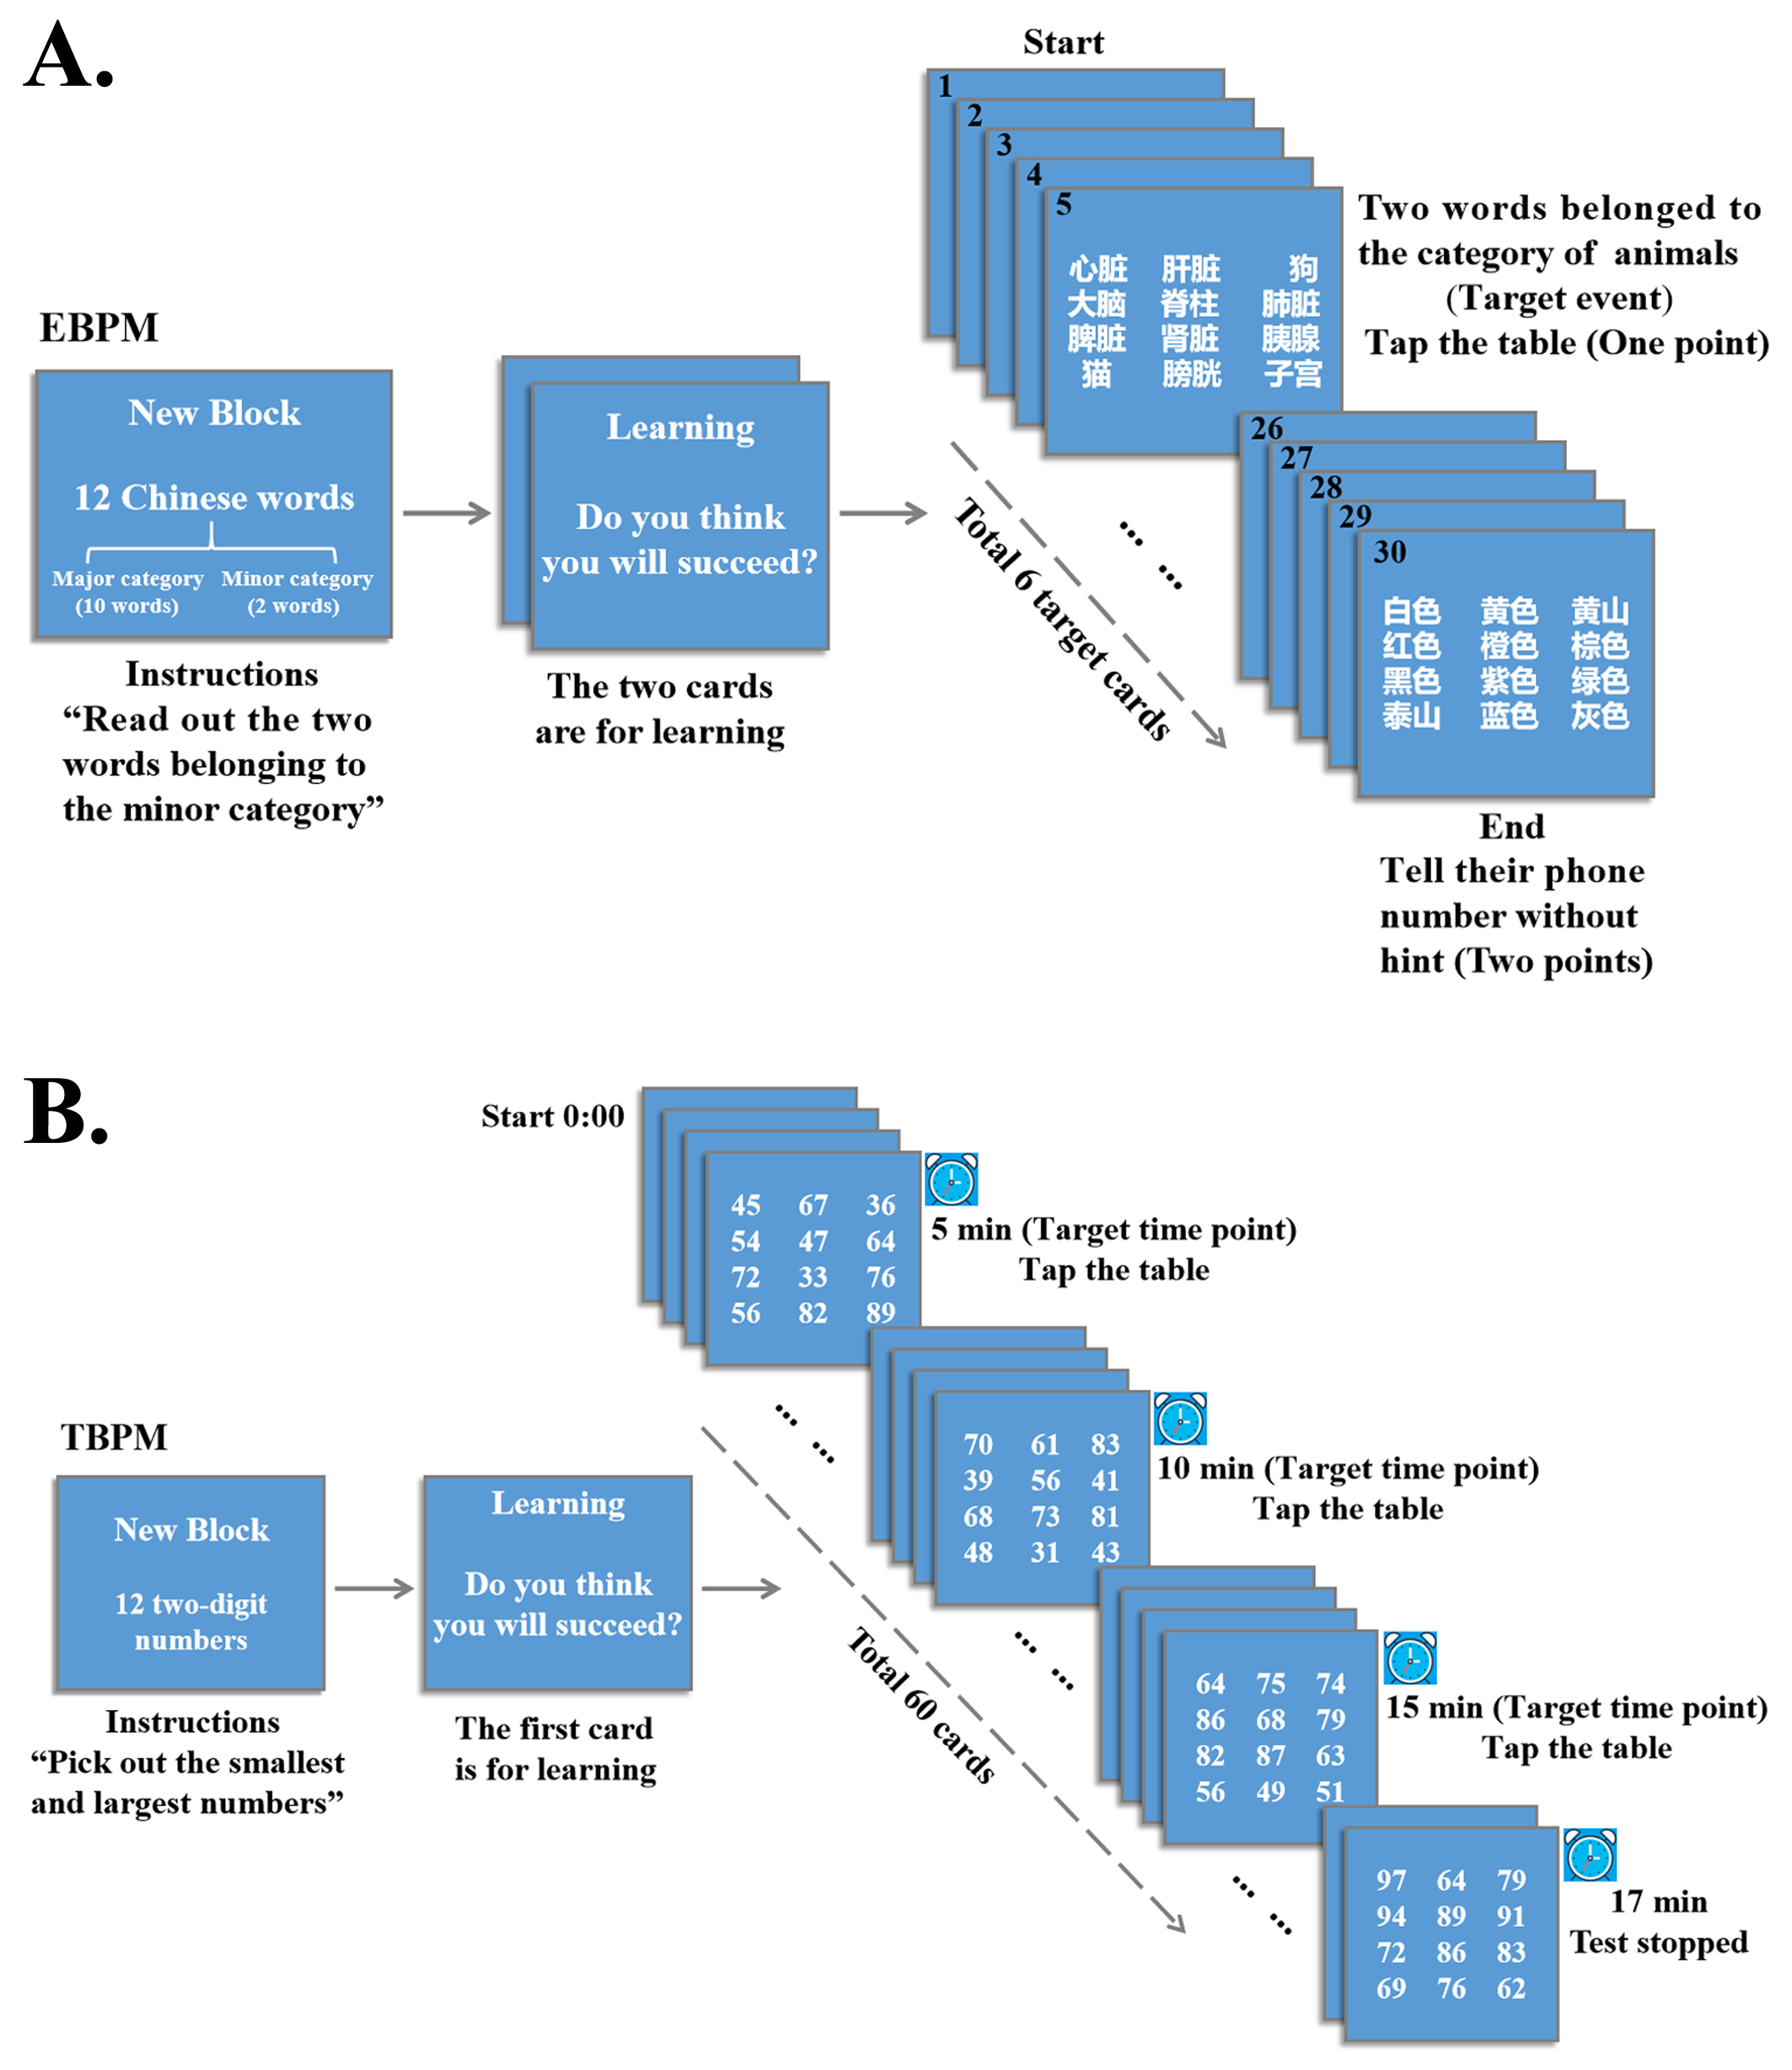
Figure S1. Schematic representation of the EBPM and TBPM tests. (A) EBPM: The experimental stimuli were 30 cards, each containing 12 Chinese words, of which 10 belonged to one major category and the other two belonged to one minor category. Subjects were instructed to read out the two words belonging to the minor category on each card. If the selected words belonged to the category of animals (target events), subjects were required to tap the table. When the test was completed, subjects should write down their telephone number without any hints at the end of the test. There were six target cards (card numbers 5, 10, 15, 20, 24, and 29) in this test. Subjects received one point for each correct response to a target card, and they received two points for remembering to provide their phone number. The maximum score was 8 points. (B) TBPM: The experimental stimuli were 100 cards, each containing 12 two-digit numbers. Subjects were asked to pick out the smallest and the largest numbers on each card and to tap the table at the target time points (5min, 10min, and 15min after the start of the test). The test stopped at the 17-min time point. Subjects received two points if they responded within 10s around the target time, and one point if within 30s. The maximum score was 6 points. Abbreviations: EBPM, event-based prospective memory; TBPM, time-based prospective memory.
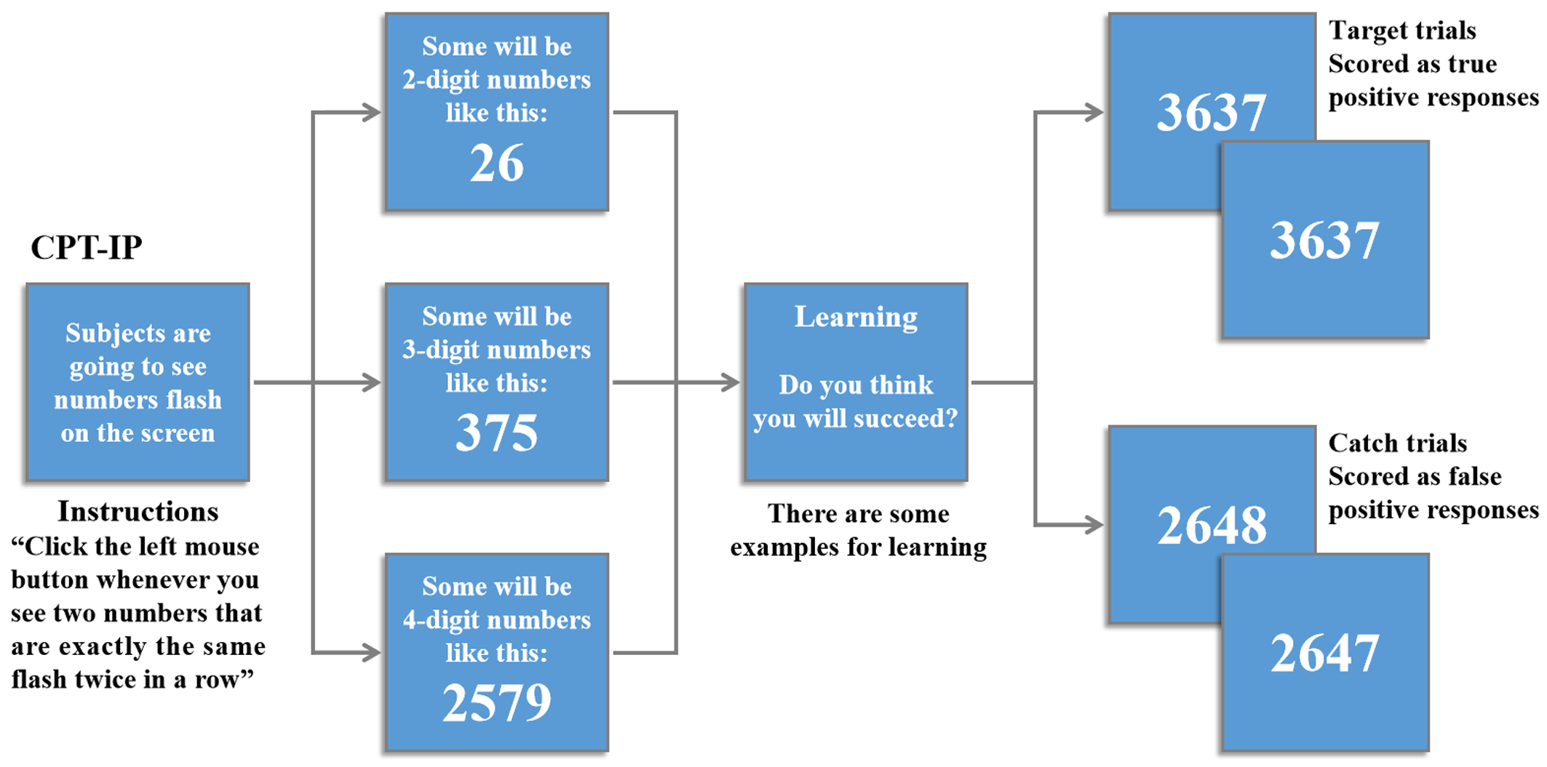
Figure S2. Schematic representation of the CPT-IP design. The stimuli were 2-, 3-, or 4-digit numbers in separate conditions, which yielded separate scores reflecting increasing memory load on digit span. Participants were asked to monitor numbers on a computer screen and respond to any consecutive presentation of identical stimuli by key pressing as quickly as possible. Responses to target trials (pairs that were identical and required a response) and catch trials (pairs that were similar but not identical) were scored as true and false positive responses. The main outcome variable of interest was d' -a well-established discrimination sensitivity index incorporating both true and false positive responses. CPT-IP-2, -3, and -4 represented d' values corresponding to the number of digits. Abbreviations: CPT-IP, Continuous Performance Task-Identical Pairs.
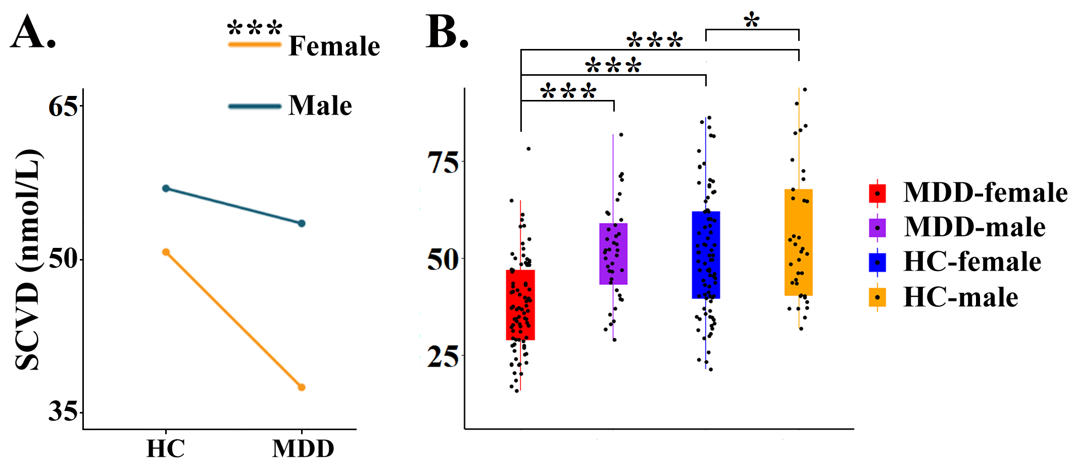
Figure S3. Interaction effect of group × gender on SCVD. (A) and (B) Significant group differences in females but not males. * P < 0.05, *** P < 0.001. Abbreviations: SCVD, serum concentration of vitamin D; MDD, major depressive disorder; HC, healthy controls.
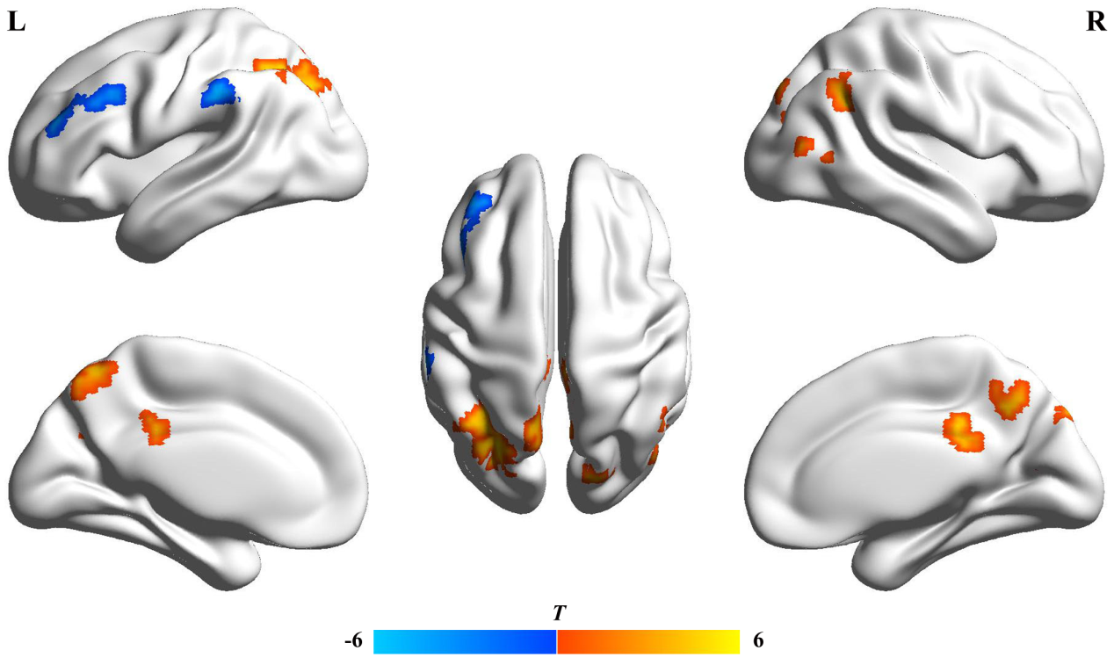
Figure S4. Group fALFF differences in females. The warm color represents increased fALFF and the cold color denotes decreased fALFF in patients with MDD. Abbreviations: fALFF, fractional amplitude of low-frequency fluctuations; MDD, major depressive disorder; L, left; R, right.
References
Cohen, J. (1992). A power primer. Psychological Bulletin, 112(1), 155-159. Retrieved from http://www.ncbi.nlm.nih.gov/pubmed/19565683

