**Supplementary material**

**Material and methods**

**Decision-making under risk**

***Prospect Theory Model***

The model assumes that participants compute the value V of each lottery *Ok* with outcomes *i* as:

$$V(O_{k})= \sum_{i=1}^{n}{π(p_{i})×v(x_{i})}$$

Where $V(O_{k})$ is the expected value (utility) of the option k to the participant, $x_{i}, i∈\{1:n\}$ are the potential outcomes of the option k and $p_{i}, i∈\{1:n\}$ their respective probabilities. The Prospect Theory assumes that the subjective representation of both outcomes and probabilities is distorted, which is captured by the respective value $v\left(x_{i}\right)$ and probability weighting $π\left(p_{i}\right)$ function. Thereby $v$ is the function that assigns a subjective value to an outcome, and $π$ is the function that assigns a subjective weight to a probability. We chose the following specifications:

$$v\left(x_{i}\right)=\left\{\begin{aligned}{x_{i}}^{r}, &x_{i}>0 \\ {{-λ(-x}_{i})}^{r}, &x_{i}<0\end{aligned}\right.$$

And

$$π\left(p_{i}\right)= \frac{{p_{i}}^{γ}}{{({p_{i}}^{γ} + {(1-p_{i})}^{γ})}^{1/γ}}$$

We then assume that choices are made by (soft) maximising this value:

$$p\left(ch=O_{1}\right)= \frac{1}{1+exp⁡(-ω(V\left(O_{1}\right)-V\left(O_{2}\right))},$$

Thereby, the model features 4 free parameters: r (utility curvature), λ (loss aversion), γ (probability distortion) and ω (choice inverse temperature). Note that, for simplicity, the only difference between our specification and the original one is that we use the same utility curvature parameter (r) for gains and loss outcomes.

We started the adaptive procedure with unbiased, loosely informative, Gaussian priors. Let θ = {r, λ, γ, ω} be the set of parameters to be estimated at each trial t, with mean μt and variance-covariance Σt, we set the prior as:

$$μ_{0}=[3,1,1,1]$$

$$Σ_{0}=\left[\begin{aligned}3 0 0 0 \\ 0 1 0 0 \\ 0 0 1 0 \\ 0 0 0 1\end{aligned}\right]$$

***Parameter recovery***

To evaluate the ability of our adaptive procedure to recover the Prospect Theory parameters properly, we performed a parameter recovery exercise (Wilson and Collins, 2019). We simulated 300 synthetic participants, sampling parameters randomly in uniform distributions (; ). We then assessed both robust regressions and Pearson correlation between the parameters used to simulate the data and the parameters recovered by the adaptive procedure – see (Correa *et al.*, 2018) for a similar approach. Overall, these analyses showed excellent recovery (**Fig.S1**).

**Decision-making under ambiguity**

***Ambiguity aversion model***

The model was also adapted from (Levy *et al.*, 2010; Tymula *et al.*, 2013).

$$V(V_{k})= \sum_{i=1}^{n}{[p_{i}-β(\frac{A_{i}}{2})]×v(x_{i})}$$

Where $V(O_{k})$ is the expected value (utility) of the option k to the participant, $x_{i}, i∈\{1:n\}$ are the potential outcomes of the option k and $p_{i}, i∈\{1:n\}$ their respective probabilities, and $A_{i}, i∈\left\{1:n\right\}$ the level of ambiguity.

Similarly to the other task/model, $v$ is the function that assigns a subjective value to an outcome and is defined as:

$$v\left(x_{i}\right)={x_{i}}^{r}$$

We then assume that choices are made by (soft) maximising this value:

$$p\left(ch=O_{1}\right)= \frac{1}{1+exp⁡(-ω(V\left(O_{1}\right)-V\left(O_{2}\right))},$$

Thereby, the model features 3 free parameters: r (utility curvature), β (ambiguity aversion), and ω (choice inverse temperature).

We estimated one set of parameters (r, β, ω) per valence condition (gains & losses), leading to a total of 6 free parameters (thereafter referred to as rG, βG, ωG, rL, βL, ωL). Because the task does not feature an adaptive design, parameters were estimated a posteriori, off-line, using a standard maximum likelihood approach.

***Parameter recovery***

To evaluate the ability of our offline model-fitting procedure to properly recover the Ambiguity aversion model parameters, we performed a parameter recovery exercise (Wilson and Collins, 2019). We simulated 300 synthetic participants, sampling parameters randomly in uniform distributions (; ; ). We then assessed both robust regressions and Pearson correlation between the parameters used to simulate the data, and the parameters recovered by the model fitting procedure – see (Correa *et al.*, 2018) for a similar approach. Overall, these analyses showed excellent recovery, except for the choice temperature parameters which appeared to be correlated with the utility curvature parameters (**Fig.S2**).

**References**

**Correa CMC, Noorman S, Jiang J, Palminteri S, Cohen MX, Lebreton M, van Gaal S** (2018) How the Level of Reward Awareness Changes the Computational and Electrophysiological Signatures of Reinforcement Learning. *The Journal of Neuroscience* **38**, 10338–10348.

**Levy I, Snell J, Nelson AJ, Rustichini A, Glimcher PW** (2010) Neural Representation of Subjective Value Under Risk and Ambiguity. *Journal of Neurophysiology* **103**, 1036–1047.

**Tymula A, Rosenberg Belmaker LA, Ruderman L, Glimcher PW, Levy I** (2013) Like cognitive function, decision making across the life span shows profound age-related changes. *Proceedings of the National Academy of Sciences* **110**, 17143–17148.

**Wilson RC, Collins AG** (2019) Ten simple rules for the computational modeling of behavioral data. *eLife* **8**, e49547.

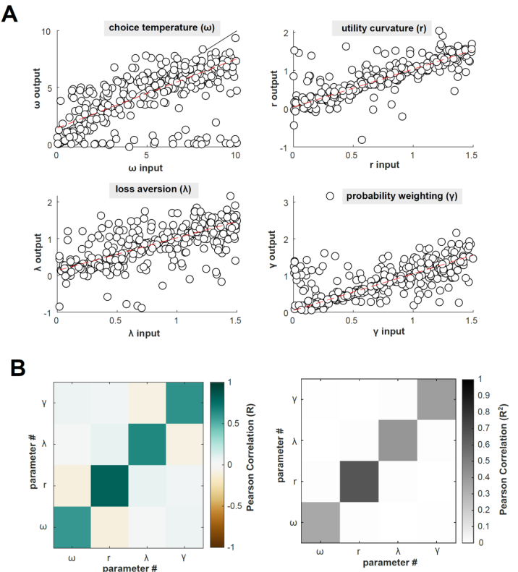

**Fig.S1 Prospect-Theory model for decision under risk, parameter recovery analysis**.

Overall, data from 300 synthetic participants (20 simulations of 90 individuals) were simulated. **A.** The 6 estimated parameters per participants were then regressed against the true parameters used for simulating the data. Each dot represents a synthetic individual. The black continuous lines represent the identity line, and the red dotted lines the best linear fits. Results show very good identifiability, with regression intercepts close to 0, regression slopes close to 1 and highly significant. **B.** The confusion matrices represent summary statistics of the correlations between parameters, estimated over 90-subjects simulations, and averaged over the 20 simulations. Diagonal: correlations between simulated and estimated parameters. Off diagonal: cross correlation between estimated parameters. Left: Pearson correlation (R). Right: explained variance (R2).

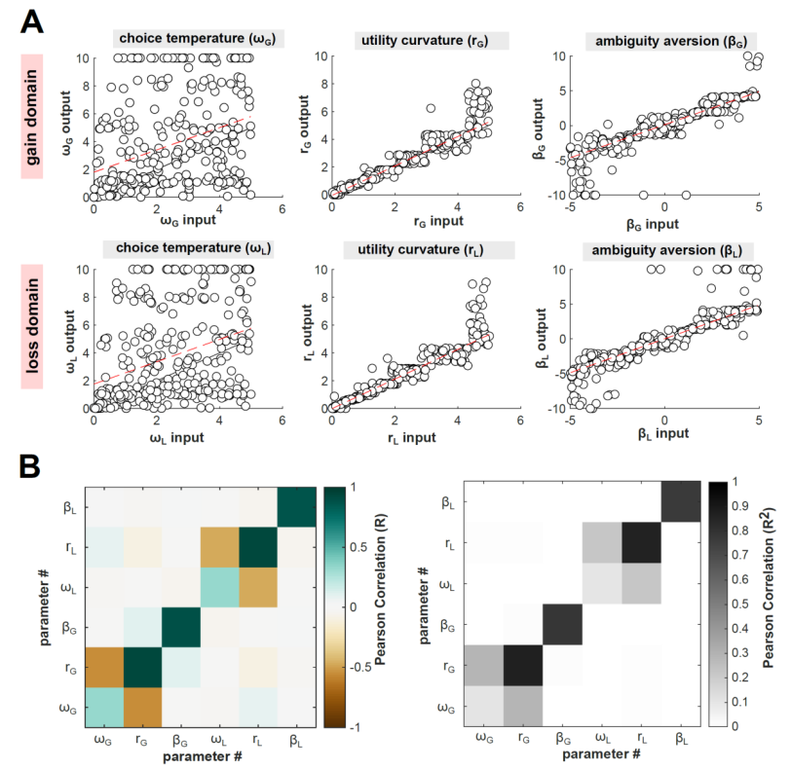

**Fig.S2 Decision under ambiguity model, parameter recovery analysis**.

Overall, data from 300 synthetic participants (20 simulations of 90 individuals) were simulated. **A.** The 6 estimated parameters per participants were then regressed against the true parameters used for simulating the data. Each dot represents a synthetic individual. The black continuous lines represent the identity line, and the red dotted lines the best linear fits. Results show very good identifiability, with regression intercepts close to 0, regression slopes close to 1 and highly significant. **B.** The confusion matrices represent summary statistics of the correlations between parameters, estimated over 90-subjects simulations, and averaged over the 20 simulations. Diagonal: correlations between simulated and estimated parameters. Off diagonal: cross correlation between estimated parameters. Left: Pearson correlation (R). Right: explained variance (R2).

**Table.S1. Correlation coefficients between each parameter of the tasks and the tics severity (YGTSS/50).**

|  |  |  |  |  |
| --- | --- | --- | --- | --- |
|  |  | **Correlation coefficient** | **p-values** | **bf** |
| **Risk** | **ω** | 0.084 ± 0.128 | 0.492 | 0.381 |
| **r** | -0.038 ± 0.129 | 0.747 | 0.322 |
| **λ** | 0.07 ± 0.128 | 0.556 | 0.359 |
| **γ** | -0.077 ± 0.129 | 0.527 | 0.368 |
| **Ambiguity**  **Gain** | **ωG** | -0.112 ± 0.128 | 0.355 | 0.453 |
| **rG** | 0.021 ± 0.129 | 0.869 | 0.311 |
| **βG** | 0.134 ± 0.127 | 0.263 | 0.543 |
| **Ambiguity**  **Loss** | **ωL** | 0.029 ± 0.129 | 0.8 | 0.316 |
| **rL** | 0.049 ± 0.129 | 0.689 | 0.33 |
| **βL** | -0.2 ± 0.124 | 0.097 | 1.076 |

ω: Choice inverse temperature; r: Utility curvature; λ: Loss aversion; γ: Probability distortion; β: ambiguity aversion; bf: Bayesian factor.