SUPPLEMENTARY MATERIAL

eAppendix 1. Search strategy

The research question was framed based on the PICO format (P: participants; I: interventions: C: comparisons; O: outcomes), which is endorsed by the Cochrane Collaboration¹.
- P: Participants: patients with severe mental disorder, that is, at least one disorder from First episode psychosis (FEP), high risk of psychosis, schizophrenia, schizoaffective, schizophreniform, psychotic disorder and non-affective psychosis.
- I: Types of studies: Randomized control trials to assess the efficacy of TBI, as a complement to TAU.
- C: Comparisons: the quantitative studies included had an intervention and a control group (patients with the same characteristics who did not receive the study treatment).
- O: Outcomes: neurocognition, symptomatology, functioning, social cognition, and quality of life.

The following search terms were used:
#1. exp SCHIZOPHRENIA/
#2. schizo$.mp.
#3. psychotic$.mp.
#4. psychosis.mp.
#5. psychoses.mp.
#6. FEP.ti,ab.
#7. EOP.ti,ab.
#8. Ultra high risk
#9. Clinical high risk
#10. Or/1-9
#11. On-line.ti,ab,kw.
#12. Online.ti,ab,kw.
#13. internet.ti,ab,kw.
#14. web.ti,ab,kw.
#15. mobile.ti,ab,kw.
#16. Smartphone.ti,ab,kw.
#17. app.ti,ab,kw.
#18. Computer.ti,ab,kw.
#19. chatbot
#20. Or /11-19
#21. exp clinical trial/
#22. exp randomized controlled trials/
#23. exp double-blind method/
#24. exp single-blind method/
#25. exp cross-over studies/
#26. randomized controlled trial.pt.
#27. clinical trial.pt.
#28. controlled clinical trial.pt.
#29. (clinic$ adj2 trial).mp.
#30. (random$ adj5 control$ adj5 trial$).mp.
#31. (crossover or cross-over).mp.
#32. ((singl$ or double$ or trebl$ or tripl$) adj (blind$ or mask$)).mp.
#33. randomi$.mp.
#34. (random$ adj5 (assign$ or allocat$ or assort$ or reciev$)).mp.
#35. or/21-34
#36. 10 AND 20 AND 35

The abstract, title and keyword(s) fields were searched in the database.

eAppendix 2. Classification of TBIs groups

Cognitive training_ TBI
Cognitive training_TBI + Vocational therapy_TBI
Cognitive training_TBI + Social cognition_TBI
Cognitive training_TBI + Psychoeducation_TBI
Cognitive training_TBI + CBT_TBI
Cognitive training_TBI + CBT_TBI + Vocational therapy_TBI
Social cognition_TBI
CBT_TBI
CBT_TBI + Vocational therapy_TBI
CBT_TBI + Mindfulness
Psychoeducation_TBI
Mindfulness_TBI

eAppendix 3. Flow Diagram of Study Selection Process

eFigure 1. Flow chart representing systematic search and extraction procedure.

eAppendix 4. Overall effect for each outcome and disaggregated by the type of control group
These tables contain the overall effect of each treatment compared to all control groups together (lines in bold) and then the overall effect of each treatment disaggregated by type of control groups. Sometimes the three-level model did not converge (due to a small number of effect sizes). In those cases, a standard random-effects model was fitted, and the cell in the column of the between-outcomes variance was left empty.

eTable 1. Neurocognition results. Meta-analytic estimates for each therapy (or combination of therapies) and for each type of control group.
NEUROCOGNITION
Types of intervention | k | g | SE | Z | p-value
Total_TBI | 321 | 0.133 | 0.032 | 4.135 | <.0001 | 0.016  (34) | 0.035  (321)
One therapy
CBT_TBI
Psychotherapy | 6 | -0.547 | 0.142 | -3.860 | <.0001 | 0.000 (1)
Cognitive training_TBI | 184 | 0.202 | 0.047 | 4.221 | <.0001 | 0.023 (21) | 0.034  (184)
Pharmacotherapy | 40 | 0.087 | 0.097 | 0.904 | .366
Technology | 105 | 0.191 | 0.057 | 3.333 | <.001
Psychotherapy | 39 | 0.290 | 0.093 | 3.107 | <.01
Social cognition_TBI
Psychotherapy | 12 | -0.015 | 0.116 | -0.131 | .896 | 0.000 (2)
Two therapies
CBT_TBI +
Vocational therapy_TBI
Psychotherapy | 14 | -0.079 | 0.114 | -0.690 | .490 | 0.009 (2) | 0.000 (14)
CBT_TBI +  Cognitive training_TBI | 13 | 0.055 | 0.167 | 0.332 | .740 | 0.000 (3) | 0.227 (13)
Pharmacotherapy | 3 | 0.017 | 0.392 | 0.043 | .966
Technology | - | - | - | - | -
Psychotherapy | 10 | 0.062 | 0.199 | 0.310 | .756
Cognitive training_TBI + Psychoeducation_TBI
Psychotherapy | 10 | 0.109 | 0.076 | 1.428 | .153 | 0.008 (1)
Cognitive training_TBI + Social cognition_TBI | 46 | 0.110 | 0.069 | 1.591 | .112 | 0.003 (5) | 0.102 (46)
Pharmacotherapy | 11 | 0.151 | 0.175 | 0.862 | .389
Technology | 1 | 0.270 | 0.629 | 0.429 | .668
Psychotherapy | 34 | 0.073 | 0.111 | 0.653 | .514
Cognitive training_TBI +
TAU
Pharmacotherapy | 12 | 0.310 | 0.224 | 1.383 | .167 | 0.000 (1) | 0.512 (12)
Cognitive training_TBI + Vocational therapy_TBI
Psychotherapy | 4 | 0.269 | 0.150 | 1.799 | .072 | 0.028 (1)
Three therapies
Cognitive training_TBI + CBT_TBI +
Vocational therapy_TBI
Psychotherapy | 32 | 0.109 | 0.054 | 2.005 | .045 | 0.000 (3) | 0.000 (32)
Notes. k= number of effect sizes within each category; g = overall effect size; SE= standard error; = between-studies variance. In this column, the number of studies analyzed is indicated in brackets; = between-outcomes variance. In this column, the number of effect sizes analyzed is indicated in brackets.
eTable 2. Symptomatology results. Meta-analytic estimates for each therapy (or combination of therapies) and for each type of control group.

SYMPTOMATOLOGY
Types of intervention | k | g | SE | Z | p-value
Total_TBI | 117 | 0.114 | 0.069 | 1.642 | .101 | 0.006 (29) | 0.377 (117)
One therapy
CBT_TBI | 20 | 0.122 | 0.306 | 0.399 | .690 | 0.225 (3) | 0.000 (20)
Pharmacotherapy | 10 | -0.095 | 0.184 | -0.516 | .606 | 0.018 | 0.000
Psychotherapy | 10 | 0.632 | 0.199 | 3.179 | <.01
Cognitive training_TBI | 35 | 0.084 | 0.079 | 1.060 | .289 | 0.029 (14) | 0.000 (35)
Pharmacotherapy | 8 | 0.084 | 0.147 | 0.575 | .566
Technology | 8 | -0.179 | 0.136 | -1.323 | .186
Psychotherapy | 19 | 0.232 | 0.095 | 2.452 | .014
Psychoeducation_TBI | 17 | -0.192 | 0.128 | -1.504 | .133 | 0.031 (3) | 0.000 (17)
Pharmacotherapy | 5 | -0.216 | 0.243 | -0.887 | .375
Technology | 3 | 0.012 | 0.094 | 0.132 | .895
Psychotherapy | 9 | -0.367 | 0.125 | -2.943 | <.01
Social cognition_TBI
Psychotherapy | 10 | 0.188 | 0.114 | 1.656 | .098 | 0.000 (4)
Two therapies
CBT_TBI +
Vocational therapy_TBI
Psychotherapy | 4 | -0.256 | 0.207 | -1.237 | .216 | 0.000 (1)
CBT_TBI +
Cognitive training_TBI
Pharmacotherapy | 3 | -0.171 | 0.209 | -0.847 | .397 | 0.000 (1)
Cognitive training_TBI + Psychoeducation_TBI
Psychotherapy | 3 | 0.135 | 0.129 | 1.047 | .296 | 0.000 (1)
Cognitive training_TBI +  Social cognition_TBI | 20 | 0.307 | 0.331 | 0.929 | .353 | 0.000 (4) | 2.090 (20)
Pharmacotherapy | 3 | 0.227 | 0.867 | 0.261 | .794 |  | 2.217
Psychotherapy | 17 | 0.323 | 0.370 | 0.871 | .383
Three therapies
Cognitive training_TBI + CBT_TBI + Vocational therapy_TBI  Psychotherapy | 5 | 0.137 | 0.171 | 0.803 | .422 | 0.000 (2)
Notes. k= number of effect sizes within each category; g = overall effect size; SE= standard error; = between-studies variance. In this column, the number of studies analyzed is indicated in brackets; = between-outcomes variance. In this column, the number of effect sizes analyzed is indicated in brackets.

eTable 3. Positive symptomatology results. Meta-analytic estimates for each therapy (or combination of therapies) and for each type of control group.

POSITIVE SYMPTOMATOLOGY
Types of intervention | k | g | SE | Z | p-value
Total_TBI | 31 | -0.052 | 0.081 | -0.643 | .520 | 0.043 (19) | 0.000 (31)
One therapy
CBT_TBI | 7 | -0.029 | 0.169 | -0.174 | .862 | 0.000 (7)
Pharmacotherapy | 4 | -0.079 | 0.223 | -0.353 | .724
Psychotherapy | 3 | 0.037 | 0.258 | 0.142 | .887
Cognitive training_TBI | 9 | 0.119 | 0.117 | 1.011 | .312 | 0.000 (9)
Pharmacotherapy | 4 | 0.098 | 0.176 | 0.555 | .579
Technology | 1 | -0.146 | 0.433 | -0.337 | .736
Psychotherapy | 4 | 0.178 | 0.169 | 1.054 | .292
Psychoeducation_TBI | 3 | -0.266 | 0.232 | -1.146 | .252 | 0.000 (3)
Pharmacotherapy | 1 | -0.159 | 0.555 | -0.286 | .775
Technology | 0 | - | - | - | -
Psychotherapy | 2 | -0.289 | 0.256 | -1.130 | .259
Social cognition_TBI
Psychotherapy | 2 | 0.090 | 0.258 | 0.350 | .726 | 0.000 (2)
Two therapies
CBT_TBI +
Vocational therapy_TBI
Psychotherapy | 1 | -0.321 | 0.412 | -0.780 | .436 | 0.000 (1)
CBT_TBI +
Cognitive training_TBI
Pharmacotherapy | 2 | -0.127 | 0.247 | -0.514 | .607 | 0.000 (2)
Cognitive training_TBI + Psychoeducation_TBI
Psychotherapy | 1 | 0.086 | 0.223 | 0.385 | .700 | 0.000 (1)
Cognitive training_TBI +  Social cognition_TBI | 5 | -0.241 | 0.286 | -0.843 | .399 | 0.331 (5)
Pharmacotherapy | 1 | 0.241 | 0.628 | 0.383 | .702
Psychotherapy | 4 | -0.380 | 0.335 | -1.133 | .257
Three therapies
Cognitive training_TBI + CBT_TBI + Vocational therapy_TBI  Psychotherapy | 1 | -0.090 | 0.418 | -0.214 | .830 | 0.000 (1)
Notes. k= number of effect sizes within each category; g = overall effect size; SE= standard error; = between-studies variance. In this column, the number of studies analyzed is indicated in brackets; = between-outcomes variance. In this column, the number of effect sizes analyzed is indicated in brackets.

eTable 4. Negative symptomatology results. Meta-analytic estimates for each therapy (or combination of therapies) and for each type of control group.

NEGATIVE SYMPTOMATOLOGY
Types of intervention | k | g | SE | Z | p-value
Total_TBI | 23 | 0.081 | 0.078 | 1.031 | .302 | 0.019 (18) | 0.000 (23)
One therapy
CBT_TBI
Psychotherapy | 1 | 0.906 | 0.447 | 2.027 | .043 | 0.000 (1)
Cognitive training_TBI | 8 | 0.091 | 0.130 | 0.701 | .483 | 0.004 (8)
Pharmacotherapy | 2 | 0.028 | 0.305 | 0.093 | .926
Technology | 1 | -0.151 | 0.475 | -0.319 | .750
Psychotherapy | 5 | 0.175 | 0.179 | 0.976 | .329
Psychoeducation_TBI | 3 | -0.516 | 0.227 | -2.269 | .023 | 0.000 (3)
Pharmacotherapy | 1 | -0.304 | 0.527 | -0.575 | .565
Technology | 0 | - | - | - | -
Psychotherapy | 2 | -0.564 | 0.252 | -2.240 | .025
Social cognition_TBI
Psychotherapy | 3 | 0.305 | 0.221 | 1.381 | .167 | 0.000 (3)
Two therapies
CBT_TBI +
Vocational therapy_TBI
Psychotherapy | 1 | -0.551 | 0.422 | -1.304 | .192 | 0.000 (1)
Cognitive training_TBI + Psychoeducation_TBI
Psychotherapy | 1 | 0.131 | 0.222 | 0.588 | .556 | 0.000 (1)
Cognitive training_TBI +  Social cognition_TBI | 5 | 0.127 | 0.121 | 1.050 | .294 | 0.000 (5)
Pharmacotherapy | 1 | 0.161 | 0.205 | 0.786 | .432
Psychotherapy | 4 | 0.108 | 0.157 | 0.687 | .492
Three therapies
Cognitive training_TBI + CBT_TBI + Vocational therapy_TBI  Psychotherapy | 4 | 0.108 | 0.157 | 0.687 | .492 | 0.000 (1)
Notes. k= number of effect sizes within each category; g = overall effect size; SE= standard error; = between-studies variance. In this column, the number of studies analyzed is indicated in brackets; = between-outcomes variance. In this column, the number of effect sizes analyzed is indicated in brackets.

eTable 5. Functioning results. Meta-analytic estimates for each therapy (or combination of therapies) and for each type of control group.

FUNCTIONING
Types of intervention | k | g | SE | Z | p-value
Total_TBI | 98 | 0.245 | 0.090 | 2.724 | .006 | 0.057 (23) | 0.274 (98)
One therapy
CBT_TBI | 8 | 0.087 | 0.108 | 0.809 | .418 | 0.000 (2)
Pharmacotherapy | 1 | 0.548 | 0.402 | 1.363 | .173
Psychotherapy | 11 | 0.052 | 0.112 | 0.462 | .644
Cognitive training_TBI | 21 | 0.085 | 0.148 | 0.578 | .563 | 0.011 (11) | 0.291 (21)
Pharmacotherapy | 3 | -0.077 | 0.421 | -0.182 | .855
Technology | 8 | -0.014 | 0.241 | -0.059 | .953
Psychotherapy | 10 | 0.241 | 0.222 | 1.084 | .278
Psychoeducation_TBI  Psychotherapy | 7 | 0.310 | 0.074 | 4.181 | <.0001 | 0.000 (2)
Social cognition_TBI  Psychotherapy | 8 | 0.554 | 0.119 | 4.665 | <.0001 | 0.004 (2)
Two therapies
CBT_TBI +  Cognitive training_TBI | 10 | 0.199 | 0.109 | 1.826 | .067 | 0.000 (2)
Pharmacotherapy | 3 | -0.090 | 0.205 | -0.441 | .659
Psychotherapy | 7 | 0.318 | 0.133 | 2.384 | <.05
Cognitive training_TBI + Psychoeducation_TBI
Psychotherapy | 2 | 0.374 | 0.255 | 1.465 | .143 | 0.078 (2)
Cognitive training_TBI + Social cognition_TBI | 36 | 0.549 | 0.265 | 2.073 | .038 | 0.097 (4) | 0.944 (36)
Pharmacotherapy | 2 | -0.023 | 0.754 | -0.030 | .976
Psychotherapy | 34 | 0.654 | 0.258 | 2.530 | .011
Three therapies
Cognitive training_TBI + CBT_TBI +  Vocational therapy_TBI  Psychotherapy | 2 | 0.147 | 0.209 | 0.702 | .483 | 0.000 (2)
Notes. k= number of effect sizes within each category; g = overall effect size; SE= standard error; = between-studies variance. In this column, the number of studies analyzed is indicated in brackets; = between-outcomes variance. In this column, the number of effect sizes analyzed is indicated in brackets.

eTable 6. Social cognition results. Meta-analytic estimates for each therapy (or combination of therapies) and for each type of control group.

SOCIAL COGNITION
Types of intervention | k | g | SE | Z | p-value
Total_TBI | 44 | 0.317 | 0.129 | 2.459 | <.05 | 0.000 (17) | 0.596 (44)
One therapy
CBT_TBI
Psychotherapy | 1 | 0.055 | 0.339 | 0.162 | .871
Cognitive training_TBI | 7 | 0.123 | 0.203 | 0.604 | .546 | 0.143 (5)
Pharmacotherapy | 2 | -0.395 | 0.248 | -1.588 | .112
Technology | 3 | 0.598 | 0.203 | 2.948 | .003
Psychotherapy | 2 | -0.164 | 0.323 | -0.508 | .611
Social cognition_TBI
Psychotherapy | 4 | 0.277 | 0.226 | 1.224 | .221 | 0.075 (4)
Two therapies
CBT_TBI + Cognitive training_TBI
Psychotherapy | 2 | 0.254 | 0.250 | 1.015 | .310 | 0.000 (2)
Cognitive training_TBI + Psychoeducation_TBI
Psychotherapy | 1 | 0.267 | 0.221 | 1.208 | .227
Cognitive training_TBI + Social cognition_TBI | 27 | 0.409 | 0.223 | 1.837 | .066 | 0.019 (5) | 1.026 (27)
Pharmacotherapy | 1 | 0.349 | 1.010 | 0.317 | .751
Technology | 1 | 0.374 | 1.204 | 0.310 | .756
Psychotherapy | 25 | 0.441 | 0.270 | 1.630 | .103
Three therapies
Cognitive training_TBI + CBT_TBI + Vocational therapy_TBI  Pharmacotherapy | 2 | 0.316 | 0.219 | 1.443 | .149 | 0.000 (2)
Notes. k= number of effect sizes within each category; g = overall effect size; SE= standard error; = between-studies variance. In this column, the number of studies analyzed is indicated in brackets; = between-outcomes variance. In this column, the number of effect sizes analyzed is indicated in brackets.

eTable 7. Quality of life results. Meta-analytic estimates for each therapy (or combination of therapies) and for each type of control group.

QUALITY OF LIFE
Types of intervention | k | g | SE | Z | p-value
Total_TBI | 38 | 0.142 | 0.080 | 1.778 | .076 | 0.046 (16) | 0.000 (38)
One therapy
Cognitive training_TBI | 14 | 0.172 | 0.159 | 1.084 | .278 | 0.108 (7) | 0.000 (14)
Pharmacotherapy | 2 | 0.035 | 0.317 | 0.111 | .911
Technology | 9 | 0.300 | 0.215 | 1.393 | .164
Psychotherapy | 2 | -0.267 | 0.544 | -0.492 | .633
Psychoeducation_TBI
Psychotherapy | 9 | 0.024 | 0.084 | 0.288 | .773 | 0.000 (2)
Social cognition_TBI
Psychotherapy | 4 | 0.348 | 0.201 | 1.732 | .083 | 1
CBT _TBI
Psychotherapy | 1 | 1.235 | 0.476 | 2.594 | <.01 | 1
Two therapies
CBT_TBI +  Cognitive training_TBI | 6 | 0.016 | 0.168 | 0.097 | .923 | 0.045 (2)
Pharmacotherapy | 2 | -0.292 | 0.268 | -1.091 | .275
Psychotherapy | 4 | 0.170 | 0.189 | 0.897 | .379
Cognitive training_TBI + Social cognition_TBI | 4 | 0.044 | 0.150 | 0.292 | .770 | 0.000 (4)
Technology | 1 | -0.277 | 0.530 | -0.529 | .601
Psychotherapy | 3 | 0.072 | 0.156 | 0.459 | .646
Notes. k= number of effect sizes within each category; g = overall effect size; SE= standard error; = between-studies variance. In this column, the number of studies analyzed is indicated in brackets; = between-outcomes variance. In this column, the number of effect sizes analyzed is indicated in brackets.

eAppendix 5. Results from the network meta-analysis and list of interventions that work best for each outcome. At a general level, according to age and according to diagnosis
For the network meta-analyses, we carried out the following analyses for each domain. First, all studies were analyzed together. Second, studies were divided based on the mean age of the participants: mean age above 25 and below 25. This cutoff is based on previous studies with a similar sample²⁻⁴. Two separate network meta-analyses were applied on each subset of studies. There were only a few studies where the mean age of the participants was below 25, so only the subset of studies with a mean age over 25 was analyzed. Third, studies were divided based on the diagnosis of the participants: First episode psychosis (FEP) (i.e., studies that labeled their patients as first episode psychosis, psychosis / high risk of psychosis*, psychotic disorder and one that spoke of "early psychosis.") and Schizophrenia (i.e., made up of those studies that labeled their patients as schizophrenia, schizophrenia / another psychotic disorder, schizophrenia / psychosis, schizophrenia / schizoaffective, schizophrenia / schizoaffective / psychosis, schizophrenia / schizophreniform / schizoaffective and non-affective psychosis).

* All the studies that have been included had at least 60% of the sample met criteria for psychosis.

Neurocognition

Results from the network meta-analysis (including all studies)
In total, there are 351 comparisons within this outcome. The mean age of this subsample is 37.75, with a standard deviation of 9.42. Thirty-four comparisons come from a sample of participants that have had a first episode of psychosis, whereas 317 comparisons come from samples of participants with schizophrenia. For the results of the P-Scores below, the reference category is the control group Technology only. Interventions are ordered by the P-score ranks.

eTable 8. Results of the P-Scores for Neurocognition for all studies.
Interventions | SMC and 95% CI | P-score
Cognitive training_TBI + Vocational therapy_TBI | 0.293 [-0.023, 0.609] | 0.9379
Cognitive training_ TBI | 0.161 [0.093, 0.228] | 0.8744
Cognitive training_TBI + Social cognition_TBI | 0.090 [-0.055, 0.234] | 0.6965
Cognitive training_TBI + Psychoeducation_TBI | 0.058 [-0.179, 0.294] | 0.5856
Pharmacotherapy | 0.051 [-0.073, 0.175] | 0.5759
Cognitive training_TBI + CBT_TBI + Vocational therapy_TBI | 0.045 [-0.124, 0.215] | 0.5656
Cognitive training_TBI + CBT_TBI | 0.042 [ -0.172, 0.257] | 0.5464
Technology | - | 0.4151
Social cognition_TBI | -0.034 [ -0.244, 0.176] | 0.3480
Psychotherapy | -0.053 [ -0.174, 0.070] | 0.2500
CBT_TBI + Vocational therapy_TBI | -0.098 [ -0.309, 0.113] | 0.2045
CBT_TBI | -0.594 [ -0.874, -0.314] | 0.0001
Notes. SMC = standardized mean change; CI = confidence intervals.

The node-splitting method showed significant differences between the direct effect of cognitive training on control group – Psychotherapy (= 0.278) and the indirect effect obtained for the same pair of treatments (= 0.001, Z=2.248, p = .025).

eFigure 2. Forest plot for relative treatment effectiveness for Neurocognition for all studies (351 comparisons).
CG = control group.
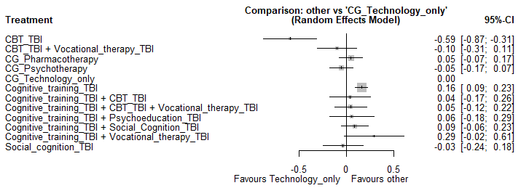

Results from the network meta-analysis Including only studies where the mean age was over 25
There are 302 comparisons from samples whose mean age is over 25. Specifically, the mean age of this subsample is 39.78, with a standard deviation of 7.47. All of these comparisons come from samples of participants with schizophrenia. For the results of the P-Scores below, the reference category is the control group Technology only. Interventions are ordered by the P-score ranks.

eTable 9. Results of the P-Scores for Neurocognition for studies where mean age of participants is over 25.
Interventions | SMC and 95% CI | P-score
Cognitive training_TBI + Vocational therapy_TBI | 0.295 [-0.039, 0.629] | 0.9327
Cognitive training_TBI | 0.174 [0.096, 0.251] | 0.8834
Cognitive training_TBI + Social cognition_TBI | 0.094 [-0.067, 0.256] | 0.6994
Pharmacotherapy | 0.062 [-0.070, 0.195] | 0.6016
Cognitive training_TBI + CBT_TBI + Vocational therapy_TBI | 0.049 [-0.141, 0.238] | 0.5698
Cognitive training_TBI + CBT_TBI | 0.045 [-0.184, 0.275] | 0.5509
Technology | . | 0.4144
Social cognition_TBI | -0.028 [-0.251, 0.195] | 0.3651
Psychotherapy | -0.059 [-0.196, 0.096] | 0.2655
CBT_TBI + Vocational therapy_TBI | -0.096 [-0.325, 0.134] | 0.2171
CBT_TBI | -0.591 [-0.887,-0.295] | 0.0002
Notes. SMC = standardized mean change; CI = confidence intervals.
Although this subsample of studies is more homogenous in terms of the mean age of the participants and their diagnosis, the node-splitting method showed again significant differences between the direct effect of cognitive training on control group – Psychotherapy (= 0.332) and the indirect effect obtained for the same pair of treatments (= 0.004, Z=2.422, p = .015).

eFigure 3. Forest plot of the relative treatment effectiveness for Neurocognition for studies where mean age of participants is over 25 (k=302).
CG = control group.
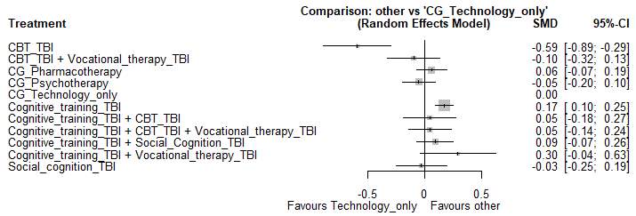

eFigure 4. Network plot for the interventions for Neurocognition (studies where mean age of participants is over 25, k=302).
The thickness of the lines is proportional to the number of studies that reported the comparison between those treatments. CG = control group.

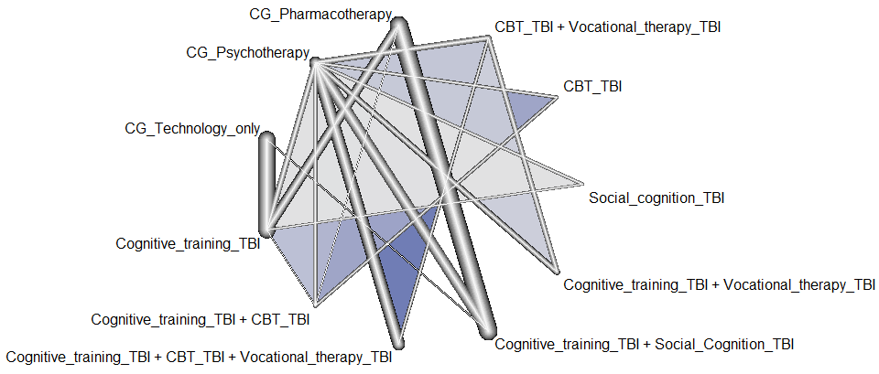

Results from the network meta-analysis including only studies where participants have a diagnosis of First Episode Psychosis
There are 34 comparisons from samples of participants that had a first episode of psychosis. The mean age of this subsample is 19.18, with a standard deviation of 4.65. For the results of the P-Scores below, the reference category is the control group Technology only. Interventions are ordered by the P-score ranks.

eTable 10. Results of the P-Scores for Neurocognition for studies where participants have a diagnosis of First Episode Psychosis.
Interventions | SMC and 95% CI | P-score
Technology | . | 0.7087
Cognitive training_TBI | -0.011 [-0.187, 0.166] | 0.6894
Cognitive training_TBI + Psychoeducation_TBI | -0.079 [-0.411, 0.253] | 0.5171
Psychotherapy | -0.189 [-0.480, 0.102] | 0.0848
Notes. SMD = standardized mean change; CI = confidence intervals.

No inconsistent effects were detected

eFigure 5. Forest plot of the relative treatment effectiveness for Neurocognition for studies where participants have a diagnosis of First Episode Psychosis (k=34).
CG = control group.
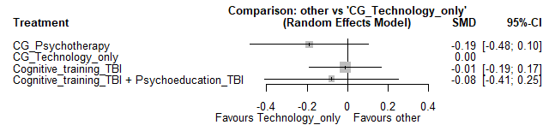

eFigure 6. Network plot for the interventions for Neurocognition (studies where participants have a diagnosis of First Episode Psychosis (k=34).
The thickness of the lines is proportional to the number of studies that reported the comparison between those treatments. CG = control group.
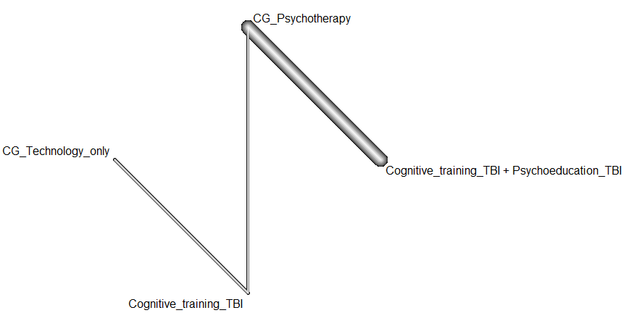

Results from the network meta-analysis Including only studies where participants have a diagnosis of schizophrenia
There are 317 comparisons from samples of participants that have schizophrenia. The mean age of this subsample is 39.30, with a standard deviation of 7.94. For the results of the P-Scores below, the reference category is the control group Technology only. Interventions are ordered by the P-score ranks.

eTable 11. Results of the P-Scores for Neurocognition for studies where participants have a diagnosis of schizophrenia.
Interventions | SMC and 95% CI | P-score
Cognitive training_TBI + Vocational therapy_TBI | 0.310 [-0.017, 0.636] | 0.9374
Cognitive training_TBI | 0.182 [0.109, 0.254] | 0.8811
Cognitive training_TBI + Social cognition_TBI | 0.107 [-0.046, 0.261] | 0.7055
Pharmacotherapy | 0.072 [-0.057, 0.200] | 0.5985
Cognitive training_TBI + CBT_TBI + Vocational therapy_TBI | 0.063 [-0.117, 0.242] | 0.5795
Cognitive training_TBI + CBT_TBI | 0.059 [-0.164, 0.282] | 0.5574
Technology | - | 0.3826
Social cognition_TBI | -0.016 [-0.233, 0.201] | 0.3668
Psychotherapy | -0.036 [-0.170, 0.098] | 0.2712
CBT_TBI + Vocational therapy_TBI | -0.081 [-0.302, 0.140] | 0.2199
CBT_TBI | -0.577 [-0.866, -0.288] | 0.0001
Notes. SMD = standardized mean change; CI = confidence intervals.
Although this subsample of studies is more homogenous in terms of the participants diagnosis, the node-splitting method showed again significant differences between the direct effect of cognitive training on control group – Psychotherapy (= 0.298) and the indirect effect obtained for the same pair of treatments (= 0.004, Z=2.95, p = .023).

eFigure 7. Forest plot of the relative treatment effectiveness for Neurocognition for studies where participants have a diagnosis of schizophrenia (k=317).
CG = control group.
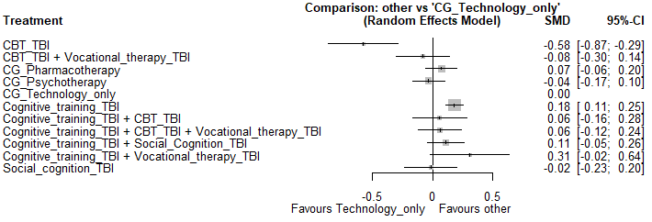

eFigure 8. Network plot for the interventions for Neurocognition (studies where participants have a diagnosis of schizophrenia, k = 317).
The thickness of the lines is proportional to the number of studies that reported the comparison between those treatments. CG = control group.
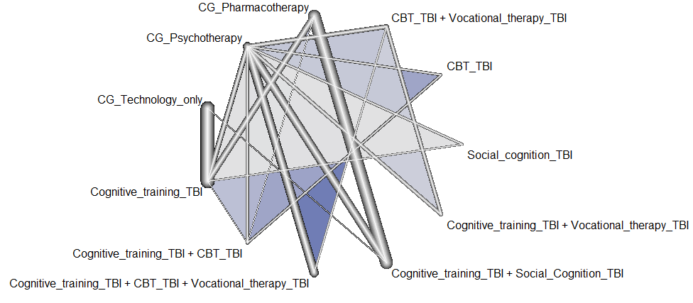
Symptomatology

Results from the network meta-analysis (including all studies)
In total, there are 130 comparisons within this outcome. The mean age of this subsample is 35.91, with a standard deviation of 9.46. Nineteen comparisons come from a sample of participants that have had a first episode of psychosis, whereas 98 comparisons come from samples of participants with schizophrenia. For the results of the P-Scores below, the reference category is the control group Technology only. Interventions are ordered by the P-score ranks.

eTable 12. Results of the P-Scores for Symptomatology for all studies.
Intervention | SMC and 95% CI | P-score
CBT_TBI | 0.105 [-0.353, 0.563] | 0.8419
Cognitive training_TBI + Social cognition_TBI | 0.038 [-0.408, 0.484] | 0.7598
Technology | - | 0.6946
Cognitive training_TBI | -0.038 [-0.382, 0.306] | 0.6518
Pharmacotherapy | -0.063 [-0.488, 0.361] | 0.6071
Social cognition_TBI | -0.089 [-0.563, 0.386] | 0.5750
Cognitive training_TBI + Psychoeducation_TBI | -0.166 [-0.887, 0.556] | 0.4849
Cognitive training_TBI + CBT_TBI + Vocational therapy_TBI | -0.186 [-0.809, 0.437] | 0.4629
Cognitive training_TBI + CBT_TBI | -0.251 [-0.903, 0.402] | 0.3859
Psychotherapy | -0.301 [ -0.683, 0.081] | 0.2675
Psychoeducation_TBI | -0.444 [-0.849, -0.038] | 0.1431
CBT_TBI + Vocational therapy_TBI | -0.540 [-1.200, 0.120] | 0.1254
Notes. SMD = standardized mean change; CI = confidence intervals.

The node-splitting method showed significant differences between the direct effect of CBT on control group – Pharmacotherapy (= -0.10) and the indirect effect obtained for the same pair of treatments (= 0.64, Z= -2.34, p = .019). Also, significant differences were found between the overall direct and indirect effect of CB treatment on control group – Psychotherapy (= 0.66; = -0.08, Z= 2.34, p = .019). Lastly, inconsistency was also found between Psychoeducation and CG-Psychotherapy (= -0.40; = 0.29, Z= -2.18, p = .030).

eFigure 9. Forest plot of the relative treatment effectiveness for Symptomatology with all studies included (k=130).
CG = control group.
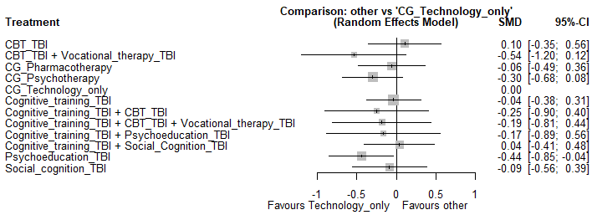

Results from the network meta-analysis Including only studies where the mean age was over 25
There are 101 comparisons from samples whose mean age is over 25. Specifically, the mean age of this subsample is 39.04, with a standard deviation of 6.51. All these comparisons came from samples diagnosed with schizophrenia. For the results of the P-Scores below, the reference category is the control group Technology only. Interventions are ordered by the P-score ranks.

eTable 13. Results of the P-Scores for Symptomatology for studies where the mean age was over 25.
Interventions | SMC and 95% CI | P-score
Cognitive training_TBI + Social cognition_TBI | 0.286 [-0.321, 0.893] | 0.8711
Social cognition_TBI | 0.163 [-0.473, 0.799] | 0.7164
Cognitive training_TBI | 0.138 [0.415, 0.691] | 0.7044
Cognitive training_TBI + CBT_TBI + Vocational therapy_TBI | 0.102 [-0.662, 0.866] | 0.6247
Technology | - | 0.5055
Psychotherapy | -0.013 [-0.574, 0.548] | 0.4647
CBT_TBI | -0.048 [-0.789, 0.692] | 0.4474
Pharmacotherapy | -0.041 [-0.638, 0.556] | 0.4392
Cognitive training_TBI + CBT_TBI | -0.153 [-0.948, 0.641] | 0.3401
CBT_TBI + Vocational therapy_TBI | -0.252 [-1.049, 0.545] | 0.2378
Psychoeducation_TBI | -0.286 [-0.810, 0.238] | 0.1489
Notes. SMD = standardized mean change; CI = confidence intervals.
There are no inconsistent effects.
eFigure 10. Forest plot of the relative treatment effectiveness for Symptomatology for the subset of studies where the man age was over 25 (k=101).
CG = control group.
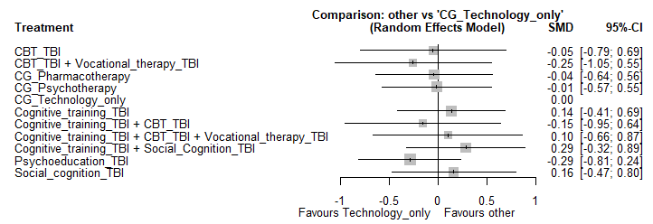

eFigure 11. Network plot for the interventions for Symptomatology for the subset of studies where the man age was over 25 (k=101).
The thickness of the lines is proportional to the number of studies that reported the comparison between those treatments. CG = control group.
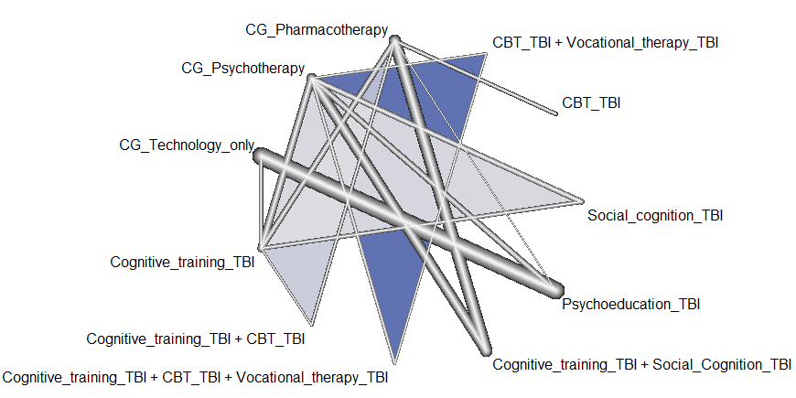

Results from the network meta-analysis including only studies where participants have a diagnosis of First Episode Psychosis
There are 19 comparisons within this subgroup. The mean age is 19.19 and the standard deviation is 3.12. For the results of the P-Scores below, the reference category is the control group Technology only. Interventions are ordered by the P-score ranks.

eTable 14. Results of the P-Scores for Symptomatology for studies where participants were diagnosed with First Episode Psychosis.
Interventions | SMC and 95% CI | P-score
CBT_TBI | 0.756 [0.094, 1.418] | 0.9965
Cognitive training_TBI + Psychoeducation_TBI | 0.265 [-0.413, 0.943] | 0.6483
Psychotherapy | 0.129 [-0.508, 0.766] | 0.4182
Technology | - | 0.3869
Cognitive training_TBI | -0.238 [0.491, 0.014] | 0.0501
Notes. SMD = standardized mean change; CI = confidence intervals.

Consistency could not be assessed because for each pair of treatments, only direct or indirect evidence was available.

eFigure 12. Forest plot of the relative treatment effectiveness for Symptomatology for the subset of studies where participants were diagnosed with First Episode Psychosis (k=19).
CG = control group.
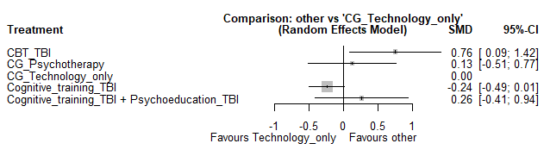

eFigure 13. Network plot for the interventions for Symptomatology for the subset of studies where participants were diagnosed with First Episode Psychosis (k=19).
The thickness of the lines is proportional to the number of studies that reported the comparison between those treatments. CG = control group.

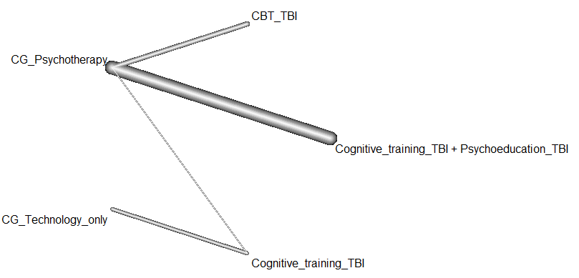

Results from the network meta-analysis including only studies where participants have a diagnosis schizophrenia
There are 111 comparisons for this subgroup, whose mean age is 38.86 and the standard deviation is 6.71. For the results of the P-Scores below, the reference category is the control group Technology only. Interventions are ordered by the P-score ranks.

eTable 15. Results of the P-Scores for Symptomatology for studies where participants were diagnosed with schizophrenia.
Intervention | SMC and 95% CI | P-score
Cognitive training_TBI + Social cognition_TBI | 0.224 [-0.330, 0.778] | 0.8508
Cognitive training_TBI | 0.161 [-0.325, 0.648] | 0.7906
Social cognition_TBI | 0.123 [-0.461, 0.708] | 0.7161
Cognitive training_TBI + CBT_TBI + Vocational therapy_TBI | 0.032 [-0.685, 0.748] | 0.5913
Technology | - | 0.5517
Pharmacotherapy | -0.055 [-0.603, 0.494] | 0.4814
Psychotherapy | -0.084 [-0.586, 0.419] | 0.4200
Cognitive training_TBI + CBT_TBI | -0.149, [-0.898, 0.601] | 0.3846
CBT_TBI | -0.157 [-0.828, 0.513] | 0.3579
CBT_TBI + Vocational therapy_TBI | -0.323 [-1.074, 0.429] | 0.2090
Psychoeducation_TBI | -0.326 [-0.811, 0.159] | 0.1467
Notes. SMD = standardized mean change; CI = confidence intervals.

There were no inconsistent effects.
eFigure 14. Forest plot of the relative treatment effectiveness for Symptomatology for the subset of studies where participants were diagnosed with schizophrenia (k=111).
CG = control group.
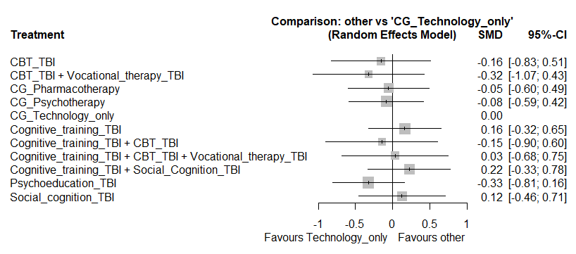

eFigure 15. Network plot for the interventions for Symptomatology for the subset of studies where participants were diagnosed with schizophrenia (k=111).
The thickness of the lines is proportional to the number of studies that reported the comparison between those treatments. CG = control group.
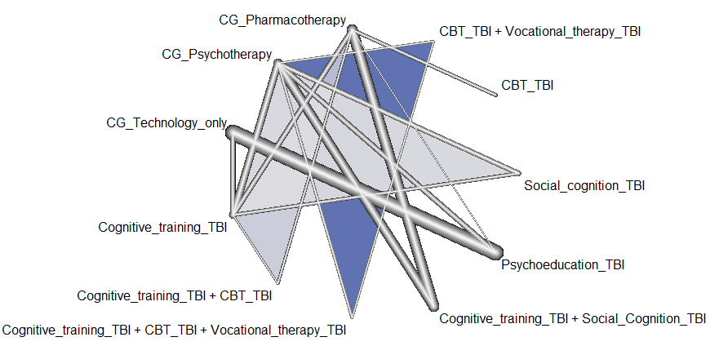

Functioning

Results from the network meta-analysis (including all studies)
In total, there are 108 comparisons within this outcome. The mean age of this subsample is 36.58, with a standard deviation of 10.66. Nine comparisons come from a sample of participants that have had a first episode of psychosis, whereas 97 comparisons come from samples of participants with schizophrenia. For the results of the P-Scores below, the reference category is the control group Technology only. Interventions are ordered by the P-score ranks.

eTable 16. Results of the P-Scores for Functioning for all studies.
Intervention | SMC and 95% CI | P-score
Cognitive training_TBI + Social cognition_TBI | 0.390 [-0.002, 0.782] | 0.9470
Social cognition_TBI | 0.294 [-0.158, 0.747] | 0.8513
Cognitive training_TBI + Psychoeducation_TBI | 0.106 [-0.553, 0.765] | 0.5964
Pharmacotherapy | 0.046 [-0.390, 0.481] | 0.5533
Technology | - | 0.4754
Psychoeducation_TBI | -0.007 [-0.477, 0.463] | 0.4663
Cognitive training_TBI | -0.013 [-0.297, 0.272] | 0.4572
CBT_TBI | -0.032 [-0.459, 0.397] | 0.4308
Cognitive training_TBI + CBT_TBI + Vocational therapy_TBI | -0.112 [-0.778, 0.554] | 0.3451
Cognitive training_TBI + CBT_TBI | -0.100 [-0.526, 0.327] | 0.3113
Psychotherapy | -0.268 [-0.636, 0.101] | 0.0657
Notes. SMD = standardized mean change; CI = confidence intervals.

The node-splitting method showed significant differences between the direct effect of CBT on control group – Pharmacotherapy (= -0.27) and the indirect effect obtained for the same pair of treatments (= 0.55, Z= 2.13, p = .033).

eFigure 16. Forest plot of the relative treatment effectiveness for Functioning with all studies included (k=108).
CG = control group.
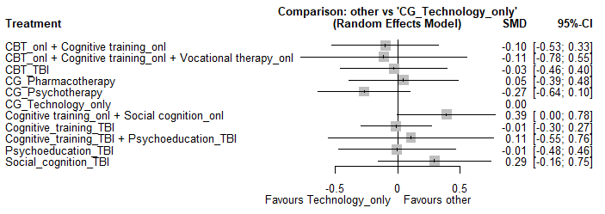

Results from the network meta-analysis Including only studies where the mean age was over 25
There are 91 comparisons from samples whose mean age is over 25. Specifically, the mean age of this subsample is 38.57, with a standard deviation of 9.46. Only one from these comparisons came from a sample of participant a first episode of psychosis, while the remaining 90 comparisons came from samples diagnosed with schizophrenia. For the results of the P-Scores below, the reference category is the control group Technology only. Interventions are ordered by the P-score ranks.

eTable 17. Results of the P-Scores for Functioning for studies where the mean age was over 25.
Intervention | SMC and 95% CI | P-score
Cognitive training_TBI + Social cognition_TBI | 0.329 [-0.370, 1.027] | 0.9243
Social cognition_TBI | 0.208 [-0.552, 0.967] | 0.7983
Pharmacotherapy | -0.011 [-0.753, 0.731] | 0.5756
Technology | - | 0.5479
CBT_TBI | -0.035 [-0.793, 0.723] | 0.3282
Cognitive training_TBI | -0.078 [-0.684, 0.528] | 0.4898
Cognitive training_TBI + CBT_TBI | -0.150 [-0.886, 0.586] | 0.3978
Cognitive training_TBI + CBT_TBI + Vocational therapy_TBI | -0.201 [-1.198, 0.796] | 0.3928
Psychotherapy | -0.357 [-1.034, 0.321] | 0.1628
Psychoeducation_TBI | -0.685 [-1.920, 0.550] | 0.1387
Notes. SMD = standardized mean change; CI = confidence intervals.
There were no inconsistent effects
eFigure 17. Forest plot of the relative treatment effectiveness for Functioning for the subset of studies where the mean age was over 25 (k=91).
CG = control group.
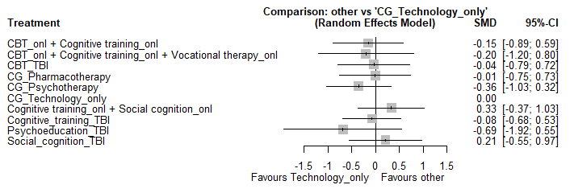

eFigure 18. Network plot for the interventions for Functioning for the subset of studies where the mean age was over 25 (k=91).
The thickness of the lines is proportional to the number of studies that reported the comparison between those treatments. CG = control group.
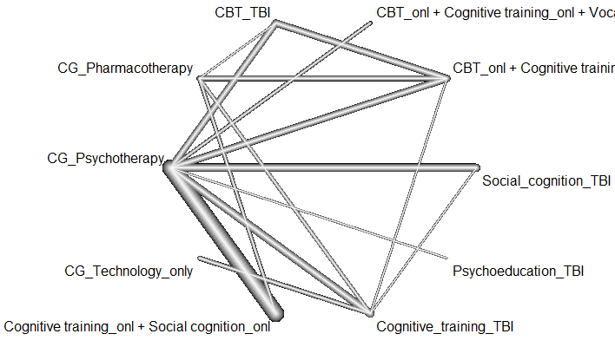

Results from the network meta-analysis including only studies where participants have a diagnosis of First Episode Psychosis
There are 9 comparisons within this subgroup. The mean age is 22.37 and the standard deviation is 8.51. For the results of the P-Scores below, the reference category is the control group Technology only. Interventions are ordered by the P-score ranks.

eTable 18. Results of the P-Scores for Functioning for studies where participants were diagnosed with First Episode Psychosis.
Intervention | SMC and 95% CI | P-score
Cognitive training_TBI + Psychoeducation_TBI | 0.174 [-0.953, 1.301] | 0.7192
Cognitive training_TBI | 0.176 [-0.401, 0.753] | 0.6992
Technology | - | 0.4784
CBT_TBI | -0.149 [-1.232, 0.935] | 0.3499
Psychotherapy | -0.199 [1.205, 0.806] | 0.2533
Notes. SMD = standardized mean change; CI = confidence intervals.

Consistency could not be assessed because for each pair of treatments, only direct or indirect evidence was available.

eFigure 19. Forest plot of the relative treatment effectiveness for Functioning for the subset of studies where participants were diagnosed with First Episode Psychosis (k=9).
CG = control group.
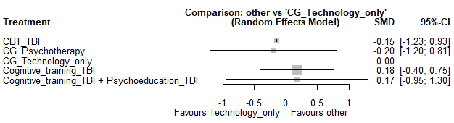

eFigure 20. Network plot for the interventions for Functioning for the subset of studies where participants were diagnosed with First Episode Psychosis (k=9).
The thickness of the lines is proportional to the number of studies that reported the comparison between those treatments. CG = control group.
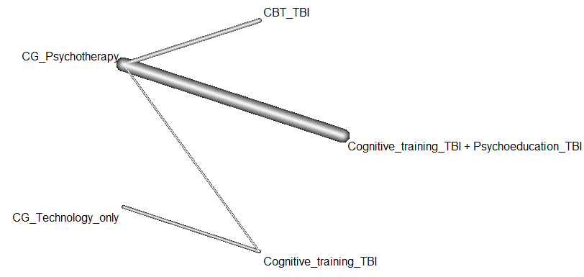

Results from the network meta-analysis including only studies where participants have a diagnosis schizophrenia
There are 90 comparisons within this subgroup. The mean age is 37.96 and the standard deviation is 9.83. For the results of the P-Scores below, the reference category is the control group Technology only. Interventions are ordered by the P-score ranks.

eTable 19. Results of the P-Scores for Functioning for studies where participants were diagnosed with schizophrenia.
Intervention | SMC and 95% CI | P-score
Cognitive training_TBI + Social cognition_TBI | 0.342 [-0.085, 0.768] | 0.9532
Social cognition_TBI | 0.244 [-0.238, 0.727] | 0.8454
Pharmacotherapy | 0.017 [-0.450, 0.483] | 0.5602
CBT_TBI | -0.001 [-0.483, 0.481] | 0.5331
Technology | - | 0.5266
Psychoeducation_TBI | -0.057 [-0.557, 0.443] | 0.4413
Cognitive training_TBI | -0.065 [-0.388, 0.258] | 0.4198
Cognitive training_TBI + CBT_TBI | -0.117 [-0.578, 0.344] | 0.3340
Cognitive training_TBI + CBT_TBI + Vocational therapy_TBI | -0.162 [-0.852, 0.527] | 0.3292
Psychotherapy | -0.318 [-0.723, 0.088] | 0.0571
Notes. SMD = standardized mean change; CI = confidence intervals.
The node-splitting method showed significant differences between the direct effect of CBT on control group – Pharmacotherapy (= 0.55) and the indirect effect obtained for the same pair of treatments (= -0.44, Z= 2.09, p = .034).

eFigure 21. Forest plot of the relative treatment effectiveness for Functioning for the subset of studies where participants were diagnosed with schizophrenia (k=90).
CG = control group.
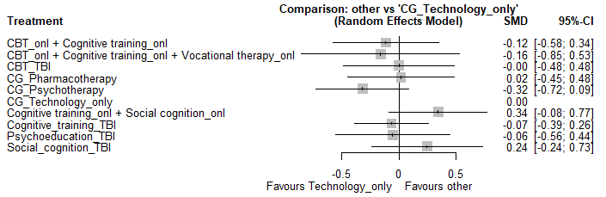

eFigure 22. Network plot for the interventions for Functioning for the subset of studies where participants were diagnosed with schizophrenia (k=90).
The thickness of the lines is proportional to the number of studies that reported the comparison between those treatments. CG = control group.

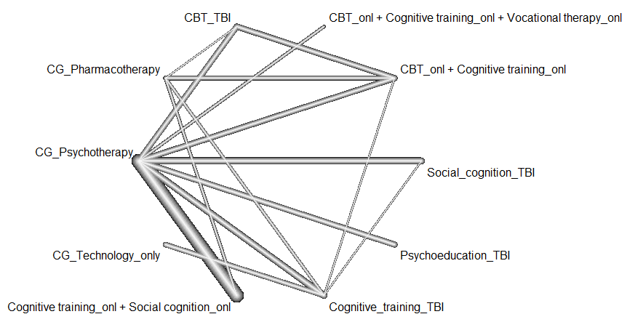

Social cognition

Results from the network meta-analysis (including all studies)
In total, there are 46 comparisons within this outcome. The mean age of this subsample is 36.84, with a standard deviation of 8.69. Only one comparison come from a sample of participants that have had a first episode of psychosis, whereas 45 comparisons come from samples of participants with schizophrenia. For the results of the P-Scores below, the reference category is the control group Technology only. Interventions are ordered by the P-score ranks.

eTable 20. Results of the P-Scores for Social cognition for all studies.
Intervention | SMC and 95% CI | P-score
Cognitive training_TBI + Social cognition_TBI | 0.800 [-0.150, 1.749] | 0.7035
Pharmacotherapy | 0.724 [-0.380, 1.827] | 0.6115
Cognitive training_TBI + CBT_TBI + Vocational therapy_TBI | 0.721 [-0.667, 2.109] | 0.5959
Social cognition_TBI | 0.690 [-0.430, 1.810] | 0.5937
Cognitive training_TBI + CBT_TBI | 0.658 [-0.734, 2.050] | 0.5599
Cognitive training_TBI + Psychoeducation_TBI | 0.671 [-1.038, 2.379] | 0.5539
CBT_TBI | 0.459 [-1.185, 2.104] | 0.4434
Cognitive training_TBI | 0.468 [-0.282, 1.218] | 0.4341
Psychotherapy | 0.404 [-0.584, 1.356] | 0.3463
Technology | - | 0.1578
Notes. SMD = standardized mean change; CI = confidence intervals.

There were no inconsistent effects.

eFigure 23. Forest plot of the relative treatment effectiveness for Social cognition (all studies included, k=46).
CG = control group.
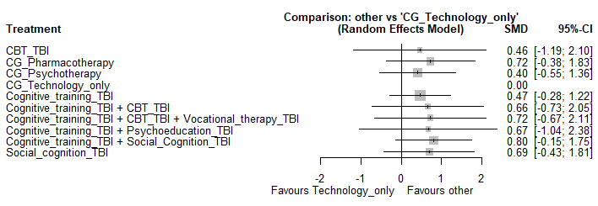

Results from the network meta-analysis Including only studies where the mean age was over 25
There are 45 comparisons from samples whose mean age is over 25. Specifically, the mean age of this subsample is 37.10, with a standard deviation of 8.60. All these comparisons come from samples of participants diagnosed with schizophrenia. For the results of the P-Scores below, the reference category is the control group Technology only. Interventions are ordered by the P-score ranks.

eTable 21. Results of the P-Scores for Social cognition for studies where the mean age was over 25.
Intervention | SMC and 95% CI | P-score
Cognitive training_TBI + Social Cognition_TBI | 0.800 [-0.150, 1.749] | 0.7203
Pharmacotherapy | 0.724 [-0.380, 1.827] | 0.6224
Cognitive training_TBI + CBT_TBI + Vocational therapy_TBI | 0.721 [-0.667, 2.109] | 0.6051
Social cognition_TBI | 0.690 [-0.430, 1.810] | 0.6042
Cognitive training_TBI + CBT_TBI | 0.658 [-0.734, 2.050] | 0.5681
CBT_TBI | 0.459 [-1.185, 2.104] | 0.4469
Cognitive training_TBI | 0.468 [-0.282, 1.218] | 0.4380
Psychotherapy | 0.404 [-0.548, 1.356] | 0.3450
Technology | - | 0.1499
Notes. SMD = standardized mean change; CI = confidence intervals.

There were no inconsistent effects

eFigure 24. Forest plot of the relative treatment effectiveness for Social cognition for the subset of studies where the mean age was over 25 (k=45).
CG = control group.
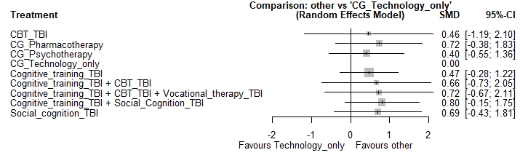

eFigure 25. Network plot for the interventions for Social cognition for the subset of studies where the mean age of the participants was over (k=45).
The thickness of the lines is proportional to the number of studies that reported the comparison between those treatments. CG = control group.

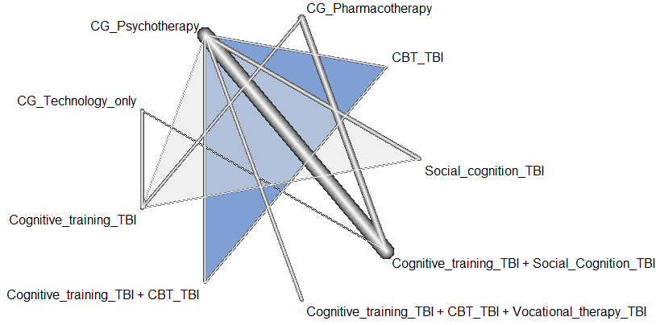

Results from the network meta-analysis including only studies where participants have a diagnosis of First Episode Psychosis
There was only one effect size for this subgroup, so we could not run the network meta-analysis.

Results from the network meta-analysis including only studies where participants have a diagnosis schizophrenia
There are 45 comparisons within this subgroup. The mean age of these participants was 37.10, and the standard deviation was 8.60. For the results of the P-Scores below, the reference category is the control group Technology only. Interventions are ordered by the P-score ranks.

eTable 22. Results of the P-Scores for Social cognition for studies where participants were diagnosed with schizophrenia.
Intervention | SMC and 95% CI | P-score
Cognitive training_TBI + Social cognition_TBI | 0.800 [-0.150, 1.749] | 0.7203
Pharmacotherapy | 0.724 [-0.380, 1.827] | 0.6224
Cognitive training_TBI + CBT_TBI + Vocational therapy_TBI | 0.721 [-0.667, 2.109] | 0.6051
Social cognition_TBI | 0.690 [-0.430, 1.810] | 0.6042
Cognitive training_TBI + CBT_TBI | 0.658 [-0.734, 2.050] | 0.5681
CBT_TBI | 0.459 [-1.185, 2.104] | 0.4469
Cognitive training_TBI | 0.468 [-0.282, 1.218] | 0.4380
Psychotherapy | 0.404 [0.548, 1.356] | 0.3450
Technology | - | 0.1499
Notes. SMD = standardized mean change; CI = confidence intervals.

There were no inconsistent effects

eFigure 26. Forest plot of the relative treatment effectiveness for Social cognition for the subset of studies where participants were diagnosed with schizophrenia (k=45).
CG = control group.
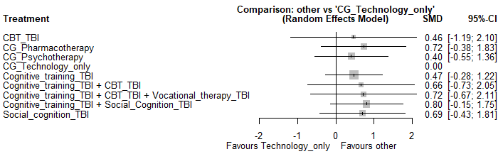

eFigure 27. Network plot for the interventions for Social cognition for the subset of studies where participants were diagnosed with schizophrenia (k=45).
The thickness of the lines is proportional to the number of studies that reported the comparison between those treatments. CG = control group.
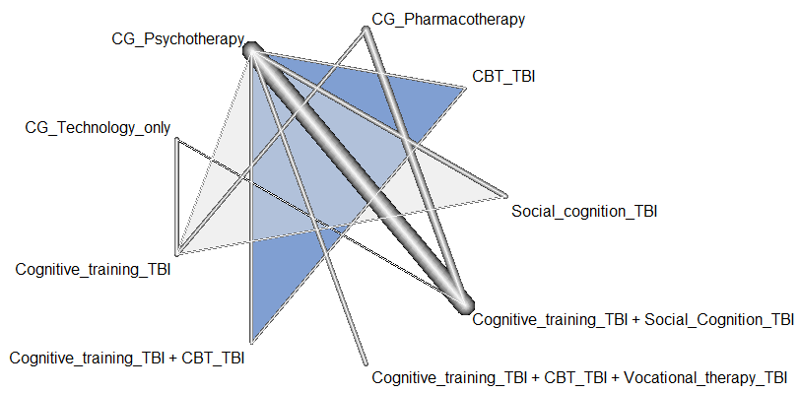

Quality of Life

Results from the network meta-analysis (including all studies)
In total, there are 40 comparisons within this outcome. The mean age of this subsample is 37.85, with a standard deviation of 6.72. Only one comparison come from a sample of participants that have had a first episode of psychosis, whereas 39 comparisons come from samples of participants with schizophrenia. For the results of the P-Scores below, the reference category is the control group Technology only. Interventions are ordered by the P-score ranks.

eTable 23. Results of the P-Scores for Quality of life for all studies.
Intervention | SMC and 95% CI | P-score
CBT_TBI | 1.266 [0.457, 2.076] | 0.9952
Social cognition_TBI | 0.383 [-0.121, 0.887] | 0.7369
Pharmacotherapy | 0.316 [-0.064, 0.697] | 0.6636
Cognitive training_TBI | 0.296 [0.102, 0.491] | 0.6575
Cognitive training_TBI + CBT_TBI | 0.124 [-0.256, 0.504] | 0.3853
Cognitive training_TBI + Social cognition_TBI | 0.088 [-0.362, 0.539] | 0.3351
Psychoeducation_TBI | 0.086 [-0.348, 0.520] | 0.3306
Psychotherapy | 0.031 [-0.359, 0.421] | 0.2057
Technology | - | 0.1901
Notes. SMD = standardized mean change; CI = confidence intervals.

The node-splitting method showed significant differences between the direct effect of Cognitive Training on control group – Psychotherapy (= -0.27) and the indirect effect obtained for the same pair of treatments (= -0.57, Z= 2.162, p = .031).

eFigure 28. Forest plot of the relative treatment effectiveness for Quality of life
for all studies (k=40).
CG = control group.
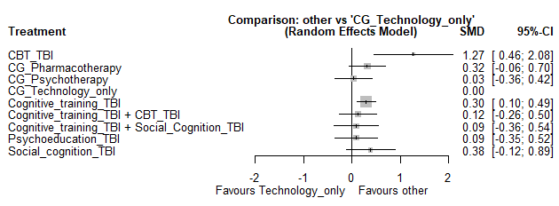

Results from the network meta-analysis Including only studies where the mean age was over 25
There are 37 comparisons within this subgroup of studies. The mean age of this subsample is 38.35 and the standard deviation is 6.04. All these comparisons come from samples of participants with schizophrenia. For the results of the P-Scores below, the reference category is the control group Technology only. Interventions are ordered by the P-score ranks.

eTable 24. Results of the P-Scores for Quality of life for studies where the man age was over 25.
Intervention | SMC and 95% CI | P-score
Social cognition_TBI | 0.398 [-0.158, 0.954] | 0.8236
Pharmacotherapy | 0.321 [-0.108, 0.750] | 0.7272
Cognitive training_TBI | 0.298 [0.078, 0.517] | 0.7205
Psychoeducation_TBI | 0.141 [-0.354, 0.636] | 0.4592
Cognitive training_TBI + CBT_TBI | 0.134 [-0.289, 0.556] | 0.4313
Cognitive training_TBI + Social Cognition_TBI | 0.096 [-0.400, 0.592] | 0.3786
Psychotherapy | 0.046 [-0.383, 0.474] | 0.2482
Technology only | - | 0.2115
Notes. SMD = standardized mean change; CI = confidence intervals.

There were no inconsistent effects.

eFigure 29. Forest plot of the relative treatment effectiveness for Quality of life for the subset of studies where the man age was over 25 (k=37).
CG = control group.
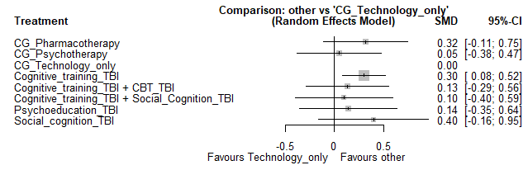

eFigure 30. Network plot for the interventions for Quality of life for the subset of studies where the mean age was over 25 (k=37).
The thickness of the lines is proportional to the number of studies that reported the comparison between those treatments. CG = control group.
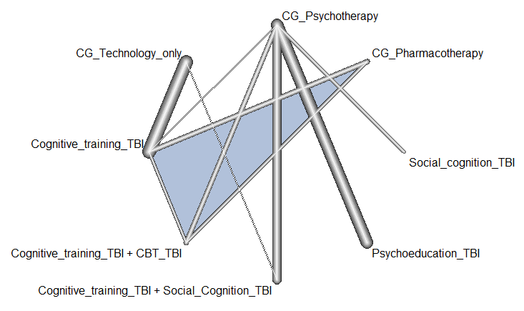

Results from the network meta-analysis including only studies where participants have a diagnosis of First Episode Psychosis
There was only one effect size for this subgroup, so we could not run the network meta-analysis.

Results from the network meta-analysis including only studies where participants have a diagnosis schizophrenia
There are 39 comparisons within this subgroup. The mean age of these participants was 38.35, and the standard deviation was 6.04. For the results of the P-Scores below, the reference category is the control group Technology only. Interventions are ordered by the P-score ranks.

eTable 25. Results of the P-Scores for Quality of life for studies where participants were diagnosed with schizophrenia.
Intervention | SMC and 95% CI | P-score
Social cognition_TBI | 0.383 [-0.121, 0.887] | 0.8403
Pharmacotherapy | 0.316 [-0.064, 0.697] | 0.7567
Cognitive training_TBI | 0.296 [0.102, 0.491] | 0.7503
Cognitive training_TBI + CBT_TBI | 0.124 [-0.255, 0.504] | 0.4401
Cognitive training_TBI + Social cognition_TBI | 0.088 [-0.362, 0.539] | 0.3828
Psychoeducation_TBI | 0.086 [-0.348, 0.520] | 0.3777
Psychotherapy | 0.404 [0.548, 1.356] | 0.2350
Technology | - | 0.2171
Notes. SMD = standardized mean change; CI = confidence intervals.

The node-splitting method showed significant differences between the direct effect of Cognitive Training on control group – Psychotherapy (= -0.27) and the indirect effect obtained for the same pair of treatments (= -0.57, Z= 2.162, p = .031).

eFigure 26. Forest plot of the relative treatment effectiveness for Quality of Life for the subset of studies where participants were diagnosed with schizophrenia (k=39).
CG = control group.
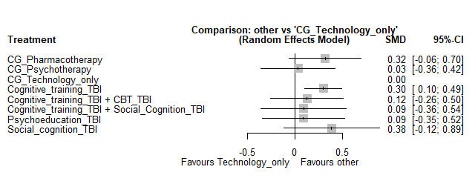

eFigure 27. Network plot for the interventions for Quality of Life for the subset of studies where participants were diagnosed with schizophrenia (k=39).
The thickness of the lines is proportional to the number of studies that reported the comparison between those treatments. CG = control group.
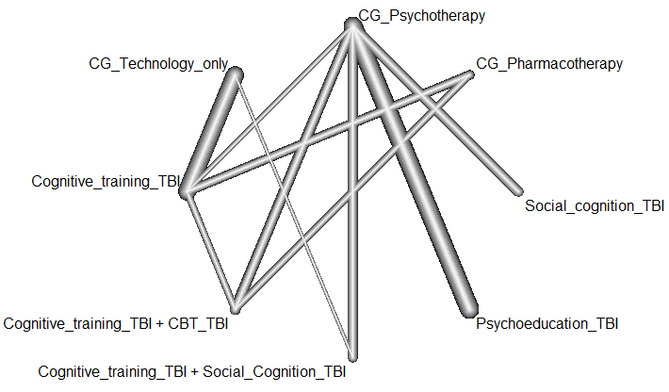

eAppendix 6. Results of the moderator analyses
These tables contain the results of the moderator analyses (for those subsets of data were more than 20 effect sizes were available). Sometimes the three-level model did not converge (due to a small number of effect sizes). In those cases, a standard random-effects model was fitted, and the cell in the column of the between-outcomes variance was left empty.

eTable 26. Results of the moderator analyses for Neurocognition. Subset of studies where the TBI intervention was Cogntive training_TBI.
NEUROCOGNITION
Intervention: Cognitive training
 | k |  | g |  | SE | Z | p-value
% men in control group |  |  |  |  |  |  |  | 0.027 (17) | 0.043 (152)
Pharmacotherapy | 40 |  | 0.087 |  | 0.105 | 0.834 | .404
Technology | 88 |  | 0.166 |  | 0.071 | 2.350 | .019
Psychotherapy | 24 |  | 0.351 |  | 0.132 | 2.651 | .008
% men_control_group | 152 |  | 0.001 |  | 0.005 | 0.180 | .857
% men in intervention |  |  |  |  |  |  |  | 0.024 (17) | 0.044 (152)
Pharmacotherapy | 40 |  | 0.081 |  | 0.102 | 0.794 | .427
Technology | 88 |  | 0.144 |  | 0.072 | 1.989 | .047
Psychotherapy | 24 |  | 0.420 |  | 0.147 | 2.855 | .004
% men_inter_group | 152 |  | 0.005 |  | 0.005 | 0.913 | .361
Mean age control group |  |  |  |  |  |  |  | 0.028 (19) | 0.036 (169)
Pharmacotherapy | 40 |  | 0.094 |  | 0.103 | 0.911 | .362
Technology | 105 |  | 0.198 |  | 0.063 | 3.147 | .002
Psychotherapy | 24 |  | 0.343 |  | 0.123 | 2.790 | .005
mean_age_control | 169 |  | 0.004 |  | 0.005 | 0.697 | .486
Mean age intervention group |  |  |  |  |  |  |  | 0.027 (19) | 0.037 (169)
Pharmacotherapy | 40 |  | 0.091 |  | 0.102 | 0.889 | .374
Technology | 105 |  | 0.196 |  | 0.062 | 3.154 | .002
Psychotherapy | 24 |  | 0.329 |  | 0.124 | 2.658 | .008
mean_age_intervent | 169 |  | 0.004 |  | 0.006 | 0.675 | .500
Education control group |  |  |  |  |  |  |  | 0.019 (17) | 0.042 (161)
Pharmacotherapy | 37 |  | 0.075 |  | 0.104 | 0.722 | .471
Technology | 105 |  | 0.156 |  | 0.060 | 2.583 | .010
Psychotherapy | 19 |  | 0.274 |  | 0.142 | 1.923 | .055
Education control | 161 |  | 0.030 |  | 0.017 | 1.788 | .074
Education intervention group |  |  |  |  |  |  |  | 0.017 (17) | 0.042 (161)
Pharmacotherapy | 37 |  | 0.059 |  | 0.102 | 0.586 | .558
Technology | 105 |  | 0.150 |  | 0.059 | 2.559 | .011
Psychotherapy | 19 |  | 0.276 |  | 0.137 | 2.015 | .044
Education intervention | 161 |  | 0.034 |  | 0.016 | 2.135 | .033
Intervention: Cognitive training (cont.)
 | k |  | g |  | SE | Z | p-value
Type of medication |  |  |  |  |  |  |  | 0.015 (18) | 0.040 (159)
Pharmacotherapy | 40 |  | -0.005 |  | 0.125 | -0.043 | .966
Technology | 88 |  | 0.148 |  | 0.122 | 1.213 | .225
Psychotherapy | 31 |  | 0.203 |  | 0.144 | 1.408 | .159
Atypical antipsychotic | 25 |  | -0.010 |  | 0.130 | 0.077 | .939
Typical antipsychotic | 33 |  | 0.243 |  | 0.145 | 1.679 | .093
Reference category: Antipsychotics (K=101). When the reference category was shifted to “Typical Antipsychotic”, no differences were found neither.
Amount of medication control |  |  |  |  |  |  |  | 0.000 (6) | 0.180 (48)
Pharmacotherapy | 19 |  | 0.211 |  | 0.127 | 1.663 | .096
Technology | 19 |  | 0.284 |  | 0.131 | 2.167 | .030
Psychotherapy | 10 |  | 0.593 |  | 0.171 | 3.462 | .001
Amount medication control |  |  | -0.001 |  | 0.001 | -1.246 | .213
Amount of medication intervention |  |  |  |  |  |  |  | 0.000 (6) | 0.178 (48)
Pharmacotherapy | 19 |  | 0.163 |  | 0.125 | 1.304 | .192
Technology | 19 |  | 0.295 |  | 0.126 | 2.336 | .020
Psychotherapy | 10 |  | 0.663 |  | 0.185 | 3.586 | .0003
Amount medication interve. |  |  | -0.001 |  | 0.001 | -1.379 | .168
Duration of intervention |  |  |  |  |  |  |  | 0.023 (21) | 0.034 (184)
Pharmacotherapy | 40 |  | 0.089 |  | 0.099 | 0.899 | .369
Technology | 105 |  | 0.191 |  | 0.060 | 3.183 | .002
Psychotherapy | 39 |  | 0.290 |  | 0.097 | 2.999 | .003
Duration intervention |  |  | 0.0003 |  | 0.005 | 0.056 | .955
Frequency of the intervention |  |  |  |  |  |  |  | 0.020 (21) | 0.035 (184)
Pharmacotherapy | 40 |  | 0.104 |  | 0.099 | 1.053 | .292
Technology | 105 |  | 0.180 |  | 0.059 | 3.054 | .002
Psychotherapy | 39 |  | 0.285 |  | 0.093 | 3.056 | .002
Frequency | 184 |  | 0.013 |  | 0.018 | 0.740 | .459
Diagnosis |  |  |  |  |  |  |  | 0.020 (21) | 0.034 (184)
Pharmacotherapy | 40 |  | -0.011 |  | 0.170 | -0.605 | .545
Technology | 105 |  | 0.180 |  | 0.140 | 0.129 | .898
Psychotherapy | 39 |  | 0.127 |  | 0.152 | 0.840 | .401
Schizophrenia | 159 |  | 0.195 |  | 0.144 | 1.352 | .176
Reference category Psychosis (k=24)
Contact control group |  |  |  |  |  |  |  | 0.024 (21) | 0.033 (184)
Pharmacotherapy | 40 |  | 0.080 |  | 0.100 | 0.802 | .423
Technology | 105 |  | 0.159 |  | 0.064 | 2.468 | .014
Psychotherapy | 30 |  | 0.206 |  | 0.111 | 1.860 | .063
Others | 21 |  | 0.243 |  | 0.143 | 1.704 | .088
Therapists | 17 |  | 0.060 |  | 0.161 | 0.372 | .710
Reference category: No contact (k=146). When the reference category was shifted to “Others”, no differences were found neither.
Intervention: Cognitive training (cont.)
 | k |  | g |  | SE | Z | p-value
Contact intervention group |  |  |  |  |  |  |  | 0.025 (21) | 0.033 (184)
Pharmacotherapy | 49 |  | 0.051 |  | 0.104 | 0.495 | .621
Technology | 105 |  | 0.164 |  | 0.065 | 2.518 | .012
Psychotherapy | 39 |  | 0.197 |  | 0.121 | 1.632 | .103
Others | 33 |  | 0.170 |  | 0.125 | 1.360 | .174
Therapists | 17 |  | 0.060 |  | 0.164 | 0.367 | .714
Reference category: No contact (k=134). When the reference category was shifted to “Others”, no differences were found neither.
Setting |  |  |  |  |  |  |  | 0.023 (21) | 0.034 (184)
Pharmacotherapy | 40 |  | 0.082 |  | 0.102 | 0.800 | .424
Technology | 105 |  | 0.187 |  | 0.062 | 3.025 | .003
Psychotherapy | 39 |  | 0.189 |  | 0.095 | 3.035 | .002
Clinic | 173 |  | 0.047 |  | 0.167 | 0.279 | .780
Reference category: Home (k=11). There are not effects within the category Clinic/Home
eTable 27. Results of the moderator analyses for Neurocognition. Subset of studies where the TBI intervention was Cognitive training_TBI + Social cognition_TBI.
Intervention: Cognitive training + Social cognition
 | k |  | g |  | SE | Z | p-value
% men in control group |  |  |  |  |  |  |  | 0.000 (5) | 0.095 (46)
Pharmacotherapy | 11 |  | 0.552 |  | 0.235 | 2.344 | .019
Technology | 1 |  | -0.020 |  | 0.627 | -0.031 | .975
Psychotherapy | 34 |  | -0.117 |  | 0.134 | -0.874 | .382
% men_control_group | 46 |  | 0.038 |  | 0.020 | 1.923 | .054
% men in intervention group |  |  |  |  |  |  |  | 0.000 (5) | 0.102 (46)
Pharmacotherapy | 11 |  | -0.113 |  | 0.190 | -0.592 | .554
Technology | 1 |  | 0.861 |  | 0.704 | 1.222 | .222
Psychotherapy | 34 |  | 0.202 |  | 0.099 | 2.042 | .041
% men_inter_group | 46 |  | -0.023 |  | 0.014 | -1.713 | .087
Mean age control group |  |  |  |  |  |  |  | 0.015 (5) | 0.102 (46)
Pharmacotherapy | 11 |  | 0.236 |  | 0.185 | 1.271 | .204
Technology | 1 |  | 0.318 |  | 0.628 | 0.506 | .613
Psychotherapy | 34 |  | 0.045 |  | 0.111 | 0.408 | .683
mean_age_control | 46 |  | -0.014 |  | 0.013 | -1.060 | .289
Mean age intervention group |  |  |  |  |  |  |  | 0.003 (5) | 0.102 (46)
Pharmacotherapy | 11 |  | 0.259 |  | 0.141 | 1.830 | .067
Technology | 1 |  | 0.492 |  | 0.633 | 0.777 | .437
Psychotherapy | 34 |  | 0.053 |  | 0.086 | 0.615 | .538
mean_age_intervent | 46 |  | -0.015 |  | 0.010 | -1.548 | .122
Intervention: Cognitive training + Social cognition (cont.)
 | k |  | g |  | SE | Z | p-value
Education control group |  |  |  |  |  |  |  | 0.108 (4) | 0.266 (28)
Pharmacotherapy | 11 |  | 0.172 |  | 0.370 | 0.464 | .643
Technology | 1 |  | 0.349 |  | 0.823 | 0.424 | .672
Psychotherapy | 34 |  | -0.020 |  | 0.277 | -0.072 | .942
mean_age_control | 46 |  | -0.057 |  | 0.121 | -0.471 | .637
Education intervention group |  |  |  |  |  |  |  | 0.108 (4) | 0.266 (28)
Pharmacotherapy | 11 |  | 0.147 |  | 0.368 | 0.399 | .690
Technology | 1 |  | 0.387 |  | 0.843 | 0.459 | .646
Psychotherapy | 16 |  | -0.025 |  | 0.277 | -0.088 | .930
mean_age_intervent | 28 |  | -0.054 |  | 0.115 | -0.471 | .637
Type of medication |  |  |  |  |  |  |  | .001 (3) | 0.000 (36)
Pharmacotherapy | 11 |  | 0.239 |  | 0.151 | 1.585 | .113
Psychotherapy | 25 |  | 0.204 |  | 0.082 | 2.488 | .013
Typical antipsychotic | 18 |  | -0.088 |  | 0.136 | -0.649 | .517
Reference category “Atypical antipsychotic” (k=36)
Amount of medication | -
Duration of intervention |  |  |  |  |  |  |  | 0.001 (4) | 0.000 (37)
Pharmacotherapy | 11 |  | 0.194 |  | 0.093 | 2.081 | .037
Technology | 1 |  | 0.315 |  | 0.530 | 0.593 | .553
Psychotherapy | 25 |  | 0.159 |  | 0.068 | 2.319 | .020
Duration intervention | 37 |  | 0.001 |  | 0.002 | 0.649 | .517
Frequency of the intervention |  |  |  |  |  |  |  | 0.000 (5) | 0.091 (46)
Pharmacotherapy | 11 |  | 0.268 |  | 0.122 | 2.193 | .028
Technology | 1 |  | 0.480 |  | 0.614 | 0.782 | .434
Psychotherapy | 34 |  | 0.046 |  | 0.079 | 0.579 | .562
Frequency | 46 |  | -0.047 |  | 0.023 | -2.028 | .043
Diagnosis | -
Contact control group |  |  |  |  |  |  |  | 0.063 (5) | 0.100 (46)
Pharmacotherapy | 11 |  | 0.151 |  | 0.274 | 0.551 | .582
Technology | 1 |  | 0.119 |  | 0.716 | 0.166 | .868
Psychotherapy | 34 |  | -0.315 |  | 0.402 | -0.782 | .434
Others | 7 |  | 0.279 |  | 0.418 | 0.669 | .504
Therapists | 18 |  | 0.371 |  | 0.401 | 0.925 | .355
Reference category: No contact (k=21). When the reference category was shifted to “Others”, no differences were found neither.
Contact intervention group |  |  |  |  |  |  |  | 0.063 (5) | 0.100 (46)
Pharmacotherapy | 11 |  | 0.151 |  | 0.274 | 0.551 | .582
Technology | 1 |  | 0.119 |  | 0.716 | 0.166 | .868
Psychotherapy | 34 |  | -0.315 |  | 0.402 | -0.782 | .434
Intervention: Cognitive training + Social cognition (cont.)
 | k |  | g |  | SE | Z | p-value
Others | 7 |  | 0.279 |  | 0.418 | 0.669 | .504
Therapists | 18 |  | 0.371 |  | 0.401 | 0.925 | .355
Reference category: No contact (k=21). When the reference category was shifted to “Others”, no differences were found neither.
Setting |  |  |  |  |  |  |  | 0.000 (5) | 0.093 (46)
Pharmacotherapy | 11 |  | 0.151 |  | 0.109 | 1.390 | .165
Technology | 1 |  | 0.270 |  | 0.607 | 0.444 | .657
Psychotherapy | 34 |  | 0.179 |  | 0.087 | 2.064 | .039
Clinic/Home | 8 |  | -0.343 |  | 0.176 | -1.956 | .050
Reference category: Clinic (k = 37). There are no studies whose setting is at home.
eTable 28. Results of the moderator analyses for Neurocognition. Subset of studies where the TBI intervention was Cognitive training_TBI + CBT_TBI + Vocational therapy_TBI.
Intervention: Cognitive training + CBT + Vocational therapy
Only data for Psychotherapy control group is available
 | k |  | g |  | SE | Z | p-value
% men in control group |  |  |  |  |  |  |  | 0.000 (3) | 0.000 (32)
% men_control_group | 32 |  | -0.002 |  | 0.004 | -0.401 | .688
% men in intervention group |  |  |  |  |  |  |  | 0.000 (3) | 0.000 (32)
% men_inter_group | 32 |  | -0.002 |  | 0.004 | -0.396 | .692
Mean age control group |  |  |  |  |  |  |  | 0.000 (3) | 0.000 (32)
Mean age control | 32 |  | 0.003 |  | 0.007 | 0.422 | .673
Mean age intervention group |  |  |  |  |  |  |  | 0.000 (3) | 0.000 (32)
Mean age intervent. | 32 |  | 0.003 |  | 0.006 | 0.441 | .659
Education control group |  |  |  |  |  |  |  | 0.000 (3) | 0.000 (32)
Education control | 32 |  | -0.012 |  | 0.028 | -0.441 | .659
Education intervention group |  |  |  |  |  |  |  | 0.000 (3) | 0.000 (32)
Education intervention | 32 |  | -0.018 |  | 0.041 | -0.435 | .663
Type of medication |  |  |  |  |  |  |  | 0.000 (3) | 0.000 (32)
Atypical antipsychotic | 22 |  | -0.045 |  | 0.147 | -0.308 | .758
Reference category: Antipsychotic (k=10)
Amount of medication control |  |  | -
Amount of medication intervention |  |  | -
Intervention: Cognitive training + CBT + Vocational therapy
Only data for Psychotherapy control group is available
 | k |  | g |  | SE | Z | p-value
Duration of intervention |  |  |  |  |  |  |  | 0.000 (3) | 0.000 (32)
Duration intervention | 32 |  | 0.001 |  | 0.003 | 0.260 | .795
Frequency of the intervention
Frequency | 32 |  | 0.004 |  | 0.033 | 0.120 | .904 | 0.009 (3) | 0.000 (32)
Diagnosis | - |  | - |  | - | - | - | - | -
Contact control group |  |  |  |  |  |  |  | 0.025 (2) | 0.013 (21)
Others | 11 |  | 0.087 |  | 0.180 | 0.485 | .628
Therapists | 10 |  | 0.148 |  | 0.211 | 0.701 | .484
No difference between categories
Contact intervention group |  |  |  |  |  |  |  | 0.025 (2) | 0.013 (21)
Others | 11 |  | 0.087 |  | 0.180 | 0.485 | .628
Therapists | 10 |  | 0.148 |  | 0.211 | 0.701 | .484
No difference between categories
Setting |  |  |  |  |  |  |  | 0.000 (3) | 0.000 (32)
Clinic |  | 32 |  | -0.014 | 0.007 | 1.931 | .054
Home |  | 0 |  | - | - | - | -
Clinic/Home |  | 0 |  | - | - | - | -
Notes. k= number of effect sizes within each category; g = overall effect size; SE= standard error; = between-studies variance. In this column, the number of studies analyzed is indicated in brackets; = between-outcomes variance. In this column, the number of effect sizes analyzed is indicated in brackets.

eTable 29. Results of the moderator analyses for Symptomatology. Subset of studies where the TBI intervention was Cognitive training_TBI.
SYMPTOMATOLOGY
Intervention: Cognitive training
 | k | g | SE | Z | p-value
% men in control group |  |  |  |  |  | 0.000 (12) | 0.000 (28)
Pharmacotherapy | 8 | 0.058 | 0.133 | 0.435 | .663
Technology | 8 | -0.154 | 0.130 | -1.178 | .239
Psychotherapy | 12 | 0.166 | 0.099 | 1.681 | .093
% men_control_group |  | -0.002 | 0.004 | -0.654 | .513
% men in intervention group |  |  |  |  |  | 0.000 (12) | 0.000 (28)
Pharmacotherapy | 8 | 0.070 | 0.132 | 0.534 | .594
Technology | 8 | -0.155 | 0.129 | -1.203 | .229
Psychotherapy | 12 | 0.168 | 0.098 | 1.708 | .088
% men_inter_group |  | -0.003 | 0.004 | -0.744 | .457
Mean age control group |  |  |  |  |  | 0.000 (12) | 0.000 (28)
Pharmacotherapy | 8 | 0.081 | 0.133 | 0.606 | .544
Technology | 8 | -0.208 | 0.137 | -1.515 | .130
Psychotherapy | 12 | 0.200 | 0.107 | 1.866 | .062
mean_age_control |  | -0.006 | 0.009 | -0.613 | .540
Mean age intervention group |  |  |  |  |  | 0.000 (12) | 0.000 (28)
Pharmacotherapy | 8 | 0.089 | 0.136 | 0.650 | .516
Technology | 8 | -0.209 | 0.141 | -1.489 | .136
Psychotherapy | 12 | 0.197 | 0.106 | 1.847 | .065
mean_age_intervent |  | -0.005 | 0.010 | -0.558 | .577
Education control group |  |  |  |  |  | 0.000 (9) | 0.000 (19)
Pharmacotherapy | 5 | 0.061 | 0.178 | 0.342 | .732
Technology | 8 | -0.172 | 0.126 | -1.356 | .175
Psychotherapy | 6 | 0.082 | 0.148 | 0.551 | .582
mean_age_control |  | 0.022 | 0.053 | 0.408 | .683
Education intervention group |  |  |  |  |  | 0.000 (9) | 0.000 (19)
Pharmacotherapy | 5 | 0.126 | 0.250 | 0.505 | .613
Technology | 8 | -0.185 | 0.159 | -1.163 | .245
Psychotherapy | 6 | 0.106 | 0.206 | 0.513 | .608
mean_age_intervent |  | 0.018 | 0.059 | 0.301 | .763
Intervention: Cognitive training (cont.)
 | k | g | SE | Z | p-value
Type of medication |  |  |  |  |  | 0.000 (12) | 0.000 (33)
Pharmacotherapy | 8 | 0.140 | 0.157 | 0.892 | .373
Technology | 7 | -0.379 | 0.246 | -1.538 | .124
Psychotherapy | 18 | 0.207 | 0.169 | 1.227 | .220
Atypical antipsychotic | 16 | 0.225 | 0.210 | 1.074 | .283
Typical antipsychotic | 8 | -0.150 | 0.181 | -0.830 | .407
Reference category: Antipsychotics (K=9). When the reference category was shifted to “Typical Antipsychotic”, significant differences were found between “Typical Antipsychotic” and “Atypical antipsychotic” (B=0.375, SE=0.180, p-value <.05)

Amount of medication control |  |  |  |  |  | 0.122 (4) | 0.000 (11)
Pharmacotherapy | 5 | 0.241 | 0.305 | 0.788 | .431
Technology | - | - | - | - | -
Psychotherapy | 6 | 0.190 | 0.265 | 0.717 | .474
Amount medication control |  | 0.002 | 0.001 | 1.133 | .257
Amount of medication interven. |  |  |  |  |  | 0.122 (4) | 0.000 (11)
Pharmacotherapy | 5 | 0.335 | 0.335 | 1.004 | .316
Technology | - | - | - | - | -
Psychotherapy | 6 | 0.110 | 0.281 | 0.394 | .694
Amount medication inter. |  | 0.002 | 0.002 | 1.056 | .291
Duration of intervention |  |  |  |  |  | 0.018 (14) | 0.000 (35)
Pharmacotherapy | 8 | 0.098 | 0.160 | 0.610 | .542
Technology | 8 | -0.184 | 0.143 | -1.290 | .197
Psychotherapy | 19 | 0.227 | 0.103 | 2.217 | .027
Duration intervention |  | 0.004 | 0.030 | 0.116 | .908
Frequency |  |  |  |  |  | 0.015 (14) | 0.000 (35)
Pharmacotherapy | 8 | 0.116 | 0.161 | 0.720 | .471
Technology | 8 | -0.212 | 0.152 | -1.394 | .163
Psychotherapy | 19 | 0.226 | 0.099 | 2.282 | .023
Frequency |  | 0.016 | 0.031 | 0.505 | .613
Diagnosis |  |  |  |  |  | 0.013 (14) | 0.000 (35)
Pharmacotherapy | 8 | 0.088 | 0.150 | 0.585 | .559
Technology | 8 | -0.091 | 0.167 | -0.546 | .585
Psychotherapy | 19 | 0.241 | 0.098 | 2.450 | .014
Diagnosis (Schizophrenia) | 29 | -0.239 | 0.247 | -0.969 | .333
Reference category Psychosis (k=6)
Contact control group
Pharmacotherapy | 8 | 0.069 | 0.132 | 0.526 | .599
Technology | 8 | -0.136 | 0.129 | -1.057 | .291
Psychotherapy | 19 | 0.233 | 0.109 | 2.126 | .034
Others | 4 | -0.284 | 0.183 | -1.548 | .122
Therapists | 6 | 0.287 | 0.203 | 1.410 | .159
Reference category: No contact (k=25). When the reference category was shifted to “Others”, significant differences were found between “Others” and “Therapist” (B = 0.510, SE=0.236, p < .05).
Intervention: Cognitive training (cont.)
 | k | g | SE | Z | p-value
Contact intervention group |  |  |  |  |  | 1 | 35
Pharmacotherapy | 8 | 0.066 | 0.133 | 0.494 | .621
Technology | 7 | -0.179 | 0.129 | -1.394 | .163
Psychotherapy | 18 | 0.126 | 0.171 | 0.736 | .462
Others | 13 | 0.032 | 0.179 | 0.177 | .860
Therapists | 6 | 0.394 | 0.242 | 1.626 | .104
Setting |  |  |  |  |  | 0.013 (14) | 0.000 (35)
Pharmacotherapy | 8 | 0.166 | 0.199 | 0.835 | .404
Technology | 7 | -0.078 | 0.219 | -0.358 | .721
Psychotherapy | 18 | 0.364 | 0.243 | 1.498 | .134
Clinic | 31 | -0.134 | 0.223 | -0.600 | .549
Reference category: Home (k = 4). There are no studies whose setting is at clinic and home.
eTable 30. Results of the moderator analyses for Symptomatology. Subset of studies where the TBI intervention was Cognitive training_TBI + Social cognition_TBI.
Intervention: Cognitive training + Social cognition
 | k | g | SE | Z | p-value
% men in control group |  |  |  |  |  | 0.000 (4) | 2.351 (20)
Pharmacotherapy | 3 | 0.008 | 1.499 | 0.005 | .996
Technology | - | - | - | - | -
Psychotherapy | 17 | 0.361 | 0.361 | 0.830 | .406
% men_control_group |  | -0.017 | 0.091 | -0.182 | .856
% men in intervention group |  |  |  |  |  | 0.000 (4) | 2.354 (20)
Pharmacotherapy | 3 | 0.314 | 1.283 | 0.245 | .806
Technology | - | - | - | - | -
Psychotherapy | 17 | 0.307 | 0.415 | 0.741 | .459
% men_inter_group |  | 0.006 | 0.064 | 0.095 | .924
Mean age control group |  |  |  |  |  | 0.000 (4) | 2.356 (20)
Pharmacotherapy | 3 | 0.222 | 0.960 | 0.231 | .817
Technology | - | - | - | - | -
Psychotherapy | 17 | 0.324 | 0.386 | 0.840 | .401
mean_age_control |  | 0.001 | 0.046 | 0.014 | .989
Mean age intervention group |  |  |  |  |  | 0.000 (4) | 2.354 (20)
Pharmacotherapy | 3 | 0.202 | 0.952 | 0.212 | .832
Technology | - | - | - | - | -
Psychotherapy | 17 | 0.327 | 0.385 | 0.850 | .395
mean_age_intervent |  | 0.003 | 0.044 | 0.075 | .940
Education control group |  |  |  |  |  | 0.000 (3) | 3.298 (12)
Pharmacotherapy | 3 | 0.252 | 1.057 | 0.238 | .812
Technology | - | - | - | - | -
Psychotherapy | 9 | 0.326 | 0.615 | 0.530 | .596
Education control |  | 0.109 | 0.284 | 0.385 | .701
Intervention: Cognitive training + Social cognition (cont.)
 | k | g | SE | Z | p-value
Education intervention group |  |  |  |  |  | 0.934 (3) | 4.456 (12)
Pharmacotherapy | 3 | 0.282 | 1.575 | 0.179 | .858
Technology | - | - | - | - | -
Psychotherapy | 9 | 0.318 | 1.004 | 0.317 | .751
Education intervention |  | 0.104 | 0.422 | 0.247 | .805
Type of medication |  |  |  |  |  | 0.001 (3) | 0.000 (14)
Pharmacotherapy | 3 | 0.278 | 0.127 | 2.186 | .029
Technology | - | - | - | - | -
Psychotherapy | 11 | 0.227 | 0.116 | 1.952 | .051
Atypical antipsychotic | 8 | -0.293 | 0.165 | -0.090 | .928
Reference category “Typical antipsychotic” (k=6)
Amount of medication control |  | -
Amount of medication intervention |  | -
Duration of intervention |  |  |  |  |  | 0.001 (3) | 0.000 (14)
Pharmacotherapy | 3 | 0.394 | 0.166 | 2.372 | .018
Technology | - | - | - | - | -
Psychotherapy | 11 | 0.153 | 0.101 | 1.506 | .132
Duration intervention |  | 0.004 | 0.003 | 1.409 | .159
Frequency |  |  |  |  |  | 0.000 (3) | 2.346 (20)
Pharmacotherapy | 3 | 0.158 | 0.926 | 0.171 | .865
Technology | - | - | - | - | -
Psychotherapy | 17 | 0.335 | 0.383 | 0.875 | .382
Frequency |  | 0.029 | 0.105 | 0.273 | .785
Diagnosis
All schizophrenia
Contact control group
-
Contact intervention group
-
Setting |  |  |  |  |  | 0.013 (14) | 0.000 (35)
Pharmacotherapy | 3 | 0.496 | 1.193 | 0.415 | .678
Technology | - | - | - | - | -
Psychotherapy | 17 | 0.497 | 0.639 | 0.778 | .437
Clinic | 14 | -0.269 | 0.794 | -0.339 | .735
Reference category: Clinic/Home (k = 6). There are no studies whose setting is at home.
Notes. k = number of effect sizes within each category; g = overall effect size; SE= standard error; = between-studies variance. In this column, the number of studies analyzed is indicated in brackets; = between-outcomes variance. In this column, the number of effect sizes analyzed is indicated in brackets.

eTable 31. Results of the moderator analyses for Functioning. Subset of studies where the TBI intervention was Cognitive training_TBI.
FUNCTIONING
Intervention: Cognitive training
 |  | k | g | SE |  | Z | p-value
% men in control group |  |  |  |  |  |  |  | 0.000 (10) | 0.381 (20)
Pharmacotherapy |  | 3 | 0.058 | 0.459 |  | 0.127 | .899
Technology |  | 8 | -0.151 | 0.292 |  | -0.517 | .605
Psychotherapy |  | 9 | 0.319 | 0.259 |  | 1.232 | .218
% men_control_group |  |  | 0.012 | 0.013 |  | 0.904 | .366
% men in intervention group |  |  |  |  |  |  |  | 0.000 (10) | 0.354 (20)
Pharmacotherapy |  | 3 | 0.053 | 0.434 |  | 0.122 | .903
Technology |  | 8 | -0.263 | 0.306 |  | -0.861 | .389
Psychotherapy |  | 9 | 0.400 | 0.267 |  | 1.500 | .134
% men_inter_group |  |  | 0.018 | 0.014 |  | 1.340 | .180
Mean age control group |  |  |  |  |  |  |  | 0.010 (10) | 0.407 (20)
Pharmacotherapy |  | 3 | -0.093 | 0.451 |  | -0.206 | .837
Technology |  | 8 | 0.027 | 0.278 |  | 0.097 | .923
Psychotherapy |  | 9 | 0.190 | 0.265 |  | 0.718 | .473
mean_age_control |  |  | 0.008 | 0.017 |  | 0.432 | .666
Mean age intervention group |  |  |  |  |  |  |  | 0.012 (10) | 0.406 (20)
Pharmacotherapy |  | 3 | -0.091 | 0.451 |  | -0.201 | .841
Technology |  | 8 | 0.027 | 0.281 |  | 0.096 | .924
Psychotherapy |  | 9 | 0.187 | 0.268 |  | 0.700 | .484
mean_age_intervent |  |  | 0.007 | 0.018 |  | 0.407 | .684
Education control group |  |  |  |  |  |  |  | 0.000 (8) | 0.274 (17)
Pharmacotherapy |  | 2 | -0.012 | 0.506 |  | -0.023 | .982
Technology |  | 8 | -0.046 | 0.226 |  | -0.203 | .839
Psychotherapy |  | 7 | 0.466 | 0.249 |  | 1.868 | .062
mean_age_control |  |  | -0.073 | 0.111 |  | -0.658 | .511
Education intervention group |  |  |  |  |  |  |  | 0.000 (8) | 0.447 (17)
Pharmacotherapy |  | 2 | -0.005 | 0.603 |  | -0.008 | .993
Technology |  | 8 | -0.038 | 0.273 |  | -0.139 | .890
Psychotherapy |  | 7 | 0.476 | 0.296 |  | 1.607 | .108
mean_age_intervent |  |  | -0.049 | 0.122 |  | -0.397 | .691
Type of medication
Pharmacotherapy |  | 3 | -0.077 | 0.411 |  | -0.187 | .852
Technology |  | 8 | 0.097 | 0.961 |  | 0.101 | .920
Psychotherapy |  | 9 | -0.356 | 0.810 |  | -0.440 | .660
Atypical antipsychotic |  | 10 | -0.111 | 0.932 |  | -0.120 | .905
Typical antipsychotic |  | 6 | 0.894 | 0.855 |  | 1.045 | .296
Reference category: Antipsychotics (k=4). When the reference category was shifted to “Typical Antipsychotic”, no differences were found neither.

Intervention: Cognitive training (cont.)
k |  |  | g | SE |  | Z | p-value
Amount of medication control |  |  |  |  |  |  |  | 0.240 (3) | 1.126 (9)
Pharmacotherapy |  | 2 | 0.409 | 1.074 |  | 0.381 | .703
Technology |  | - | - | - |  | - | -
Psychotherapy |  | 7 | 0.210 | 0.560 |  | 0.375 | .708
Amount medication control |  |  | -0.003 | 0.003 |  | -0.985 | .325
Amount of medication intervention |  |  |  |  |  |  |  | 0.240 (3) | 1.126 (9)
Pharmacotherapy |  | 2 | 0.110 | 0.974 |  | 0.113 | .910
Technology |  | - | - | - |  | - | -
Psychotherapy |  | 7 | 0.296 | 0.560 |  | 0.528 | .598
Amount medication inter. |  |  | -0.003 | 0.003 |  | -0.985 | .325
Duration of intervention |  |  |  |  |  |  |  | 0.003 (11) | 0.383 (21)
Pharmacotherapy |  | 3 | -0.075 | 0.437 |  | -0.173 | .863
Technology |  | 8 | -0.010 | 0.257 |  | -0.038 | .970
Psychotherapy |  | 10 | 0.238 | 0.237 |  | 1.003 | .316
Duration intervention |  |  | 0.006 | 0.069 |  | 0.080 | .937
Frequency |  |  |  |  |  |  |  | 0.013 (11) | 0.375 (21)
Pharmacotherapy |  | 3 | -0.062 | 0.466 |  | -0.132 | .895
Technology |  | 8 | -0.024 | 0.273 |  | -0.088 | .930
Psychotherapy |  | 10 | 0.232 | 0.238 |  | 0.974 | .330
Frequency |  |  | 0.007 | 0.068 |  | 0.098 | .922
Diagnosis |  |  |  |  |  |  |  | 0.010 (11) | 0.367 (21)
Pharmacotherapy |  | 3 | -0.077 | 0.434 |  | -0.177 | .860
Technology only |  | 8 | -0.060 | 0.273 |  | -0.219 | .827
Psychotherapy |  | 10 | 0.212 | 0.238 |  | 0.893 | .372
Diagnosis (Schizophrenia) |  | 18 | 0.210 | 0.487 |  | 0.431 | .666
Reference category Psychosis (k=3)
Contact control group |  |  |  |  |  |  |  | 0.000 (11) | 0.371 (21)
Pharmacotherapy |  | 3 | 0.198 | 0.583 |  | 0.339 | .735
Technology |  | 8 | 0.227 | 0.425 |  | 0.534 | .593
Psychotherapy |  | 10 | 0.354 | 0.278 |  | 1.276 | .202
Others |  | 7 | 0.275 | 0.395 |  | 0.696 | .486
Reference category: No contact (k=14)
Contact intervention group |  |  |  |  |  |  |  | 11 (0.060) | 21
Pharmacotherapy |  | 3 | -0.241 | 0.324 |  | -0.742 | .458
Technology |  | 8 | -0.317 | 0.289 |  | -1.098 | .272
Psychotherapy |  | 10 | -0.025 | 0.190 |  | -0.131 | .896
Others |  | 11 | -0.338 | 0.273 |  | -1.238 | .216
Reference category: No contact (k=10).
In this analysis, a standard random-effects model was fitted because the three-level model did not converge.

Intervention: Cognitive training (cont.)
 |  | k | g | SE |  | Z | p-value
Setting |  |  |  |  |  |  |  | 0.013 (11) | 0.377 (21)
Pharmacotherapy |  | 3 | -0.109 | 0.522 |  | -0.210 | .834
Technology |  | 8 | -0.046 | 0.371 |  | -0.123 | .902
Psychotherapy |  | 10 | 0.177 | 0.511 |  | 0.347 | .729
Clinic |  | 17 | 0.052 | 0.452 |  | 0.116 | .116
Reference category: Home (k = 4). There are no studies whose setting is at clinic and home.
eTable 32. Results of the moderator analyses for Functioning. Subset of studies where the TBI intervention was Cognitive training_TBI + Social cognition_TBI.
Intervention: Cognitive training + Social cognition
 |  | k | g | SE |  | Z | p-value
% men in control group |  |  |  |  |  |  |  | 0.000 (4) | 0.937 (36)
Pharmacotherapy |  | 2 | 1.618 | 1.246 |  | 1.298 | .194
Technology |  | - | - | - |  | - | -
Psychotherapy |  | 34 | 0.642 | 0.189 |  | 3.393 | .0007
% men_control_group |  |  | 0.096 | 0.060 |  | 1.589 | .112
% men in intervention group |  |  |  |  |  |  |  | 0.075 (4) | 0.950 (36)
Pharmacotherapy |  | 2 | -0.728 | 0.969 |  | -0.751 | .452
Technology |  | - | - | - |  | - | -
Psychotherapy |  | 34 | 0.790 | 0.294 |  | 2.684 | .007
% men_inter_group |  |  | -0.057 | 0.049 |  | -1.159 | .247
Mean age control group |  |  |  |  |  |  |  | 0.227 (4) | 0.956 (36)
Pharmacotherapy |  | 2 | 0.407 | 1.022 |  | 0.399 | .690
Technology |  | - | - | - |  | - | -
Psychotherapy |  | 34 | 0.697 | 0.399 |  | 1.746 | .081
mean_age_control |  |  | -0.033 | 0.044 |  | -0.757 | .449
Mean age intervention group |  |  |  |  |  |  |  | 0.113 (4) | 0.952 (36)
Pharmacotherapy |  | 2 | 0.472 | 0.913 |  | 0.517 | .605
Technology |  | - | - | - |  | - | -
Psychotherapy |  | 34 | 0.717 | 0.310 |  | 2.314 | .021
mean_age_intervent |  |  | -0.037 | 0.036 |  | -1.040 | .298
Education control group |  |  |  |  |  |  |  | 0.000 (3) | 2.714 (10)
Pharmacotherapy |  | 2 | 0.192 | 1.194 |  | 0.161 | .872
Technology |  | - | - | - |  | - | -
Psychotherapy |  | 8 | 0.361 | 0.600 |  | 0.601 | .545
Education control |  |  | -0.260 | 0.269 |  | -0.969 | .333
Intervention: Cognitive training + Social cognition (cont.)
 |  | k | g | SE |  | Z | p-value
Education intervention group |  |  |  |  |  |  |  | 0.987 (3) | 4.097 (10)
Pharmacotherapy |  | 2 | 0.122 | 1.764 |  | 0.069 | .945
Technology |  | - | - | - |  | - | -
Psychotherapy |  | 8 | 0.393 | 1.022 |  | 0.385 | .700
Education intervention |  |  | -0.257 | 0.427 |  | -0.602 | .547
Type of medication |  |  |  |  |  |  |  | 0.224 (3) | 0.516 (33)
Pharmacotherapy |  | 2 | -0.023 | 0.707 |  | -0.032 | .974
Technology |  | - | - | - |  | - | -
Psychotherapy |  | 31 | 0.622 | 0.594 |  | 1.047 | .295
Atypical antipsychotic |  | 26 | 0.192 | 0.777 |  | .290 | .772
Reference category “Typical antipsychotic” (k=7)
Amount of medication control |  |  | - | - |  | - | -
Amount of medication intervention |  |  | - | - |  | - | -
Duration of intervention |  |  |  |  |  |  |  | 0.224 (3) | 0.516 (33)
Pharmacotherapy |  | 2 | 0.155 | 0.935 |  | 0.166 | .869
Technology |  | - | - | - |  | - | -
Psychotherapy |  | 31 | 0.800 | 0.414 |  | 1.933 | .053
Duration intervention |  |  | 0.003 | 0.009 |  | 0.290 | .772
Frequency |  |  |  |  |  |  |  | 0.000 (4) | 0.931 (36)
Pharmacotherapy |  | 2 | 0.624 | 0.786 |  | 0.794 | .428
Technology |  | - | - | - |  | - | -
Psychotherapy |  | 34 | 0.700 | 0.181 |  | 3.878 | <.001
Frequency |  |  | -0.137 | 0.078 |  | -1.767 | .077
Diagnosis |  | - | All schizophrenia
Contact control group |  |  |  |  |  |  |  | 0.312 (4) | 0.979 (36)
Pharmacotherapy |  | 2 | -0.023 | 0.906 |  | -0.025 | .980
Technology |  | - | - | - |  | - | -
Psychotherapy |  | 34 | -0.276 | 0.826 |  | -0.334 | .738
Others |  | 5 | 1.012 | 1.104 |  | 0.917 | .359
Therapist |  | 26 | 1.133 | 1.019 |  | 1.112 | .266
Reference category: No contact (k=5). When the reference category was shifted to “Other”, no statistical difference was found neither.
Contact intervention group |  |  |  |  |  |  |  | 0.312 (4) | 0.979 (36)
Pharmacotherapy |  | 2 | -0.023 | 0.906 |  | -0.025 | .980
Technology |  | - | - | - |  | - | -
Psychotherapy |  | 34 | -0.276 | 0.826 |  | -0.334 | .738
Others |  | 5 | 1.133 | 1.019 |  | 1.112 | .266
Therapist |  | 25 | 1.012 | 1.104 |  | 0.917 | .359
Reference category: No contact (k=5)
Intervention: Cognitive training + Social cognition (cont.)
 |  | k | g | SE |  | Z | p-value
Setting |  |  |  |  |  |  |  | 0.000 (4) | 0.946 (36)
Pharmacotherapy | 2 |  | -1.132 |  | 0.942 | -1.202 | .229
Technology | - |  | - |  | - | - | -
Psychotherapy | 34 |  | -0.273 |  | 0.599 | -0.456 | .648
Clinic | 33 |  | 1.109 |  | 0.628 | 1.766 | .078
Reference category: Clinic/Home (k = 3). There are no studies whose setting is at home only.
Notes. k= number of effect sizes within each category; g = overall effect size; SE= standard error; = between-studies variance. In this column, the number of studies analyzed is indicated in brackets; = between-outcomes variance. In this column, the number of effect sizes analyzed is indicated in brackets.

eTable 33. Results of the moderator analyses for Social cognition. Subset of studies where the TBI intervention was Cognitive training_TBI + Social cognition_TBI.
SOCIAL COGNITION
Intervention: Cognitive training + Social cognition
 | k | g | SE | Z | p-value
% men in control group |  |  |  |  |  | 0.000 (5) |  | 1.085 (27)
Pharmacotherapy | 1 | -1.300 | 1.473 | -0.882 | .378
Technology | 1 | 0.583 | 1.174 | 0.497 | .620
Psychotherapy | 25 | 0.442 | 0.223 | 1.978 | .048
% men_control_group |  | -0.102 | 0.063 | -1.610 | .107
% men in intervention group |  |  |  |  |  | 0.022 (5) |  | 1.110 (27)
Pharmacotherapy | 1 | 1.253 | 1.282 | 0.978 | .328
Technology | 1 | -0.862 | 1.515 | -0.569 | .569
Psychotherapy | 25 | 0.399 | 0.243 | 1.643 | .100
% men_inter_group |  | 0.058 | 0.044 | 1.314 | .189
Mean age control group |  |  |  |  |  | 0.156 (5) |  | 1.110 (27)
Pharmacotherapy | 1 | 0.015 | 1.205 | 0.012 | .990
Technology | 1 | 0.131 | 1.274 | 0.103 | .918
Psychotherapy | 25 | 0.432 | 0.333 | 1.296 | .195
mean_age_control |  | 0.034 | 0.040 | 0.862 | .389
Mean age intervention group |  |  |  |  |  | 0.055 (5) |  | 1.110 (27)
Pharmacotherapy | 1 | -0.021 | 1.140 | -0.018 | .985
Technology | 1 | -0.282 | 1.323 | -0.213 | .832
Psychotherapy | 25 | 0.431 | 0.267 | 1.611 | .107
mean_age_intervent |  | 0.038 | 0.033 | 1.179 | .239
Education control group |  |  |  |  |  | 0.000 (4) |  | 1.328 (13)
Pharmacotherapy | 1 | 0.186 | 1.176 | 0.158 | .874
Technology | 1 | 0.011 | 1.303 | 0.008 | .993
Psychotherapy | 11 | 0.742 | 0.362 | 2.052 | .040
Education control |  | 0.194 | 0.163 | 1.191 | .234
Education intervention group |  |  |  |  |  | 0.446 (4) |  | 1.992 (13)
Pharmacotherapy | 1 | 0.259 | 1.578 | 0.164 | .870
Technology | 1 | -0.143 | 1.804 | -0.079 | .937
Psychotherapy | 11 | 0.760 | 0.649 | 1.172 | .241
Education intervention |  | 0.191 | 0.272 | 0.703 | .482
Type of medication |  |  |  |  |  | 0.091 (3) |  | 0.252 (22)
Pharmacotherapy | 1 | 0.163 | 0.800 | 0.203 | .839
Technology | 1 | - | - | - | -
Psychotherapy | 25 | 0.181 | 0.350 | 0.517 | .605
Atypical antipsychotic | 14 | -0.186 | 0.515 | -0.364 | .716
Reference category “Typical antipsychotic” (k=8)
Intervention: Cognitive training + Social cognition (cont.)
 | k | g | SE | Z | p-value
Amount of medication control |  | -
Amount of medication intervention |  | -
Duration of intervention |  |  |  |  |  | 0.085 (4) |  | 0.252 (23)
Pharmacotherapy | 1 | 0.236 | 0.682 | 0.345 | .730
Technology | 1 | 0.256 | 0.845 | 0.304 | .762
Psychotherapy | 21 | 0.254 | 0.252 | 1.009 | .313
Duration intervention |  | -0.002 | 0.006 | -0.373 | .709
Frequency |  |  |  |  |  | 0.000 (5) |  | 1.066 (27)
Pharmacotherapy | 1 | -0.165 | 1.090 | -0.151 | .880
Technology | 1 | -0.412 | 1.242 | -0.332 | .740
Psychotherapy | 25 | 0.439 | 0.221 | 1.984 | .047
Frequency |  | 0.136 | 0.077 | 1.758 | .079
Diagnosis
All schizophrenia
Contact control group |  |  |  |  |  | 0.287 (5) |  | 1.124 (27)
Pharmacotherapy | 1 | 0.349 | 1.203 | 0.290 | .772
Technology | 1 | 0.374 | 1.299 | 0.288 | .774
Psychotherapy | 25 | 1.247 | 0.772 | 1.616 | .106
Others | 7 | -0.877 | 1.027 | -0.854 | .393
Therapist | 14 | -1.095 | 0.988 | -1.108 | .268
Reference category: No contact (k=6). When the reference category was shifted to “Other”, no statistical difference was found neither.
Contact intervention group |  |  |  |  |  | 0.287 (5) |  | 1.124 (27)
Pharmacotherapy | 1 | 0.349 | 1.203 | 0.290 | .772
Technology | 1 | 0.374 | 1.299 | 0.288 | .774
Psychotherapy | 25 | 1.247 | 0.772 | 1.616 | .106
Others | 7 | -1.095 | 0.988 | -1.108 | .268
Therapist | 14 | -0.877 | 1.027 | -0.854 | .393
Reference category: No contact (k=6). When the reference category was shifted to “Other”, no statistical difference was found neither.
Setting |  |  |  |  |  |  | 0.000 (5) |  | 1.075 (27)
Pharmacotherapy | 1 | 1.362 | 1.211 | 1.125 | .261
Technology | 1 | 1.387 | 1.306 | 1.062 | .288
Psychotherapy | 25 | 1.243 | 0.544 | 2.284 | .022
Clinic | 23 | -1.013 | 0.595 | -1.702 | .089
Reference category: Clinic/Home (k = 4). There are no studies whose setting is at home only.
Notes. k= number of effect sizes within each category; g = overall effect size; SE= standard error; = between-studies variance. In this column, the number of studies analyzed is indicated in brackets; = between-outcomes variance. In this column, the number of effect sizes analyzed is indicated in brackets.

eAppendix 7. Publication bias analyses

eFigure 31. Funnel plot for effect sizes of Neurocognition domain

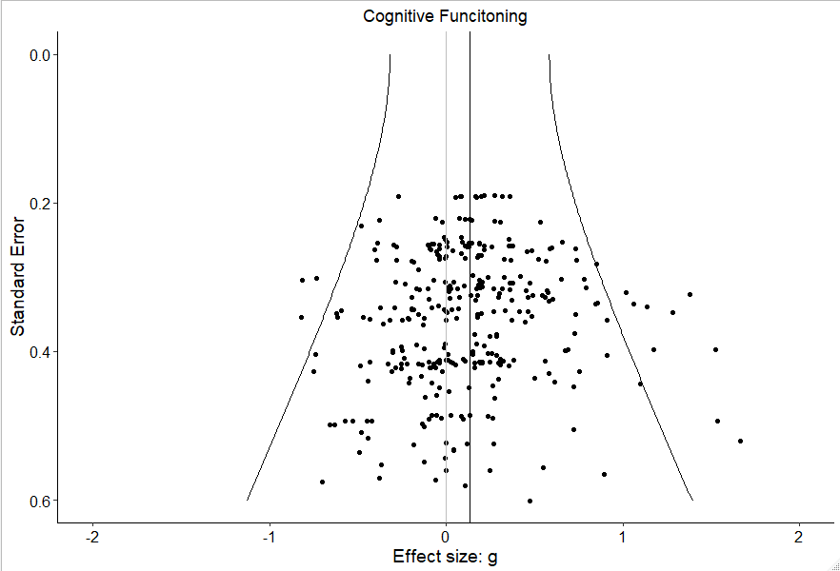

eFigure 32. Funnel plot for effect sizes of Symptomatology domain

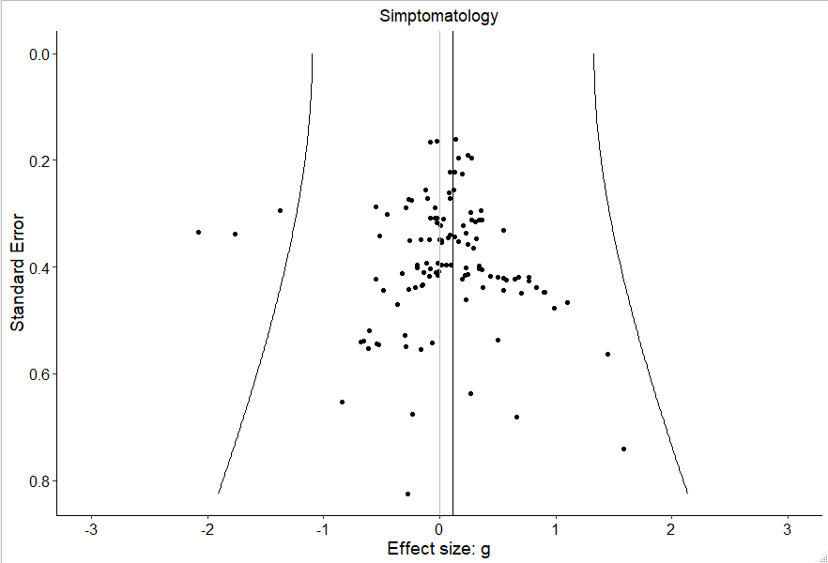

eFigure 33. Funnel plot for effect sizes of Functioning domain

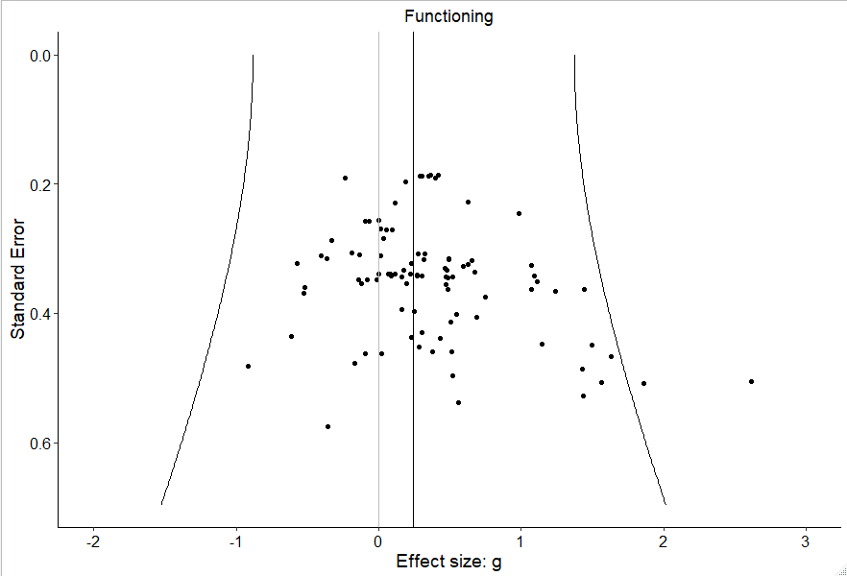

eFigure 34. Funnel plot for effect sizes of Social Cognition domain

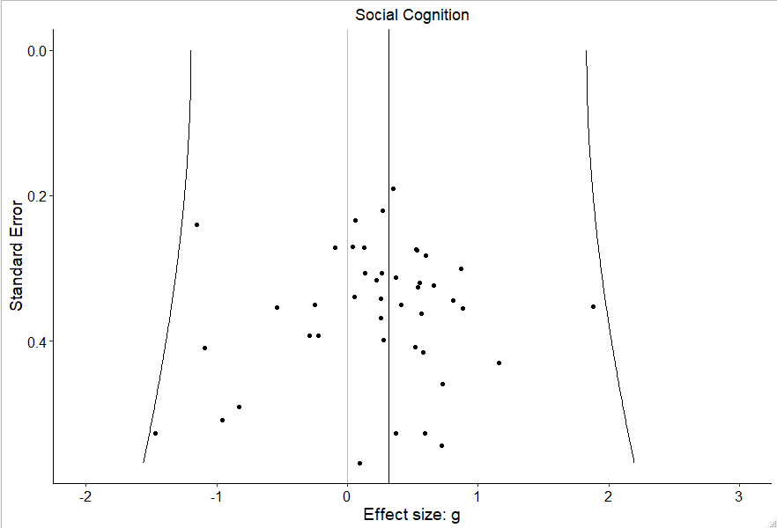

eFigure 35. Funnel plot for effect sizes of Quality of Life domain

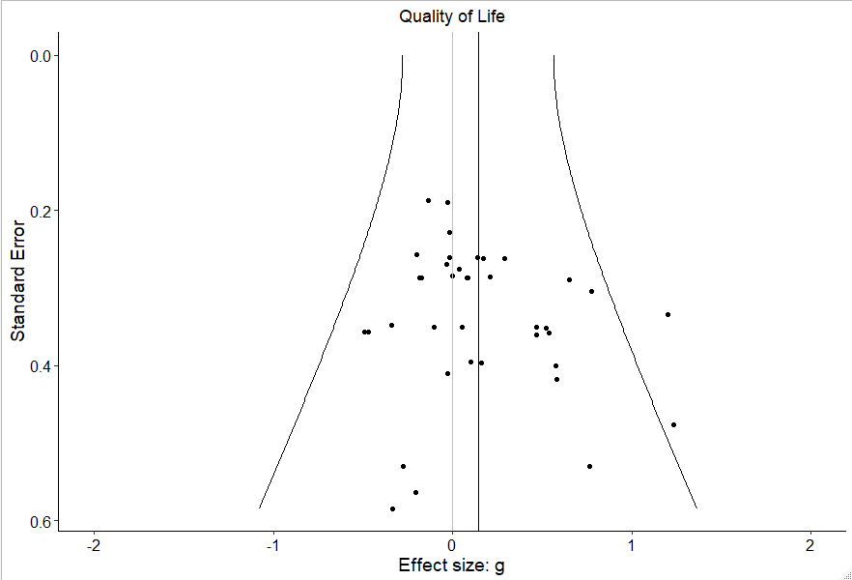

eTable 34. Results from the three-level Egger regression test.

 | k | B | SE | Z | p
Neurocognition | 321 | 0.064 | 0.370 | 0.172 | .863
Symptomatology | 117 | 0.402 | 0.643 | 0.626 | .532
Functioning | 98 | 2.673 | 0.835 | 3.200 | .001
Social cognition | 44 | 0.388 | 1.450 | 0.268 | .789
Quality of life | 38 | 1.083 | 0.855 | 1.266 | .206
Notes. k = number of effect sizes; B= unstandardized effect of the “Standard error” variable; SE= standard error.

eReferences.

- Higgins, J. P., Thomas, J., Chandler, J., Cumpston, M., Li, T., Page, M. J., & Welch, V. A. (2019). Cochrane handbook for systematic reviews of interventions. John Wiley & Sons.
Higgins JP, Thomas J, Chandler J, et al. Cochrane handbook for systematic reviews of interventions. John Wiley & Sons; 2019.
- Bucci, S., Barrowclough, C., Ainsworth, J., Machin, M., Morris, R., Berry, K.,… Haddock, G. (2018). Actissist: Proof-of-concept trial of a theory-driven digital intervention for psychosis. Schizophrenia Bulletin, 44(5), 1070-1080. doi:10.1093/schbul/sby032.
Bucci S, Barrowclough C, Ainsworth J, et al. Actissist: Proof-of-concept trial of a theory-driven digital intervention for psychosis. Schizophr Bull. 2018;44(5):1070-1080. doi: 10.1093/schbul/sby032.
- Holzer, L., Urben, S., Passini, C. M., Jaugey, L., Herzog, M. H., Halfon, O., & Pihet, S. (2014). A randomized controlled trial of the effectiveness of computer-assisted cognitive remediation (CACR) in adolescents with psychosis or at high risk of psychosis. Behavioural and Cognitive Psychotherapy, 42(4), 421-434.
Holzer L, Urben S, Passini CM, et al. A randomized controlled trial of the effectiveness of computer-assisted cognitive remediation (CACR) in adolescents with psychosis or at high risk of psychosis. Behavioural and cognitive psychotherapy. 2014;42(4):421-434.
- Østergaard Christensen, T., Vesterager, L., Krarup, G., Olsen, B. B., Melau, M., Gluud, C., & Nordentoft, M. (2014). Cognitive remediation combined with an early intervention service in first episode psychosis. Acta Psychiatrica Scandinavica, 130(4), 300-310.
Østergaard Christensen T, Vesterager L, Krarup G, et al. Cognitive remediation combined with an early intervention service in first episode psychosis. Acta Psychiatr Scand. 2014;130(4):300-310.

