Supplementary Material
Table S1 The main effects of childhood maltreatment experience on gray matter volume in participants exposed to childhood maltreatment
Regions | Maximum |  |  |  |  | Cluster
 | MNI coordinates |  |  | SDM Value | P | Number of voxels* | Breakdown (number of voxels)
 | X | Y | Z
Left median cingulate / paracingulate gyri, BA 23 | 0 | -20 | 36 | -1.528 | 0.000159979 | 1596 | Left supplementary motor area, BA 6 (272)  Right median cingulate / paracingulate gyri, BA 23 (268)  Left median cingulate / paracingulate gyri, BA 23 (253)  Corpus callosum (114)  Left supplementary motor area (91)  Right median cingulate / paracingulate gyri (90)  Left median network, cingulum (84)  Right median network, cingulum (78)  Left median cingulate / paracingulate gyri (68)  Right supplementary motor area, BA 6 (58)  Right supplementary motor area (44)  Left posterior cingulate gyrus, BA 23 (32)  Right median cingulate / paracingulate gyri, BA 24 (19)  Left median cingulate / paracingulate gyri, BA 24 (15)  Left posterior cingulate gyrus (5)  Right posterior cingulate gyrus, BA 23 (4)  Left supplementary motor area, BA 23 (2)  (undefined), BA 23 (62)  (undefined) (37)
*All voxels with P < 0.005.
BA: Brodmann area; MNI, Montreal Neurological Institute; SDM, seed‐based d mapping.

Table S2 Regional gray matter volume reductions in adult participants with childhood maltreatment experience compared with unexposed comparison subjects
Regions | Maximum |  |  | SDM Value | P | Cluster
 | MNI coordinates |  |  | SDM Value | P | Number of voxels*
 | X | Y | Z
Left supplementary motor area, BA 6 | -6 | -8 | 62 | -1.525 | 0.000185788 | 1149
Left parahippocampal gyrus, BA 35 | -20 | -16 | -26 | -1.228 | 0.001238585 | 80
*All voxels with P < 0.005.
BA: Brodmann area; MNI, Montreal Neurological Institute; SDM, seed‐based d mapping.

Table S3 Correlation between gray matter volume changes and age in adults participants exposed to childhood maltreatment revealed by meta‐regression analyses
 | MNI coordinates
Anatomic label | X | Y | Z | SDM Value | P | Number of voxels**
Left supplementary motor area, BA 6 | -8 | -4 | 64 | -1.277 | 0.000129044 | 17
** All voxels with P < 0.0005.
MNI, Montreal Neurological Institute; SDM, seed‐based d mapping.

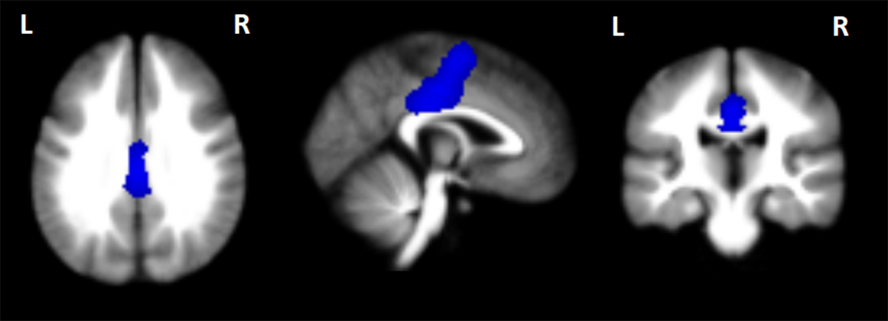
Fig. S1 Regions showing GMV reductions in the median cingulate / paracingulate gyri in axial, sagittal, and coronal views identified by the main effect of childhood maltreatment. Significant clusters are overlaid on MRIcron template for Windows for display purposes only.

