**Supplemental material: Sticky criticism? Affective and neural responses to parental criticism and praise in adolescents with depression**

**Supplement 1: Study procedures**

During an initial phone screening, families were briefed about the study, family circumstances were discussed, and adolescents were screened for current or past psychiatric disorders. After inclusion, families filled out several online questionnaires and were invited for a lab session. During this session, adolescents and their parents provided written informed consent, and subsequently performed several tasks and questionnaires, including questions about personality characteristics of the adolescent. After the lab session, families completed EMA for 14 consecutive days on their smartphones using the Ethica app (Ethica Data, 2019).

Adolescents and their parents were also invited for an MRI-scanning session (scheduled at least one week after the lab session: *M* = 7.61 weeks, *SD* = 6.36, *range:* 1.00–37.86). Participants again provided written informed consent, were accustomed to the scanning environment with use of a mock-scanner, received detailed task instructions, and practiced with button boxes as used in the MRI-scanner. In addition to the parental feedback task (Figure S1), adolescents performed three other tasks in the MRI-scanner (i.e., an eye-contact task (Wever et al., 2022), a peer evaluation task (Will, Rutledge, Moutoussis, & Dolan, 2017), and an autobiographical memory task (van Houtum et al., *in prep*). We counterbalanced the order of the parental social feedback task and peer evaluation task to control for carry-over effects. Before and after each task, adolescents filled out visual analogue scales to assess their current level of self-esteem, sadness, relaxation and irritation (see also *Supplement 3*).

Once outside the scanner, adolescents were asked to recall as much feedback words as possible within two minutes (see also Figure S2). Next, adolescents filled out several questionnaires, e.g. on level of depressive symptoms and handedness. Finally, a manipulation check interview was held to check the extent to which adolescents believed that feedback was provided by their parent. No adolescent disbelieved our cover story (see also *Supplement 4*). Hereafter, a thorough debriefing took place about the study purpose and reasons for preprogramming the parental feedback (see also van Houtum et al., 2022). Families received a monetary compensation for the MRI-scanning session (€20 for adolescents, €30 for parents) plus compensation for travel expenses.

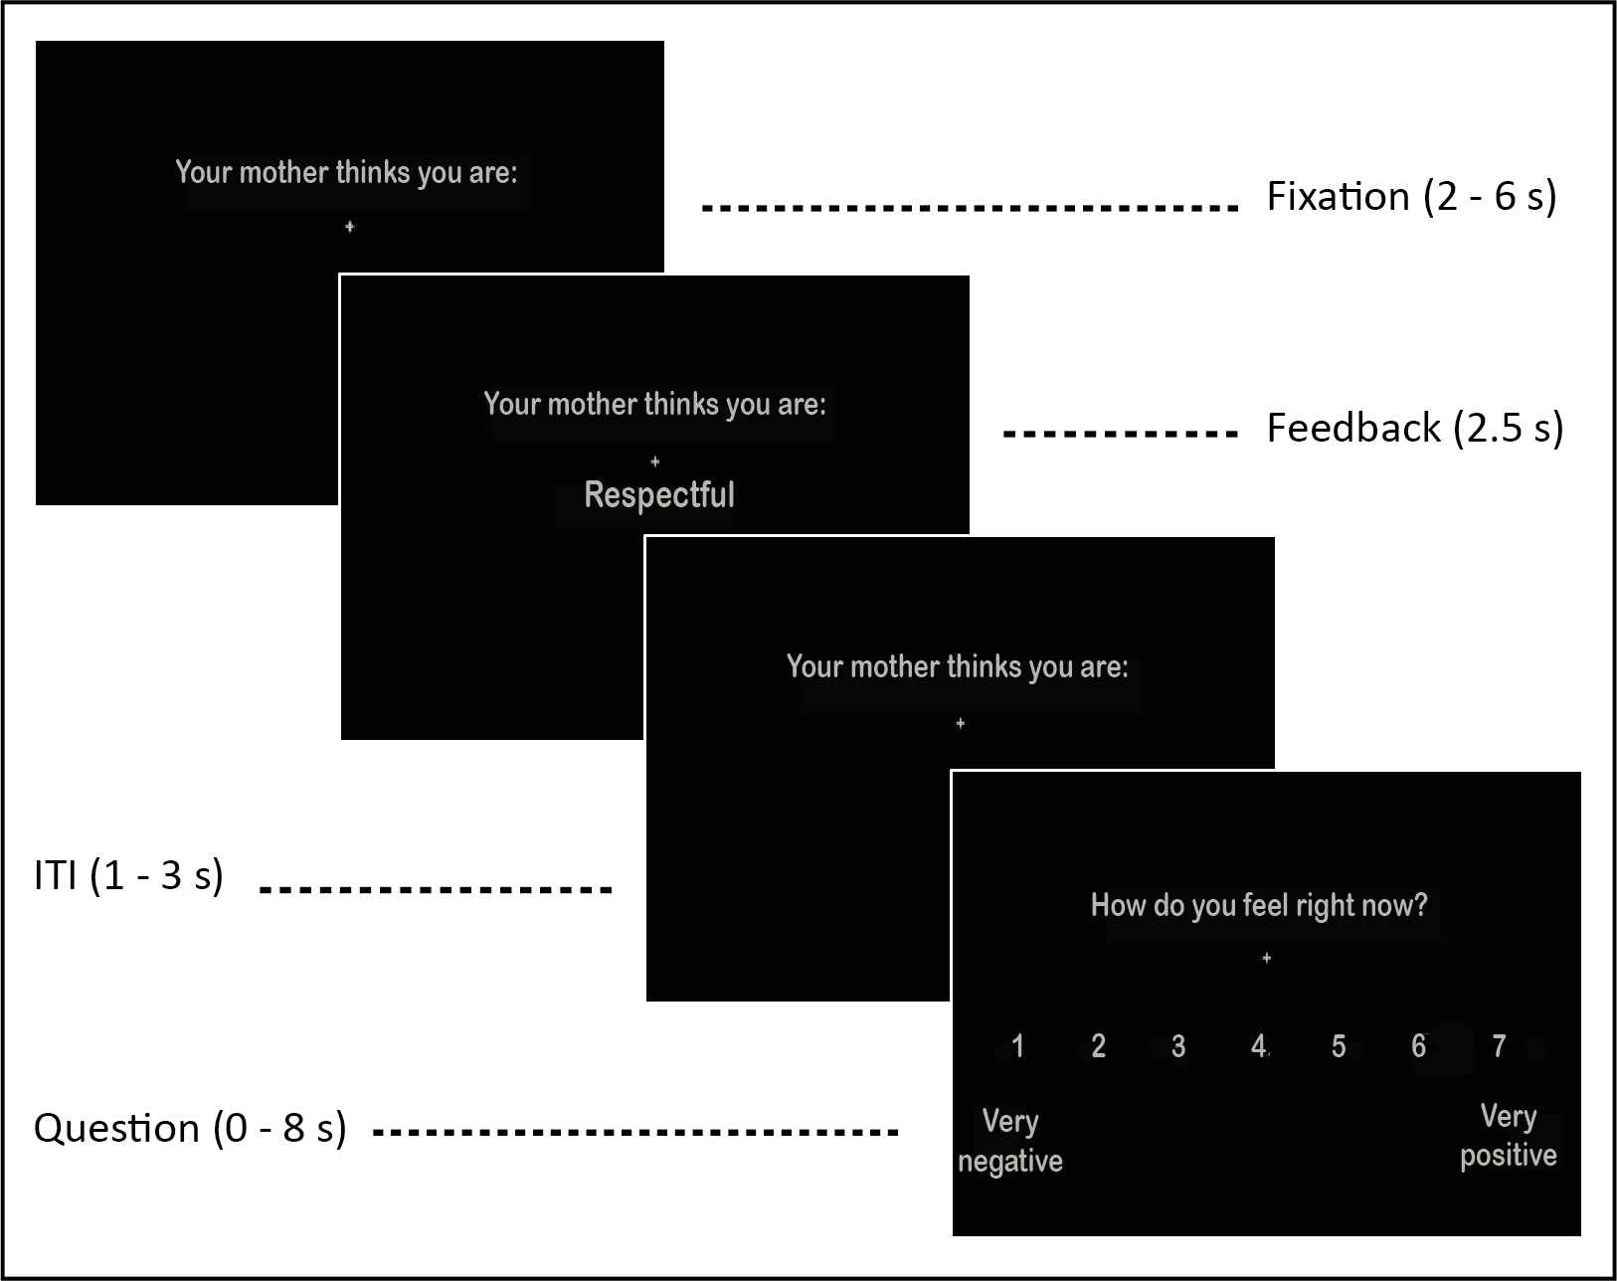

**Figure S1.** Trial structure of parental social feedback task. Depending on which parent participated, *‘mother’* was replaced by *‘father’*.

C:\Users\houtumlaemvan\Dropbox\SFT\figure_paper\SFT_dep\sft_dep_recall.tif

**Figure S2.** Mean % recall of negative, intermediate and positive feedback words by adolescents with depression and healthy controls. Negative and positive feedback words were better recalled than intermediate feedback words [main effect feedback valence: *p* <.001]. In addition, depressed adolescents recalled more negative than positive feedback words (*p* = .043), whereas healthy control adolescents recalled a similar amount of negative and positive feedback words (*p* = .704) [depression status\*feedback valence interaction: *p* = .028]. *Note.* \* *p* < .05; \*\* *p* < .01; \*\*\* *p* < .001.

**Supplement 2: Comorbidities and medication use**

Current and past diagnostic comorbidities of adolescents with depression are shown in Table S1. Two depressed adolescents reported psychotropic medication use (i.e., SSRIs: *n* = 2) the evening before, or at the day of scanning. Furthermore, four healthy control adolescents reported medication use for physical ailments at the day of scanning (hay fever/allergy medication (H1-antagonist): *n* = 2; asthma inhaler (long-acting-β2-agonist): *n* = 1; anti-inflammatory pain reliever (NSAID): *n* = 1).

**Table S1.** Current and past comorbidities of adolescents with depression (*n* = 20)

|  |  |  |  |
| --- | --- | --- | --- |
| **Comorbidity** | **Current, n (%)** | **Past, n (%)** | **Total, n** |
| Social anxiety disorder (social phobia) | 8 (40.0) | 3 (15.0) | 11 |
| Posttraumatic stress disorder | 4 (20.0) | 5 (25.0) | 9 |
| Attention deficit hyperactive disorder | 5 (25.0) | 0 | 5 |
| Generalized anxiety disorder | 3 (15.0) | 1 (5.00) | 4 |
| Specific phobia | 3 (15.0) | 1 (5.00) | 4 |
| Panic disorder | 0 | 3 (15.0) | 3 |
| Oppositional defiant disorder | 1 (5.00) | 1 (5.00) | 2 |
| Agoraphobia | 1 (5.00) | 0 | 1 |
| Separation anxiety disorder | 0 | 1 (5.00) | 1 |
| Eating disorder | 1 (5.00) | 0 | 1 |
| Obsessive compulsive disorder | 1 (5.00) | 0 | 1 |

**Supplement 3: VAS-ratings before and after performing parental social feedback task**

Both before and after the parental social feedback task, depressed adolescents reported a significantly lower level of self-esteem (*b* = -1.83, *SE* = 0.28, *t* = -6.58) [χ2(1) = 63.5, *p* < .001] and relaxation (*b* = -1.57, *SE* = 0.35, *t* = -4.47) [χ2(1) = 22.2, *p* < .001], and higher level of sadness (*b* = 1.74, *SE* = 0.31, *t* = 5.63) [χ2(1) = 38.9, *p* < .001] and irritation (*b* = 0.66, *SE* = 0.30, *t* = 2.17) [χ2(1) = 3.90, *p* = .048] as compared to healthy controls. Although we did not find any interaction effects between depression status (yes/no) and time (pre vs. post task), we found main effects of time, indicating that after vs. before the task, adolescents (independent of depression status) displayed a lower level of self-esteem (*b* = -0.25, *SE* = 0.11, *t* = -2.26) [χ2(1) = 13.2, *p* < .001; interaction: *p* = .077], and higher levels of sadness (*b* = 0.24, *SE* = 0.11, *t* = 2.11) [χ2(1) = 7.51, *p* = .006; interaction: *p* = .613] and irritation (*b* = 0.53, *SE* = 0.15, *t* = 3.47) [χ2(1) = 12.1, *p* < .001; interaction: *p* = .361]. Moreover, no main (*p* = .075) or interaction effect (*p* = .788) on adolescents’ level of relaxation was found, see Figure S3.

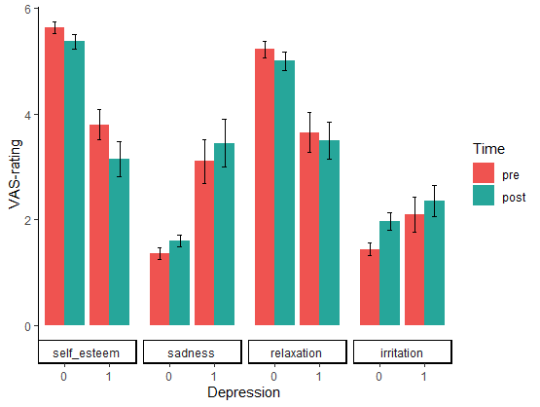

**Figure S3.** VAS-ratings before and after performing the parental social feedback task in depressed (1) and healthy control (0) adolescents. We found main effects of depression status (yes/no) on adolescents’ level of self-esteem (*p* <.001), sadness (*p* <.001), relaxation (*p* <.001), and irritation (*p* =.048) as well as main effects of time (pre vs. post) on level of self-esteem (*p* <.001), sadness (*p* =.006), and irritation (*p* <.001), but no depression status\*time interactions were found.

**Supplement 4: Manipulation check interview**

Upon completion of scanning, we conducted an audio-recorded manipulation check interview to assess whether participants believed that their parents actually provided the feedback they received in the scanner (see van Houtum et al., 2022 for a complete description).

To assess doubts about the authenticity of feedback, we used a funneling suspicion probe derived from prior feedback studies (van Houtum et al., 2021; van Schie, Chiu, Rombouts, Heiser, & Elzinga, 2018). The goal of this probe was to first ask three general questions about the task (i.e. questions 1-3) to allow those who had strong disbeliefs about the task to express their disbeliefs and/or doubts spontaneously. The second part of the interview consisted of three additional questions becoming more and more explicit one by one about potential deception and questioning the authenticity of feedback (i.e. questions 4-6), to assess more subtle indications of doubt. Participants were categorized in three groups: i) ‘non-believers’ (i.e., those who showed spontaneous expressions of disbelief during questions 1-3), ii) ‘mild doubters’ (i.e., those who expressed some doubt in response to questions 1-6, but no serious disbelief about the task), and iii) 'full-believers’ (i.e, those who showed no expressions of doubt, not even to questions 4-6 implicitly mentioning deception). Five research assistants independently judged whether each participant should be assigned to the full-believer, mild doubter, or non-believer category, by listening to the recorded interviews. In case of inter-rater disagreement, the final rater (LvH) made a final categorization decision (disagreements across raters in healthy control sample: *n* = 18; 30.5%; in depressed sample: *n* = 8; 40%).

Adolescents either believed the cover story completely (full-believers in healthy control sample: *n* = 18/59, 30.5%; in depressed sample: *n* = 9/20, 45%) or expressed some doubt (mild doubters in healthy control sample: *n* = 41/59, 69.5%; in depressed sample: *n* = 11/20, 55%), while no one could be categorized as non-believer (see *Methods* section in main text). For example, mild doubters expressed in response to questions 1-3: *‘I doubted at a certain point, like huh, did my mother really say that?’*, or in response to question 4: *‘I already was not sure whether you made this up or not’,* while full-believers e.g. responded to question 4 with: *‘I am very sure that my parent gave the feedback’.* Belief status was not differentially distributed among groups (χ2(1) = 0.82, *p* = .364).

**Table S2.** Verbally asked questions during manipulation check interview of parental social feedback task in Dutch (left) and English (right)

|  |  |  |  |
| --- | --- | --- | --- |
| *Question* | |  | |
| 1 | In hoeverre ben je het eens met de feedbackwoorden die je ontvangen hebt van je ouder? | | To what extent do you agree with the feedback words you have received from your parent? | |
| 2 | Hoe denk je nu over je vader/moeder na het krijgen van de feedback? | | How do you feel about your father/mother after getting the feedback? | |
| 3 | Heeft de feedback je emotioneel geraakt? Waarom wel of niet? | | Were you emotionally affected by the feedback? Why (not)? | |
| 4 | Hoe zeker ben je ervan dat je ouder de feedback heeft gegeven? | | How confident are you that your parent gave the feedback? | |
| 5 | Dacht je dat de hele tijd? Vanaf wanneer wel of niet? | | Did you have this feeling during the whole task? Or at what point did this feeling change? | |
| 6 | Wat waren redenen om te twijfelen aan de opzet? | | What were reasons to doubt the task setup? | |

**Supplement 5: fMRI data acquisition and preprocessing**

We acquired MRI images using a Philips Achieva 3.0-Tesla scanner (Philips Medical Systems, Best, NL) equipped with a SENSE-32 whole-head coil. Head motion was restricted using foam inserts. First, we acquired a structural 3D T1-FFE scan (TR/TE: 7.9/3.5 ms; flip angle: 8°; 155 transverse slices; FOV: 250×195.83×170.5 mm; voxel size: 1.10 mm3; duration: 4:11 min). Next, we collected functional scans with T2\*-weighted echo-planar imaging (EPI) sequence (TR/TE: 2200/30 ms; flip angle: 80°; 38 transverse slices (anterior-to-posterior); FOV: 220×220×114.68 mm; voxel size: 2.75 mm3). Number of volumes per participant varied due to self-paced mood ratings (HC: *M*(*SD*) = 237.8(10.5), *range:* 221–273; DEP: *M*(*SD*) = 233.1(11.1), *range:* 215–259; no difference between groups [*U* = 749, *p* = .075]). Finally, a b0-field map was acquired for EPI distortion correction (TR/TE: 200/3.2 ms; maximum: 58 slices (optimum: 29 slices); voxel size: 2.75 mm3). Anatomical scans were examined by a radiologist for structural brain abnormalities.

fMRI data were preprocessed and analyzed using SPM12 (Wellcome Trust Centre for Neuroimaging, London, UK). Functional scans were corrected for slice-timing, corrected for field-strength inhomogeneity using b0-field maps, unwarped and realigned, co-registered with the subject-specific anatomical scan, normalized to MNI-space using the DARTEL-toolbox(Ashburner, 2007), resliced to 1.5 mm3 voxels and spatially smoothed with an 8-mm FWHM isotropic Gaussian kernel. Both raw and preprocessed data were checked for quality, registration, and movement (HC: *M*(*SD*) = 0.09(0.07) mm, *range:* 0.002–3.80; DEP: *M*(*SD*) = 0.12(0.07) mm, *range:* 0.003–3.01).

**Table S3.** Effect parameters of model predicting mood ratings by feedback valence category (intermediate = reference category), depression status (healthy control = reference group), and applicability of feedback and two- and three-way interactions

|  |  |  |  |  |
| --- | --- | --- | --- | --- |
| **Effect** | **Estimate (b)** | **Standard Error** | **t-value** | **p-value** |
| Intermediate feedback (intercept) | 0.22 | 0.08 | 2.90 | .005\*\* |
| Depression status: yes | -0.69 | 0.15 | -4.58 | <.001\*\*\* |
| Criticism | -0.43 | 0.06 | -7.02 | <.001\*\*\* |
| Praise | 0.43 | 0.05 | 8.35 | <.001\*\*\* |
| Applicability | 0.21 | 0.03 | 7.22 | <.001\*\*\* |
| Depression\*Criticism | 0.11 | 0.11 | 0.97 | .333 |
| Depression\*Praise | -0.19 | 0.10 | -1.96 | .053 |
| Depression\*Applicability | -0.18 | 0.06 | -3.20 | .002\*\* |
| Criticism\*Applicability | 0.06 | 0.04 | 1.70 | .088 |
| Praise\*Applicability | -0.08 | 0.03 | -2.28 | .022\* |
| Depression\*Criticism\*Applicability | 0.03 | 0.06 | 0.52 | .602 |
| Depression\*Praise\*Applicability | 0.19 | 0.06 | 3.17 | .002\*\* |

*Note.* \* *p* < .05; \*\* *p* < .01; \*\*\* *p* < .001.

**Table S4.** Differences in activity in brain regions revealed by whole-brain analysis in response to negative and positive parental feedback in depressed vs. healthy control adolescents

|  |  |  |  |  |  |  |
| --- | --- | --- | --- | --- | --- | --- |
| *Contrast* | MNI coordinates | | | Voxel test value | Cluster | Cluster |
| Brain regions | **x** | **y** | **z** | **Z** | ***p*-value** | **size** |
| *Negative > Intermediate (DEP>HC)* |  |  |  |  |  |  |
| R Superior temporal gyrus | 66 | -9 | -11 | 4.68 | <.001 | 1460 |
| R Middle temporal gyrus | 44 | -39 | -2 | 3.81 |  |  |
| L Temporal pole | -39 | 8 | -36 | 4.33 | <.001 | 1443 |
| L Inferior temporal gyrus | -42 | -6 | -41 | 4.30 |  |  |
| L Temporal pole | -35 | 15 | -29 | 3.90 |  |  |
| *Positive > Negative (HC>DEP)* |  |  |  |  |  |  |
| R Lingual gyrus | 23 | -75 | -2 | 4.69 | <.001 | 1649 |
|  | 29 | -63 | 0 | 4.17 |  |  |
| R Calcarine fissure | 27 | -71 | 8 | 3.90 |  |  |

*Note.* Neural results are corrected for multiple comparisons using Family-wise Error cluster-correction at *p* < .05 with a cluster-forming threshold of *p* < .001. DEP = adolescents with depression; HC = healthy control adolescents; L = left; R = right; MNI = Montreal Neurological Institute; Z = Z-score.

**Supplement 6: Differences in associations with parents’ general view of the child**

Parents of depressed adolescents viewed their child less positively as compared to parents of healthy control adolescents [*U* = 768, *p* = .045]. More specifically, parents of depressed adolescents rated positive feedback words (*b* = -0.29, *SE* = 0.09, *t* = -3.39) as less applicable to their child, and negative (*b* = 0.02, *SE* = 0.09, *t* = 0.22) and intermediate (= reference category; *b* = 0.12, *SE* = 0.06, *t* = 2.13) feedback words as more applicable as compared to parents of healthy controls [χ2(2) = 11.6, *p* < .003] (Figure S4). However, contrary to expectations the Kolmogorov-Smirnov test indicated that the variable’s distribution between the two samples did not significantly differ [*D* = 0.28, *p* = .095].

We did not find a three-way interaction between parents’ general view of their adolescent child, depression status and feedback valence on adolescents’ mood responses [χ2(2) = 0.22, *p* = .897], neither a two-way interaction between depression status and parents’ general view of the child [χ2(1) = 2.89, *p* = .089], or between feedback valence and parents’ general view [χ2(2) = 0.29, *p* = .865] on mood.

Whole-brain analyses testing for group differences in neural responses to parental feedback related to parents’ general view of the child did not yield any significant clusters that survived correction for multiple comparisons.

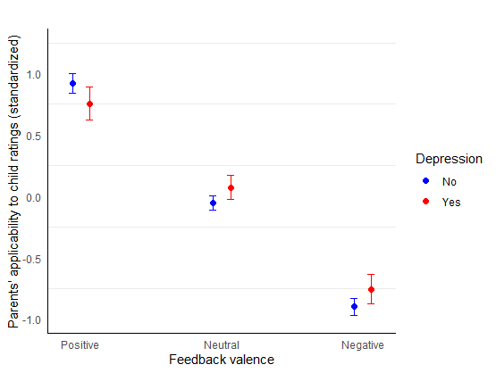

**Figure S4.** Interaction effect of depression status (yes/no) and feedback valence (*p* = .003) on parents’ applicability to child ratings.

**Supplement 7: Confound analyses**

Results from analyses on behavioral measures did not change when adding sex, age, pubertal status, parental sex, or strength of belief in the feedback cover story as covariate. Regarding the neural results, all outcomes remained significant and only minor changes in peak coordinates were observed when taking sex, age, pubertal status, parental sex, belief, or left-handedness into account.

**Supplemental references**

Ashburner, J. (2007). A fast diffeomorphic image registration algorithm. *Neuroimage, 38*(1), 95-113. doi:10.1016/j.neuroimage.2007.07.007

van Houtum, L. A., Wever, M., Janssen, L. H., van Schie, C. C., Will, G.-J., Tollenaar, M. S., & Elzinga, B. M. (2021). Vicarious Praise and Pain: Parental Neural Responses to Social Feedback about Their Adolescent Child. *Social Cognitive and Affective Neuroscience, 16*(4), 406-417.

van Houtum, L. A., Will, G.-J., Wever, M. C., Janssen, L. H., van Schie, C. C., Tollenaar, M. S., & Elzinga, B. M. (2022). Adolescents’ affective and neural responses to parental praise and criticism. *Developmental Cognitive Neuroscience, 54*, 101099.

van Schie, C. C., Chiu, C. D., Rombouts, S., Heiser, W. J., & Elzinga, B. M. (2018). When compliments do not hit but critiques do: an fMRI study into self-esteem and self-knowledge in processing social feedback. *Social Cognitive and Affective Neuroscience, 13*(4), 404-417. doi:10.1093/scan/nsy014

Wever, M. C., van Houtum, L. A., Janssen, L. H., Wentholt, W. G., Spruit, I. M., Tollenaar, M. S., . . . Elzinga, B. M. (2022). Neural and Affective Responses to Prolonged Eye Contact with One's Own Adolescent Child and Unfamiliar Others. *Neuroimage, 260*, 119463.

Will, G. J., Rutledge, R. B., Moutoussis, M., & Dolan, R. J. (2017). Neural and computational processes underlying dynamic changes in self-esteem. *Elife, 6*. doi:10.7554/eLife.28098