**Supplementary materials**

*Regional GMV difference detected in a parametric test with a liberal threshold*

We found regional GMV difference between VLOSLP and healthy subjects in the whole-brain analysis using a nonparametric approach with a stringent statistical threshold. Here we also report the results with a more liberal statistical threshold and using a parametric approach that is commonly used in the literature, particularly in smaller samples. This is because few studies have investigated the neurobiology of VLOSLP and our results even with a liberal statistical threshold may provide additional insight into the neurobiology of VLOSLP.

When we set the statistical threshold for the voxel-wise whole-brain analyses at cluster-level family-wise error correction (FWE) corrected p <.05 with an individual voxel threshold of p = .001, the right thalamic cluster and the left frontal regions, including the left inferior frontal gyrus and insula, both of which were detected in the nonparametric test, were identified as lower GMV regions in patients with VLOSLP. With a liberal threshold (uncorrected voxel-level p = .001 with 100 voxels), we found the following additional brain regions showing lower GMV in patients with VLOSLP compared to healthy controls: the right inferior temporal gyrus, right hippocampus, left thalamus, and right cerebellum (supplementary table 1; supplementary figure 1)

Supplementary table 1. Regions of significantly lower GMV in VLOSLP detected in the whole-brain GMV analysis with an uncorrected voxel level p = 0.001 with 100 voxels.

|  |  |  |  |  |  |  |
| --- | --- | --- | --- | --- | --- | --- |
| Brain Regions | Peak MNI coordinates | | | T values | Z scores | Cluster Size (voxels) |
| X | y | z |
| Right thalamus | 14 | -8 | 15 | 4.65 | 4.31 | 1202 |
| Left frontal regions  left inferior frontal gyrus  left insula | -51 | 38 | 9 | 4.43 | 4.13 | 1541 |
| Right inferior temporal gyrus | 51 | -54 | -15 | 4.36 | 4.07 | 340 |
| Right hippocampus | 32 | -30 | -10 | 3.91 | 3.70 | 380 |
| Left thalamus | -8 | -9 | 16 | 3.90 | 3.69 | 450 |
| Right cerebellum | 18 | -69 | -58 | 3.71 | 3.53 | 282 |

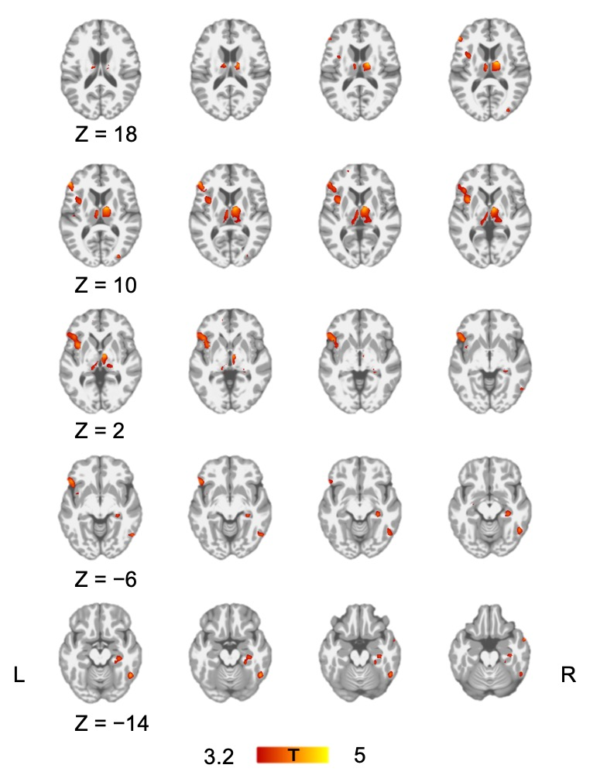

Supplementary Figure 1. Brain regions showing significantly lower GMV in patients with VLOSLP compared to healthy controls using a parametric approach. Brain regions associated with lower GMV in VLOSLP are shown in red in the figure. Statistical threshold was set at uncorrected voxel-level p = 0.001 with a cluster extent threshold of 100 voxels.

*Multivariate source-based morphometry analysis*

Voxel-based morphometry (VBM) is an automated technique, which utilizes multiple univariate analyses to identify clusters of voxels which differ between two groups (e.g., lower gray matter volume (GMV) in patients with VLOSLP compared to healthy controls). In contrast to identifying multiple single regions in isolation in the univariate analysis such as VBM, identifying spatially distinct regions that show similar patterns of GM abnormalities may provide complementary information on the neurobiology of psychiatric disorders as neuronal network disorders. Source-based morphometry (SBM) is a data-driven, multivariate extension of VBM utilizing independent component analysis (ICA) to identify patterns across multiple covarying networks (Xu et al., 2009). This technique can reduce the severity of multiple comparison correction and improve sensitivity to detect GM difference between groups while also providing biologically meaningful information. Previous research into the neurobiology of schizophrenia has shown that SBM identified GMV differences that were not identified by VBM (Xu et al. 2009; Wolf et al. 2014; Gupta et al., 2015).

Therefore, in the current study, we also conducted the SBM analysis as well as the VBM analysis. First, using individual pre-processed GM image, an independent component analysis (ICA) was performed. An Infomax algorithm implemented in the SBM module of the GIFT toolbox (http://mialab.mrn.org/software/gift) was used to perform ICA decompositions. We set the number of components to 30 in accordance with similar studies (Xu et al., 2009; Gupta et al., 2015), and we used the ICASSO algorithm (Himberg et al., 2004) to increase component reliability and consistency. The ICA estimation was repeated 20 times with bootstrapping and permutation. Artifact components were identified visually and were excluded. Components with a quality index >0.9 indicating stable decomposition (Allen et al., 2011) were used in subsequent analyses.

Group comparisons were conducted by using ICA loading parameters which represent the contribution of every GMV component to the 71 participants (35 patients with VLOSLP and 36 healthy controls): thus, these parameters contain information about the relationship between each subject and each component. When the spatial component is positive, and when the loading coefficients are larger in healthy controls than in patients with VLOSLP, we interpret that GMV is larger in healthy controls for the spatial component. A multivariate analysis of covariance (MANCOVA) was used with loading parameters as dependent variables, diagnosis as a factor, and age as a covariate. We set p <.05 as a statistically significant threshold. The following separate ANCOVAs including age as a covariate were conducted to identify which components differed between groups. For the purpose of the visualization, the source matrix was reshaped back to a 3-D image, scaled to unit standard deviations (Z maps) and thresholded at Z >3.0. Detailed description of methodology for SBM can be found in a previous paper (Xu et al., 2009).

*Group comparisons of structural networks*

SBM analysis identified eight stable components in our cohort (supplementary figure 2). There was a significant main effect of diagnosis on ICA loading parameters (F8, 61 = 2.87, p = .009). Separate univariate ANCOVAs revealed that there was a main effect of diagnosis in the component2 (thalamic and hippocampal component) (F1, 68 = 15.2, p <.001) even after multiple comparisons correction.

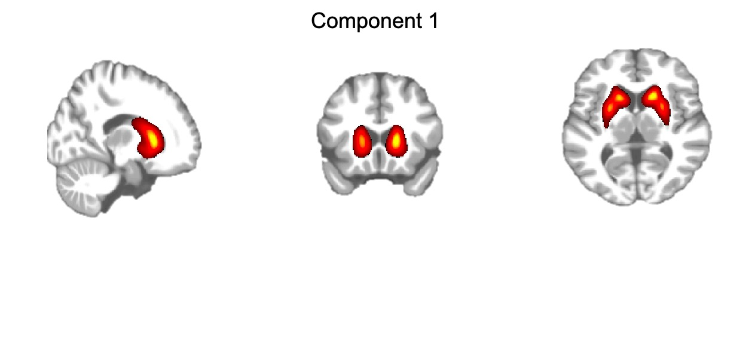

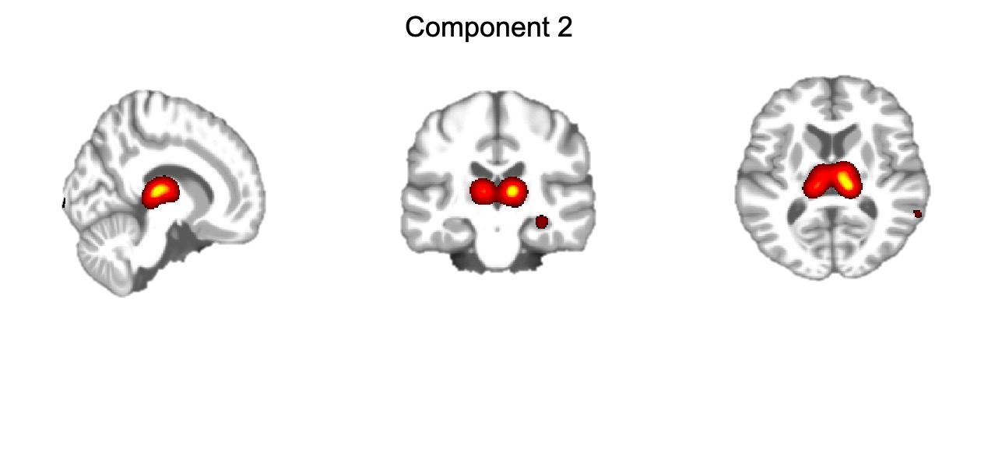

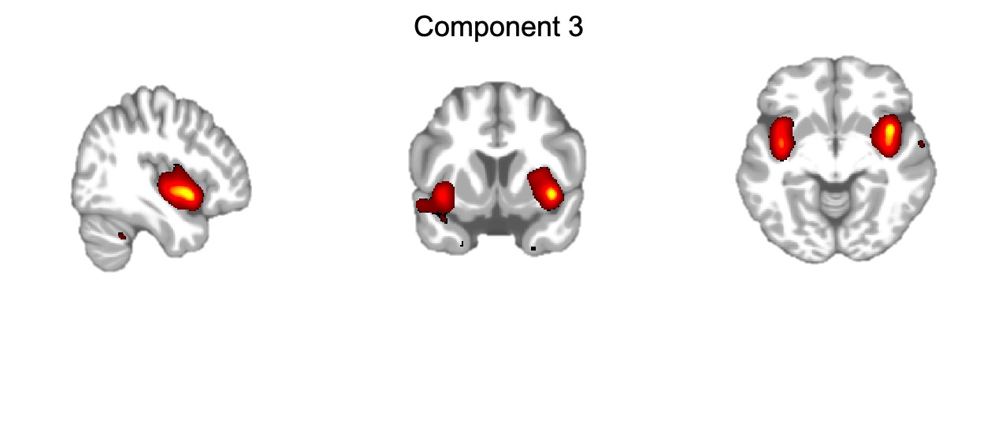

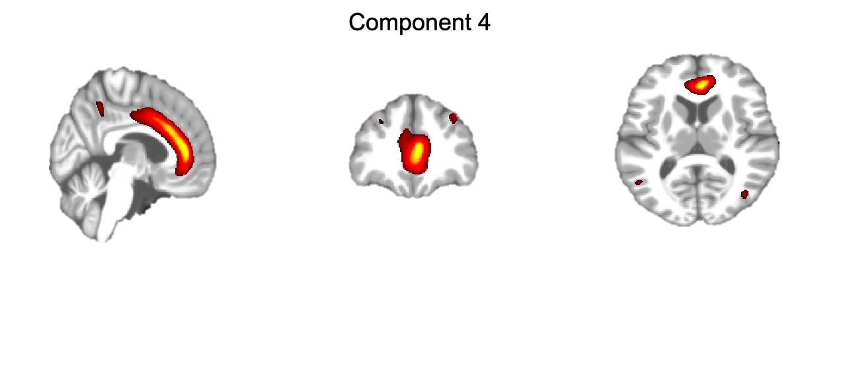

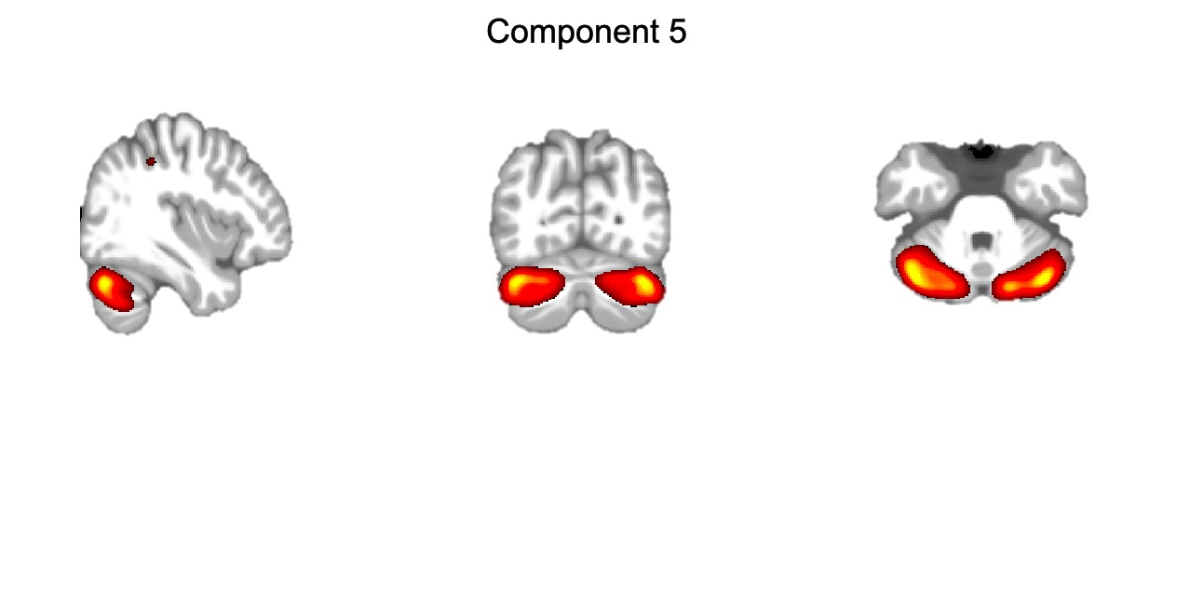

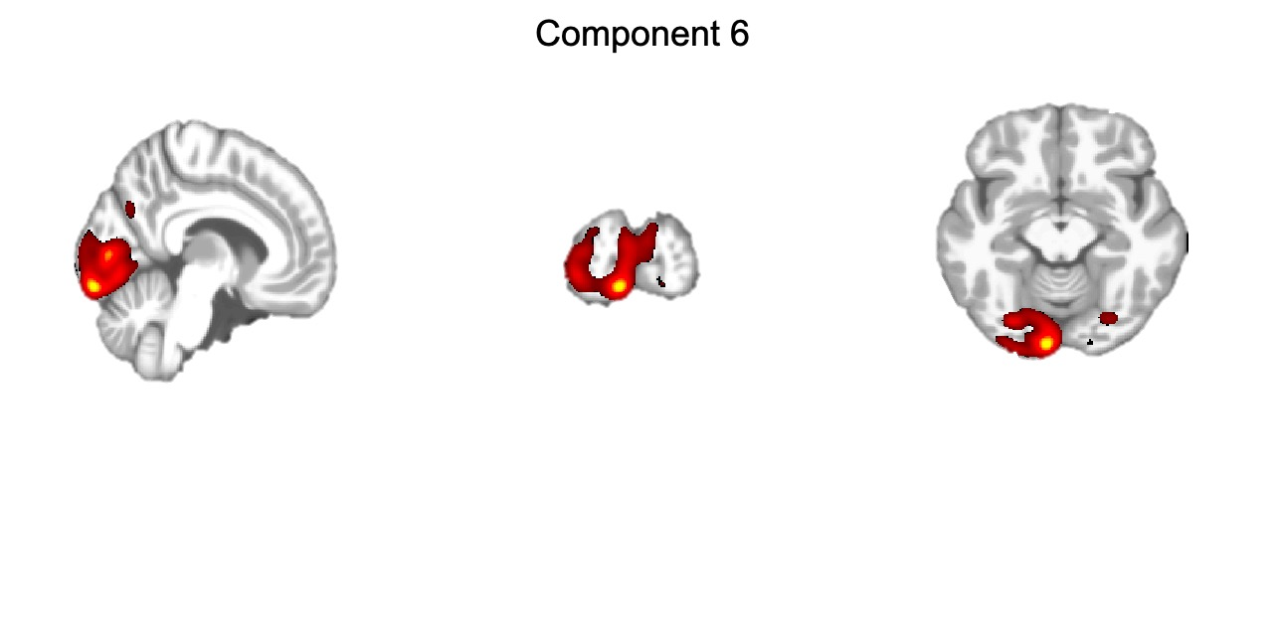

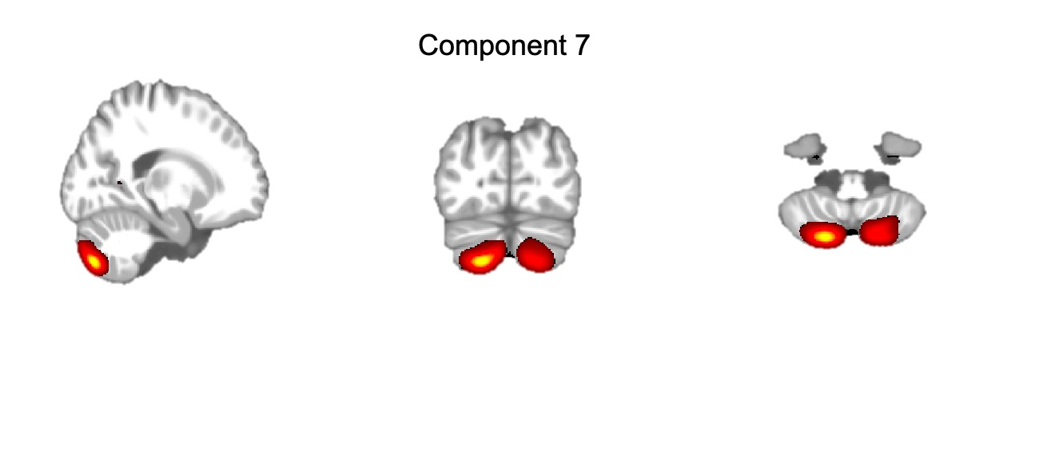

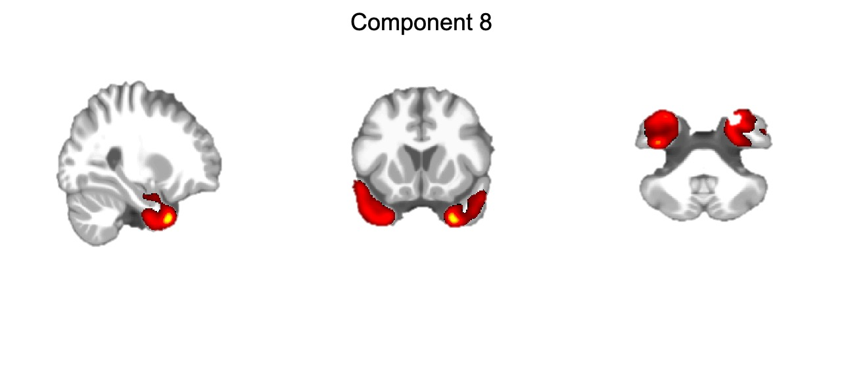



Supplementary Figure 2. (A) Eight stable components detected in the ICA in our cohort. For visualization purpose, all maps in the supplementary figure 2A were thresholded at Z >3.0. (B) Lower ICA loading parameters in the thalamic and hippocampal component in the patients with VLOSLP.

Supplementary Figure 3. Partial correlation between thalamic volumes and RAVLT delayed recall in participants with VLOSLP with age as a covariate, illustrating an association between larger volumes and better performances.